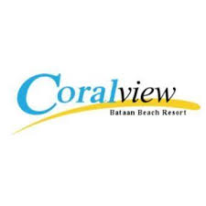

POOL RULES

* Strictly NO DIVING.
* NO PUSHING
* NO BOMBING
* WATCH YOUR CHILDREN
* NO FOOD OR DRINKS
* NO ROUGH PLAY

POLICIES

* NO SHOWS are NON REFUNDABLE
* 4years old and above will be count as excess person
* Wear a white color of shirt for swimming attire
* Strictly NOT ALLOWED MAONG SHORTS wearing in the pool
* Electric appliances are not allowed inside the resort, use portable or gas burner stove only
* No eating inside the room
* NO TOWELS provided
* Swimming pools are open until 12 midnight only
* Swimming at the beach until 6pm only
* NOT ALLOWED after the Breakwater

. TERMS AND CONDITIONS

* We assume that all amenities inside the room are in good working conditions and any damage or lost shall be charge to my account.
* Check-in time is **2:00pm** while check-out time is **12:00nn**
* Late check-out will be charge **20%** total of the room accommodation/hour and is subject to availability.
* CANCELLATION of the event by the guest for whatever reason made one (1) month will be charge **(50%)** percent penalty while fifteen (15) days before the reservation date is eighty **(80%)** percent penalty for the total package, the deposited to our account shall be forfeited.
* RESCHEDULING of the event should be advised one (1) month before the event and subject for availability. Later than one (1) month is subject to **(30%)** percent penalty. Rescheduling shall only be allowed once.
* Lost Key will be charge Five **(500)** hundred pesos.
* Resort Management reserves the right to refuse entry of any persons or group of persons.
* The Management is not liable for any damaged or lost of item left in and outside the room.
* The Management is not responsible for any accident, death or injuries within the resort premises.
* Early arrival at the resort for overnight stay will be charge entrance fee.
* CANCELLATION on the same date of reservation will be charge full payment.