|  |  |
| --- | --- |
|  | **University of Sheffield**  **Risk Assessment Form** |

Examples Potential Hazards:

|  |  |  |  |  |  |  |  |  |  |  |  |
| --- | --- | --- | --- | --- | --- | --- | --- | --- | --- | --- | --- |
|  | Fall of person (from work at height) |  | Lighting levels |  | Use of portable tools / equipment |  | Vehicles / driving at work |  | Hazardous fumes,  chemicals, dust |  | Occupational stress |
|  | Fall of objects |  | Heating & ventilation |  | Fixed machinery or lifting equipment |  | Outdoor work / extreme weather |  | Hazardous biological agent |  | Violence to staff / verbal assault |
|  | Slips, Trips & Housekeeping |  | Layout , storage, space, obstructions |  | Pressure vessels |  | Fieldtrips / field work |  | Confined space / asphyxiation risk |  | Work with animals |
|  | Manual handling operations |  | Welfare facilities |  | Noise or Vibration |  | Work with lasers |  | Condition of Buildings & glazing |  | Lone working / work out of hours |
| 1. **55** | Display screen equipment |  | Electrical Equipment |  | Fire hazards & flammable material |  | Radiation sources |  | Food preparation |  | Other Hazards specific to your work. |

|  |  |  |  |  |  |  |  |  |
| --- | --- | --- | --- | --- | --- | --- | --- | --- |
| **PERSONS AT RISK:** Employees ( ) Contractors ( ) Public ( )  Visitors ( ) Others ( ) | | | | **Reference number:** | | | | |
| **RISK (H) High (M) Medium (L) low (O) No Risk** | | | | **Environment** | | | | |
| **TASK or ACTIVITY:** | | | **INITIAL RISK LEVEL** |  | | |  | **FINAL RISK LEVEL** |
| **Significant Hazard** | **Potential Consequences of Hazard** | |  | **Existing Control Measures** | | | **Additional Control Measures (If Required)** |  |
| **Lone working** |  | |  | Nothing rather than computer work when lone;  F1666, busier lab, more likely to be more people. | | |  |  |
|  |  | |  |  | | |  |  |
| **Fire hazard** |  | |  |  | | |  |  |
| **Electrical shot/damage** |  | |  | No main level working, all low voltage < 12 volts DC, using a lab power supply. | | |  |  |
|  |  | |  |  | | |  |  |
| **Using equipments** |  | |  | Ask technician for advice before use. | | |  |  |
|  |  | |  |  | | |  |  |
|  |  | |  |  | | |  |  |
|  |  | |  |  | | |  |  |
|  |  | |  |  | | |  |  |
|  | | | | | | | **Overall Risk:** |  |
| **Comments:** | | | | | | | | |
|  | | | | | | | | |
|  | | | | | | | | |
| **Additional References, Tasks Etc** | | | | | | | | |
|  | | | | | | | | |
|  | | | | | | | | |
| **Undertaken By:** | |  | | |  | | | |
|  | |  | | | **Revision Date:** |  | | |
| **Other Persons Consulted:** | |  | | | **Revision Date:** |  | | |
|  | |  | | | **Revision Date:** |  | | |
| **Date:** | |  | | | **Revision Date:** |  | | |

Use the table given on the risk matrix to score your hazard or activity for the probability (‘L' ) likelihood harm will occur and the severity ('S') of the outcome.

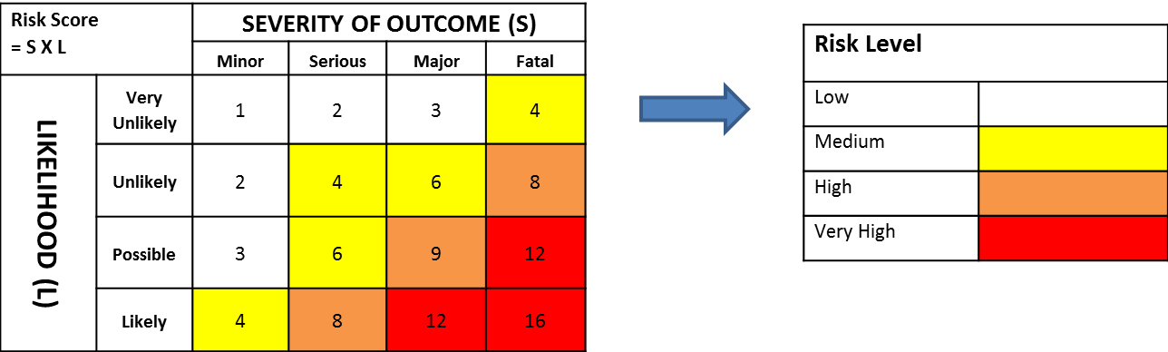

Plot the scores on the matrix or multiply them together (LxS) to obtain a risk score – then use the colour of that score to determine the Risk Level, Low to Very High.

Activities that are High or Very High must not start (or will need to be suspended), without appropriate controls in place to reduce the risk to an acceptable level.

Wherever it is a possibility that a serious injury may occur risk must be lowered by putting in extra control measures.