# Introduction

International students and fresher usually trend to live in student accommodations where they pay fixed bills, such as electricity bills. However, they often have sleeping issues in the winter since the timer of the radiator typically found in such student accommodation work for a maximum period of two hours. Therefore, if they wake up because they felt cold, they either have to get up to turn on the radiator again by pressing a button on the timer, or stay in the bed and hope they can fall asleep again. Of course, buying a mobile radiator is not a bad solution since it can be on for the whole night without being automatically shut down. Plus it does not violate the accommodation regulations since the bill is fixed. But a mobile radiator may be costly, and it takes up extra room. To address this issue, the essential aim of this project is to develop a simple, cheap, reliable thermostat attaching to the radiator timer so that the thermostat is able to press the button on the existing room timer automatically to make sure the radiator is as necessary on throughout the night. The product also has additional product requirements, such as reasonable energy saving, smart controls to keep a constant temperature. This project will involve product requirements definition, project management, documentation writing, system design, simulation, verification, and hardware prototyping with mechanics, hardware, and software. It aims to build up a hardware prototype to prove this concept.

# Objectives

A product with reasonable customer desired feature needs to be specified. A reasonable low-cost design has to be implemented against the product specification. And a hardware prototype is supposed to be delivered to prove the concept of this product.

# Product definition

Product definition is the most important phase in this project because this project aims to build up a practical low-cost solution. And it is crucial to conduct more investigations on what to build and how to implement in a low-cost manner rather than building it up itself.

There are a few student accommodations whose rent includes bills and radiators can be on for only limited time once set. A few investigations have been conducted on these accommodations. Generally there are two radiator controller products widely used in Sheffield student accommodations. One of them is a Newlec® controller, widely used in Opal® student accommodations in the UK including Sheffield, Manchester, London, etc. And it is used in Sheffield student accommodation Opal 1®, Opal 2®, and Sheffield 3®. Students can pressed the “BOOST” button on the timer to set up how long they want the radiator to be on, shown in Figure 1. Every time the “BOOST” button pressed will extend the on time for half an hour. But unfortunately, it is only can be on only for maximum two hours. Moreover it does not have a temperature control feature. Once it is on, it is always on before it is timed out.

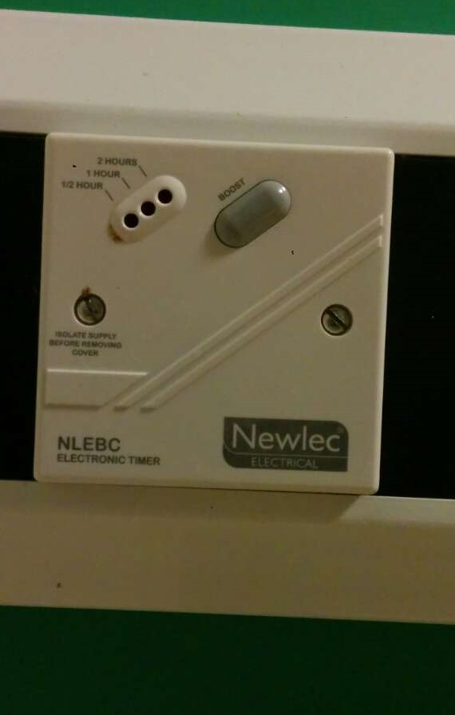

**Figure 1 : Newlec® controller in Sheffield Opal 1, Opal 2 and Sheffield 3 student accommodation**

Another controller is a series of Prefect® controllers. It is also widely used in UK for many student accommodations. And it is used in Sheffield student accommodation Exchange Works®, IQ®, Aspect 3®, etc. But for each student accommodations they may have different radiators under controlled by one of this controller and different radiators have various range of maximum on time. Students can tap a “TOUCH” switch on the radiator and it will be off once it is timed out. One of types of Prefect® controllers is shown in Figure 2. The one shown below is a Prefect® PRE5003 thermostat which has a 20-level temperature set. It will keep room temperature constant once the “TOUCH” switch is tapped and be off once the time setting on the radiator times out. But this Prefect® PRE5003 thermostat only be used in Sheffield Exchange Works®. Other student accommodations are using another simple Prefect® touch switch which will only be switched on by tapping the “TOUCH” switch and be off once it is timed out but it does not have thermostat feature. And the accommodations with this type of controller are Sheffield Aspect 3®, IQ®.

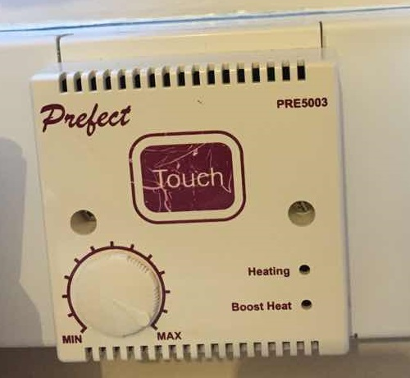

**Figure 2: Prefect® PRE5003 thermostat in Exchange Works®, Sheffield**

To seek for desired product features, a few interviews has been conducted to the tenancies in above student accommodations to talk about the feedback of their user experience of such two controllers. The reason why conducting interviews rather than sending out surveys is that interviews are more interactive and it normally come out with the ideas and topics that a survey unable to cover. A summary of the desired requirements were below:

1. **Controlling room temperature in a comfortable temperature is essential.** Most of users of Newlec® controllers had the same issue about inability to keep room temperature confortable. Especially for cold days in either spring or autumn, they found they felt cold if they left their radiators off, but they felt too warm and uncomfortable if they kept their radiators on for more than an hour because their radiators had no temperature control feature in it and once it is on, it used the maximum power to generate heat and kept heating the air. This issue is quite common in en-suite small bedrooms in Opal® student accommodations. And it seriously affects their sleeping qualities since they failed to fall into sleep if the room is too warm and they sometimes then waked up due to the cold air. Some students have to buy portable radiators with temperature control feature to resolve this problem.
2. **Cheap.** Most of potential customer liked the idea of this product if it is cheap enough. Some said they will buy it if it solved their issues on radiator as well as it is much cheaper than buying a portable radiator. Some said they did not use portable radiators yet and they were bearing with such issues but if a cheap and easy solution come out and they will trend to buy it.
3. **Temperature can be set manually.** This feature is not required from customer perspective. But during the interview to different students, it turned out that conformability of each room did not only depend on the room temperature but also the geographic location of the bedroom, the sunshine, etc. This means sometimes users may have to set up the temperature they find comfortable rather than a fixed temperature. This feature will also help the product to reduce the inability of knowing the various condition of this small room by using user to feed the right temperature setting back.
4. **Power last longer enough.** This is not required by potential customers but it is the feature that they will assume this product would have. If the system is powered by battery, it is supposed to be designed to last long enough that customer can stand.
5. **Low noise.** This is not required by potential customers but it is the feature that they will assume this product would have.
6. **Simple non-invasive installation.** This is not required by potential customers but it is the feature that they will assume this product would have. Installation of the product would not be invasive and therefore users would not be fined by drilling holes or cutting mains in the bedroom.
7. **Other Physical requirements.** This is not required by potential customers but it is the feature that they will assume this product would have. Product Sunshine has to tightly attached to the controller pad. The size and weight of product has to be reasonable. User can see LED indicator originally on the controller pad.

Some of features required by potential customers were either too costly for this phase of the project or not widely required, for example, remote control to switch the radiator when users are on the bed, smart programmed and controlled by mobile phones applications.

In a summary, comparing to Newlec® controller, Prefect® series controllers had different types in different accommodations even some of them had temperature control feature, better feedback from user experience, and harder to design an external system to touch the touch switch, while only one type of Newlec® controller was widely used in Opal® student accommodations, the controller mechanism was simple and unified, easier to design an universal solution for it, and worse feedback from its user experience. In conclusion, the product Sunshine will start with Newlec® controllers, shown in Figure 1.

Before starting to implement these features in the design, a series of interviews to people from technical perspectives have been taken and a SWTO analysis was taken into account if this product has an opportunity into the marketing.

|  |  |
| --- | --- |
| Product Sunshine | |
| Strength | Weakness |
| 1. Low cost 2. Small and simple solution easy to be carried away and installed, better than a heavy big portable radiator 3. Non-invasive installation (no drilling holes) 4. User friendly 5. Low power. Battery lasts longer enough that users can bear with. 6. Short Development Cycle 7. Extendable for extra features | 1. Non-universal solution. Each controller needs a different type of product Sunshine. 2. Unverified reliability of non-invasive installation. It is an external device with non-invasive installation (no drilling holes) and it is possible that product Sunshine is not as tightly attached as it was for a long time. |
| Opportunities | Threads |
| 1. Fresher and international students. They are lots of students troubled with inability of temperature control, limited on-time radiator in Opal® student accommodations. They might be potential customers from interview results to buy a cheap solution. 2. Opal® property Ltd. It is a much cheaper solution to solve tenants issues about its heating system than a total replacement of every heating system in Opal student accommodations. They can either install product Sunshine as an improvement of heating system or provide product Sunshine as an extra service with a one-off charge. | 1. Opal® Student accommodations may update the regulation to forbid product Sunshine to keep energy bills down. 2. Even there is no regulation to forbid product Sunshine, there is still a possibility that Opal® student accommodations provides another heating system with better performance to have no space for product Sunshine. 3. The market of this product may be quite limited for this initial product. It is only for a few bill-included-in-rent Opal® student accommodations in the UK. |

**Table 1: SWTO analysis on product Sunshine**

Because the project was from scratch, based on time given, a straight forward quick and simple solution was better than a complicated one. Therefore, the product Sunshine used 8051 as its processor and did not contain any remote control feature in this phase. Further features, such as ultra-low power, remote control, can be implemented in the improved version of product Sunshine in the future.

# Design

To implement these necessary features specified in addition to a few common features, the design of Sunshine is primarily made of the design of four subsystems, mechanic subsystem, hardware subsystem, software subsystem, and physical subsystem.

## System Specification

1. **Physical subsystem.** The product Sunshine has to tightly attached to the controller pad in a non-invasive way and hence the accommodation will not fine users for drilling holes on the wall. The size and weight of product has to be reasonable so that users will not think it is too big to use or it is too heavy that it might be harmful for the controller to carry. And users have to have visibility of LED indicators originally on the controller pad.
2. **Mechanic subsystem.** A simple straight forward mechanic solution has to be implemented to achieve pressing button in a predictable way and it has to be driven by low voltage source and therefore DC-DC clamper will not be used, which reduces the cost.
3. **Hardware subsystem.** The product at least has to 8051 processor controlling a display and a few buttons to set various settings, while sensing the temperature using a thermal sensor, and driving mechanic solution to press buttons on the timer.
4. **Software subsystem.** The software needs to provide a friendly user interface on setting time and temperature while handling the sensor and driving mechanics. The software style is required to be in an expandable way, i.e. each individual function running in parallel with others, and further feature may be possible to be added in. In addition, drivers for each parts needs to be written in a generic style and therefore the libarary can be reused by other 8051 products.

## Physical Subsystem Specification

## Mechanic subsystem specification

## Hardware subsystem specification

