Reporting Module From GKE

In this Document, I had explained about the setup we used and how we can create it as a new one.

GKE-Setup View
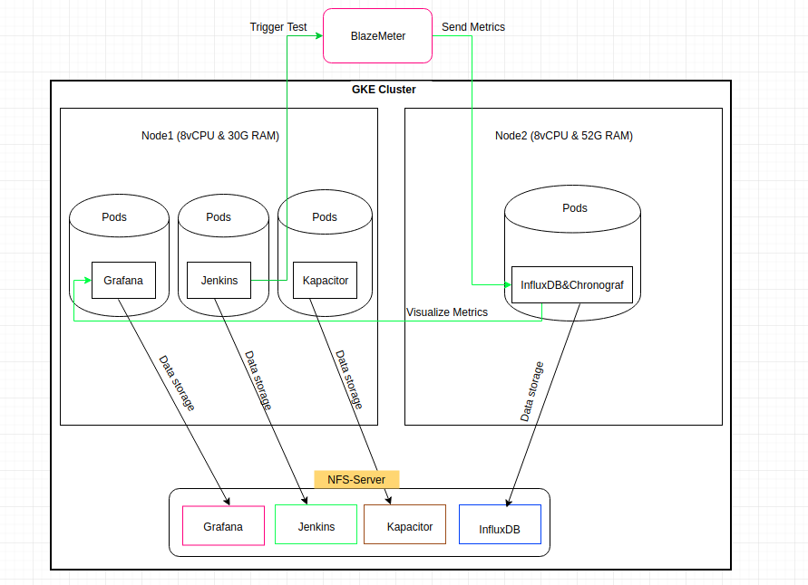
Application Used
- Grafana
- InfluxDB
- Jenkins
- Kapacitor
- Chronograf

Kubernetes Objects
- Deployment
- Service

Data Storage
- FileStore (Google’s NFS Service)

Setup-Creation
- Create a GKE Cluster with 2 Nodes with required configuration.
- Reserve some static IP and use it for the Services.
- Use NFS Service from GCP to store the Pods data which will act as Persistant storage.
- Deploy the Pods and Services to expose the pods.
- Check all application are up and working.

GKE Cluster Creation
Step1: Log-In to the Google coud console and get into the Kubernetes Engine.

Step2: Create a cluster with nodepools with required configurations.

Step3: Once the cluster is ready, then connect to the cluster using the connect link.

Reserve Static IP
Step1: We need some Static IP for the Services.

Step2: Go to VPC network --> External IP addresses.

Step3: Reserve the static IP as required.

Create NFS:
Step1: For DataPersistantStorage, we have to use the FileStore.

Step2: Go to “FileStore” from the GCP console and create one.

Deploy the Application
Step1: Get the “TR-ClusterFiles” from the BitBucket and get into that folder.

Step2: Modify the Deployment and Service files with the IP of NFS and LoadBalancer.

Step3: We can also modify the file with NodeSelector, so that specific pods will be deployed in the specified node.

Step4: Create a namespace in the cluster.

Step5: Once modifications done, then deploy the Deployment and service files in the cluster using the kubectl command. For example,
$ kubectl create -n NAMESPACE -f DEPLOYMENT_FILE -f SERVICE_FILE

Step6: Check the pods and Service are available by using the kubectl commands like,
$ kubectl get po,svc -n NAMESPACE

Check Application
Step1: Once above steps are done, we can check the application with mention IP with specified ports in the browser.

