

**Palestine Technical University – Kadoorie College of Engineering and Technology Department of Computer Systems Engineering**

Software Requirements Specification (SRS Document)

FOR

**SWEET SHOP "Pinky"**



**By:**

Ibrahem Mazen Fahmawe –201910221

Jumana Nasr Atyani – 202111766

Rema'a Menwer Qub – 202010798

**Supervisor:**

Dr. Osama Hamid

**Tulkarm, Palestine**

8 April 2024

**Table of contents**

Contents

Abstract 1

CHAPTER 1 INTRODUCTION 2

* 1. Overview and Background 2
  2. Purpose 2
  3. Scope 2
  4. ER Diagram 3

# Abstract

# This project aims to design and develop an online sweet shop website to provide a convenient platform for users to browse, select, and purchase a variety of sweets. The website will feature a user-friendly interface with categories for different types of sweets, including candies, chocolates, and traditional sweets from various cultures. Users will be able to create accounts, add items to their shopping carts, and securely checkout using various payment methods. The website will also include features such as user reviews, ratings, and a search functionality to enhance the user experience. The goal of the project is to create a visually appealing and functional website that meets the needs of sweet enthusiasts looking to satisfy their cravings online."

# CHAPTER 1 INTRODUCTION

## Overview and Background

The online sweet shop is a digital platform that sells various types of sweet treats, including candies, chocolates, cakes, and pastries. Customers can place orders online and have their purchases delivered directly to their doorstep.

The online sweet shop was founded in 2024 by our colleague who wanted to share her love of sweets with a wider audience. She started the business as a small side project, selling her homemade treats to friends and family. As word spread about her delicious creations, she decided to expand her business and create an online presence.

## Purpose

The purpose of this SRS is to document the software requirements for an online sweet shop. The SRS will define the functional and non-functional requirements for the system and user, as well as any constraints, assumptions, and dependencies that must be considered during the development process.

## Scope

The online sweet shop system will provide customers with the ability to browse and purchase a variety of sweets and confections online. The system will also allow customers to create accounts, track their order history, and receive notifications about new products and special offers.

* 1. **ER Diagram**

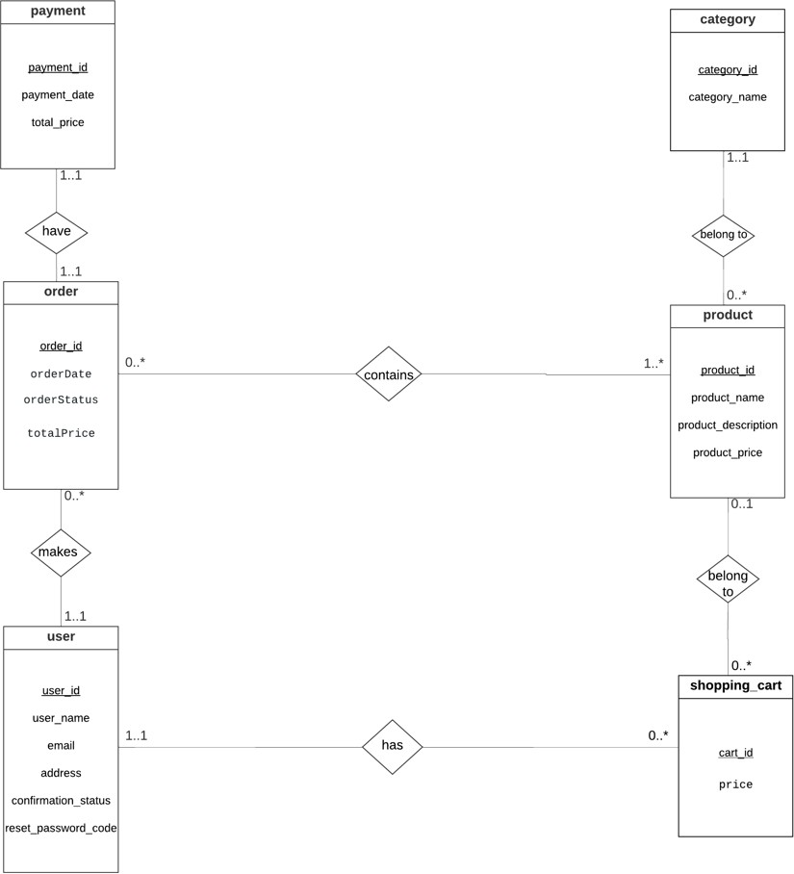

*Figure 1.1 : ER diagram*