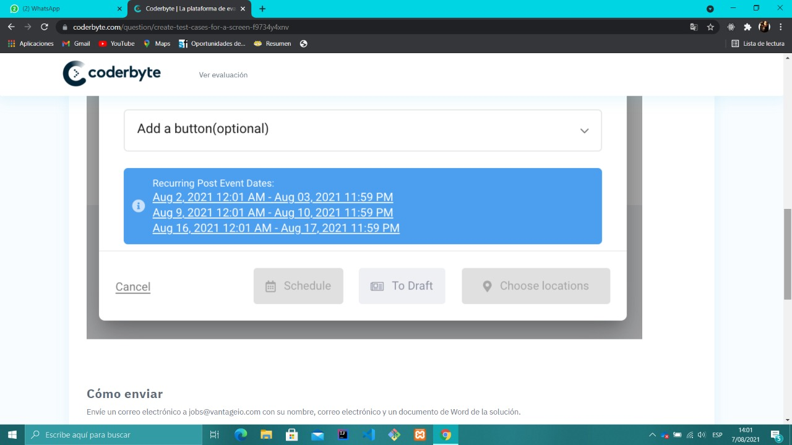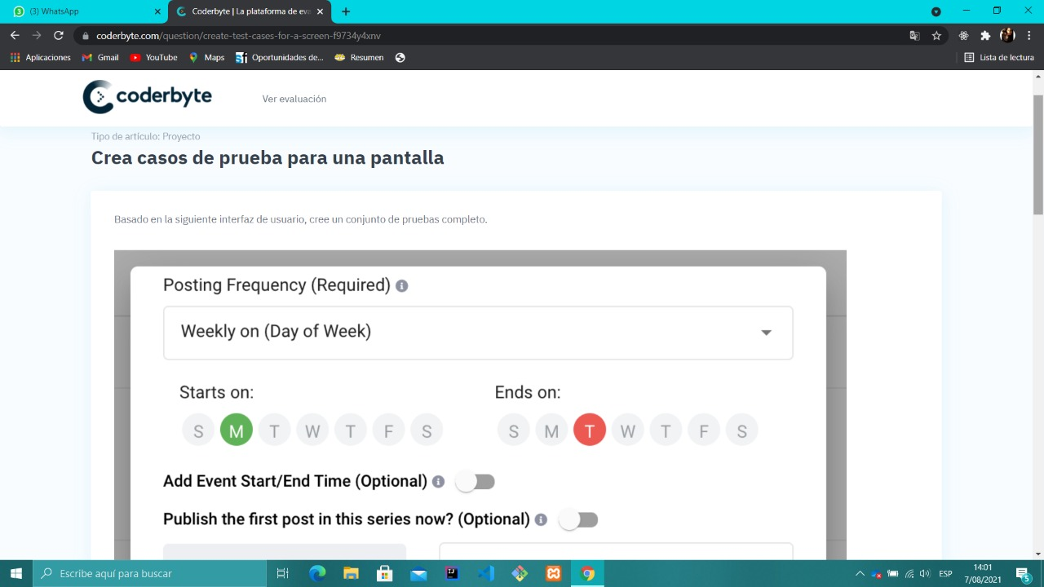

|  |  |  |  |  |  |  |  |  |  |  |  |
| --- | --- | --- | --- | --- | --- | --- | --- | --- | --- | --- | --- |
| Nº TC | Weekly on Day of Week/Others values | Starts on | Ends On | Add Event Start/End time | Publish the first post in this series now | Foto | Title | Description | Placeholders | Add buttom | Resultado esperado |
| 0001 | Monday | M | M | ON | ON | No | Titulo | Texto | NO | NO | Error no puede ser el mismo día incio y fin |
| 0002 | Sunday | M | T | ON | OFF | Si | Titulo | Texto | SI | SI | OK |
| 0003 | Monday | M | W | OFF | ON | Si | Titulo | Texto | SI | NO | OK |
| 0004 | Thrusday | T | W | OFF | OFF | NO |  |  | SI | SI | ERROR debe ingresar titulo y descripcion |
| 0005 | Wednesday | W | T | OFF | ON | NO | TITULO | TEXTO | NO | NO | OK |
| 0006 | Tursday | W | S | OFF | ON | SI | TITULO | TEXTO | SI | NO | OK |
| 0007 | Friday | F | S | ON | OFF | NO | TITULO | TEXTO | NO | NO | OK |
| 0008 | FRIDAY | M | S |  |  |  |  |  |  |  | ERROR, INGRESE DATOS OBLIGATORIOS |
| 0009 | FRIDAY | M | S | ON | ON | SI | BAR SPACE | BAR SPACE | SI | SI | ERROR DEBE INGRESAR TITULO Y TEXTO |