# Tag Service

# Overview

The **Tag Service** (TS) is a container tag solution, allowing for the remote administration of ad tags. It is implemented via the TS tag, a small block of markup trafficked as 3rd-party creative in DFP (or other ad server), which calls out to the Tag Service via a script tag, identifying a specific ad tag via an id parameter in the query string of the script tag's src attribute. This script call returns the necessary code to build a DFP ad tag. The Tag Service returns the following JavaScript:

1. The meta data for the identified tag, as JSON.
2. A client script responsible for building the ad tag, based on the tag's meta data.
3. Dependent local and remote scripts, including GPT, any DMP dependencies, and the client script described in #2 above.

# Architecture

1. **TS Tag:** A block of markup that contains:
   1. An empty div tag into which the DFP tag will be inserted.
   2. A script tag that calls out to the Tag Service, which in turn returns a text/javascript response.
2. **Tag Service:**A Node.js application that returns the following as a single JavaScript response:
   1. Metadata for a specific ad tag from the Tag Database (see item #5 in this list).
   2. A number of external dependencies, such as a DMP client script, and the Google Publisher Tag (GPT) script.
   3. A number of internal static scripts, currently only including the Tag Client script (see next).
3. **Contextualization Service:**The Contextualization Service is a separate application.
4. **Tag Client:**A script returned with the Tag Service response, which consumes the tag data and contextual data objects also in the response, and builds a DFP tag. This tag is injected into the placeholder <div> in #1a above.
5. **Tag Database:**This MongoDB database holds metadata on DFP tags.

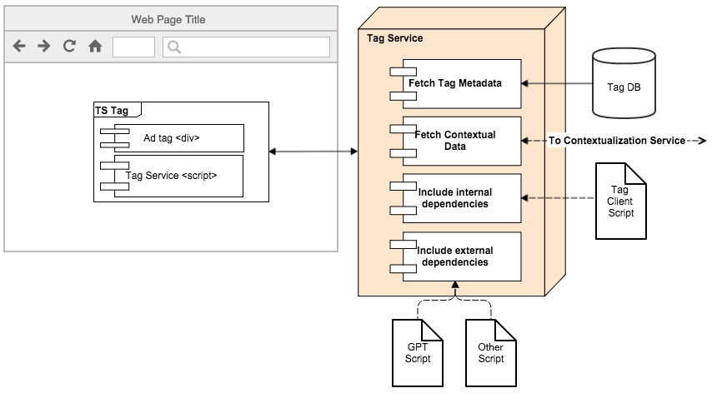

# Sample JavaScript Response

# The entire response is wrapped in a closure to account for multiple tags being on the same page.

(function(){

var __ad_data = {

"timeForRequest": "44ms",

"tag": {

"_id": "5580d875e4b0f89fa1b8afc0",

"adUnit": "/1234/adunit_level_1/adunit_level_n",

"orgId": "xyzcompany",

"date": "2015-06-17T03:48:57.765Z",

"targeting": [{

"key": "key1",

"values": [

"value1",

"value2"

]

}],

"type": "script",

"format": "GPT",

"sizes": [

"728x90"

]

},

"context": {...}

};

// Internal and external dependencies output here.

// Tag Client script output here.

});