# ANOVA

# R output

Anova Table (Type 3 tests)  
  
Response: Sepal.Width  
 num Df den Df MSE F ges Pr(>F)   
Species 2 147 0.11539 49.16 0.40078 < 2.2e-16 ***  
---  
Signif. codes: 0 '***' 0.001 '**' 0.01 '*' 0.05 '.' 0.1 ' ' 1

# Text

Species: ***F*(2, 147) = 49.16, *p* < 10-6, = 0.4, = 0.4, 95% CI [0.3, 0.48]**

# Description

Means  
 setosa versicolor virginica   
 3.43 2.77 2.97   
Variances  
 setosa versicolor virginica   
 0.14 0.10 0.10

# Assumptions

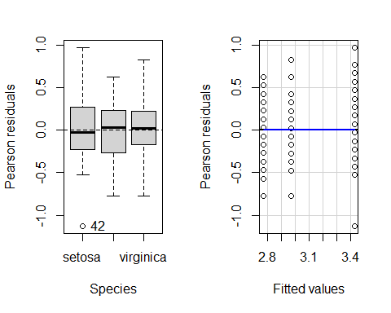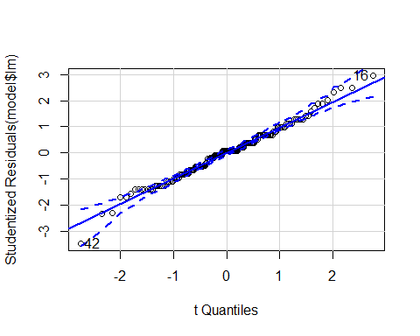

[1] 16 42

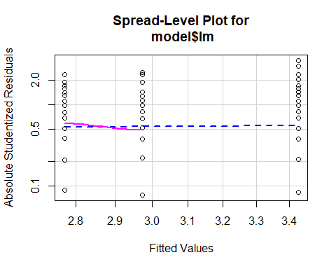

Suggested power transformation: 0.8154187

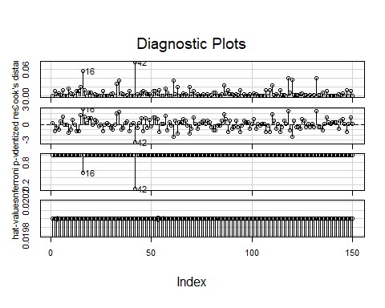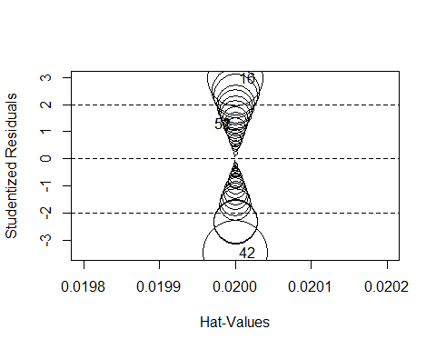

StudRes Hat CookD  
16 2.966181 0.02 0.05683677  
42 -3.478772 0.02 0.07654469  
51 1.281511 0.02 0.01112330  
52 1.281511 0.02 0.01112330

# Wally plots

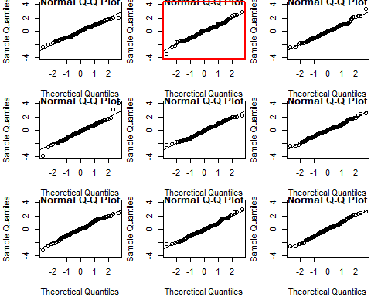

Hit <Enter> to show the original plot.

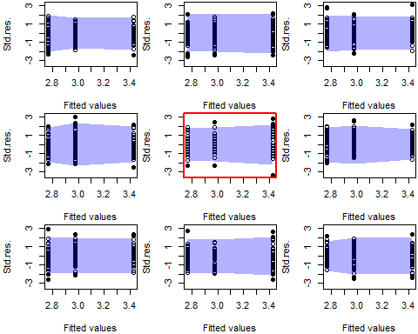

Hit <Enter> to show the original plot.