T-test

# R output

Welch Two Sample t-test  
  
data: mpg by vs  
t = -4.6671, df = 22.716, p-value = 0.0001098  
alternative hypothesis: true difference in means is not equal to 0  
95 percent confidence interval:  
 -11.462508 -4.418445  
sample estimates:  
mean in group 0 mean in group 1   
 16.61667 24.55714

# Text

*M* = -7.94, 95% CI [-11.46, -4.42], *t*(22.72) = -4.67, *p* < .001

# Diagnostic

## Dependent variable distribution

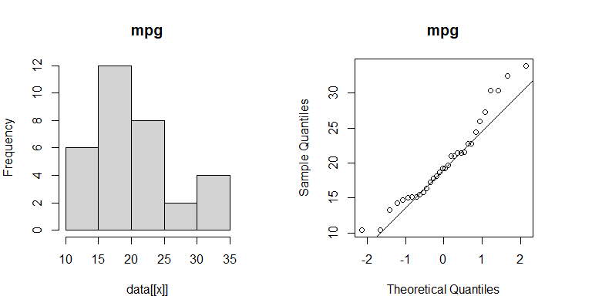

Shapiro-Wilk normality test  
  
data: measure  
W = 0.94756, p-value = 0.1229

## Dependent variable distribution by group

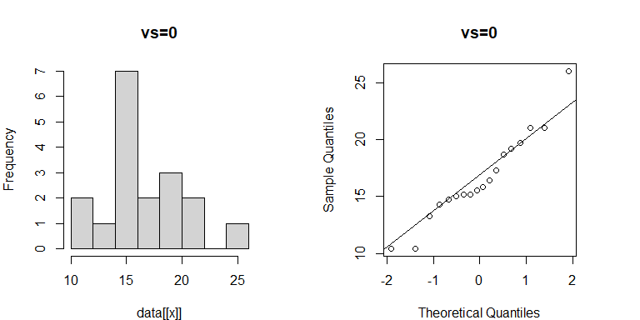

Shapiro-Wilk normality test  
  
data: d[d$iv == i, dv]  
W = 0.95151, p-value = 0.4491

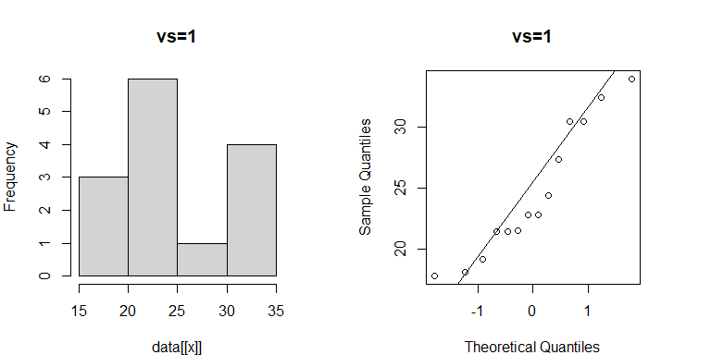

Shapiro-Wilk normality test  
  
data: d[d$iv == i, dv]  
W = 0.91166, p-value = 0.1666

## Variances and Variance ratio

## 0 1   
## 14.90 28.93

## [1] 1.94

## Test of heteroscedasticity

Fligner-Killeen test of homogeneity of variances  
  
data: mpg by vs  
Fligner-Killeen:med chi-squared = 1.1765, df = 1, p-value = 0.2781

## Means

## 0 1   
## 16.62 24.56

## SD

## 0 1   
## 3.86 5.38