# ANOVA

# R output

Fitting linear model: highschool ~ city + language

|  |  |  |  |  |
| --- | --- | --- | --- | --- |
|  | Estimate | Std. Error | t value | Pr(>|t|) |
| **(Intercept)** | 43.15 | 2.635 | 16.38 | 2.196e-24 |
| **citystate** | -9.478 | 2.539 | -3.733 | 0.0004089 |
| **language** | -1.204 | 0.4468 | -2.695 | 0.009018 |

# Text

(Intercept): ***t*(63) = 16.38, *p* < 10-6, = 43.15, 95% CI [37.88, 48.41]**

citystate: ***t*(63) = -3.73, *p* < 10-6, = -9.48, 95% CI [-14.55, -4.4]**

language: ***t*(63) = -2.69, *p* < .01, $B$ = -1.2, 95% CI [-2.1, -0.31]**

# Assumptions

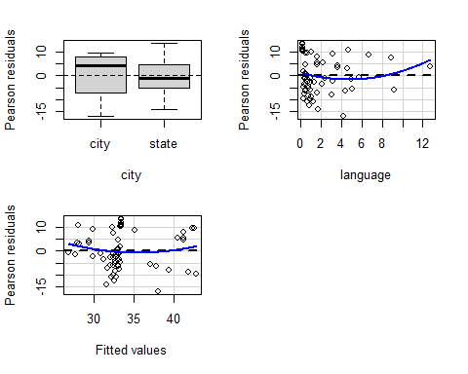

Test stat Pr(>|Test stat|)  
city   
language 1.2457 0.2176  
Tukey test 1.0269 0.3045

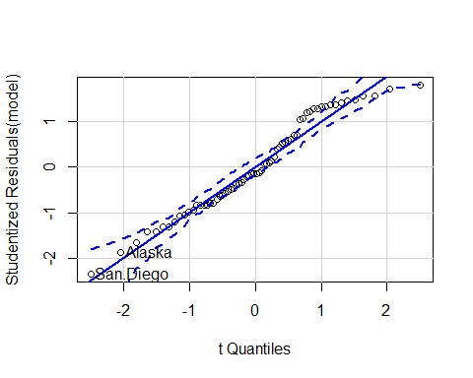

Alaska San.Diego   
 2 64

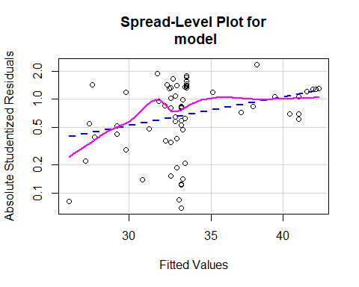

Suggested power transformation: -1.426985

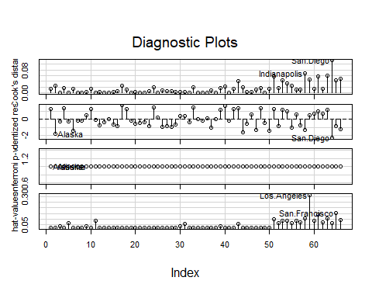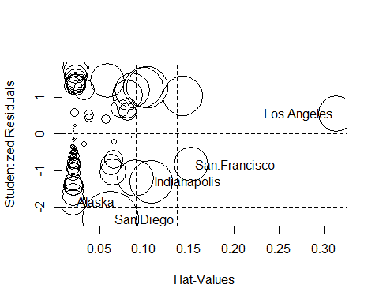

StudRes Hat CookD  
Alaska -1.8768598 0.02063133 0.02378334  
Indianapolis -1.3023012 0.10781246 0.06756829  
Los.Angeles 0.5491405 0.31423576 0.04657663  
San.Diego -2.3424627 0.06264128 0.11410337  
San.Francisco -0.8483611 0.15251869 0.04336802

# Wally plots

