

|  |
| --- |
| Project Documentation |
| Library Management Software |

|  |  |
| --- | --- |
| **Group 2** | |
| **Group Members** | **Truong Vu Binh – C2005L0005**  **Dao Ngoc Quan - C2005L0001** |
| **Supervisor** | **Nguyen Ngoc Duy** |
| **Project code** |  |

- Hanoi, 11/2021-

Table of Contents

1 Acknowledgements 3

2 Project Synopsis 4

2.1 Problem Definition 4

2.1.1 The purpose and target of a project 4

2.1.2 The outline of a system 4

2.2 Project Organisation 4

2.3 Project work plan 5

2.3.1 Master plan 5

2.3.2 Main Milestone 5

3 Project Analysis 6

3.1 Context Diagram 6

3.2 The mandatory functions of the system 6

4 Project Design 7

4.1 Architecture 7

4.2 Database Design 7

4.3 Flow Charts / Sequence diagram 7

5 Screenshots 10

6 Source Code with Comments 13

Code Structure: 13

7 Testing & Check List 13

7.1 Testing 13

7.2 Tasks list 15

8 User’s guide & install’s guide 17

8.1 System Requirements 17

8.2 Users Guide: 17

# Acknowledgements

During the time of studying, we have well provided and imparted for all the necessary and highly valuable of professional knowledge by our teacher in Aptech, we have our faithful, careful style and creative mind in studying in the future.

Project is a good opportunity to apply appropriate for our knowledge and subjects. While performing project, we have real life and valuable experience. After the term, we were getting all one’s thoughts together and labour at a task of project. During executing this project, we have received a lot of helpful advice from our tutors, teachers.

Especially, we wish would thank to our teacher- Mr: Nguyen Ngoc Duy- for his enthusiastic, thoughtful, and careful guidance.

# Project Synopsis

## Problem Definition

### The purpose and target of a project

In the age of technology, the use of computer software for simplifying certain tasks has becoming common. As such, we developed the software for Library Management Software, to put books information management, managing issued books, returned books information at ease.

As stated above, the software allows librarian to manage books data, issued books and returned books information at ease, avoiding non-necessary mistakes.

### The outline of a system

Below are the software functions and capability:

* Signing in, Signing out of the software
* Books management
* Students/borrower information management
* Issuing, returning, as well as managing issued books, returned books information
* Changing sign-in password
* For software administrator: Managing users’ information, managing books category name, publishers list, and author list.

## Project Organisation

## Project work plan

### Master plan



### Main Milestone

|  |  |  |  |
| --- | --- | --- | --- |
| **No.** | **Date** | **Milestone name** | **Delivery goods etc.** |
| 1 | 25/10/2021 | Finished coding | Beginning Software testing |
| 2 | 30/10/2021 | Finished testing | Report testing results |

# Project Analysis

## Context Diagram

## The mandatory functions of the system

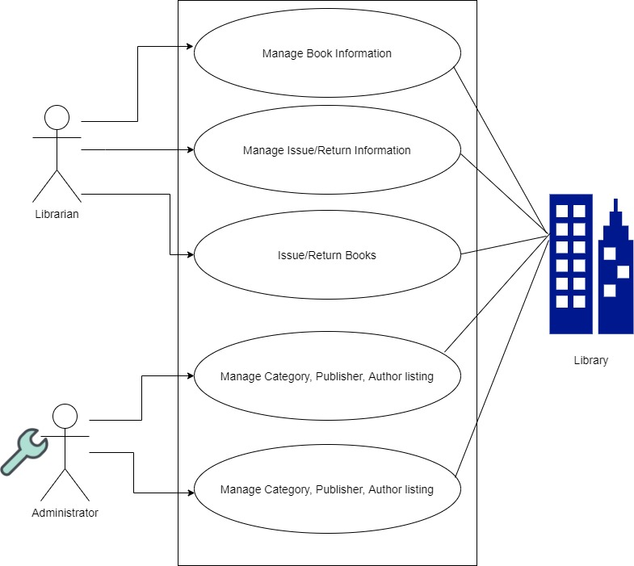

# Project Design

## Architecture

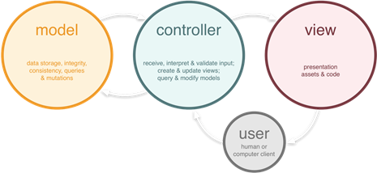

## Database Design

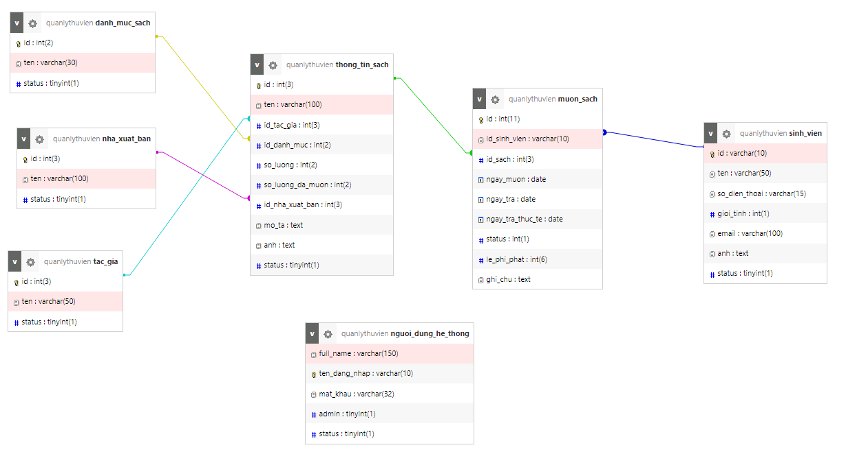

## Flow Charts / Sequence diagram

**Sign-in to the Program**

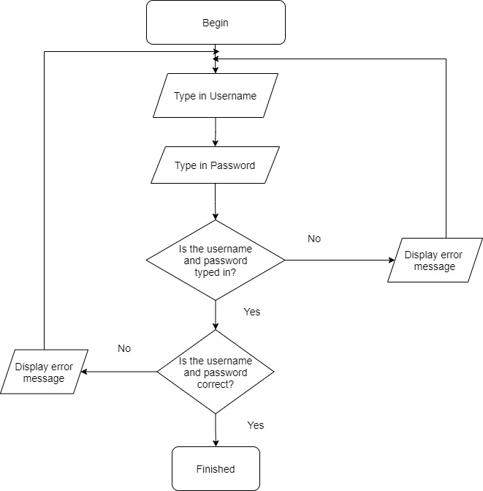

**Add Books:**

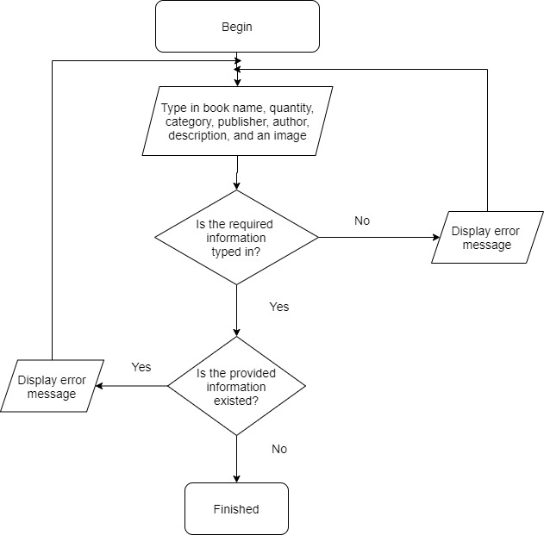

**Issue Book**

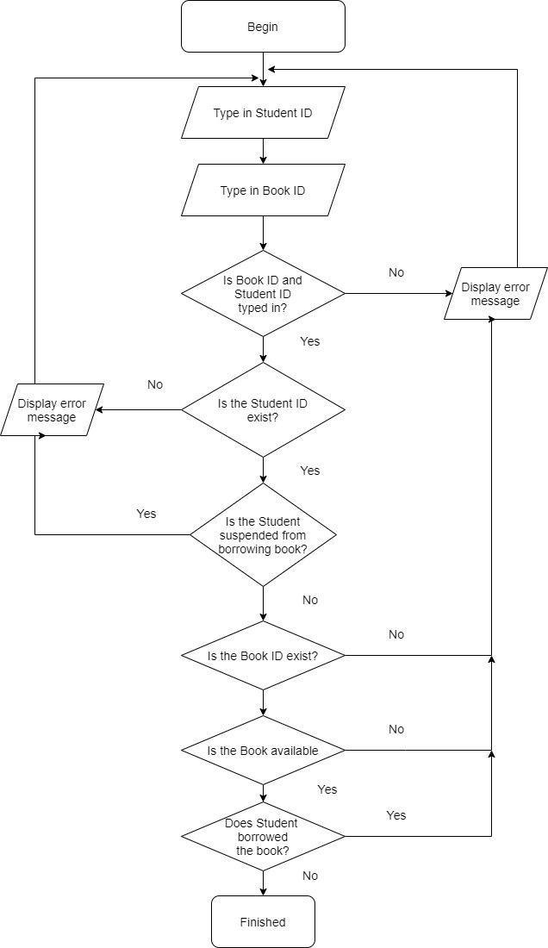

# Screenshots

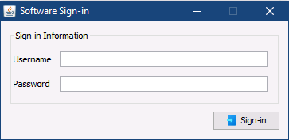

Program signing-in interface

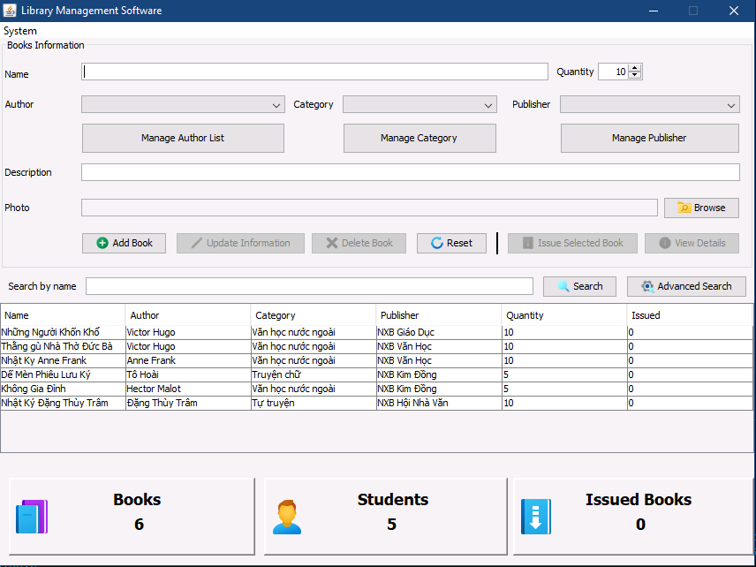

The main interface, where librarian can easily manage books data

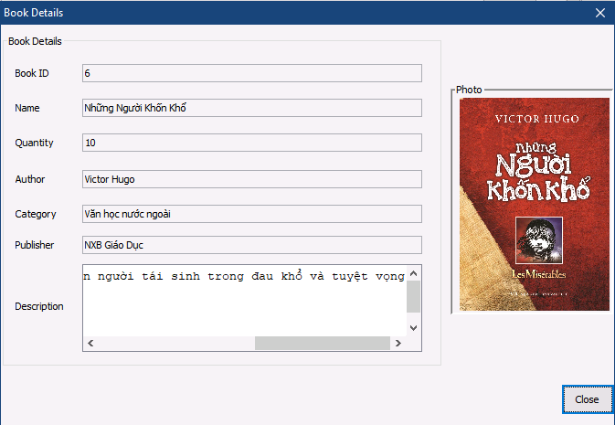

Books details dialogue box, librarian can click on the thumbnail to view the original image

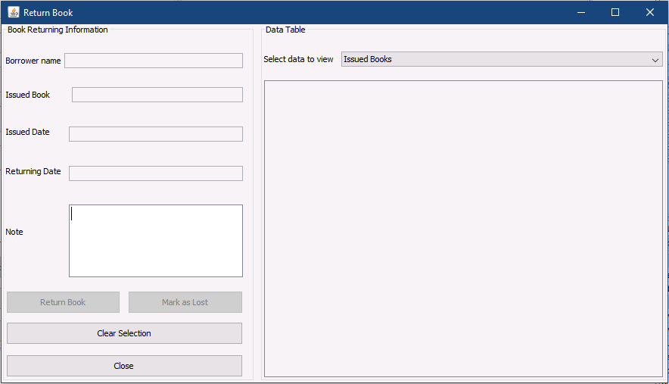

Return Books dialogue box, in this interface, librarian can easily keep tracks of issued books, returned books information

# Source Code with Comments

## Code Structure:

Inside the source code, there are 4 folders:

* dao: Contains classes, functions that do all the data manipulations in the database. These include collecting data from various tables, manipulating (insert, update, delete) data from tables
* gui: Contains the forms (user interface), along with all the relevant dialogue boxes with them. These forms and dialogue boxes contain function calls to “dao” for displaying data and allow users to update data in the database via a graphical user interface
* model: Contains different classes representing tables in the databases. These classes include getters and setters for related variables.
* util: Contains small functions for various purposes, for instance: getting database connections, generating MD5 for passwords, converting date to displays in “dd/MM/yyyy” format

# Testing & Check List

## Testing

**Signing-in to the software:**

|  |  |  |
| --- | --- | --- |
| STT | Test Case | Result |
| 1 | No information inputted and clicked on Sign-in | Display a message asking user to type in sign-in information |
| 2 | Typed in username but didn’t type in the password | Display a message asking user to type in sign-in information |
| 3 | Typed in password but didn’t type in username | Display a message asking user to type in sign-in information |
| 4 | Wrong username and or/ password | Display a message stating incorrect username and/or password |
| 5 | Correctly typed in the username and password combination | Close the sign-in prompt, display the main interface |

**Books managing:**

|  |  |  |
| --- | --- | --- |
| STT | Test Case | Result |
| 1 | No information inputted and clicked on “Add book” button | Display a message asking to fill in the required information |
| 2 | Adding books information that already available | Display a message stating the book is already in the database |
| 3 | Fully filled in the required information and click on “Add book” button | Display a message stating the operation completed successfully |
| 4 | No keyword inputted and clicked on “Search” button | Display all available books in the library in the corrects ponding table |

**Advanced searching**

|  |  |  |
| --- | --- | --- |
| STT | Test Case | Result |
| 1 | No information inputted and clicked on “Search” button | Display a message asking user to type in a keyword to search |
| 2 | No keyword inputted but selected publisher, author, and/or book category to search and clicked on “Search” button | Display a message asking user to type in a keyword to search |
| 3 | User typed in keyword for book name, but haven’t select publisher, category, and/or authors they wished to search for. | Search by the keyword and selected category. |
| 4 | User provided all the information and click “Search” | Search by the keyword and all the provided information |

**Category, Publishers, Author lists managing**

|  |  |  |
| --- | --- | --- |
| STT | Test Case | Result |
| 1 | User do not type in category name and click “Add” button | Display a message asking user to provide information |
| 2 | User typed in a category that already in the system and click “Add” button | Display a message stating that the category is already available |
| 3 | User typed in a category name and click “Add” button | Display a message stating the operation completed and update in the Database |

**Student Managing**

|  |  |  |
| --- | --- | --- |
| STT | Test Case | Result |
| 1 | No information provided and clicked “Add” button | Display a message asking user to type in required information |
| 2 | The information provided is already on the system | Display a message stating that the information is already available |
| 3 | User provided all information and clicked “Add” button | Display a message stating the operation completed and update in the Database |

**User managing**

|  |  |  |
| --- | --- | --- |
| STT | Test Case | Result |
| 1 | No information provided and clicked “Add” button | Display a message asking user to type in required information |
| 2 | The information provided is already on the system | Display a message stating that the information is already available |
| 3 | User provided all information and clicked “Add” button | Display a message stating the operation completed and update in the Database |

**Issue Book**

|  |  |  |
| --- | --- | --- |
| STT | Test Case | Result |
| 1 | User do not provide Student ID and/or Book ID | Display a message asking user to type in required information |
| 2 | User typed in Student ID, and/or Book ID but have not click the button to check availability in corresponding field | Display a message asking user to verify the typed in information using provided buttons |
| 3 | User typed in required information, and have checked validity, and click “Issue Book” button | Display a message stating the operation completed and update in the Database |

**Return Book**

|  |  |  |
| --- | --- | --- |
| STT | Test Case | Result |
| 1 | No issue information selected | The “Return Book” and “Mark as Lost” button will not be enabled |
| 2 | Selected an issue information and click “Return Book” button | Display a message stating the operation completed, save the changes to Database, and update data table in the interface |
| 3 | Selected an issue information and click “Mark as Lost” button | Display a message stating the operation completed, save the changes to Database, and update data table in the interface |
| 4 | Select issue information when in “Returned”, “Returned late”, “Lost”, “Suspended” view | Display corresponding information to the textboxes, but disable the “Return Book” and “Mark as Lost” button |

## Tasks list

|  |  |  |  |  |
| --- | --- | --- | --- | --- |
| **Task** | **Start time** | **Finish time** | **Implemented by** | **Evaluation(%)** |
| **Feasibility study phase** |  |  |  |  |
| Writing Documentation | 01/11/2021 | 01/11/2021 | Truong Vu Binh | 50 |
| Idea Contribution | 25/09/2021 | 25/09/2021 | Dao Ngoc Quan | 15 |
| Idea Contribution | 25/09/2021 | 25/09/2021 | Truong Vu Binh | 15 |
| Finalising Ideas | 26/09/2021 | 26/09/2021 | Truong Vu Binh  Dao Ngoc Quan | 20 |
| **Requirement Analysis phase** |  |  |  |  |
| System Designing | 01/10/2021 | 02/10/2021 | Truong Vu Binh | 50% |
| System Designing | 01/10/2021 | 02/10/2021 | Dao Ngoc Quan | 50% |
| **Design phase** |  |  |  |  |
| Database Designing | 29/09/2021 | 29/09/2021 | Truong Vu Binh | 50% |
| Graphical User Interface Designing | 30/09/2021 | 5/10/2021 | Dao Ngoc Quan | 50% |
| **Development phase** |  |  |  |  |
| Signing-in/Signing-out the software | 03/10/2021 | 03/10/2021 | Truong Vu Binh | 15% |
| Books Managing Function | 05/10/2021 | 08/10/2021 | Truong Vu Binh | 10% |
| Software User Managing Function | 06/10/2021 | 09/10/2021 | Dao Ngoc Quan | 10% |
| Issued books/Returned book information managing function | 09/10/2021 | 11/10/2021 | Dao Ngoc Quan | 15% |
| Managing publisher, books categories, authors listing | 09/10/2021 | 09/10/2021 | Dao Ngoc Quan | 10% |
| View Books Details | 23/10/2021 | 24/10/2021 | Truong Vu Binh | 10% |
| Books title searching, advanced book searching | 24/10/2021 | 25/10/2021 | Truong Vu Binh | 10% |
| Issue Books | 13/10/2021 | 19/10/2021 | Truong Vu Binh | 10% |
| Return books | 19/10/2021 | 22/10/2021 | Truong Vu Binh | 10% |
| **Testing phase** |  |  |  |  |
| Testing sign-in, sign-out ability | 25/10/2021 | 25/10/2021 | Truong Vu Binh | 15% |
| Testing Books Managements Function | 27/10/2021 | 27/10/2021 | Truong Vu Binh | 10% |
| Testing publishers, books categories, authors listing management function | 28/10/2021 | 28/10/2021 | Dao Ngoc Quan | 10% |
| Testing View Books Details screen | 29/10/2021 | 30/10/2021 | Dao Ngoc Quan | 15% |
| Testing the ability to search books by title, and advanced books searching | 29/10/2021 | 29/10/2021 | Truong Vu Binh | 10% |
| Testing the user managing function | 30/10/2021 | 30/10/2021 | Dao Ngoc Quan | 10% |
| Testing the student information managing function | 31/10/2021 | 31/10/2021 | Dao Ngoc Quan | 10% |
| Testing the Book Issuing Function | 01/11/2021 | 01/01/2021 | Truong Vu Binh  Dao Ngoc Quan | 10% |
| Testing the Book Returning Function | 01/01/2021 | 01/01/2021 | Truong Vu Binh  Dao Ngoc Quan | 10% |

# User’s guide & install’s guide

## System Requirements

|  |  |
| --- | --- |
| Minimum Requirements   * Intel Pentium 4, 1GHz or greater * 1GB RAM or greater * Windows XP or greater * 20GB Disk free space or greater * JRE 8 or greater | Recommended Requirement   * Intel Core 2 Duo, 2GHz or greater * 2GB RAM or greater * Windows XP, 7 or greater * 20GB of Disk free space or greater * JRE 8 or greater |

## Users Guide:

When the user starts the program, the program will ask for user credential as shown below:



User then type in their username and password in the corresponding textbox, then Click “Sign-in” or press Enter key on the keyboard after finished typing in the password to sign-in to the program.

Below is the default sign-in credential for the built-in user admin:

Username: admin

Password: remichan

After successfully signed-in, the following screen appears:



On this screen, user can now manage books data, as well as managing publishers, authors, and books categories listing using the respective tool provided.

User can click “Add book” after provided all the required information on the screen to add the provided information to the database.

To update book information, first, select the book that needs updating, after which, the “Update Information”, “Delete Book”, “Issue Book”, “View Details” button will be enabled allowing user to perform the corresponding operation:

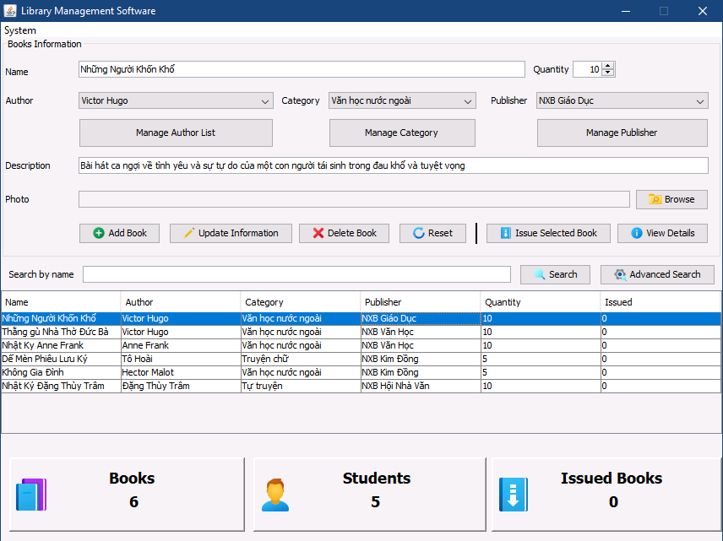

User may either edit the information and click “Update Books Information” to save the changes to the database, or they can click “Delete Book” to delete the selected book.

**Issue Book:**

To issue a book to the student, first, select the book they wished to be issued, and click “Issue Selected Book”, when doing so, the following screen appear:

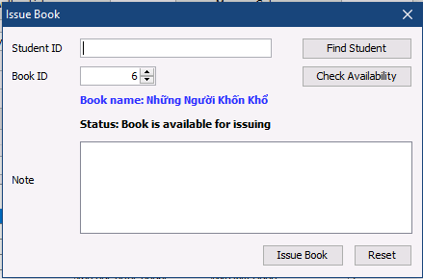

User then type in the Student ID of the Student they wished to issue book to, then click “Find Student” to check whether the given ID is present or not, then type in the Book ID of the book they wish to be issued if not present, then click “Check Status” to see whether the book is available for issuing, has already issued all copies, or is not available in the system. The “Issue Book” button will not enable if the book has all its copies issued, or the student already has 3 books issued for them.

If all the information is sufficient and there is no discrepancy, user may click “Issue Book” to save the information to the database. Each issued book will have 07 days of returning to the library, and all the issuing date, returning date would be saved automatically to the database.

**View book details:**

To view a book detail, select a book that needs checking information, then click “View Details” to see all the information related to the book:



On this screen, user may click on the book image, and the program would then open the image in its original size. When finished checking information, user may click “Close” to close the dialogue box and return to the main screen.