

|  |
| --- |
| Project Document |
| Shipping System |

|  |  |
| --- | --- |
| **Group 2** | |
| **Group Members** | Binh Truong Vu – C2005L0005  Dong Nguyen Van -  <Member name> - <Student code > |
| **Supervisor** |  |
| **Project code** |  |

- Hanoi, 10/2022 -

**Table of Contents**

Acknowledgement 4

Definition and Acronyms 4

I. Project Introduction 5

1. Overview 5

2. Product Background 5

3. Existing Systems 5

4. Business Opportunity 5

5. Software Product Vision 5

6. Project Scope & Limitations 5

II. Project Management Plan 6

1. Overview 6

2. Management Approach 6

3. Master Schedule 6

4. Project Organization 6

5. Project Communication 6

6. Configuration Management 6

III. Software Requirement Specification 7

1. Overall Description 7

2. User Requirements 7

3. Functional Requirements 7

4. Non-Functional Requirements 7

5. Other Requirements 7

IV. Software Design Description 8

1. Overall Description 8

2. System Architecture Design 8

3. System Detailed Design 8

4. Class Specification 8

5. Data & Database Design 8

V. Software Testing Documentation 9

1. Overall Description 9

2. Test Plan 9

3. Test Cases 9

4. Test Reports 9

VI. Release Package & User Guides 10

1. Deliverable Package 10

2. Installation Guides 10

3. User Manual 10

VII. Appendix 10

1. Glossary [Optional] 10

2. References [Optional] 10

3. Others [Optional] 10

# Acknowledgement

*[Fill team’s acknowledgement here…]*

During the time of studying, we have well provided and imparted for all the necessary and highly valuable of professional knowledge by our teacher in Aptech, we have our faithful, careful style and creative mind in studying in the future.

Project is a good opportunity to apply appropriate for our knowledge and subjects. While performing project, we have actual and valuable experience. After one term, we were getting all one’s thoughts together and labor at a task of project. During executing this project, we have received a lot of helping from our guider, teachers.

Especial, we wish thank to our teacher- Mr: Nguyen Van A- for his enthusiastic, thoughtful, and careful guidance.

…..

# Definition and Acronyms

*[Fill all the definitions, acronyms,… used within the document] in the table format as below]*

|  |  |
| --- | --- |
| **Acronym** | **Definition** |
| BA | Business Analysis |
| BR | Business Rule |
| ERD | Entity Relationship Diagram |
| GUI | Graphical User Interface |
| PM | Project Manager |
| SDD | Software Design Description |
| SPMP | Software Project Management Plan |
| SRS | Software Requirement Specification |
| UC | Use Case |
| API | Application Program Interface |

# Project Introduction

## Project Information

*[Provide the brief information of the project: project name, project code, group name, etc.]*

## Project Team

*[List out the details of the project team and stakeholders…]*

## Product Background

*[This section summarizes the rationale for the new product. Provide a general description of the history or situation that leads to the recognition that this product should be built. You should also mention here the information on the customer /the people who raise project idea/request]*

## Existing Systems

[Add the system which might help solving the problems you listed above or the systems in which you can learn/refer the features for your system design]

## The proposed system

*[Write a concise vision statement that summarizes the purpose and intent of the new product and describes what the world will be like when it includes the product. The vision statement should reflect a balanced view that will satisfy the needs of diverse customers as well as those of the developing organization. It may be somewhat idealistic, but it should be grounded in the realities of existing or anticipated customer markets, enterprise architectures, organizational strategic directions, and cost and resource limitations]*

## Project Scope & Limitations

*[The project scope defines the concept and range of the proposed solution. It’s also important to define what will not be included in the product. Clarifying the scope and limitations helps to establish realistic expectations of the many stakeholders. It also provides a reference frame against which proposed features and requirements changes can be evaluated. Proposed requirements that are out of scope for the envisioned product must be rejected, unless they are so beneficial that the scope should be enlarged to accommodate them (with accompanying changes in budget, schedule, and/or resources)]*

# Project Management Plan

## The purpose and target of a project

### Project Objectives

*[Provide the overall project objective description and then the specific target metrics of your project in term of quality, time, and cost (allocated effort distribution for project activities: requirement, design, coding, testing, project management, etc)]*

### Project Risks

*[List out the details on project risks in the table below]*

## Management Approach

*[Describe the approach you would use the manage and implement your project]*

### Project Process

*[Draw and describe the software development process model that the team would apply into the project implementation]*

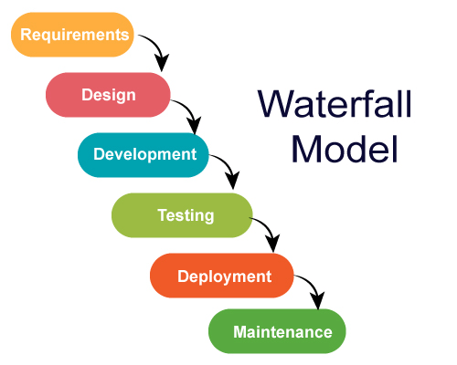

### Quality Management

*[Provide the approach you would apply to improve the project quality, reach the project quality objectives*

### Training Plan

*[You need to plan the training activities in case any of your team member lack of knowledge/skills to handle the project works]*

## Responsibility Assignments

*[Describe the main responsibilities in your project (to complete the outputs as defined in the above section), in the format as the sample below]*

## Project Communications

*[Provide the details of project communication plan, the to-be-used tools, the project interface, etc.]*

## Project Work Plan



## Configuration Management

### Document Management

*[Describe how you would manage project documents & their changes/versions]*

### Source Code Management

*[Describe how you would manage project source codes & their changes/versions]*

### Tools & Infrastructures

*[List out the tools & infrastructure that you would use in the software development and deployment]*

# Software Requirement Specification

## User Requirements

*[Provide specification of the user requirement: actor, use case diagram(s), use case description, etc.]*

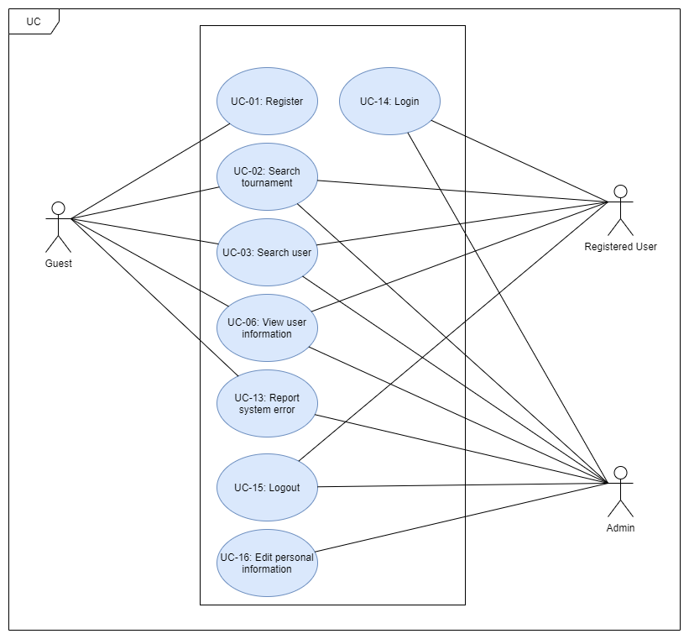

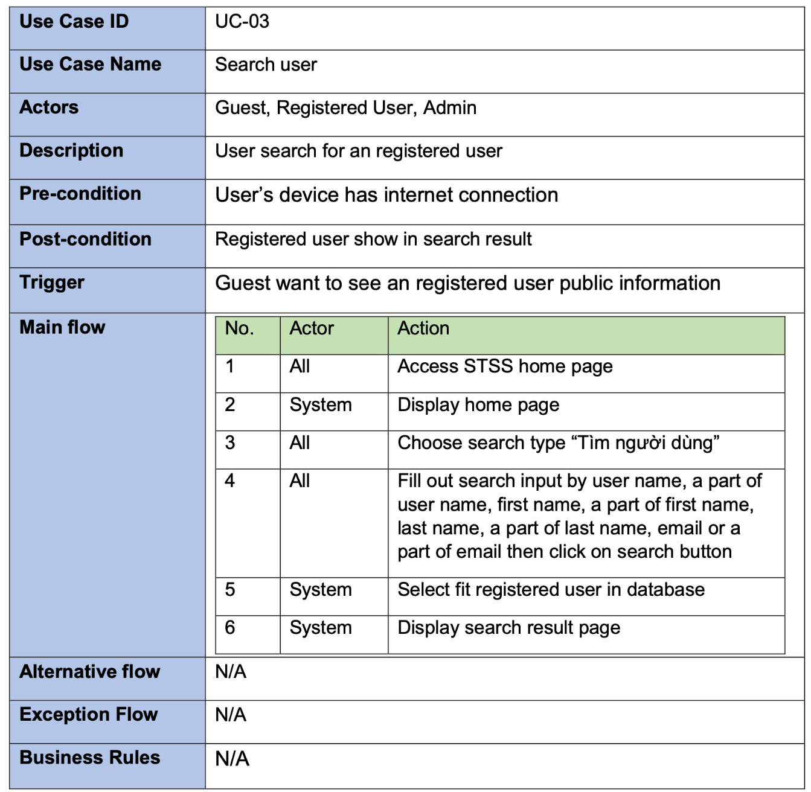

## Functional Requirements

### System Functional Overview

*[Provide functionality overview of software system: screen flow, screen descriptions, system user roles, screen authorization, non-screen functions, ERD]*

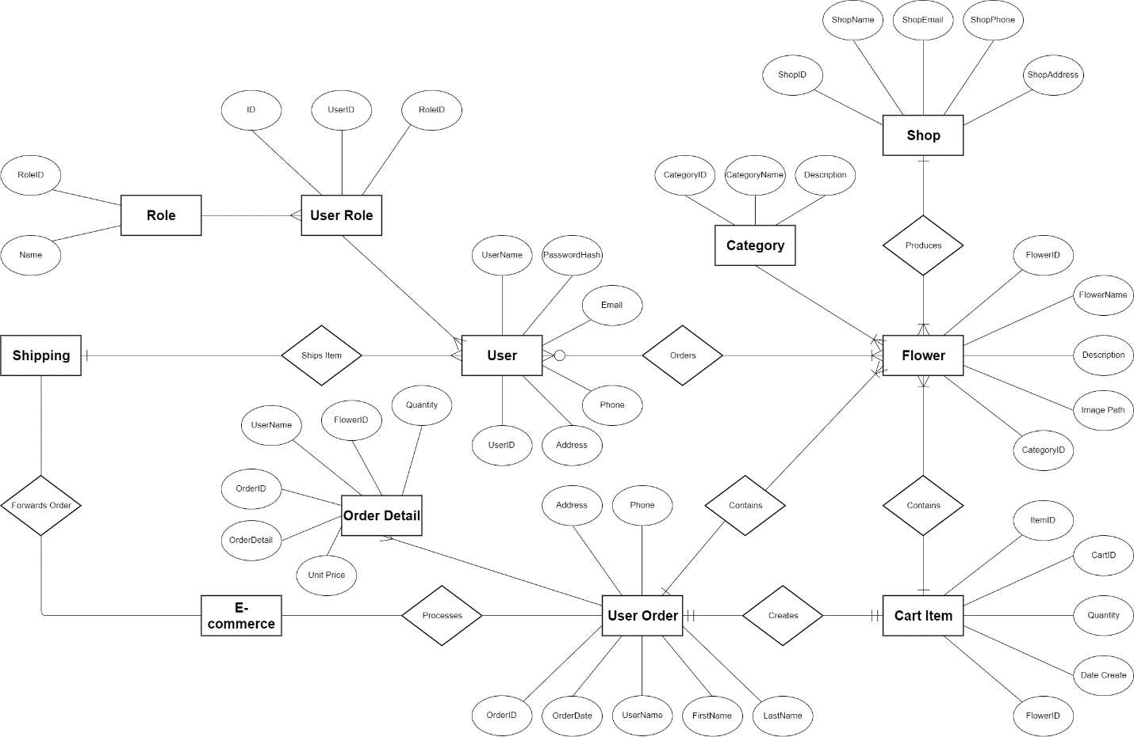

## Non-Functional Requirements

### Reliability

-This is a communication website, so the reliability is very important. The information from this website must be real and exactly (phone number, store address)

### Availability

Systems created using the platform should be generally available to user.

### 3.2.3.3 Security

The security is necessary for almost website. Protect user information is important

### Maintainability

The platform should contain interfaces that are extensible to allow new communication protocols to be added with ease.

### Portability

We can connect website by every device have internet

## Other Requirements…

# Software Design Description

*[Provide final software design information follow the template as part II in the Report #4]*

## 1. System Design

### 1.1 System Architecture

*[The content of this section includes the overall diagram which includes the sub-systems, the external systems, and the relationship/connection among them. You need also provide the explanation for each of the diagram components (modules, sub-systems, external systems, etc.)].*

### 1.2 Package Diagram

*[Provide the package diagram for each sub-system. The content of this section includes overall package diagram(s) and the explanation for each package (or namespace)]*

## 2. Database Design

*[Provide the files description, database table relationship & table descriptions]*

## 3. Detailed Design

### 3.1 <Feature/Function Name1>

*[Provide the detailed design for the feature <Feature Name1>. It includes Class Diagram, Class Specifications, and Sequence Diagram(s);* ***For the features/functions with the same structure of class & sequence diagrams, you need to provide the diagrams once for one feature/function and refer to those diagrams from other features/functions****]*

#### 3.1.1 Class Diagram

*[This part presents the class diagram for the relevant feature]*

***3.1.2 <Sequence Diagram Name1>***

*[Provide the sequence diagram(s) for the feature]*

***3.1.2 <Sequence Diagram Name2>***

***3.1.3 …***

### 3.2 <Feature/Function Name2>

…

# Software Testing Documentation

*[Provide final software testing information follow the template as part II in the Report #5]*

## 1. Scope of Testing

*[Describe the scopes of the test. Those include the target-of-test’s features, functions, and non-functional requirements that will or will not be tested.*

*Describe the stages/levels of testing that would be applied to your project­ - Unit, Integration, or System test. Each includes the in-charge, inputs/time, focuses, acceptance criteria.*

*List any constraints or assumptions made during the development of this document that may impact the design, development or implementation of testing]*

## 2. Test Strategy

*[List out and describe all testing types (you can refer the test types listed below or any other test types to selected the suitable ones for the project; for each selected test types you need to provide the following information: test objective, technique, completion criteria, etc.), test levels that those test types would be performed, & the details of test supporting tools would be used in the project]*

### 2.1 Testing Types

*[List out and describe here the testing types which you would apply in your project. You need to mention following information for each type of testing: objective, technique, completion criteria]*

### 2.2 Test Levels

*<List out and describe here the testing levels which you would execute in your project. Besides, clearly state the test types which are performed in each test level that you plan for this project>*

### 2.3 Supporting Tools

*<List of the test supporting tools which will be employed for this project>*

## 3. Test Plan

### 3.1 Human Resources

*[List and provide the details on roles and responsibilities of the project members who would involve in testing works]*

### 3.2 Test Environment

*[List and provide the details about the tools (software, hardware, infrastructure) which the project would use for testing]*

### 3.3 Test Milestones

*[Separate test milestones, which should be identified to communicate project status accomplishments]*

## 4. Test Cases

*[Prepare the details on the test cases following the provided template*

* *Unit Test Cases: Report5_Unit Test.xls*
* *Other Test Cases (IT, ST, AT): Report5_Test Report.xls]*

## 5. Test Reports

*[Provide the test result, statistics and the relevant test analysis for your testing in the project]*

# Release Package & User Guides

*[Provide final software testing information follow the template as part II in the Report #6]*

## 1. Deliverable Package

*[The section will list all source programs, scripts, documents with version number in this release. You can see the example following table for reference, can customize or delete if not using belong to each project characteristics]*

| **No.** | **Deliverable Item** | **Description** |
| --- | --- | --- |
| 1 | Schedule/Task Tracking |  |
| 2 | Project Backlog |  |
| 3 | Source Codes |  |
| 4 | Database Script(s) |  |
| 5 | Final Report Document |  |
| 6 | Test Cases Document |  |
| 7 | Defects List |  |
| 8 | Issues List |  |
| 9 | Slide |  |

## 2. Installation Guides

### 2.1 System Requirements

*[Define any system requirements necessary to support the application, including the software and relevant configurations]*

### 2.2 Installation Instruction

*[Includes installation instructions and configuration guidelines]*

## 3. User Manual

### 3.1 Overview

*[Descript the overview of the application and if could, insert the features workflow to help user has the overview of all the features in this application]*

### 3.2 Workflow 1

*[Describe the purpose of this workflow, draw workflow diagram and other relevant diagrams]*

*[Describe the detailed guides for the workflow by providing the brief description, step by step guides (attached with user interface) of how to use that function]*

### 3.3 Workflow 2