**For reference I used this tutorial as a basis**

https://aws.amazon.com/blogs/big-data/running-r-on-aws/

1. First create a VPC with a single public subnet

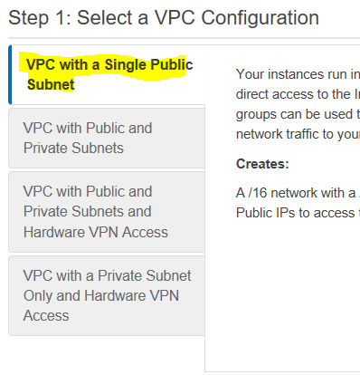

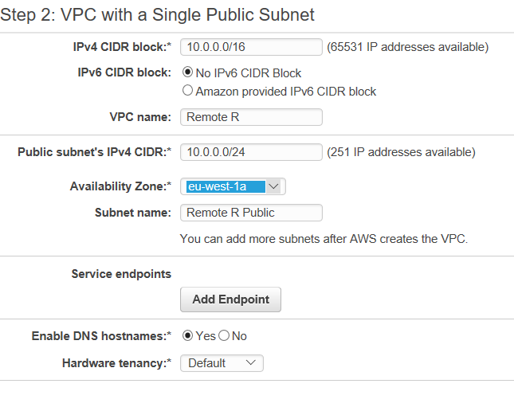

**Note: This wizard includes an internet gateway attached to the VPC**

1. Create an EC2 instance as R server

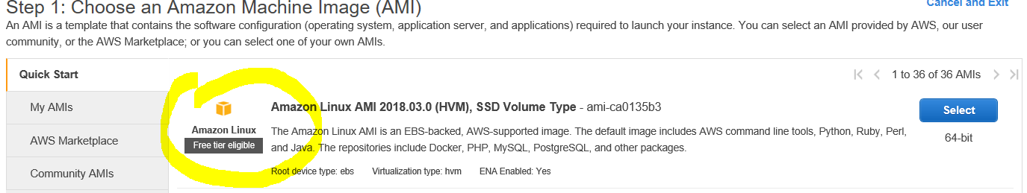

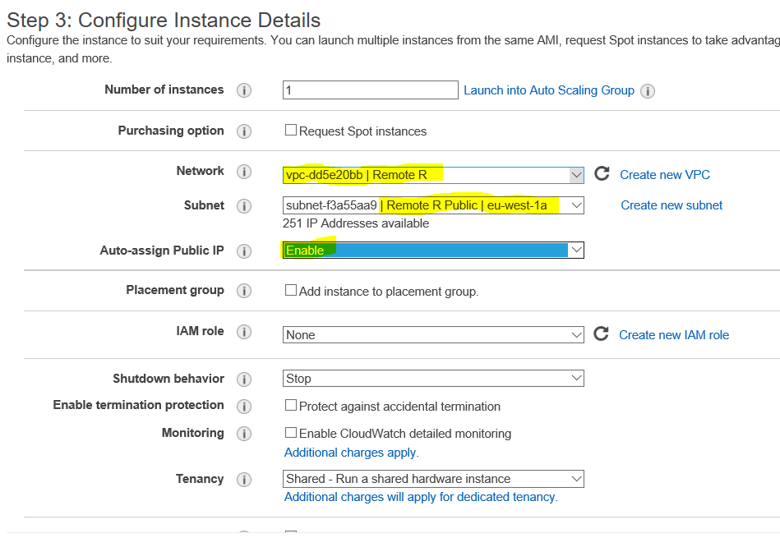

1. Insert the following script in UserData

#!/bin/bash

#install R

yum install -y R

#install RStudio-Server 1.0.153 (2017-07-20)

wget https://download2.rstudio.org/rstudio-server-rhel-1.0.153-x86_64.rpm

yum install -y --nogpgcheck rstudio-server-rhel-1.0.153-x86_64.rpm

rm rstudio-server-rhel-1.0.153-x86_64.rpm

**#####THIS PART IS OPTIONAL**

#install shiny and shiny-server (2017-08-25)

R -e "install.packages('shiny', repos='http://cran.rstudio.com/')"

wget https://download3.rstudio.org/centos5.9/x86_64/shiny-server-1.5.4.869-rh5-x86_64.rpm

yum install -y --nogpgcheck shiny-server-1.5.4.869-rh5-x86_64.rpm

rm shiny-server-1.5.4.869-rh5-x86_64.rpm

**######END OF OPTIONAL PART**

#add user(s), **MANDATORY**

useradd remihardy

echo remihardy:paflechien | sudo chpasswd

1. Update the security groups as follows

Custom TCP=3838 for Shiny server is **OPTIONAL**

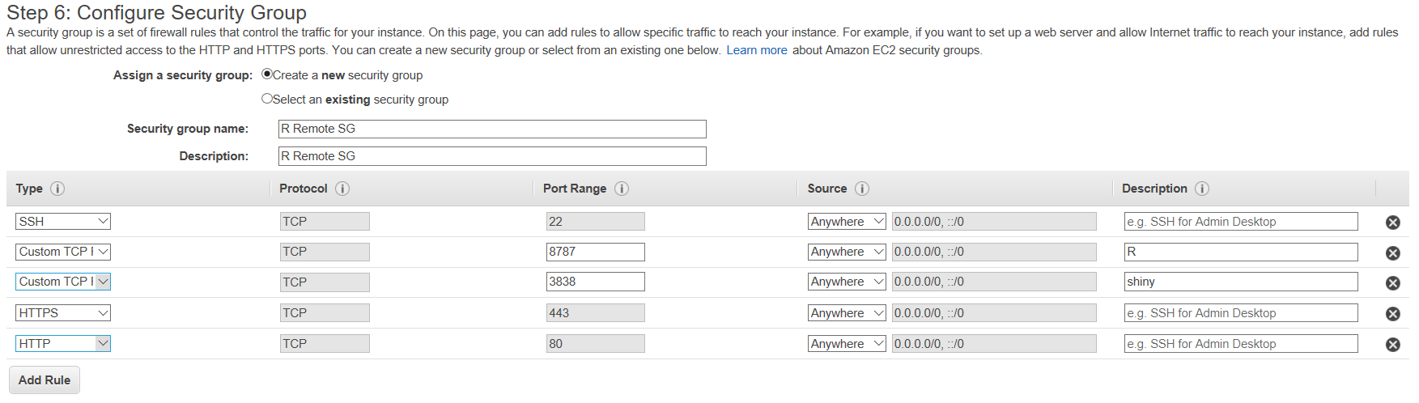

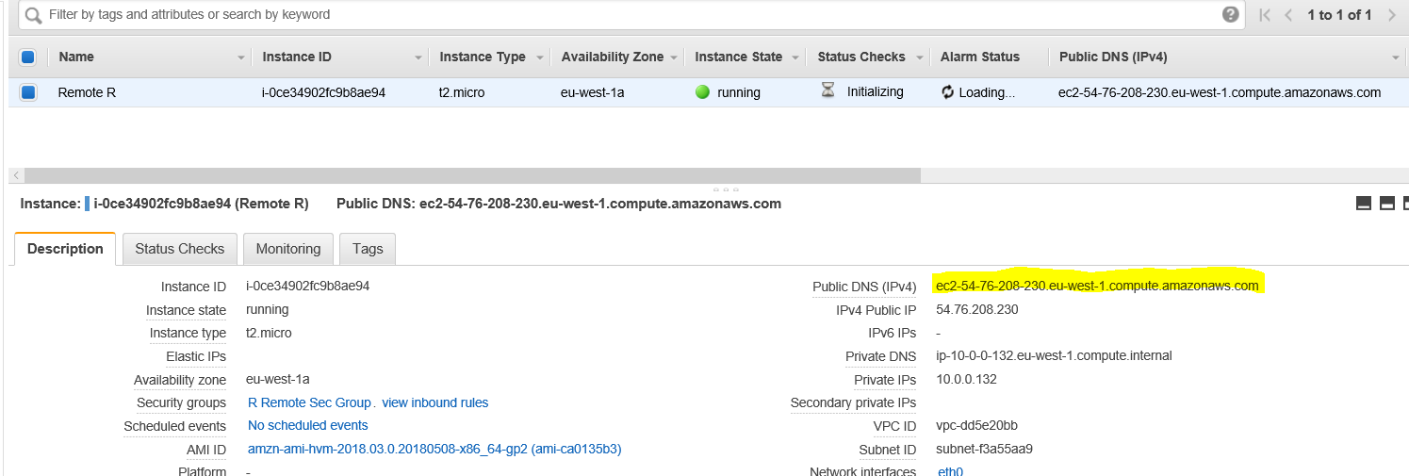

1. Access R server

* Wait for EC2 initialization to be complete
* Open internet browser and copy the Public DNC address: http://<Public_DNS>:8787

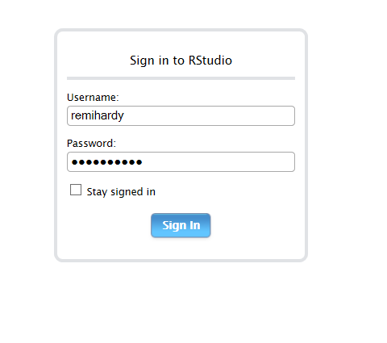

* Then type username and password to access R studio

