**Goal:**

Create 2 Apache Web Servers in private subnets, in 2 different AZ.

Add a Load Balancer in between them.

AZ1 will respond with “Hello”, AZ2 with “Goodbye”

1. **Allocate a new Elastic IP**

It will be assigned used in VPC definition in the next step

1. **Create a VPC**

Start the VPC Wizard to create 1 public subnet and 1 private subnet, these will be used in AZ1

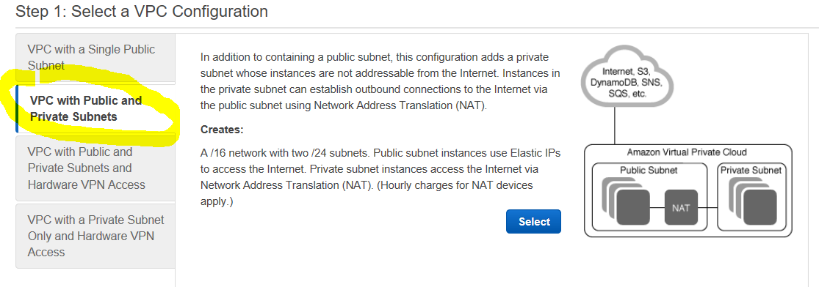

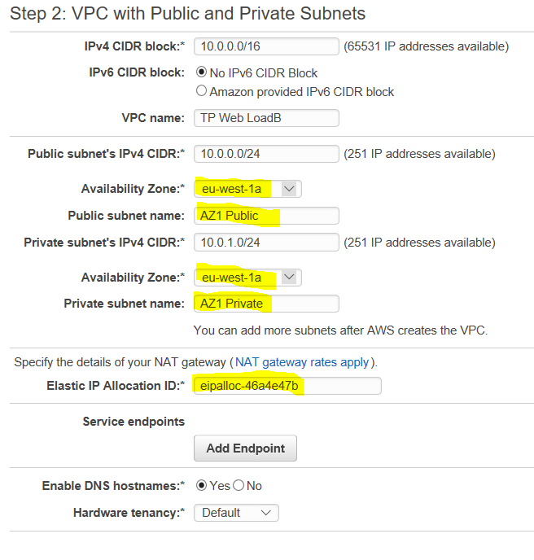

1. **Create 2 extra subnets for AZ2**

1 public subnet

1 private subnet

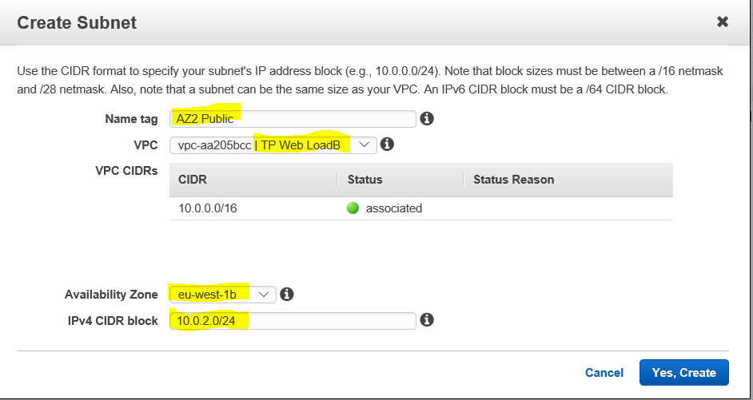

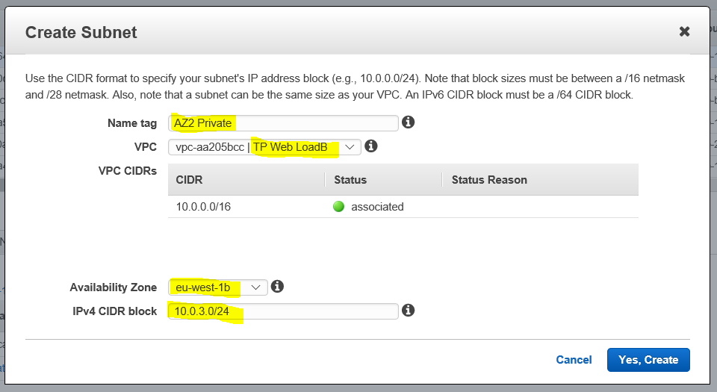

We end up with 2 AZ and 4 subnets:

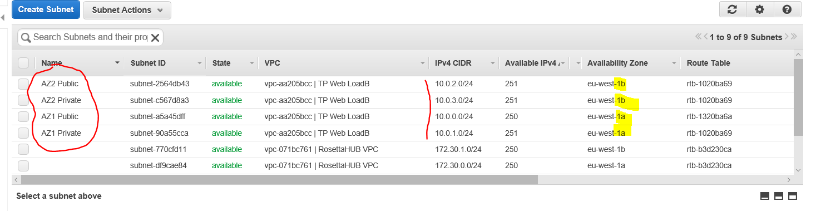

1. **Create 2 additional Route Tables for AZ2 subnets**

Associate subnet, and route targets for these 2 Route Tables

AZ2 Private subnet is associated to the NAT

AZ2 Public subnet is associated to the IGW

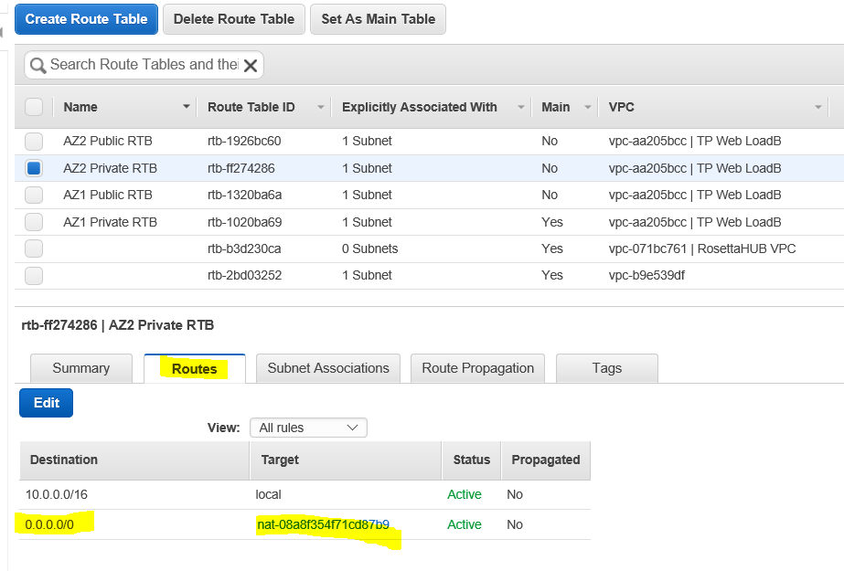

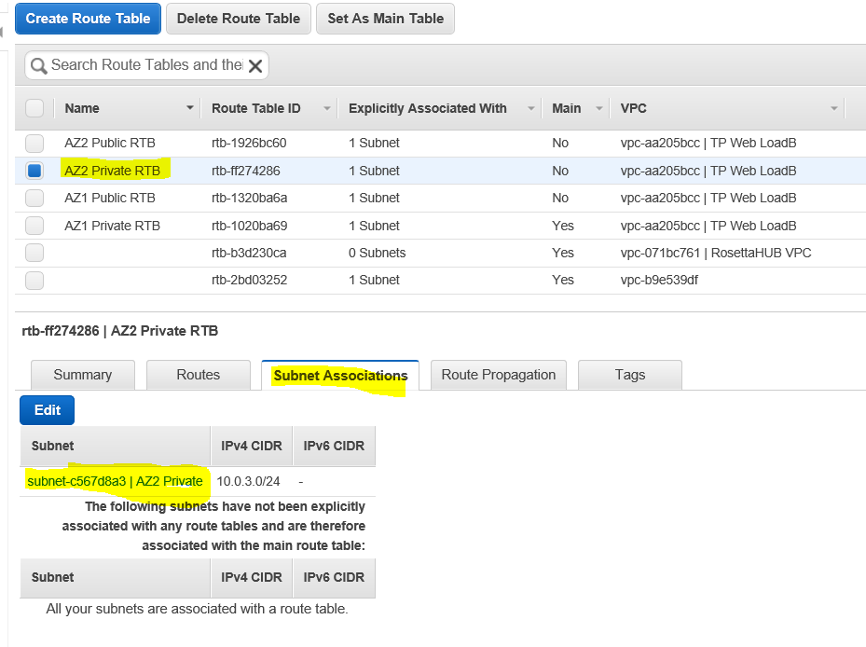

N**ow, all together, we have 1 IGW, 1 NAT, 4 subnets, 4 route tables**

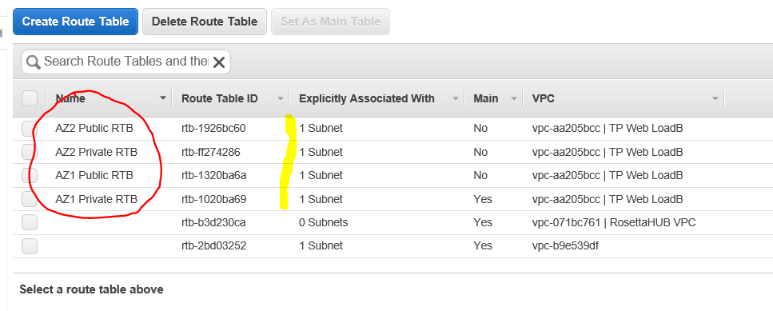

1. **Launch 2 EC2 instances**

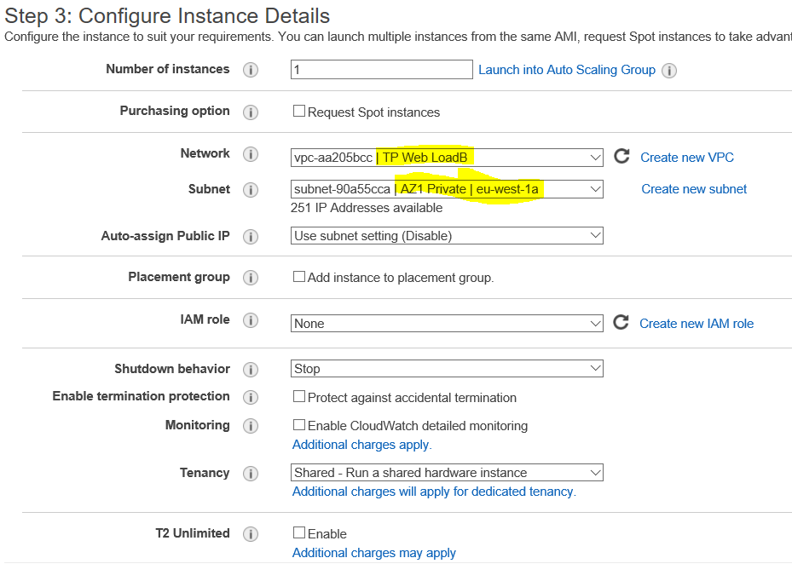

Copy the following in User Data section to install Apache Web Server

#!/bin/bash

sudo yum update -y

sudo yum -y install httpd

sudo service httpd start

sudo bash -c 'echo HELLO REMI > /var/www/html/index.html'

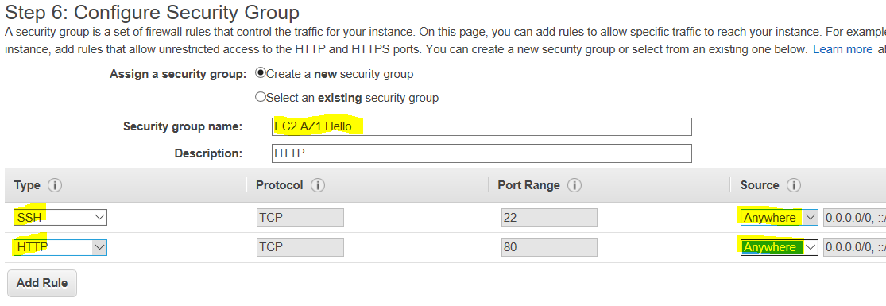

Second instance is in the private subnet of AZ2, will respond with “GOODBYE REMI”

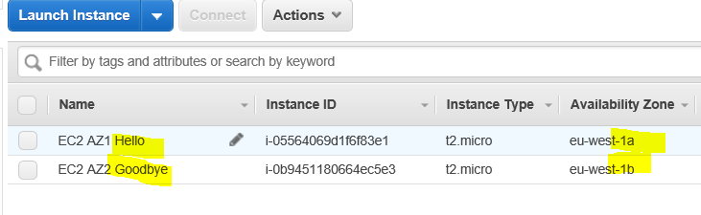

1. **Create the Load Balancer**

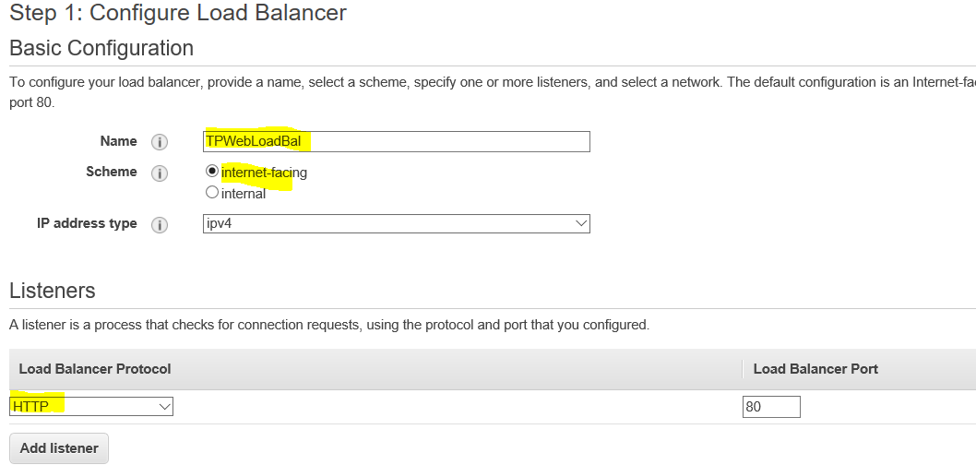

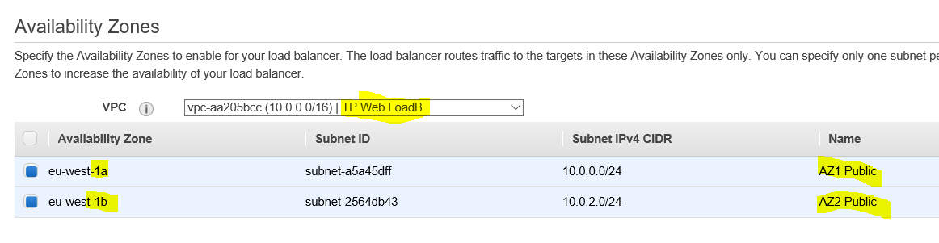

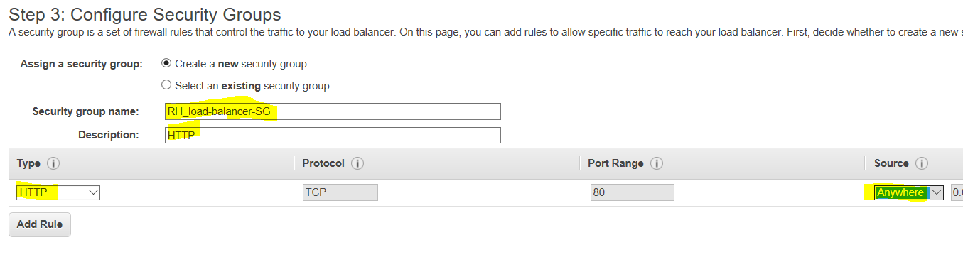

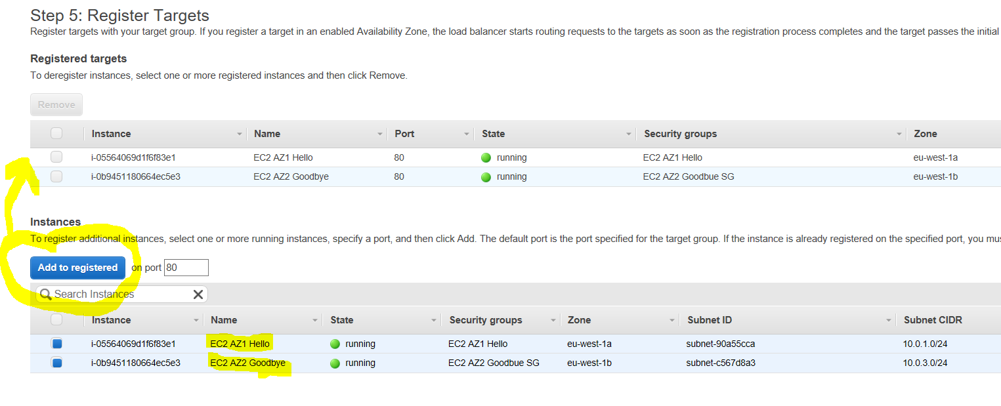

1. **Wait for Load Balancer Provision**

In target Group, check EC2 Targets health

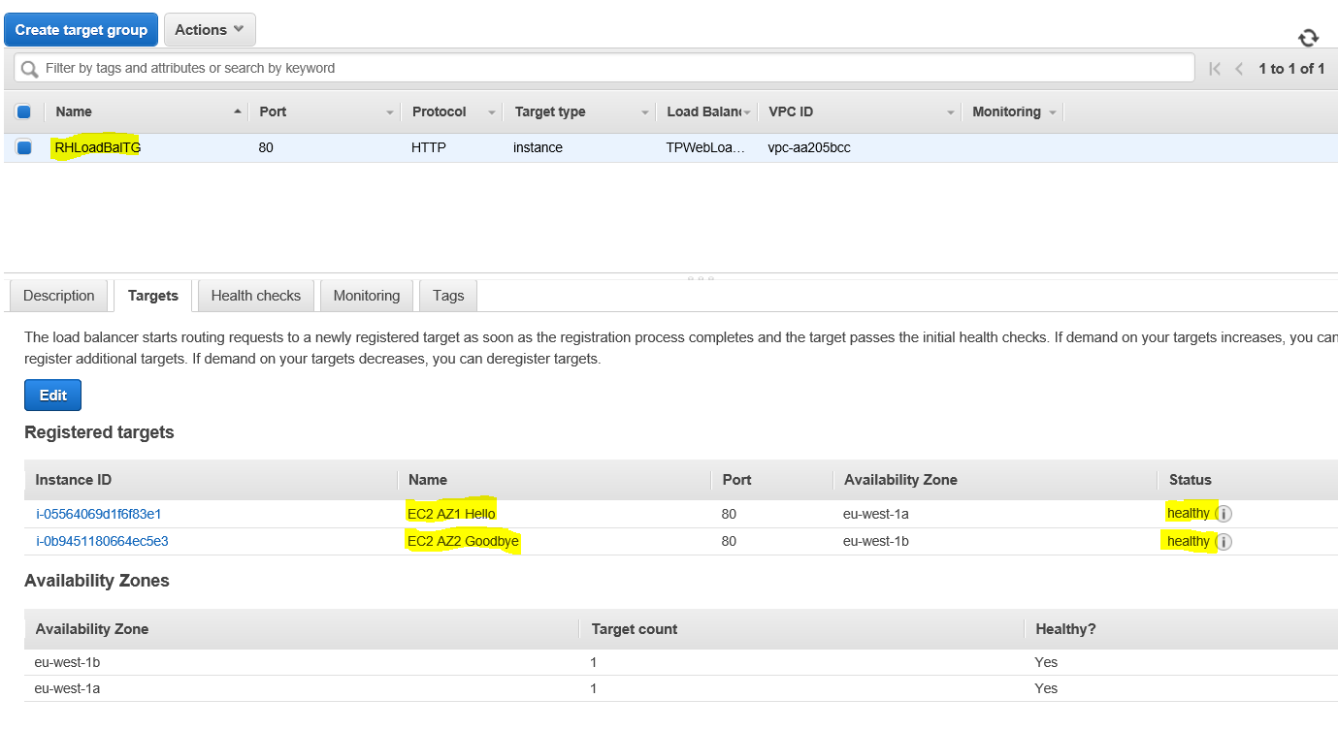

1. **Copy Load Balancer DNS name to Web Browser**

To display HELLO or GOODBYE depending on the Load Balancing

