1. **Build a VPC**

Using NAT Gateway (managed NAT Gateway Elastic IP),

Alternative : instance ECZ w/ AMI NAT

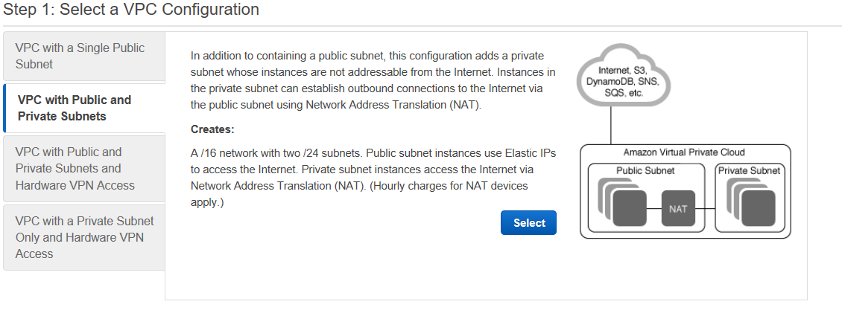

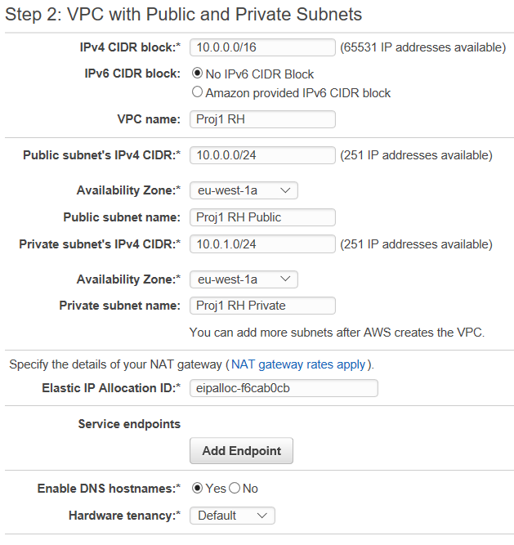

1. **Review VPC**

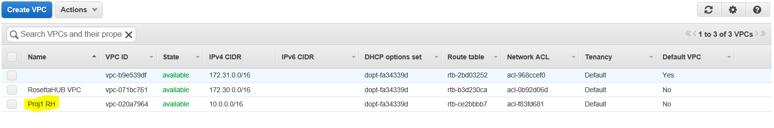

1. **Display the 2 subnets public / private**

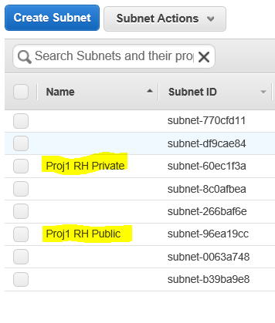

1. **Check Route Table of public subnet.**

It is associated with internet gateway (IGW), OK

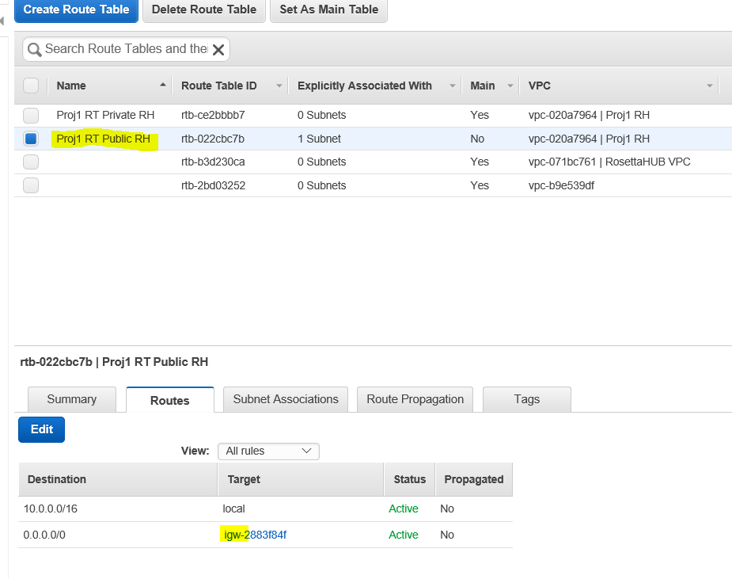

1. **Check Route Table of private subnet**

It is associated with NAT, OK

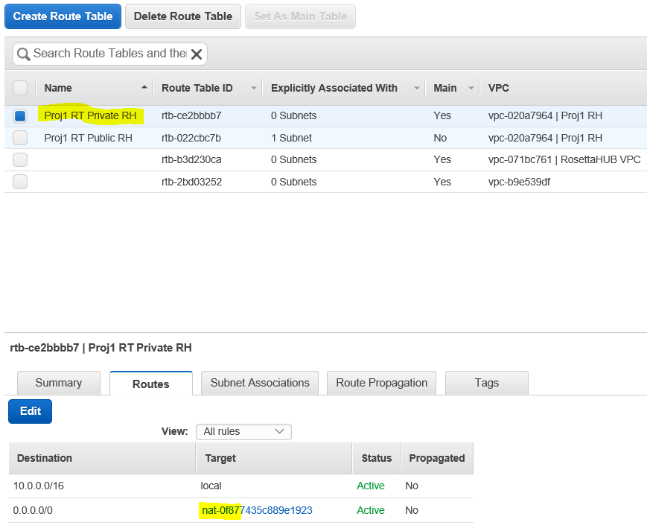

1. **Associate VPC and subnet for private part**

The public subnet was pre-configured

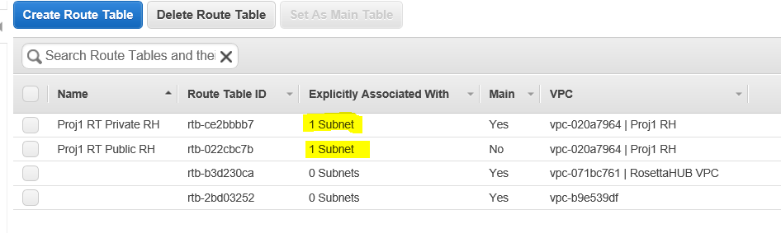

1. **Public part is responding**

I can ping google from bastion host

I can ping bastion host from my laptop

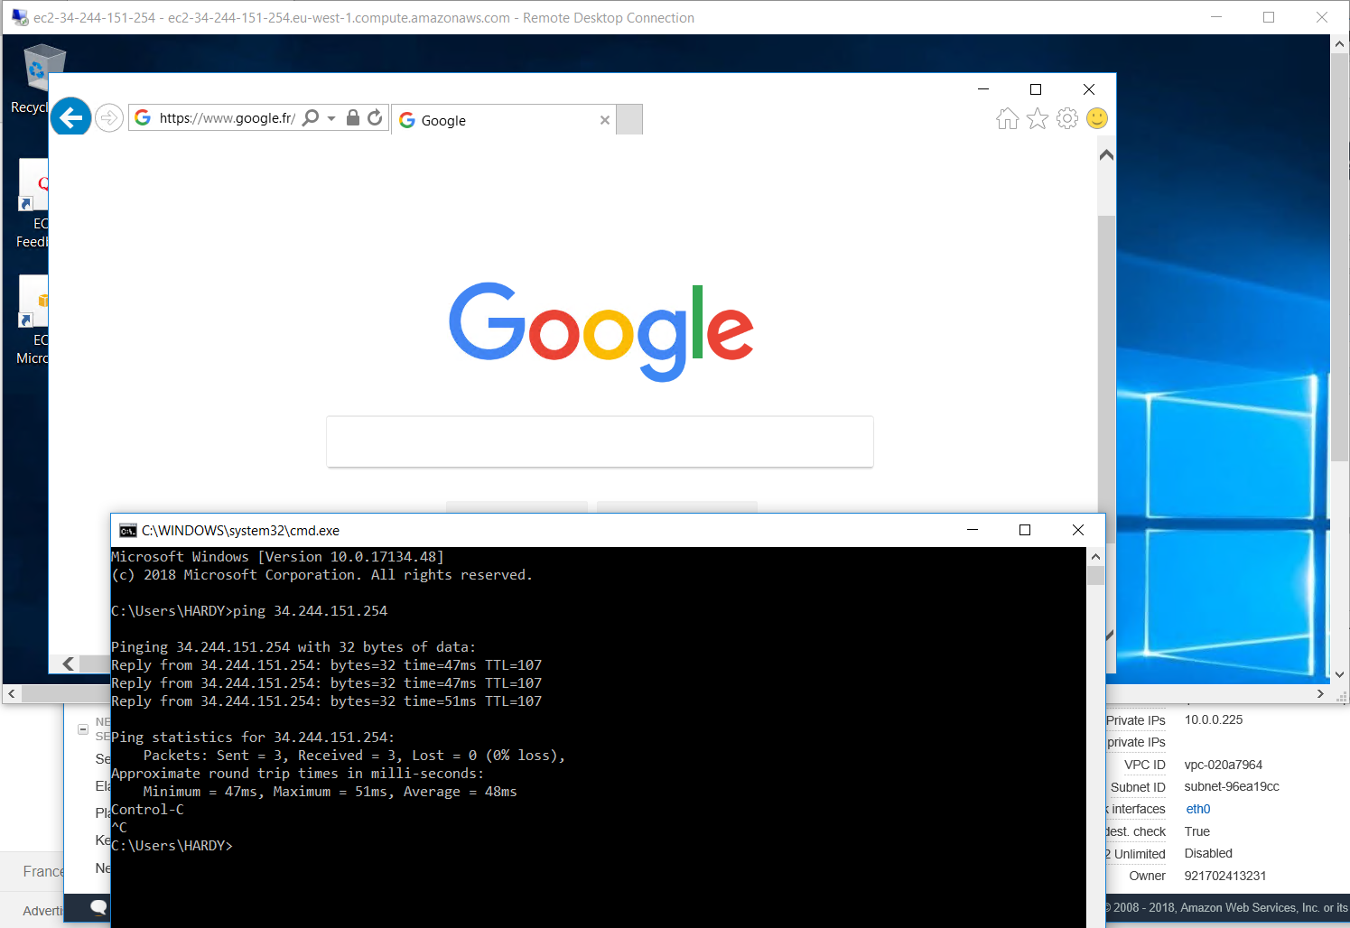

1. **Bastion host security group**

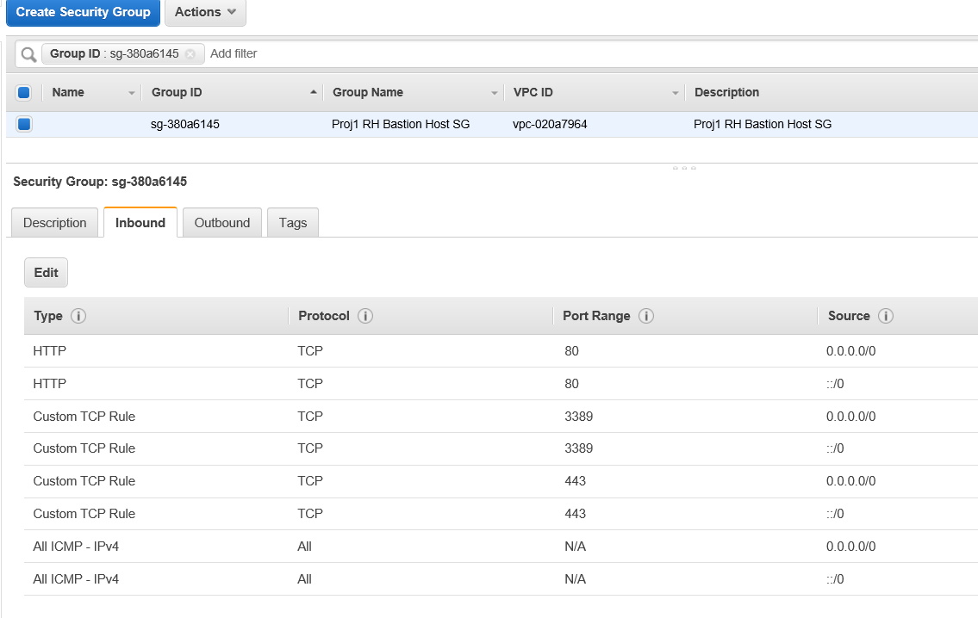

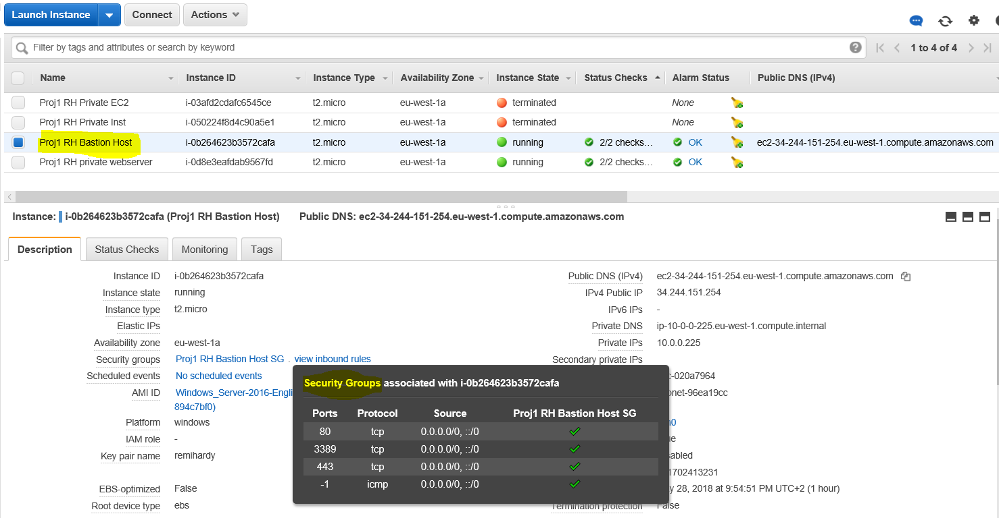

1. **Create Private EC2 instance (aka webserver)**

Note : use the following Public IP setting : Use subnet setting (disable) for private instance

Private IP of the EC2 : 10.0.1.55

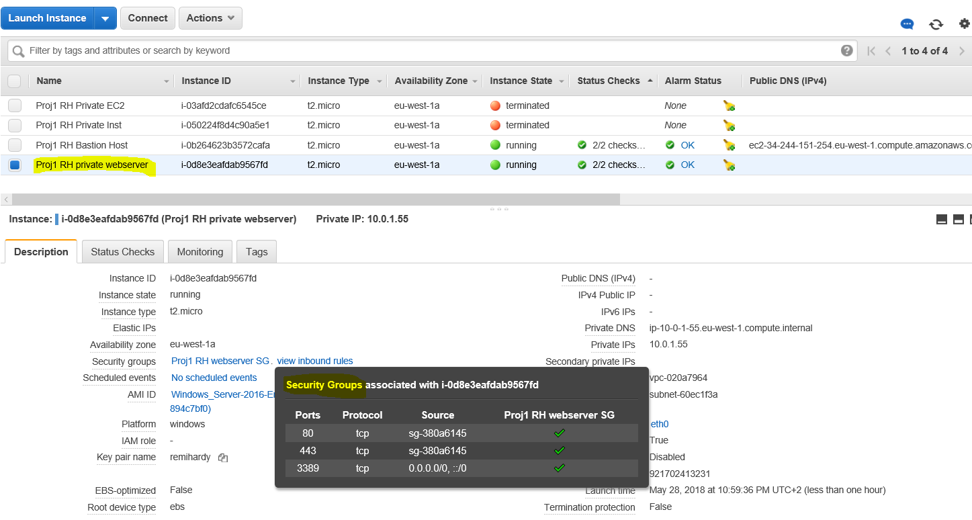

The 2 EC2 instances are running ok

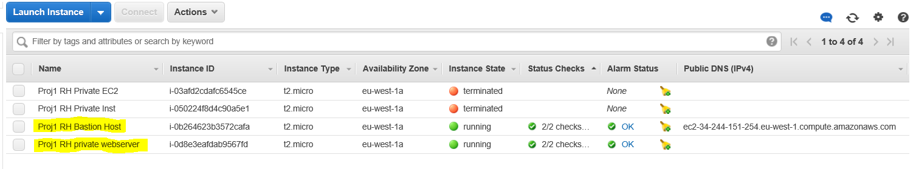

1. **Ping Google from Webserver (private EC2)**

From bastion host, open a remote desktop, log on 10.0.1.55 address of webserver, providing credentials from AWS.

I can ping google from webserver:

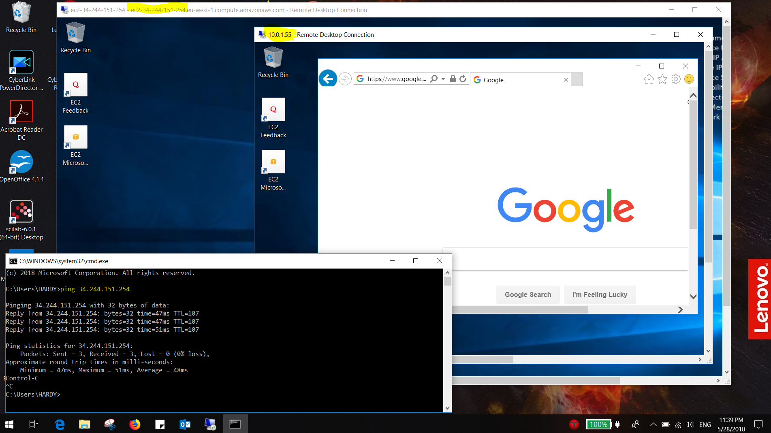

1. **Show remote desktops connections**

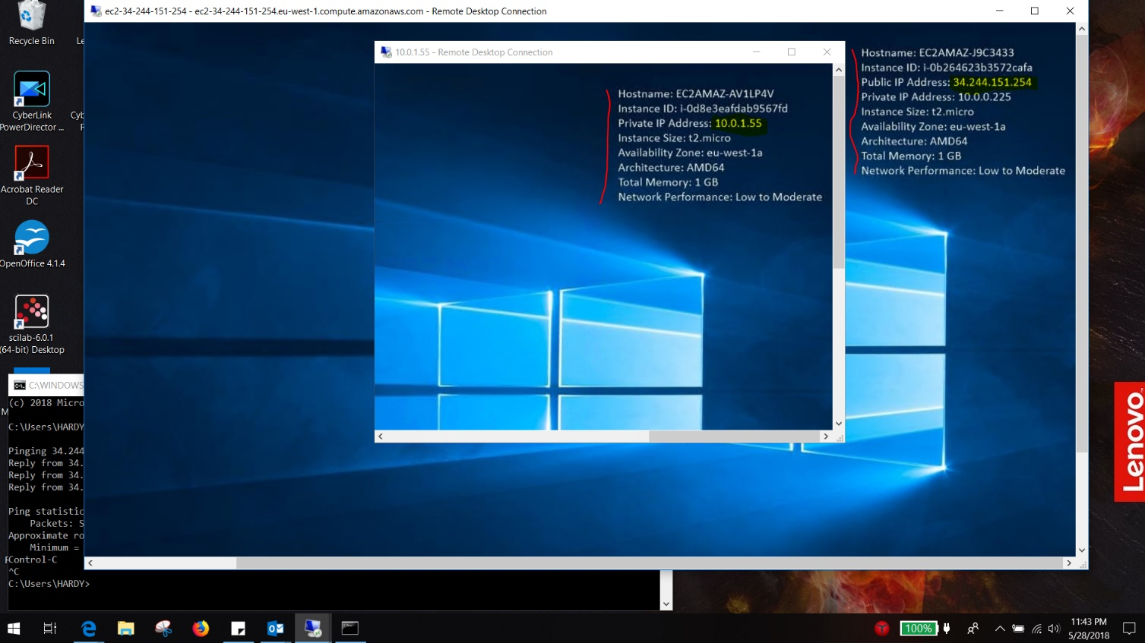

1. **Ping webserver from bastion host**

After

* disabling windows firewall on webserver (private EC2)
* And enabling ping as inbound security rule on webserver

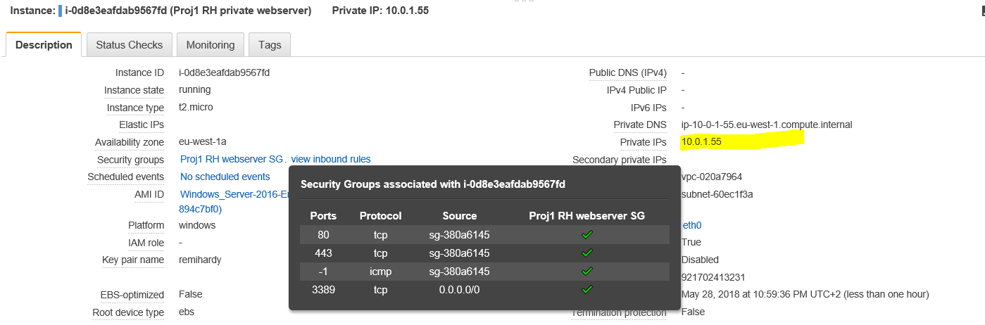

I can ping webserver from bastion host:

