# Supplementary material S1

## Statistical shape model

The curves extracted from the fundus photographs were smooted using B-splines and their inflection points computed. For a B-spline curve sampled at times , the inflection points are times where changes sign, i.e., . In this work, we used and to compute the inflection points. Higher sampling rates lead to more inflections points. The start and end points of the curves along with the inflection points form the primary training data-set for the statistical shape model. Because not all segmented curves yield the same amount of inflection points, we up sample the curves by splitting the longest vessel segments in half, repeating as necessary. This results in training sets, one for each arcade, with varying number of training points between sets. All shape in a training sets are aligned using the Kabsch-Umeyama algorithm [1]. Effectively, all shapes are rotated, translated and scaled as to minimise the root-mean-squared deviation between the shapes and their (aligned) mean.

For arcade vessel , with points in each shape, a data matrix is assembled by stacking the curves row-wise. Denoting the eigenvectors and associated eigenvalues of the Pearson correlation matrix of , construct by stacking the eigenvectors with the largest eigenvalues column-wise. The number of modes of variations may be chosen as to explain of the variance in the data. Finally, denoting the mean of all shapes, one can create a new, unique shape using where follows a -dimensional, centered normal distribution with standard deviation . The resulting points are interpolated using centripetal Catmull-Rom splines [2] before being used in the next steps.

## Sobol indices

Let be the variance in the model’s output. For input parameters, is decomposed into fractions attributed to sets of inputs as:

,

where

is the first order contribution of variable to and

,

Is the contribution of the interactions between and . For higher interactions (e.g., ), similar expressions can be built.

In this work, we report first and total order indices defined as:

,

where is the set of all input parameters excluding and is the first order contribution of variable to [3].

## Uncertainty quantification

Table S - Results from the 9 scenarios tested for uncertainty quantification.

|  |  |  |  |  |  |
| --- | --- | --- | --- | --- | --- |
|  |  | Total retinal blood flow  () | | Macular flow fraction () | |
| ℛ | OPP | mean | std | mean | std |
|  | 80 | 17.9 | 7.3 | 3.2 | 1.0 |
|  | 100 | 22.4 | 9.1 | 3.2 | 1.0 |
|  | 120 | 26.9 | 11.0 | 3.2 | 1.0 |
|  | 80 | 15.3 | 5.9 | 4.5 | 1.2 |
|  | 100 | 19.1 | 7.3 | 4.5 | 1.2 |
|  | 120 | 23.0 | 8.8 | 4.5 | 1.2 |
|  | 80 | 14.0 | 5.2 | 5.5 | 1.3 |
|  | 100 | 17.5 | 6.5 | 5.5 | 1.3 |
|  | 120 | 20.9 | 7.8 | 5.5 | 1.3 |

Table S - Pearson’s scores testing linear association between ℛ and OPP for the 9 scenarios tested for uncertainty quantification.

|  |  |  |  |  |  |  |
| --- | --- | --- | --- | --- | --- | --- |
| Dependent variable | ℛ | | | OPP | | |
| Group |  |  |  |  |  |  |
| Total retinal blood flow | 0.82 | 0.82 | 0.82 | 0.89 | 1.00 | 0.99 |
| Macular flow fraction | 0.93 | 0.93 | 0.93 | 0.0 | 0.00 | 0.00 |

.

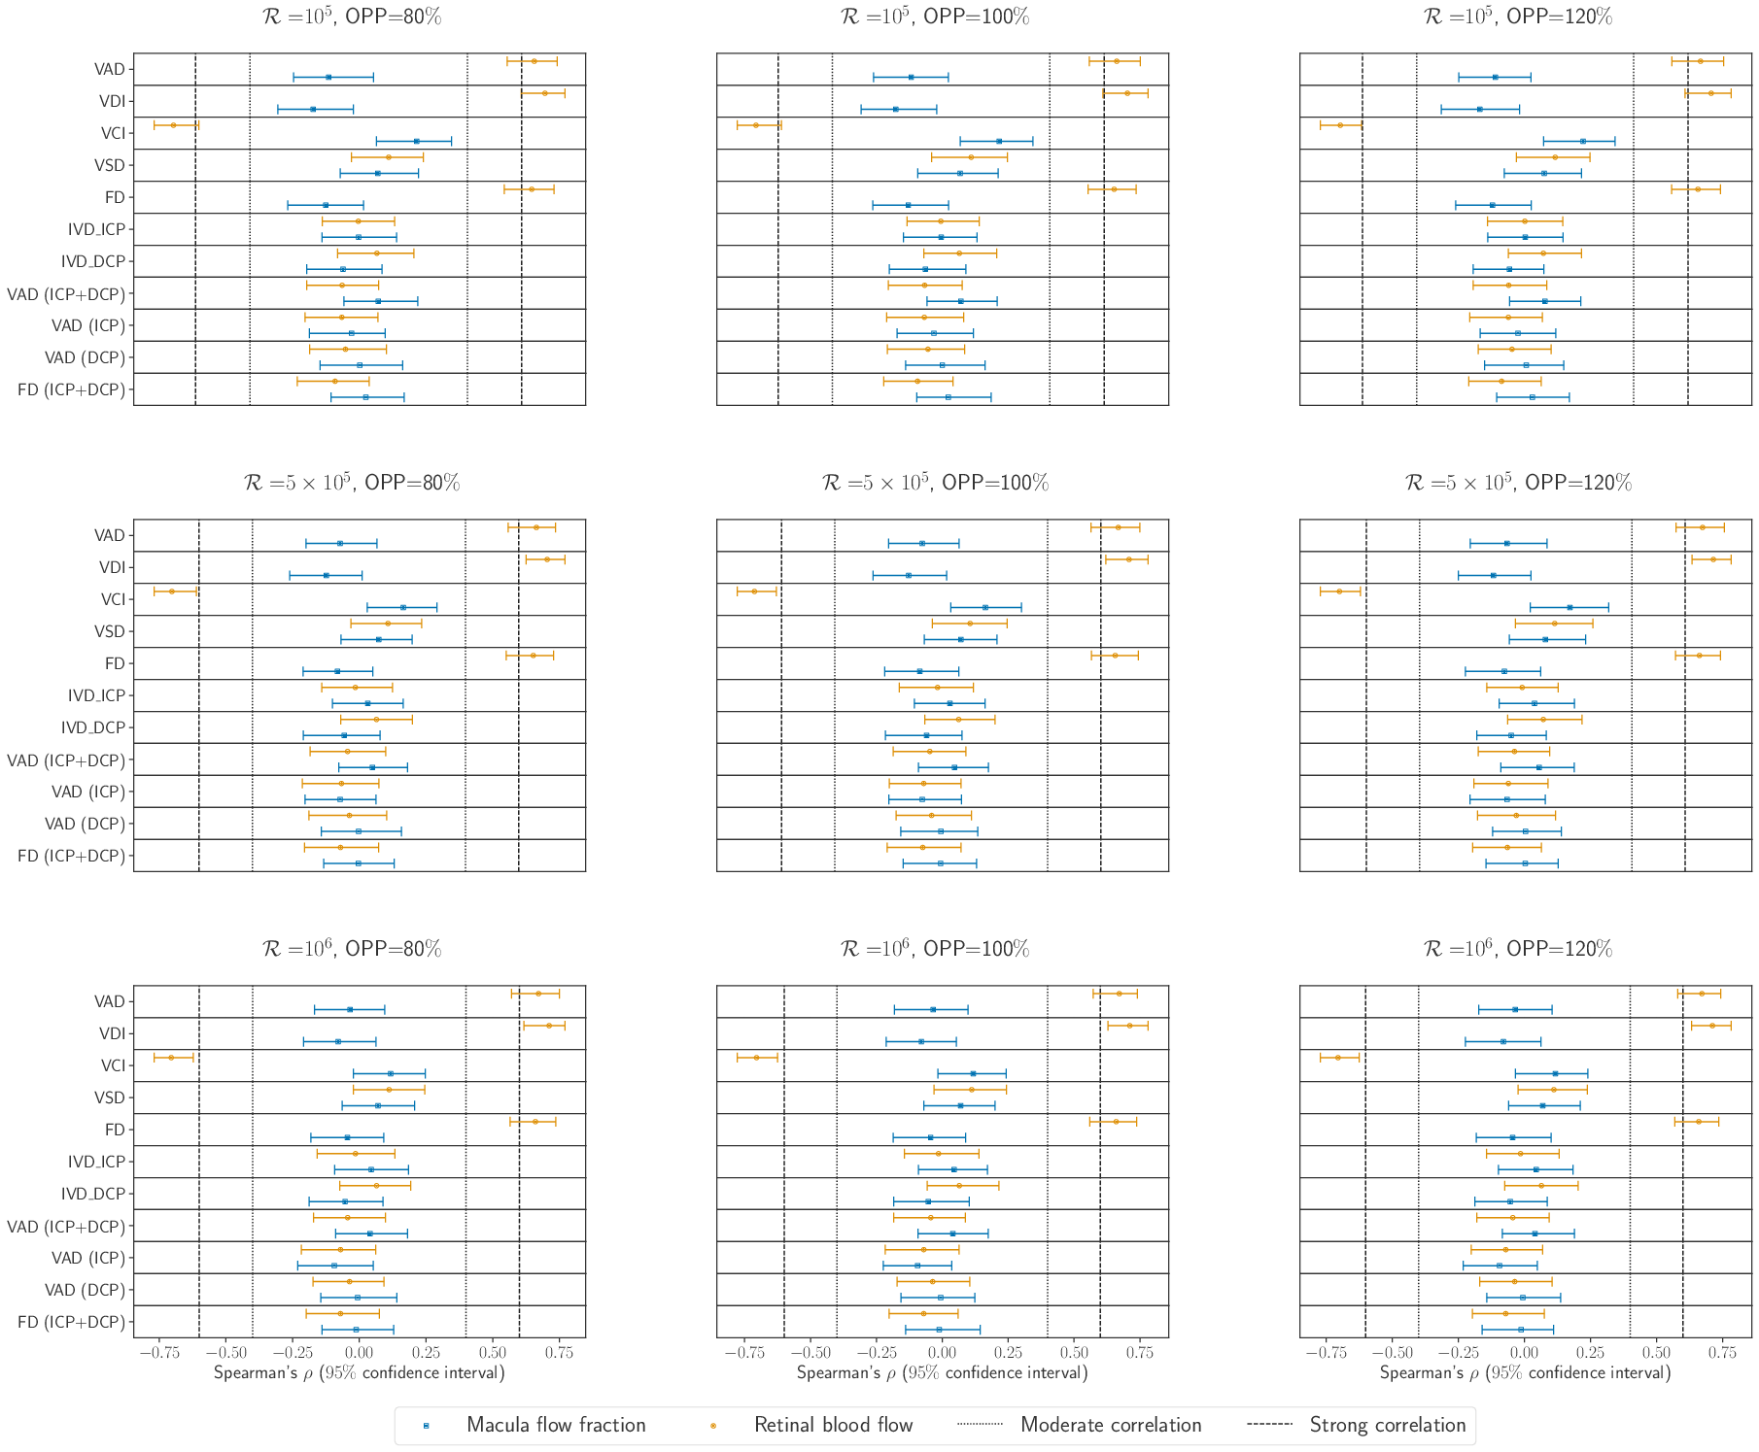

Figure S - Effect of varying OPP and on the associations between structural and haemodynamics outcomes.

Figure S - Effects of varying OPP and on the haemodynamics outcomes.

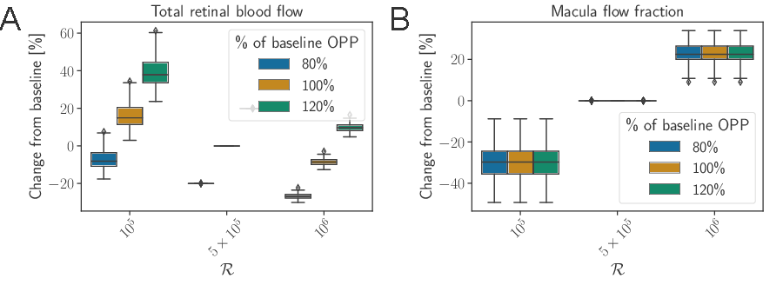

## References

[1] S. Umeyama. Least-squares estimation of transformation parameters between two point patterns. *IEEE Trans Pattern Anal Mach Intell*, 13(4):376–380, 1991.

[2] E. Catmull and R. Rom. A Class of Local Interpolating Splines. *In Computer Aided Geometric Design*, pages 317–326. Elsevier, 1974.

[3] A. Saltelli, Global sensitivity analysis: the primer. Wiley, Chichester, West Sussex, 2008.