**Jingpeng Wu**

**add $t0, $s1, $s2 # R-format**

add has no opcode, function code is 20(hex). $t0 = 8, $s1 = 17, $s2 = 18

In binary this gives us 0000 0010 0011 0010 0100 0000 0010 0000, which in hex is:

02324020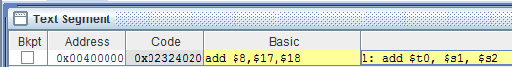

**addi $t0, $t0, -64 # I-format, arithmetic**

opcode = 001000

$t0 = 8 = 01000, -64 = 1111111111000000

In binary which is: 0010 0001 0000 1000 1111 1111 1100 0000, which in hex is 2108ffc0



**lw $t1, 8($s3) # I-format, data transfer**

rt = $t1 =9

rs = $s3 = 19

opcode = 100011, rs = 19 = 10011, rt = 01001 = 9, constant = 0000000000001000

In binary which is: 1000 1110 0110 1001 0000 0000 0000 1000, which in hex is 8e690008

