**Collaboration assignment 7: Unit Testing**

Date: 4/28/2021

All members are present: Arick M., Jeremy B., Tran N., Kyron E., Victoria O.

Meeting place: Discord:

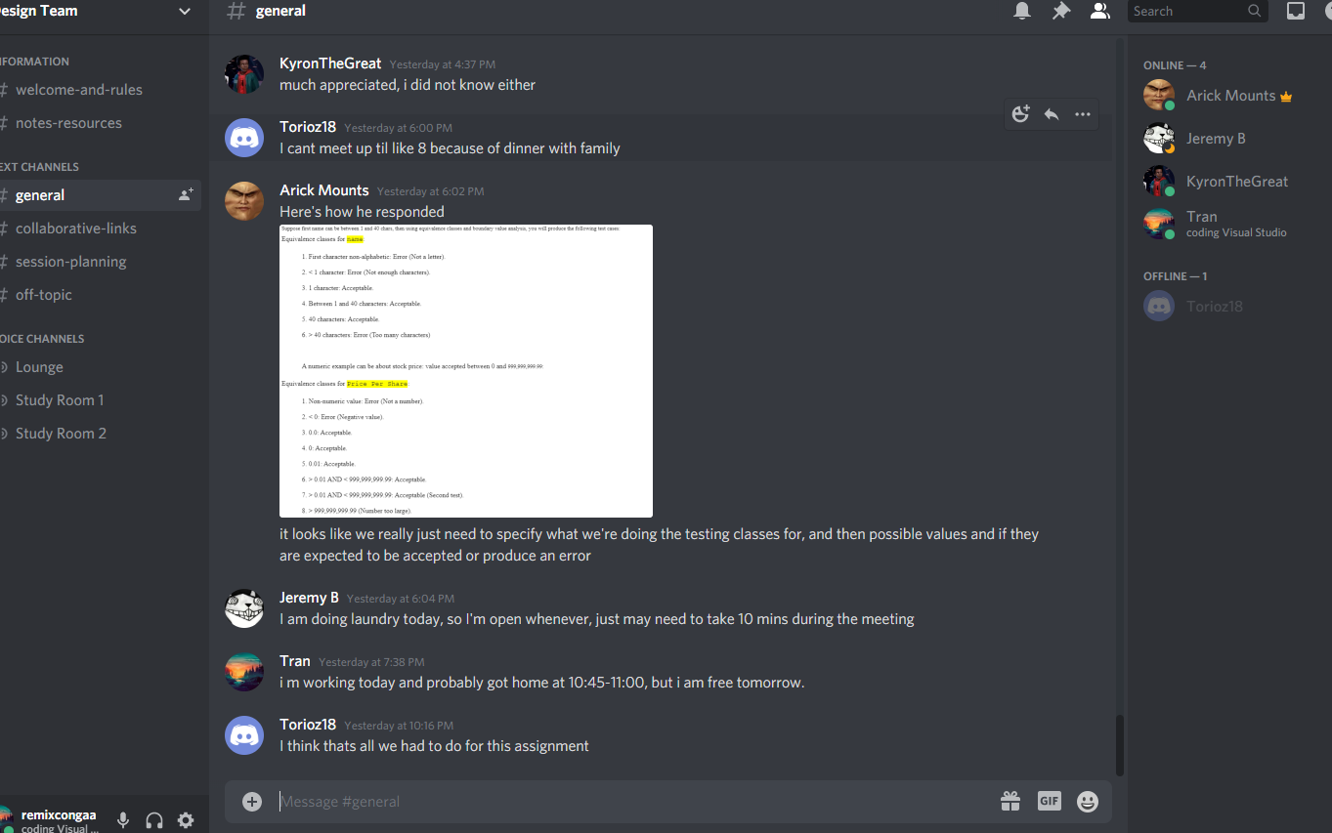

Team leader: Arick Mounts

Scribe: Tran Nguyen

* For this assignment: Each member needs to work on individual draft then all members will meet up and upload the work.