Assignment 4

***Major Entities and Attributes***

**Entities:**

|  |  |  |
| --- | --- | --- |
| Entity | Detail | Name |
| Account | Holds information for a customer's account | Arick Mounts |
| User | Customer who purchases/sells stocks | Arick Mounts |
| Stock | Stock with available shares to purchase or view | Jeremy B. |
| Payment Method | Holds payment information | Jeremy B. |
| Trade | Transaction information | Tran N |
| Broker | Agent to process transactions | Victoria O. |
| Brokerage Firm | Firm agent is connected to for processing transactions | Victoria O. |
|  |  |  |

Entities and their attributes

|  |  |  |  |  |  |  |  |
| --- | --- | --- | --- | --- | --- | --- | --- |
| Account | User | Payment Method | Stock | Trade | Broker | Brokerage Firm |  |
| Account_ID | User_ID | Payment_ID | Stock_ID | Trade_ID | Broker_ID | Firm_ID |  |
| User_ID | First name | Card_ID 1:1 | Stock Price | Date | Broker Name | Firm Name |  |
| Payment info 1:M | Last name | Bank | Ticker | Number of shares | Address | Address |  |
| Stocks held M:M | Address | Paypal | Company name | Stocks traded M:1 | Phone Number | Phone Number |  |
| Balance 1:M | Phone Number |  |  | Price | Broker Email | FirmEmail |  |
|  | Username |  |  | Trade Type | Firm_ID 1:1 |  |  |
|  | Email |  |  |  |  |  |  |
|  | Password |  |  |  |  |  |  |
|  |  |  |  |  |  |  |  |
|  |  |  |  |  |  |  |  |
|  |  |  |  |  |  |  |  |
|  |  |  |  |  |  |  |  |

ER diagram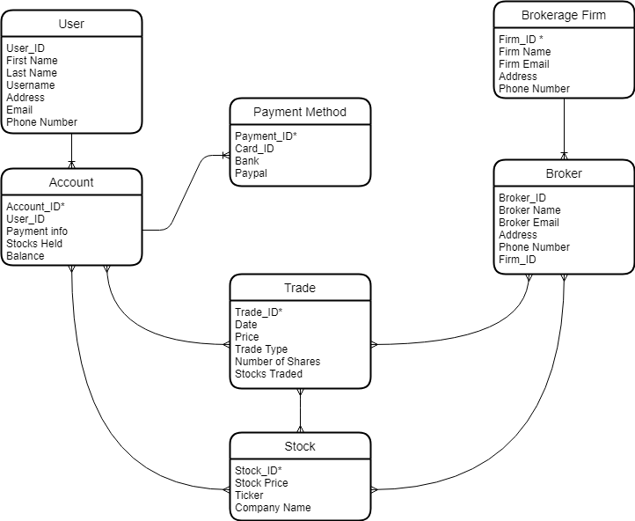

**Level 1 Data Flow Diagram**

