Assignment 5

Sequence Diagrams

Kyron:

Instant Deposit:

Deposit:

Tran: 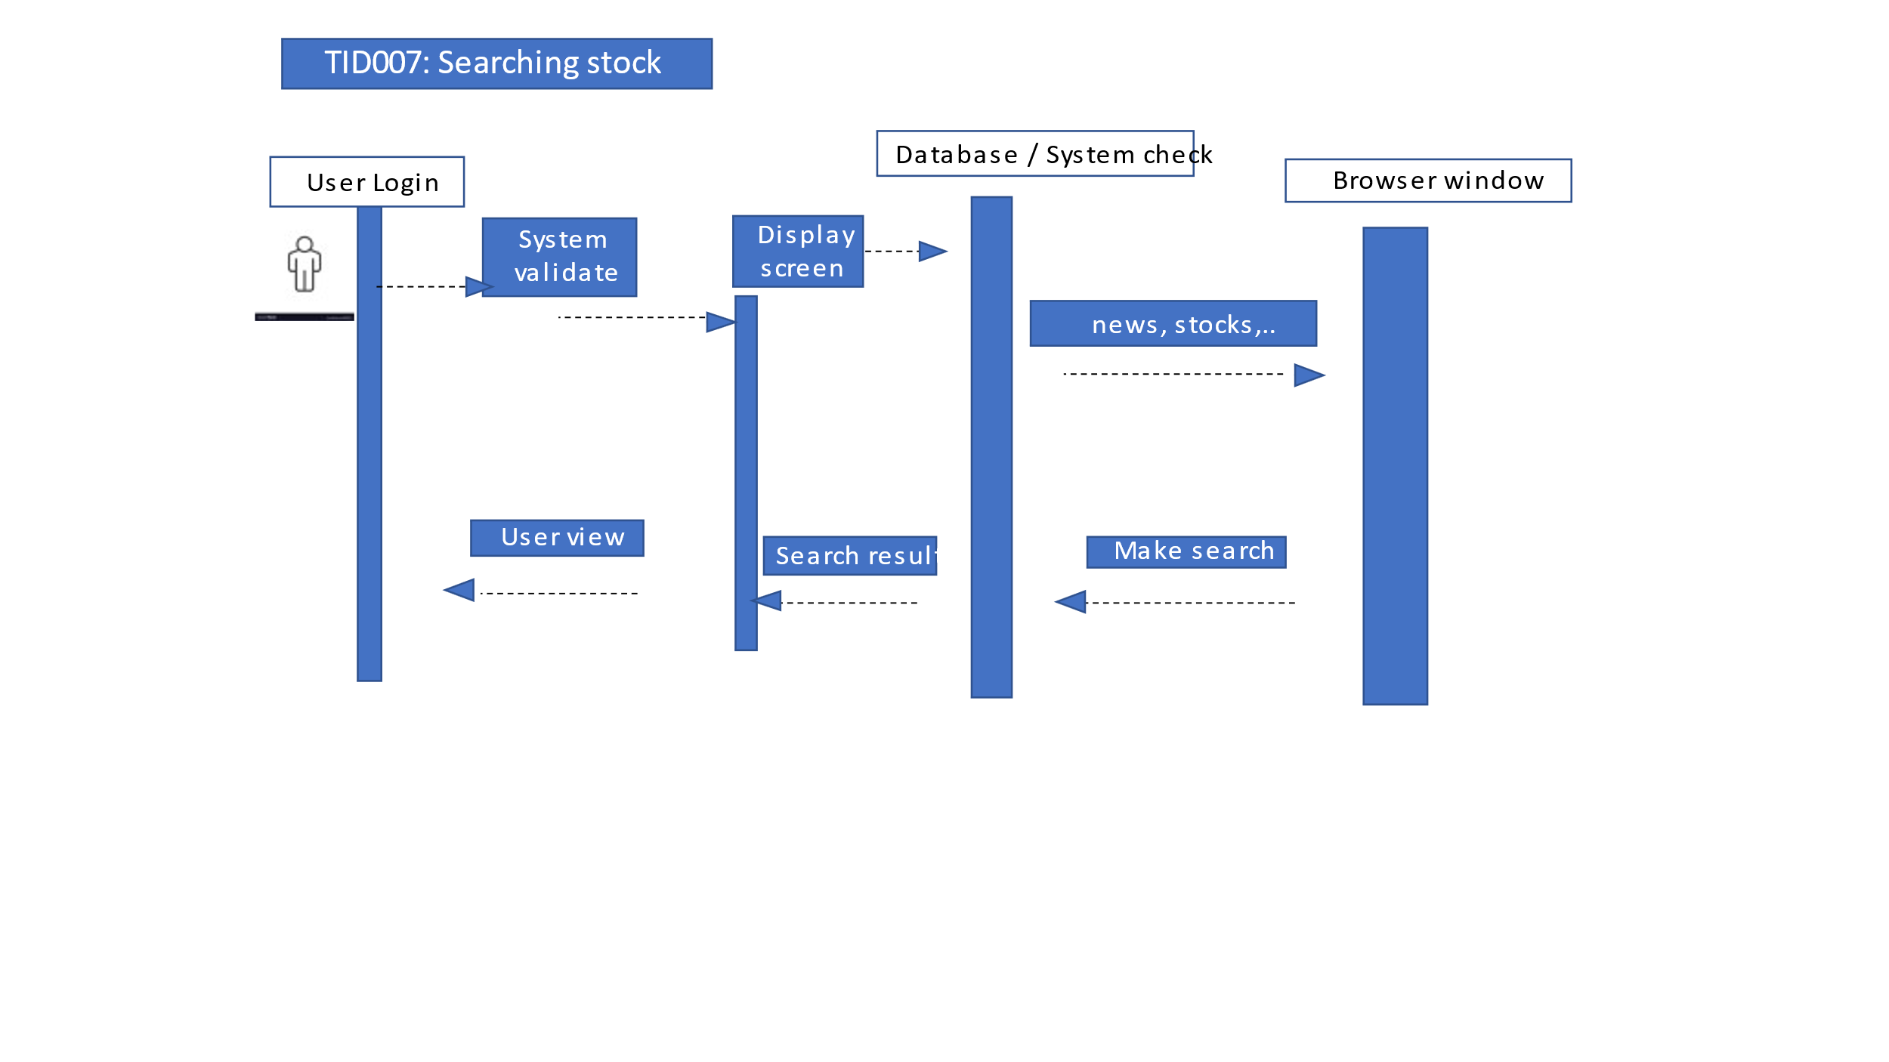

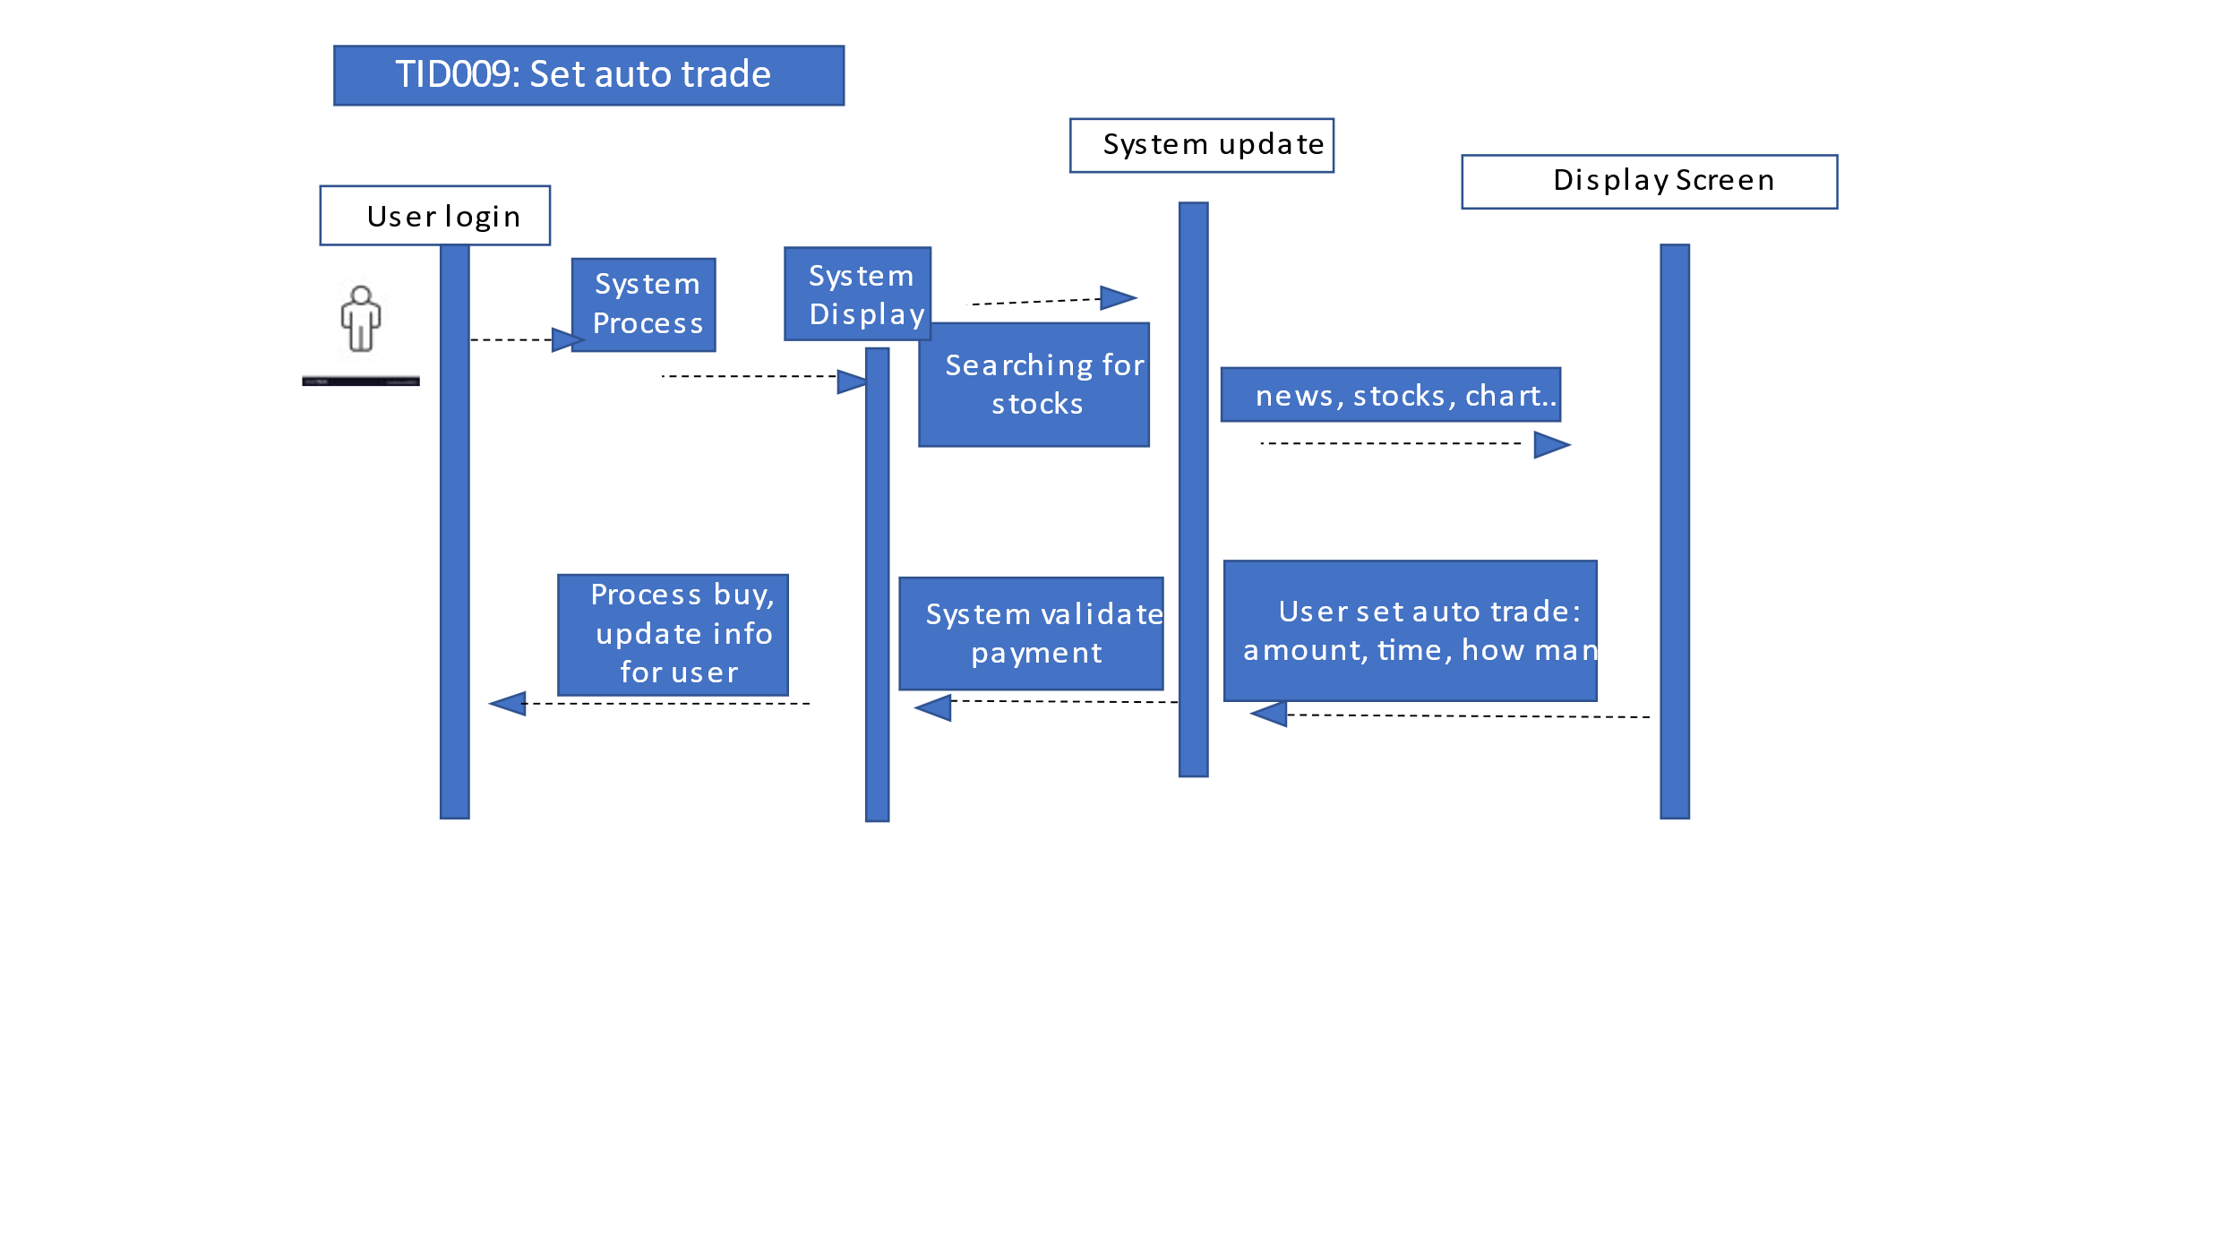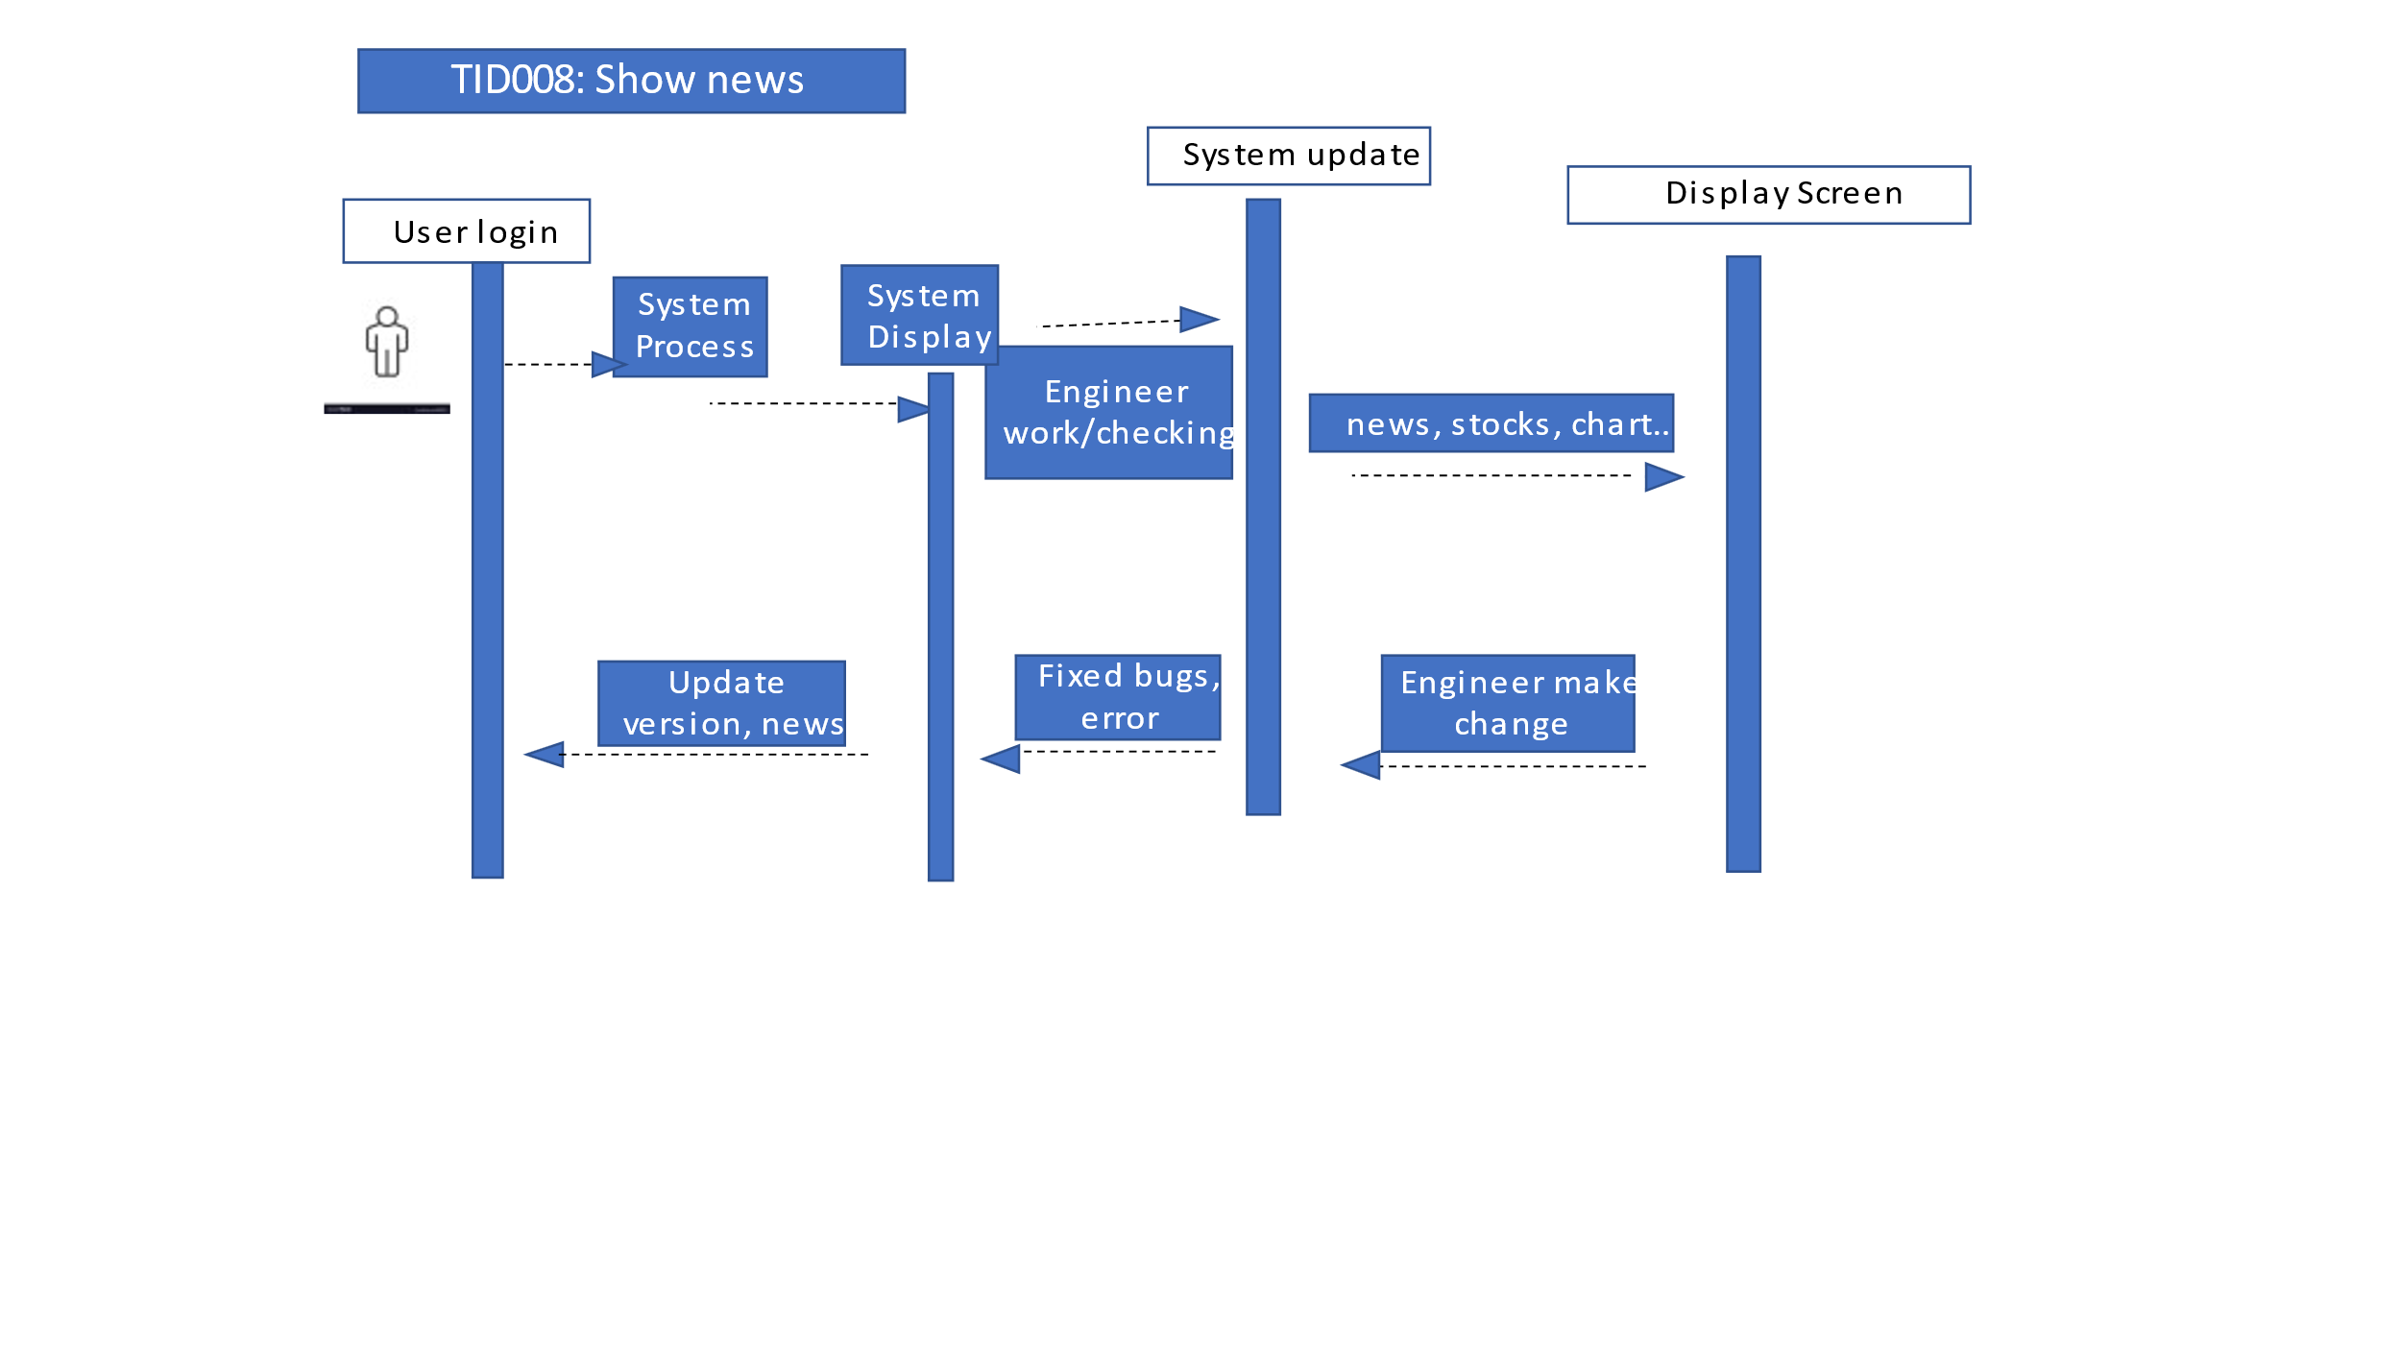

Jeremy:

Logout:

Set limit buy order:

Victoria:

Arick:

