**ABSTRACT**

With the advancement of science and technology, the pharmaceutical industries have flourished drastically in recent years. However, the domain of pharmaceutical waste management is not in check and hence the improper disposal of pharmaceutical waste like dumping, burning, flushing, land filling has led to harmful impact in the environment like air and water pollution, change in aquatic ecosystem, destruction of flora and fauna, genetic changes, antimicrobial resistance, etc. The idea of reusing dispensed medicines is appealing to the general public provided its benefits are illustrated, its risks minimized, and the logistics resolved. For example, medicine reuse could help reduce medicinal waste, protect the environment and improve public health. A literature survey is undertaken to lay down the groundwork for implementing technologies on and around pharmaceutical packaging in order to meet stakeholders’ previously expressed misgivings about medicine reuse (’stakeholder requirements’), and propose a novel ecosystem for, in effect, reusing returned medicines.

**Methods:** A structured literature search examining the application of existing technologies on pharmaceutical packaging to enable medicine reuse was conducted and presented as a narrative review.

**Results:** Reviewed technologies are classified according to different stakeholders’ requirements, and a novel ecosystem from a technology perspective is suggested as a solution to reusing medicines.

**Conclusion:** Active sensing technologies applying to pharmaceutical packaging using printed electronics enlist medicines to be part of the Internet of Things network. Validating the quality and safety of returned medicines through this network seems to be the most effective way for reusing medicines and the correct application of technologies may be the key enabler.

i

**CHAPTER-1**

**INTRODUCTION**

The World Health Organization (WHO) defines pharmaceutical waste as undesirable pharmaceuticals, including expired, unused, spilled, and infected pharmaceutical products, medications, vaccines, and sera that are not required and should be disposed of appropriately [1]. The volume of pharmaceutical waste has increased primarily due to growth in the number of patients and prescriptions and the use and overproduction of medicines. The increase in unused, expired, and misplaced medicines contributes to medicine shortages, higher percentages of pharmaceuticals waste, and increased medicine disposal costs, and it is a growing concern globally requiring a systemic approach to its resolution [2]. According to the Pharmaceutical Services Negotiating Committee (PSNC), prescribing pharmaceuticals represents the second-highest cost in the United Kingdom (UK), after medical staff [3]. As of 2019, around $1.25 trillion USD had been spent on medicines globally, up from only $887 billion in 2010. The spending on medicines is anticipated to increase to $1.59 billion by 2024 [4]. By 2019, the UK had around £127 billion spent in healthcare [5]. Such figures indicate an extensive waste of resources in the healthcare system. This waste includes inappropriately prescribed medication, which results in the overstocking of medications. Gebremariam et al. [6] reported that supply chain management and related variables were principal contributors to the generation of pharmaceutical waste. Likewise, poor storage conditions, storing medicines on the floor, the absence of specific stocking plans, poor climate control, and overstocking expired medicines can lead to significant medication spoilage [6].

Medicinal waste has not only been a problem in the NHS (National Health Service) [[**1**](https://www.mdpi.com/2226-4787/8/2/58#B1-pharmacy-08-00058)], but also a challenge in other countries in terms of public health, the environment and governmental expenditures [[**2**](https://www.mdpi.com/2226-4787/8/2/58#B2-pharmacy-08-00058),[**3**](https://www.mdpi.com/2226-4787/8/2/58#B3-pharmacy-08-00058),[**4**](https://www.mdpi.com/2226-4787/8/2/58#B4-pharmacy-08-00058)]. Trueman et al. [[**5**](https://www.mdpi.com/2226-4787/8/2/58#B5-pharmacy-08-00058)] reported that £300M of prescribed medicines are wasted every year mainly through medication non-adherence. Together with those unused, unwanted and unexpired medicines, they are major sources of preventable medicinal waste that can currently only be disposed of through managed (e.g., disposal centers at community pharmacies) and unmanaged methods (e.g., domestic sewage, public bins, etc.). One of the ways to tackle medicinal waste is to explore the idea of medicine reuse, which is currently not permitted in the UK [[**6**](https://www.mdpi.com/2226-4787/8/2/58#B6-pharmacy-08-00058),[**7**](https://www.mdpi.com/2226-4787/8/2/58#B7-pharmacy-08-00058)]. A legally approved re-dispensing of medicines scheme has started to work in some areas of the world such as the *SIRUM (Supporting Initiatives to Redistribute Unused Medicine* ([**https://www.sirum.org/**](https://www.sirum.org/))) originating from the California [[**8**](https://www.mdpi.com/2226-4787/8/2/58#B8-pharmacy-08-00058)], the *Pharmaceutical donation and reuse programs* operating now in many states of the US [[**9**](https://www.mdpi.com/2226-4787/8/2/58#B9-pharmacy-08-00058)], and the *GivMed* ([**https://givmed.org/en/**](https://givmed.org/en/)) programme facilitating access to leftover medicines using a smartphone app in Greece [[**7**](https://www.mdpi.com/2226-4787/8/2/58#B7-pharmacy-08-00058)]. However, there are restrictions to the types and the sources of medicines to be reused since the quality and safety of the returned medicines are not guaranteed [[**10**](https://www.mdpi.com/2226-4787/8/2/58#B10-pharmacy-08-00058)].

## Problem Statement

## The increase in pharmaceutical waste medicines is a global phenomenon and financial burden. The Circular Economy, as a philosophy within the pharmaceutical supply chain, aims to promote waste reduction, maximize medicines value, and enable sustainability within this supply chain (increasing circularity).

## Solution Strategy

## A detailed narrative literature review was conducted in order to examine pharmaceutical waste creation, management, disposal, and the application of circular economy principles.

## Scope

## The aim of this study was to determine whether the application of circular economy principles can minimize pharmaceutical waste and support sustainability in the pharmaceutical supply chain.

## Objectives

* These principles act as a binding mechanism for disparate waste management initiatives. Medicines, or elements of a pharmaceutical product, can be better managed to reduce waste, cost, and reduce negative environmental impacts through unsafe disposal.
* The study findings outline a Circular Pharmaceutical Supply Chain and suggest that it should be considered and tested as a sustainable supply chain proposition.

Donating medicines to remote areas that lack resources is another way of reducing medicinal waste through recycling medicines. Nevertheless, the reusing of dispensed medicines is generally not allowed because a proper way of validating the quality of returned medicines is not yet available. Thus, prescribed medicines from individuals are usually not allowed to be donated abroad either [[**11**](https://www.mdpi.com/2226-4787/8/2/58#B11-pharmacy-08-00058),[**12**](https://www.mdpi.com/2226-4787/8/2/58#B12-pharmacy-08-00058)]. A sustainable pharmaceutical supply chain (PSC) management may provide an alternative solution to reducing medicinal waste through the concept of reverse flows. Viegas et al. [[**13**](https://www.mdpi.com/2226-4787/8/2/58#B13-pharmacy-08-00058)] classifies reverse flows into donation, Reverse Logistics (RL) and Circular Economy (CE), where CE illustrates a close loop supply chain paving the way to reuse returned medicines. The complicated communication flows between a large numbers of PSC stakeholders could be an obstacle blocking a smooth reverse flow implementation. Pharma 4.0, an extension of Industry 4.0 to pharmaceutical manufacturing, may help establish seamless connections between stakeholders through Internet of Things (IoT) technologies [[**14**](https://www.mdpi.com/2226-4787/8/2/58#B14-pharmacy-08-00058),[**15**](https://www.mdpi.com/2226-4787/8/2/58#B15-pharmacy-08-00058)]; however, the big concern in managing and monitoring the quality of returned medicines still needs to be resolved.

The World Health Organization (WHO) defines pharmaceutical waste as undesirable pharmaceuticals, including expired, unused, spilled, and infected pharmaceutical products, medications, vaccines, and sera that are not required and should be disposed of appropriately [16]. The volume of pharmaceutical waste has increased primarily due to growth in the number of patients and prescriptions and the use and overproduction of medicines. The increase in unused, expired, and misplaced medicines contributes to medicine shortages, higher percentages of pharmaceuticals waste, and increased medicine disposal costs, and it is a growing concern globally requiring a systemic approach to its resolution [17].

The last phase of the pharmaceutical waste is disposal, traditional burning or non-burning technique utilized. It is essential to note that, out of all pharmaceutical waste, only 15% is hazardous, whilst the remaining 85% is general [18]. Large amounts of prescribed pharmaceutical waste are found in the waterways, streams and groundwater, and it has similarly been shown that a percentage of these are affecting the water and the climate [19]. The WHO classification of different types of healthcare waste is [20]:

• Pathological; this includes body parts, body fluids, human waste, and tissue waste and animal corpses that are contaminated;

• Pharmaceutical; this is either unused, contaminated medicine or medicine which has expired;

• Cytotoxic; genotoxic waste (highly hazardous);

• sharps; includes syringes, needles, and blades, etc.;

• Infectious; this usually contains blood or any bodily fluid which is contaminated and could, therefore, infect other people when they come into contact;

• Non-hazardous; these waste materials can not cause any chemical, radioactive, biological, or physical dangers; and,

• Radioactive; products that are infected by radionuclide’s.

These different types of waste require differing methods of disposal and/or new approaches in order to reduce or eliminate waste. It is important to determine the most suitable method to help preventing/reducing the negative consequences of the disposing methods on the environment, specifically on water, soil, air, and on human well-being [17,18].

The circular economy (CE) is a holistic philosophy that is conveyed through a system for managing and preserving resources ‘in use as long as possible through recovery and reuse’, hence circularity [21]. The CE approach closes the gap between production and the life cycle of the natural ecosystem upon which individuals rely for business and physical survival. It signposts practical ways of eliminating waste, transforming biodegradable and non-biodegradable waste, and promoting reuse and recycling. In CE, a distinction is made amongst different choices of circularity, represented as the R-model of 3R, 4R, or even 9R models (the 9R model being the optimal application of CE incorporating Refuse, Rethink, Reduce, Reuse, Repair, Refurbish, Remanufacture, Repurpose, Recycle, and Recover) [22,23]. Kirchherr et al. [24] claimed that the CE is ‘the combination of reduce, reuse and recycle activities’ to ensure systematic change. The CE has been rapidly growing to realise the United Nation Sustainable Development Goals (SDGs) and as an alternative strategy for business advancement. In the CE, products and services operate in closed loops (being produced and then recycled for further use) and they are intended to work in harmony with the environment. The Ellen MacArthur Foundation, which was founded in 2010 and aims to accelerate progress towards a regenerative CE [25], defines the CE as a move from a linear model of resource consumption, which pursues a take-make-dispose design, to an economy that is restorative by intention. The CE associates the supply and demand of supply chain industries in order to increase resource efficiency and help achieve sustainable production and consumption [24].

Sufficiency economy philosophy (SEP) is another approach that has been considered in academic circles as contributing to the sustainability agenda. SEP is defined by the United Nations [26] as “an innovative method for development that is designed for practical application over a wide range of problems and situations”. The objective of SEP is to improve planning procedures in order to ensure sustainability, manage changes in the world and utilize natural resources in a capable way while preserving nature.

## Organization of the report

The following chapters give a systematic overview about the proposed system.

The chapters are organized as follows:

* Chapter-1: Introduction deals with the overview of medicine waste of medicine, Remedy for medicine, problem statement, solution Strategy, scope and objectives.
* Chapter-2: Literature Survey mainly deals with the initial study before the actual development of the project. It includes study about the existing systems and the related functionalities of the proposed system.
  + - Chapter-3: Software Requirements Specification describes about the product perspective, user characteristics, assumptions and dependencies, specific requirements, functionality along with resource requirements.
    - Chapter-4: System Design deals with the entire flow of the proposed system. The data flow diagram, use case diagram, flow chart etc. are used to provide an overview of the proposed system.
    - Chapter-5: System Implementation deals with the steps involved in developing the proposed work.
    - Chapter-6: Testing mainly deals with the various types of the test cases to prove the validity of the proposed work.
    - Chapter-7: Results and Discussion mainly deals with analyzing the result to show the outcome of the work.
    - Chapter-8: Conclusion provides a summary of the proposed system.

**CHAPTER-2**

**LITERATURE SURVEY**

**Introduction**

The literature survey is also known as a Literature Review. It uses a descriptive writing approach; it describes the existing and established theory and research in report area by providing a context for the work. It can show where one can fill a perceived gap in the existing theory or knowledge, to obtain a better result.

The concept of technology for the reuse of medicine primarily involves developing systems and solutions to safely recycle or repurpose medications. Reusing medicine is a complex and challenging area due to factors like dosage precision, contamination risks, and regulatory considerations. One of the ways to tackle medicinal waste is to explore the idea of medicine reuse, which is currently not permitted in the UK. A legally approved re-dispensing of medicines scheme has started to work in some areas of the world such as the *SIRUM (Supporting Initiatives to Redistribute Unused Medicine* ([**https://www.sirum.org/**](https://www.sirum.org/))) originating from the California [8], the *Pharmaceutical donation and reuse programs* operating now in many states of the US [[**9**](https://www.mdpi.com/2226-4787/8/2/58#B9-pharmacy-08-00058)], and the *GivMed* ([**https://givmed.org/en/**](https://givmed.org/en/)) programmer facilitating access to leftover medicines using a smartphone app in Greece [[**7**](https://www.mdpi.com/2226-4787/8/2/58#B7-pharmacy-08-00058)]. However, there are restrictions to the types and the sources of medicines to be reused since the quality and safety of the returned medicines are not guaranteed [[**10**](https://www.mdpi.com/2226-4787/8/2/58#B10-pharmacy-08-00058)].

## Related Work

Stakeholder Views on the Idea of Medicines Reuse in the UK - PMC - NCBI is method to propose by [Parastou Donyai](https://pubmed.ncbi.nlm.nih.gov/?term=Donyai%20P%5BAuthor%5D),[Rachel McCrindle](https://pubmed.ncbi.nlm.nih.gov/?term=McCrindle%20R%5BAuthor%5D) [27] to analyze this includes the current uncertainty about the quality of unused medicines returned to pharmacies, which could otherwise be reused. However, stakeholders have also been very willing to propose solutions to a range of existing barriers. Our commentary draws on stakeholder meetings to elaborate the range of views about medicines reuse within a UK context.

[Ashish Atreja](https://pubmed.ncbi.nlm.nih.gov/?term=Atreja%20A%5BAuthor%5D), MD, MPH, Fellow, [Naresh Bellam](https://pubmed.ncbi.nlm.nih.gov/?term=Bellam%20N%5BAuthor%5D), MD, MPH [28] proposed a Medicine Reuse: A Viable Approach for Improving Medication Adherence. It consists Chronic lifestyle behavior change often requires a combination of all the aforementioned strategies. We suggest a conceptual framework, which calls for a multidisciplinary approach with the above strategies in the context of a healthcare team and system-related factors.  We conducted a narrative review of the current literature to help providers become more familiar with proven interventions that can enhance patient adherence. We then grouped the interventions into categories that can be remembered by the mnemonic “SIMPLE”:

1. Simplifying regimen characteristics;
2. Imparting knowledge;
3. Modifying patient beliefs;
4. Patient communication;
5. Leaving the bias; and
6. Evaluating adherence.

[Yasmin Lam](https://pubmed.ncbi.nlm.nih.gov/?term=Lam%20Y%5BAuthor%5D), [Rachel McCrindle](https://pubmed.ncbi.nlm.nih.gov/?term=McCrindle%20R%5BAuthor%5D) [29] Presented a study on A between participant studies was designed with two independent factors testing the hypothesis that sensors and visual checks would increase pro-medicines-reuse beliefs. A questionnaire was used to measure medicines reuse beliefs and collect qualitative comments. Eighty-one participants took part. Attitudes toward medication offered for reuse, participants’ perceived social pressure to accept the medication, and their intention to take part in medicines reuse all increased with the presence of sensors on packaging and with the promise of pharmacist visual checking, with the former causing a greater increase than the latter, and the combination of both making the greatest increase.

[Hamza Alhamad](https://pubmed.ncbi.nlm.nih.gov/?term=Alhamad%20H%5BAuthor%5D), [Nilesh Patel](https://pubmed.ncbi.nlm.nih.gov/?term=Patel%20N%5BAuthor%5D), and [Parastou Donyai](https://pubmed.ncbi.nlm.nih.gov/?term=Donyai%20P%5BAuthor%5D) [30] proposed a Navigating Medicine Reuse: A Quick Guide by This narrative review provides insights about the different therapeutic classes and dosage forms of medication waste returned by patients, collected through waste campaigns, or indicated in survey responses. The findings could help policy makers understand the potential implications of treating most unused medicines as medication waste and whether therefore pursuing a medicines reuse scheme could be environmentally or financially logical. The quality and the safety of these returned medicines using criteria related to the storage conditions (such as heat and humidity), physical shape (such as being sealed, unopened, unused, and in blister packaging), and tampering are other important considerations for a medicines reuse scheme.

[Hamza Qasim Alhamad](https://www.researchgate.net/profile/Hamza-Alhamad?_tp=eyJjb250ZXh0Ijp7ImZpcnN0UGFnZSI6InB1YmxpY2F0aW9uIiwicGFnZSI6InB1YmxpY2F0aW9uIn19), [Nilesh Patel](https://www.researchgate.net/profile/Nilesh-Patel-17?_tp=eyJjb250ZXh0Ijp7ImZpcnN0UGFnZSI6InB1YmxpY2F0aW9uIiwicGFnZSI6InB1YmxpY2F0aW9uIn19), [Parastou Donyai](https://www.researchgate.net/profile/Parastou-Donyai?_tp=eyJjb250ZXh0Ijp7ImZpcnN0UGFnZSI6InB1YmxpY2F0aW9uIiwicGFnZSI6InB1YmxpY2F0aW9uIn19) [31] proposed a method A Narrative Review of the Different Therapeutic Classes and Dosage Forms of Medication Waste in Different Countries This narrative review provides insights about the different therapeutic classes and dosage forms of medication waste either returned by patients, collected through waste campaigns, or indicated in survey responses. The findings could help policy makers understand the potential implications of treating most unused medicines as medication waste and whether therefore pursuing a medicines reuse scheme could be environmentally or financially logical.

[Muluneh Guadie](https://pubmed.ncbi.nlm.nih.gov/?term=Guadie%20M%5BAuthor%5D),[Mulusew Andualem Asemahagn](https://pubmed.ncbi.nlm.nih.gov/?term=Asemahagn%20MA%5BAuthor%5D) [32], presented an overview about the Medicines Wastage, There is an excessive rate of medicines wastage which needs immediate mitigation by exchanging nearly expired medicines with other health facilities, communicating with suppliers and even prescribers, using auditable pharmaceutical transactions and services (APTS), providing continuous training, pursuing quality and safety medicines reuse scheme, implementation of pharmacist waste-reducing activities in all stages of the pharmaceutical supply chain, reducing medication amounts in stock, and through the use of electronic stock management tools.

[Hamza Alhamad](https://pubmed.ncbi.nlm.nih.gov/?term=Alhamad%20H%5BAuthor%5D),[Nilesh Patel](https://pubmed.ncbi.nlm.nih.gov/?term=Patel%20N%5BAuthor%5D),and [Parastou Donyai](https://pubmed.ncbi.nlm.nih.gov/?term=Donyai%20P%5BAuthor%5D)[33], How do people conceptualize the reuse of medicines? An interview study, People could potentially agree to reuse medicines if their concerns are addressed and the process is well defined and managed. This is a qualitative study with a small number of participants meaning the results may not be generalisable. The themes generated will enable a structured questionnaire to be developed for quantifying broader views.

[Parastou Donyai](https://pubmed.ncbi.nlm.nih.gov/?term=Donyai%20P%5BAuthor%5D), [Rachel McCrindle](https://pubmed.ncbi.nlm.nih.gov/?term=McCrindle%20R%5BAuthor%5D) [34], Reusing Medicines - An Unexplored Concept in India presented an overview about the This includes the current uncertainty about the quality of unused medicines returned to pharmacies, which could otherwise be reused. However, stakeholders have also been very willing to propose solutions to a range of existing barriers. Our commentary draws on stakeholder meetings to elaborate the range of views about medicines reuse within a UK context. The challenge is to move forward from these views to advance the technologies that will facilitate medicines reuse practically as well as legally.

**CHAPTER -3**

# SOFTWARE REQUIREMENT SPECIFICATION

## Introduction

For efficient use, all [computer software](http://en.wikipedia.org/wiki/Computer_software) needs certain [hardware](http://en.wikipedia.org/wiki/Computer_hardware) components and other software resources to be present on a [computer](http://en.wikipedia.org/wiki/Computer). These prerequisites are known as software requirements and are often used as a guideline for the development of proposed system. With increasing demand for higher processing power and resources in newer versions of software, system requirements tend to increase over time. This trend plays a bigger role in driving upgrades to existing computer systems than technological advancements [9].

**Overall Description**

This section of the SRS explains the methodology used for Optimizing Medication Management: A Technological Ecosystem for Advanced Pharmaceutical Packaging to Enhance Remedies and Minimize Medicinal Waste. The SRS include the general factors that affect the outcome of the proposed system and its necessities, for instance user credentials, assumptions and project constraints. The outlines of the system features, software requirements and the functional and non-functional requirements are described in following sections.

**Product Perspective**

A detailed narrative literature review was conducted in order to examine pharmaceutical waste creation, management, disposal, and the application of circular economy principles. The study findings outline a Circular Pharmaceutical Supply Chain and suggest that it should be considered and tested as a sustainable supply chain proposition.

**User Classes and Characteristics**

The system is designed with the intension to provide easy to use simple system so that no cumbersome and elaborate training for operation is needed. The user characteristics are as follows:

* Registration is compulsory for every user to interact with the proposed system.
* Login as user unique User ID and Password.
* User can View the Account Details and change password.
* User can add the medicine information and view Medicine Details.

**Design and Implementation Constraints**

Design and implementation constraints are as follows:

* Each user must have an individual username and password.
* User can add Medicine information and View medicine information.
* Internet must be available to have accessibility between user and admin.
* Admin can view user details and view the medicine information.
* Admin can check the medicine information.

**Software requirements**

Software requirements deals with defining software resource requirements and prerequisites that needs to be installed on a computer to provide optimal functioning of an application.

The recommended software requirements for the proposed system are

* Operating System: Windows 10
* Database: MySQL Workbench
* Java toolkit: JDK 1.8
* Language: Java
* Development Tool: Eclipse IDE

**Hardware Requirements**

The recommended hardware requirements for the proposed system are

* Processor: Pentium Dual Core
* Memory: 4GB RAM
* Disk space: 200 GB

**Functional Requirements**

Functional requirements describe the working of the proposed system. It also shows the interaction among the user and admin. The functional requirements of proposed system are:

**User**

**Input:**

* + - * User enters user name and password

#### Process:

* + - * Authorized user can successfully login to the User Home.
      * User can add medicine information and view the medicine information.
      * User can add medicine information of medicine brand name, generic name, manufacture date, Expiry date, Quantity and upload medicine packet updated.

#### Output:

* + - * The user medicine information and user information is sent to admin panel.

### Admin Panel

#### Input:

#### Admin enters user name and password

#### Process:

* Admin can view user details and track medicine information.
* Admin can view the user sent medicine information check the expiry date and conform medicine is reuse or not.
* Admin can track the all the medicine information.
* Admin resell the medicine they have expire date.

#### Output:

* + - * Admin can check the details of user sent medicine and resell to the user.

## Non-functional requirements

Non-functional requirements are the functions offered by the system. It includes time constraints and constraints on the development process and standards. The non- functional requirements are as follows:

* **Speed:** The system should process the given input into output within appropriate time.
* **Ease of use:** The software should be user friendly. So that, the customers can use easily, and doesn’t require much training time.
* **Reliability:** The rate of failures should be less. Then only, the system is more reliable
* **Portability**: It should be working in any environment.

## CHAPTER-4

# SYSTEM DESIGN

**Introduction**

Software occasionally can be a complex entity. Its development generally follows Software Development Life cycle (SDLC). In the software development life cycle the design stage is the second stage. The intention of this is to create the overall design of the software. System design is the practice of shaping the architecture, interfaces, elements, modules and data for a system to satisfy particular requirements. Several tools and techniques are available that are used for describing the design of the system. The tools and methods are Flowchart, Data flow diagram (DFD), ER diagram, Sequence diagram, Use case diagram. This section will give an outline of the design of the system and how it is structured.

## 4.1 System Architecture

Designing system architecture for a remedy system involving medicine requires careful consideration of various components to ensure efficiency, security, and user-friendliness. Here's a high-level overview of potential system architecture:

### 1. ****User Interface (UI):****

* **Patient Portal:**
  + Allows users to log in, view their medication information, and request remedies.
  + Should provide a user-friendly interface accessible via web or mobile applications.
* **Administrator Dashboard:**
  + Enables administrators to manage user accounts, monitor system activities, and process remedy requests.
  + May include analytics and reporting tools for administrators to assess system performance.

### 2. ****Authentication and Authorization:****

* **User Authentication:**
  + Secure user authentication methods, such as multi-factor authentication, to ensure that only authorized users access the system.
* **Role-Based Access Control (RBAC):**
  + Assign different roles (patient, healthcare provider, administrator) with specific permissions to control access to various system functionalities.

### 3. ****Data Storage:****

* **Patient Database:**
  + Stores user profiles, medication histories, and remedy requests.
  + Ensures data integrity, security, and compliance with privacy regulations.
* **Medication Database:**
  + Contains information about available medications, including dosage, expiration dates, and storage requirements.

### 4. ****Remedy Request and Processing:****

* **Remedy Request Module:**
  + Allows users to submit requests for remedies, including reasons for the request.
* **Decision Engine:**
  + Evaluates remedy requests based on predefined criteria, taking into account medical guidelines, user history, and availability of medications.

### 5. ****Medication Inventory Management:****

* **Inventory Database:**
  + Tracks the availability, expiration dates, and storage conditions of medications.
* **Automated Dispensing System:**
  + Interfaces with the inventory database to dispense medications based on approved remedy requests.

### 6. ****Communication Module:****

* **User Notifications:**
  + Sends notifications to users regarding the status of their remedy requests.
* **Alerts for Administrators:**
  + Notifies administrators of critical events, such as low medication stock or system errors.

### 7. ****Integration with Healthcare Ecosystem:****

* **Electronic Health Records (EHR) Integration:**
  + Interfaces with existing EHR systems to access relevant patient health information.
* **Pharmacy Integration:**
  + Collaborates with pharmacies to manage medication dispensing and inventory.

### 8. ****Security Measures:****

* **Encryption:**
  + Implements encryption protocols to secure data transmission and storage.
* **Audit Trails:**
  + Maintains audit trails for user activities, ensuring accountability and compliance.

### 9. ****Scalability and Performance:****

* **Load Balancing:**
  + Distributes user requests across multiple servers to ensure system scalability.
* **Caching Mechanisms:**
  + Implements caching for frequently accessed data to optimize system performance.

### 10. ****Regulatory Compliance:****

* **Compliance Module:**
  + Monitors and ensures adherence to regulatory requirements related to healthcare, pharmaceuticals, and data protection.

### 11. ****User Support and Helpdesk:****

* **Support Ticket System:**
  + Allows users and administrators to raise issues or seek assistance.
* **Knowledge Base:**
  + Provides a repository of FAQs and help documentation.

### 12. ****Analytics and Reporting:****

* **Analytics Engine:**
  + Generates reports on system usage, user behavior, and medication dispensing trends.
* **Dashboard for Administrators:**
  + Presents visualizations and insights for administrators to make informed decisions.

This system architecture serves as a foundation and can be customized based on specific requirements, regulatory environments, and technological preferences. Regular updates and security audits are essential to ensure ongoing system reliability and compliance with evolving standards.

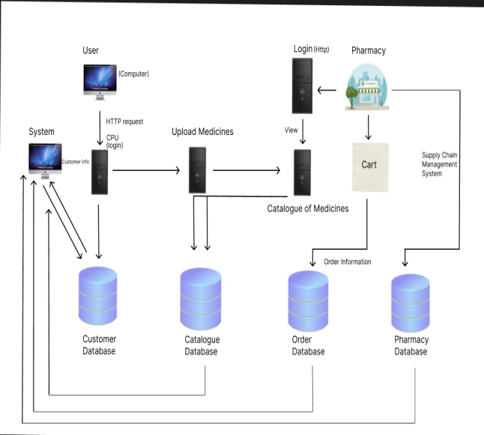

**Figure 4.1: System Architecture**

**4.2 Materials and Methods**

A review of current pharmaceutical waste management studies was undertaken to document how pharmaceuticals be reused and whether implementation of the CE philosophy and associated principles could help to reduce waste. The following keywords were used for the primary search: ‘Medicines’ AND ‘Pharmaceutical’ AND ‘Pharmaceutical Waste’ OR ‘Drugs’ OR ‘Pharmaceutical Return’ OR ‘Disposal’ OR ‘Hospitals’ OR ‘Pharmaceutical Supply Chain’ OR ‘Medicines Reuse’ OR ‘Circular Economy’ OR ‘Circular Economy Principles’.

First, the titles and abstracts of each article were screened, and the most significant articles were selected. Second, the related abstracts were chosen, and the full form of each selected article was retrieved. A few papers were eliminated after their selection, as described below. Journals and papers published in English were chosen. Articles, papers, and studies published before July 2020 were explored while using Elsevier, Google Scholar, MDPI, PubMed, SAGE, and Science Direct.

To be included in the review, articles/papers had to be related to pharmaceuticals, medicine reuse, waste management, and/or CE, and they had to present new and/or relevant information. Articles/papers on approaches to waste management improvement, legislation, the PSC, waste generation minimization, and CE application were also included. Excluded papers are not explicitly related to the keywords highlighted above.

The search was conducted while using electronic databases, avoiding manual exploration. Duplications were eliminated. Non-academic grey literature was also searched in Google utilizing similar keywords. These sources included journalistic articles, reports, and WebPages on pharmaceuticals waste and CE. A conventional quality examination was not utilized, as one of the goals of this study was to gather a broad base of proof, including all of the procedures and studies related to gathering in-depth literature data. Figure 4.2 shows the areas of the literature that were reviewed to meet the aim of this study.

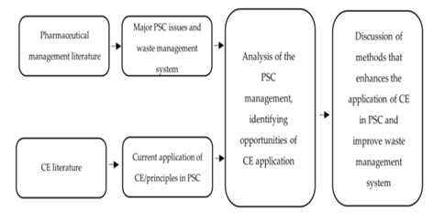

**Figure 4.2: System Architecture**

**4.3 Results**

**4.1. Pharmaceutical Waste Management**

The literature review identified three clearly defined areas of focus when examining pharmaceutical waste management. These are discussed individually below.

**4.1.1. Waste Creation**

Instances of pharmaceuticals waste may be caused by patients who are unable to utilize all of their administered pharmaceuticals due to unfavorable impacts (side effects), daily dosage modifications, health improvements, and the expiry of medicines, doctors’ prescribing practices, or dispensers’ practices. Non-adherence to prescriptions can also cause stockpiling of leftover medications in the home. According to the WHO, half of the patients neglect to take medication effectively [22]. As such, families and patients around the world are in possession of unused or terminated prescriptions, and the associated dangers have prompted research interest. Many individuals who stockpile undesirable, unused, or expired pharmaceuticals in their homes dispose of them through waste containers or sinks or by flushing them down the toilet. It is important to realize that discarding unused or terminated pharmaceuticals through non-permitted methods affects the environment and individual wellbeing [6,23].

Table 1 shows the different waste creation of pharmaceuticals.

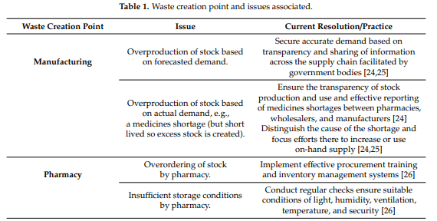

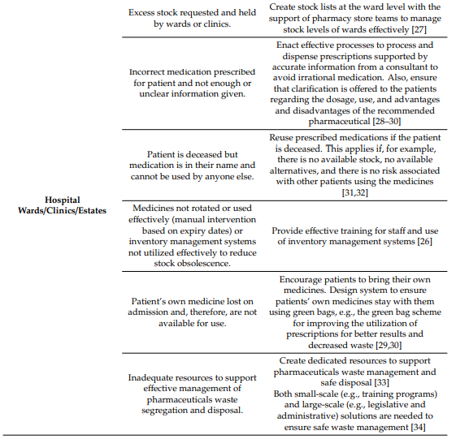

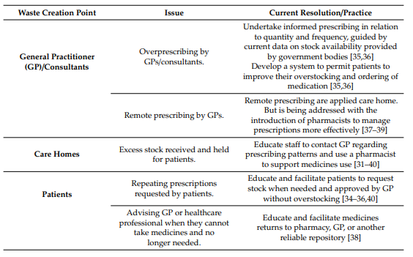

**4.4 Data Flow Diagrams (DFD)**

A Data Flow Diagram (DFD) is a graphical illustration of the "flow" of data through an information system, modeling its process aspects. A DFD shows what sort of information will be the input and what sort of output from the system will be obtained, from where the data will come and go to, and where it will be stored. It will not show any details about the timing of process or whether processes will function in series or in parallel.

The figure 4.3 shows data flow diagram for the proposed system. User has to login to the User Home Page by providing authorized user name and password. After user can add the information of medicine like brand, medicine name, manufacture date, expiry date and upload medicine packet and user can view the medicine information. All medicine data stored in database. User medicine information sent to admin. Admin has to login to the Admin panel. Admin can track information of medicine. Admin checks the expiry date of medicine if it is correct then reuse the medicine otherwise dispose the medicine. This data flow diagram provides a visual representation of how information flows within the reuse medicine system, from user requests to regulatory compliance checks and reporting. It's a simplified representation, and the actual system design may include additional details and refinements based on specific requirements.

**4.4.1 User Panel:**

User Login

User Home Page

User

User Registration

Add Medicine Information

Stored in Database

User view medicine information

Medicine Information

View Medicine Information

**Figure 4.4.1: Data Flow Diagram of the User Panel**

* + 1. **Admin Panel:**

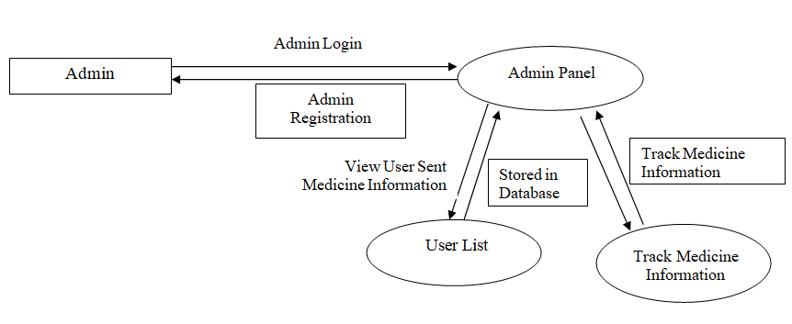

**Figure 4.4.2: Data Flow Diagram of the Admin Panel**

**4.5 Sequence Diagram**

A sequence diagram is a sort of association outline that shows how procedures work with each other and in what request. The sequence diagram gives the Logical View of the framework in progress.

* The user logs in, submits a remedy request, views the remedy status, and logs out.
* The administrator logs in, views pending remedy requests; approve a remedy request, and logs out.
* The system processes the remedy request, checks for approval or rejection, dispenses medication, and notifies both the user and administrator accordingly.

This is a simplified representation, and in a real-world scenario, additional steps and conditions may be necessary based on the specific requirements and functionalities of the reuse medicine system.

Admin Panel

Admin

System

User Panel

User

Login

System Send

Medicine Information

User List

Add Medicine Information

Login

Track Medicine Information

Add Medicine Information

System Send

User Information

View Medicine Information

System Reuse of Medicine

System Reuse of Medicine

Admin send valid medicine information

Medicine Information Valid

**Figure 4.5: Sequence Diagram of the proposed system**

## 4.6 Flow Charts

A flow chart is a graphical representation of a procedure. The following flow charts explain about the flow of proposed system functionalities.

### 4.6.1 Flow chart for user

The figure 4.6.1 describes the work flow of user module. User enters valid user name and password for successful login to User Panel.

1. The process starts with the user logging in and submitting a remedy request.
2. The system processes the remedy request and evaluates whether it is approved.
3. If the request is approved, the system dispenses the medication and notifies the user.
4. If the request is rejected, the system notifies the user of the rejection.
5. The administrator can log in, view pending requests, and approve a remedy request.
6. If the administrator approves the request, the system processes the approval, dispenses the medication, and notifies both the user and the administrator.
7. The process ends for both the user and the administrator.

Start

User

No

Registered?

Sign Up

Yes

Sign In

User Panel

View Medicine History

Add Medicine Information

Log Out

Send Medicine Information to Admin

**Figure 4.6.1: Flow Chart for User Panel**

### 4.6.2 Flow chart for Admin

This flowchart outlines the following steps:

1. The process starts with the administrator logging in and viewing the dashboard.
2. The administrator checks if there are any pending requests.
3. If there are pending requests, the administrator views and processes them.
4. The administrator then checks if there are any reports to generate.
5. If there are reports to generate, the administrator generates and views the reports.
6. The process ends for the administrator.

Start

Admin

No

Registered?

Sign Up

Yes

Sign In

Admin Panel

Track Medicine Information

User List

Log Out

**Figure 4.6.2: Flow Chart for Admin Panel**

## 4.7 ER Diagram

## Entity relationship modeling is a high-level data modeling technique that helps designers create accurate and useful conceptual models. ER models are best expressed using graphical ER diagrams. ER diagrams provide a visual, graphical model of the information content of a system. An entity relationship (ER) data model is a high-level conceptual model that describes data as entities, attributes, and relationships.

ER diagram for proposed system as shown in the figure.4.7. Entities are user and admin. User contains the attributes like name, password, and email. Admin contains the attributes like name, password, and email.

In this ER diagram:

* The "User" entity represents individuals who log in and submit remedy requests.
* The "Remedy Request" entity represents the requests submitted by users for medication reuse.
* The "Medication" entity represents the medications associated with each remedy request.
* The "Administrator" entity represents individuals who log in to process and approve remedy requests.

The relationships between entities indicate how they are connected. For example, each user can have multiple remedy requests, each remedy request is associated with one medication, and each administrator can process multiple remedy requests.

**4.7.1 ER-Diagram of User Panel**

User_Id

Name

N

1

N

User Panel

Entries of Medicine

Password

User

N

1

N

N

Email_Id

Has

View Medicine History

Add Medicine Information

1

1

Logout

Login Views Account Details

**Figure 4.6.1: ER Diagram Showing Relationships in User Panel**

**4.7.2 ER-Diagram of User Panel**

Admin_Id

Name

N

1

Admin Panel

Track of Medicine

Password

Admin

N

N

N

N

Email_Id

Has

User List

Track medicine information

1

1

Logout

Login Views Account Details

N

Valid?

**Figure 4.6.2: ER Diagram Showing Relationships in Admin Panel**

Reuse medicine

## 4.7 Modules

## Proposed system is divided into following sub modules. These sub modules will describe step by step work flow of the proposed system. The reuse of medicine system typically involves different modules to cater to the needs of both users (patients) and administrators. Here's a breakdown of potential modules for both user and admin perspectives Sub modules are:

### User Modules:

1. **User Registration:**
   * Allow users to create accounts with necessary details.
   * Capture user information such as name, contact details, and medical history.
2. **User Authentication:**
   * Implement secure login mechanisms for user authentication.
   * Include password protection and potentially multi-factor authentication.
3. **Remedy Request Submission:**
   * Enable users to submit requests for medicine remedy.
   * Collect information on the reason for the remedy request and any supporting details.
4. **Remedy Status Tracking:**
   * Provide a dashboard or interface for users to track the status of their remedy requests.
   * Display information about approved or rejected requests.
5. **Medication Information:**
   * Allow users to access information about available medications.
   * Include details such as dosage, expiration dates, and storage conditions.
6. **Notification System:**
   * Implement a notification system to alert users about the status of their remedy requests.
   * Send reminders about medication pickup or any updates on their requests.

### Admin Modules:

1. **Admin Dashboard:**
   * Provide a centralized dashboard for administrators to monitor and manage system activities.
   * Display key metrics, pending requests, and system alerts.
2. **Remedy Request Management:**
   * Enable administrators to view and process pending remedy requests.
   * Include features for approval, rejection, or additional review.
3. **User Management:**
   * Allow administrators to manage user accounts.
   * Perform actions such as user verification, account suspension, or updating user details.
4. **Medication Inventory Management:**
   * Provide tools for administrators to manage the inventory of available medications.
   * Include features for adding new medications, updating stock levels, and removing expired items.
5. **Reports and Analytics:**
   * Implement a reporting module for administrators to generate reports on system usage, trends, and performance.
   * Provide insights into the volume of remedy requests, popular medications, etc.
6. **Notification and Alert System:**
   * Implement a system to alert administrators about critical events, low medication stock, or system errors.
   * Ensure timely responses to issues within the system.
7. **User Support and Communication:**
   * Include a module for administrators to communicate with users.
   * Handle queries, provide assistance, and resolve issues raised by users.
8. **Audit Trail:**
   * Implement an audit trail system to log and track administrator activities.
   * Ensure accountability and compliance with regulations.

These modules collectively contribute to a comprehensive and effective reuse of medicine system, providing a seamless experience for both users and administrators while maintaining security and regulatory compliance.

## 4.8 Use Case Diagram

## Use case diagram is used to model dynamic nature of proposed system. Use case diagrams consist of actors, use cases and their relationships. The diagram is used to model the system or subsystem of an application. The actors can be human user, some internal applications or some external applications.

The figure 4.8 shows the use case diagram for proposed system. The user and Admin are the actors.

A Use Case Diagram is a visual representation of the interactions between different actors and the system. In the context of the reuse of medicine system, here's an explanation of the use cases for both users (patients) and administrators:

### User (Patient) Use Case Diagram:

1. **Log In:**
   * The user initiates the process by logging into the system, providing authentication credentials.
2. **Submit Remedy Request:**
   * After logging in, the user can submit a remedy request by providing necessary details, including the reason for the request and any supporting information.
3. **View Remedy Status:**
   * Users can check the status of their submitted remedy requests to see if they have been approved, rejected, or are still pending.
4. **Log Out:**
   * Users can log out of the system when their session is complete.

### Administrator Use Case Diagram:

1. **Log In:**
   * Administrators log into the system using their credentials to access administrative functionalities.
2. **View Pending Requests:**
   * Administrators can view a list of pending remedy requests, allowing them to review and process each request.
3. **Process Remedy Request:**
   * After reviewing a remedy request, administrators can take actions such as approving or rejecting the request.
4. **Generate Reports:**
   * Administrators have the capability to generate reports on various aspects of the system, such as request statistics, inventory status, etc.
5. **Log Out:**
   * Administrators can log out of the system when their administrative tasks are complete.

### Associations and Relationships:

* **User to Use Cases:**
  + The "Log In" use case is associated with "Submit Remedy Request" and "View Remedy Status" since these actions typically occur after the user logs in.
* **Administrator to Use Cases:**
  + "View Pending Requests" is associated with "Process Remedy Request" as administrators need to view requests before processing them.
  + "Generate Reports" may be performed after the administrator logs in.

### Include and Extend Relationships:

* **Include Relationship (User):**
  + "Submit Remedy Request" includes "View Remedy Status" since users may want to view the status of their requests after submission.
* **Extend Relationship (Administrator):**
  + "Generate Reports" extends "Log In" as it is an additional action that administrators can take after logging in.

In a visual representation of this diagram, actors (User and Administrator) are represented as stick figures, and use cases are represented as ovals. Arrows indicate associations between actors and use cases, and you may use additional symbols to represent include and extend relationships.

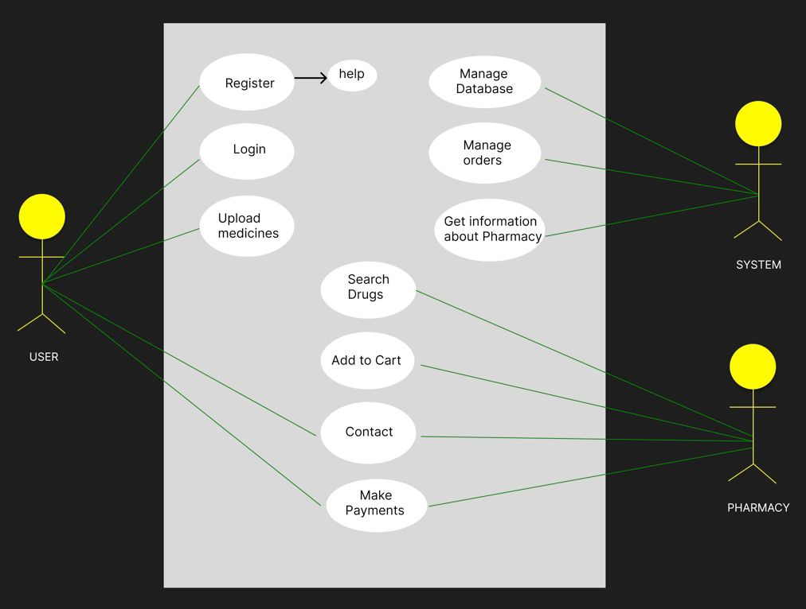

**Figure 4.8: Use Case Diagram for Proposed System**

**CHAPTER 5**

# IMPLEMENTATION

**Introduction**

Implementation is the phase where the theoretical design is turned out into a working system. Thus, it is considered as the most critical stage in building a successful system and providing the user a confidence that the system will work correctly and be effective. The implementation of the proposed system uses different tools and technologies and various methodologies as explained in the following sections.

## Development Platform and Tools Used

The Integrated Development Environment, programming language and technologies etc. used for developing proposed system are explained as follows.

#### Eclipse

Since eclipse supports installation of many plugins and it helps in managing database functions for which java codes are used.

#### Java

Java language is used in the development of the proposed system. Since Java is an Object Oriented Programming Language, developing OOPS application is much easier, and it also helps to keep system modular and extensible. Java is platform independent and it allows the user to write once and run it anywhere. It also provides supporting APIs for different applications.

* **J2EE**

Java 2 Platform, Enterprise Edition (J2EE) is a set of specifications, APIs (Application Programming Interfaces), and protocols that extend the Java SE (Standard Edition) platform to provide a robust and scalable platform for developing enterprise-level applications. J2EE, now referred to as Java EE (Enterprise Edition), is designed to simplify the development and deployment of large-scale, distributed, and multi-tiered enterprise applications. J2EE Components are JSP, CSS and Servlets.

* **MySQL Workbench**

MySQL Workbench is a visual database design and modeling tool provided by MySQL. It allows developers and database administrators to design, manage, and document MySQL database systems. MySQL Workbench provides a graphical user interface (GUI) that simplifies database design, modeling, SQL development, and administration tasks.

Managing medicine details, including brand name, generic name, manufacture date, expiry date, quantity, and the ability to upload medicine packet information. To manage such information, you can design a database schema and implement a system to store and retrieve these details. Here's an example of a simplified database schema:

### 5.1 Database Schema:

1. **Medicine Table:**
   * **MedicineID** (Primary Key)
   * **BrandName**
   * **GenericName**
   * **ManufactureDate**
   * **ExpiryDate**
   * **Quantity**
2. **Packet Information Table:**
   * **PacketID** (Primary Key)
   * **MedicineID** (Foreign Key referencing Medicine Table)
   * **UploadDate**
   * **PacketFile** (Reference/link to the uploaded packet information file)

### Fields Explanation:

* **Medicine Table:**
  + **MedicineID**: Unique identifier for each medicine.
  + **BrandName**: Brand name of the medicine.
  + **GenericName**: Generic name of the medicine.
  + **ManufactureDate**: Date when the medicine was manufactured.
  + **ExpiryDate**: Date when the medicine expires.
  + **Quantity**: Quantity of the medicine in stock.
* **Packet Information Table:**
  + **PacketID**: Unique identifier for each packet of medicine information.
  + **MedicineID**: Foreign key linking to the corresponding medicine in the Medicine Table.
  + **UploadDate**: Date when the packet information was uploaded.
  + **PacketFile**: Reference or link to the uploaded packet information file. This could be a file path, URL, or binary data.

### Implementation:

1. **User Interface (UI):**
   * Develop a user interface for users to input and view medicine details.
   * Include forms for adding new medicines and uploading packet information.
2. **Database Interaction:**
   * Implement database interactions to insert, update, and retrieve medicine details.
   * Use SQL queries or an Object-Relational Mapping (ORM) framework for data manipulation.
3. **File Upload Handling:**
   * Implement a mechanism to handle file uploads for packet information.
   * Store the uploaded files in a secure and accessible location.
4. **User Authentication and Authorization:**
   * Implement user authentication to secure the system.
   * Apply authorization mechanisms to control access based on user roles.
5. **Reporting and Analytics (Optional):**
   * Consider adding reporting and analytics features to track medicine usage, stock levels, and other relevant metrics.
6. **Error Handling and Validation:**
   * Implement error handling and validation to ensure data integrity and prevent issues.

**5.1 Results**

**5.1.1. Pharmaceutical Waste Management**

The literature review identified three clearly defined areas of focus when examining pharmaceutical waste management. These are discussed individually below.

**5.1.2. Waste Creation**

Instances of pharmaceuticals waste may be caused by patients who are unable to utilize all of their administered pharmaceuticals due to unfavorable impacts (side effects), daily dosage modifications, health improvements, and the expiry of medicines, doctors’ prescribing practices, or dispensers’ practices. Non-adherence to prescriptions can also cause stockpiling of leftover medications in the home. According to the WHO, half of the patients neglect to take medication effectively [26]. As such, families and patients around the world are in possession of unused or terminated prescriptions, and the associated dangers have prompted research interest. Many individuals who stockpile undesirable, unused, or expired pharmaceuticals in their homes dispose of them through waste containers or sinks or by flushing them down the toilet. It is important to realize that discarding unused or terminated pharmaceuticals through non-permitted methods affects the environment and individual wellbeing [6,27].

**User Remedy for Medicine Algorithm:**

Creating an algorithm for user reuse of medicine involves developing a system that considers various factors to suggest or guide users in repurposing existing medications. Here's a basic outline of such an algorithm:

1. **User Input:**
   * Gather information about the user, including medical history, current medications, and any existing health conditions.
2. **Disease or Condition Identification:**
   * Identify the specific disease or condition for which the user is seeking medication reuse.
3. **Drug Repurposing Database Search:**
   * Utilize a drug repurposing database or knowledge base that contains information on existing drugs and their potential uses for different conditions.
   * Implement algorithms to match the user's condition with potential repurposed medications.
4. **Risk Assessment:**
   * Evaluate the safety and potential risks of repurposing a particular medication for the identified condition.
   * Consider known side effects, contraindications, and the user's individual health profile.
5. **Effectiveness Assessment:**
   * Assess the efficacy of the repurposed medication for the user's specific condition.
   * Consider available clinical evidence, studies, and real-world data.
6. **Dosage Adjustment:**
   * Calculate and recommend appropriate dosage adjustments based on the repurposed use of the medication.
7. **Interaction Analysis:**
   * Evaluate potential drug interactions with the user's existing medications.
   * Consider the overall impact on the user's health and well-being.
8. **Monitoring Plan:**
   * Develop a monitoring plan for the user, including recommended follow-up visits, laboratory tests, or other assessments to track the effectiveness and safety of the repurposed medication.
9. **Educational Resources:**
   * Provide educational resources to the user, explaining the rationale behind the repurposing recommendation, potential benefits, and risks.
   * Ensure the user is informed and understands the decision-making process.
10. **Feedback and Iteration:**
    * Allow users to provide feedback on their experience with the repurposed medication.
    * Implement mechanisms to continuously improve the algorithm based on user feedback and emerging clinical evidence.
11. **Privacy and Security Measures:**
    * Implement robust privacy and security measures to protect the user's health information.
12. **Integration with Healthcare Providers:**
    * Facilitate communication and information exchange with healthcare providers, ensuring that the user's decision to repurpose medication is coordinated with their overall healthcare plan.

**Admin Remedy for Medicine Algorithm:**

Creating an algorithm for administering remedies or medications involves considering various factors related to patient health, medical history, and specific treatment requirements. Here's a generalized outline for an algorithm that an administrator or healthcare provider might follow:

1. **Patient Assessment:**
   * Gather patient information, including medical history, current medications, allergies, and any existing health conditions.
   * Consider the patient's age, weight, and other relevant demographic factors.
2. **Diagnosis or Condition Identification:**
   * Identify the specific diagnosis or health condition for which the remedy or medication is needed.
3. **Clinical Guidelines and Protocols:**
   * Refer to established clinical guidelines and protocols for the treatment of the identified condition.
   * Ensure adherence to evidence-based medicine and best practices.
4. **Medication Selection:**
   * Choose the appropriate medication based on the diagnosis, considering factors such as efficacy, safety, and patient-specific characteristics.
   * Consider potential drug interactions and contraindications.
5. **Dosage Calculation:**
   * Calculate the correct dosage based on the patient's weight, age, renal function, and other relevant factors.
   * Consider any adjustments needed for special populations (e.g., pediatric or geriatric patients).
6. **Administration Route:**
   * Determine the most suitable route of administration (oral, intravenous, intramuscular, etc.) based on the medication and patient's condition.
7. **Patient Monitoring:**
   * Establish a monitoring plan to track the patient's response to the medication.
   * Define parameters for assessing effectiveness and potential side effects.
8. **Documentation:**
   * Ensure accurate and comprehensive documentation of the prescribed remedy, including dosage, administration route, and any specific instructions.
   * Record patient responses and any observed adverse effects.
9. **Communication with Patient:**
   * Communicate with the patient regarding the prescribed remedy, explaining the purpose, potential side effects, and any necessary precautions.
   * Confirm the patient's understanding and address any concerns.
10. **Follow-Up:**
    * Schedule follow-up appointments to assess the patient's progress.
    * Adjust the treatment plan as needed based on ongoing evaluation.
11. **Collaboration with Healthcare Team:**
    * Coordinate with other healthcare team members, such as pharmacists and nurses, to ensure seamless administration and monitoring.
12. **Emergency Response Plan:**
    * Develop and communicate an emergency response plan in case of adverse reactions or unexpected events during or after administration.
13. **Adherence Monitoring:**
    * Implement measures to monitor and promote patient adherence to the prescribed remedy.
    * Provide support and education to address potential barriers to adherence.
14. **Continuous Learning and Improvement:**
    * Stay updated on new research, medications, and treatment modalities.
    * Use feedback and outcomes data to continuously improve prescribing practices.

## Pseudo code for Modules

### Registration for user and admin

The registration is used to authorize user and admin allow them to access User Panel, Admin Panel. The following pseudo code explains registration process.

**Pseudo code User Registration:**

Registration ( ) // register user

{

user_registration ( ) // Pseudo code for user registration

// user enters specified values in the form for registration.

{

user_name = check whether input user_name is unique

user_password = check whether input user_password is unique

user_number = check whether input phone_number is 10 digit number and unique

Address = check whether input address

user_email = check whether input user_email is of correct format

if ( all check results == true)

{

Connect to user_login_page ( )

if (any registration fails)

return to user_registration ( )

else

display registration complete message

end if

}

End if

}

**Pseudo code Admin Registration:**

Registration ( ) // register Admin

{

Admin_registration ( ) // Pseudo code for Admin registration

// admin enters specified values in the form for registration.

{

admin_name = check whether input admin_name is unique

admin_password = check whether input admin_password is unique

admin_number = check whether input admin_number is 10 digit number and unique

Address = check whether input address

admin_email = check whether input admin_email is of correct format

if ( all check results == true)

{

Connect to admin_login_page ( )

if (any registration fails)

return to admin_registration ( )

else

display registration complete message

end if

}

End if

}

## Login for user and Admin

The following pseudo code segment explains the login of user and admin.

Login ( )

{

User_login page ( ) // Pseudo code for user login

// the user name and password entered by the cloud user is verified and the authorized user will be allowed to access the system.

{

user_name = check whether input user_name is unique

user_password = check whether input user_password is unique if( all check results == true)

{

Connect to user ( ) // connect to the user page.

if (any login fails)

return to user_login page ( ) else

display registration complete message end if

}

end if

}

Login ( )

{

Admin_login page ( ) // Pseudo code for admin login

// the admin name and password entered by the admin is verified and the authorized admin will be allowed to access the system.

{

admin_name = check whether input admin_name is unique

admin_password = check whether input admin_password is unique

if( all check results == true)

{

Connect to admin ( ) // connect to the admin page.

if (any login fails)

return to admin_login page ( ) else

display registration complete message end if

}

end if

}

}

### User Module

The user module of a reuse of medicine system involves functionalities and features that cater to the needs of individuals who are seeking remedies or medications. Here's an outline of potential features within the user module:

### 1. ****User Registration:****

* Allow new users to create accounts by providing necessary information.
* Capture details such as name, contact information, and any essential medical history.

### 2. ****User Authentication:****

* Implement a secure login system to authenticate users.
* Include password protection and potentially multi-factor authentication for added security.

### 3. ****Remedy Request Submission:****

* Provide a form or interface for users to submit remedy requests.
* Include fields for the reason for the request, specific medication needed, dosage, and any supporting information.

### 4. ****Remedy Status Tracking:****

* Enable users to track the status of their submitted remedy requests.
* Display information about whether the request is approved, rejected, or still pending.

### 5. ****Medication Information:****

* Allow users to access information about available medications.
* Include details such as brand name, generic name, dosage, manufacture date, expiry date, and any relevant instructions.

### 6. ****Notification System:****

* Implement a notification system to alert users about the status of their remedy requests.
* Send reminders for medication pickup or provide updates on the processing status.

### 7. ****User Profile Management:****

* Allow users to manage their profiles, including updating personal information and preferences.
* Provide an option to reset passwords if needed.

### 8. ****Medication History:****

* Maintain a record of the user's medication history.
* Display a list of previously requested and dispensed medications.

### 9. ****Communication Channel:****

* Implement a communication channel for users to ask questions or seek clarifications.
* Provide a support system for user assistance.

### 10. ****Feedback and Ratings:****

* Include a feedback system to gather user opinions on the system's functionality and service quality.
* Allow users to rate their experience and provide comments.

### 11. ****Privacy and Security Measures:****

* Ensure that user data, especially medical information, is handled securely and in compliance with privacy regulations.
* Implement measures to protect user confidentiality.

### 12. ****Logout Functionality:****

* Provide users with a secure logout option to end their session.

### 13. ****Educational Resources:****

* Include educational resources or links to provide users with information about medications, usage, and potential side effects.

### 14. ****Language and Accessibility Options:****

* Offer language preferences and accessibility features to cater to a diverse user base.

### 15. ****Mobile Responsiveness:****

* Ensure the system is responsive and accessible on various devices, including mobile phones and tablets.

This user module aims to create a user-friendly and efficient experience for individuals seeking remedies, emphasizing accessibility, security, and clear communication throughout the process. Regular user feedback and iterative improvements contribute to the module's ongoing enhancement.

**Pseudo code User Panel:**

Below is a simple pseudo code representation for a user panel that includes functionalities for adding medicine information and viewing the history of requested medicines. The pseudo code assumes a basic understanding of programming concepts and is a high-level representation. Please adapt and implement according to your specific programming language and system architecture.

// Pseudocode for User Panel

// Function to Add Medicine Information

function addMedicineInformation():

// Get user input for medicine details

brandName = getUserInput("Enter the brand name of the medicine")

genericName = getUserInput("Enter the generic name of the medicine")

dosage = getUserInput("Enter the dosage of the medicine")

manufactureDate = getUserInput("Enter the manufacture date of the medicine")

expiryDate = getUserInput("Enter the expiry date of the medicine")

// Validate input and add medicine to the system

if isValidInput(brandName, genericName, dosage, manufactureDate, expiryDate):

medicineID = generateUniqueID() // Generate a unique ID for the medicine

addMedicineToDatabase(medicineID, brandName, genericName, dosage, manufactureDate, expiryDate)

displayMessage("Medicine information added successfully.")

else:

displayErrorMessage("Invalid input. Please check the provided information.")

// Function to View Medicine History

function viewMedicineHistory():

// Retrieve and display the user's medicine history

userID = getCurrentUserID() // Get the current user's ID from the session

medicineHistory = getMedicineHistory(userID)

// Check if there is any history to display

if isEmpty(medicineHistory):

displayMessage("No medicine history found.")

else:

displayMedicineHistory(medicineHistory)

// Sample Function to Display Medicine History

function displayMedicineHistory(history):

for each entry in history:

displayMessage("Medicine ID: " + entry.medicineID)

displayMessage("Brand Name: " + entry.brandName)

displayMessage("Generic Name: " + entry.genericName)

displayMessage("Dosage: " + entry.dosage)

displayMessage("Manufacture Date: " + entry.manufactureDate)

displayMessage("Expiry Date: " + entry.expiryDate)

displayMessage("Request Date: " + entry.requestDate)

displayNewLine()

// Sample Function to Add Medicine to Database

function addMedicineToDatabase(medicineID, brandName, genericName, dosage, manufactureDate, expiryDate):

// Connect to the database and execute SQL query to add medicine

// INSERT INTO MedicineTable (medicineID, brandName, genericName, dosage, manufactureDate, expiryDate) VALUES (medicineID, brandName, genericName, dosage, manufactureDate, expiryDate)

// Handle database connection, query execution, and error handling

// Sample Function to Get Medicine History from Database

function getMedicineHistory(userID):

// Connect to the database and execute SQL query to retrieve medicine history for the user

// SELECT * FROM UserMedicineHistoryTable WHERE userID = userID

// Handle database connection, query execution, and error handling

// Return the retrieved medicine history

// Sample Function to Validate Input

function isValidInput(brandName, genericName, dosage, manufactureDate, expiryDate):

// Implement validation logic based on your requirements

// For example, check if fields are not empty, validate date formats, etc.

// Return true if input is valid, otherwise return false

// Sample Function to Generate Unique ID

function generateUniqueID():

// Implement logic to generate a unique ID (e.g., using timestamps, random numbers, or a combination)

// Return the generated unique ID

// Sample Function to Display Message

function displayMessage(message):

// Implement logic to display messages to the user (e.g., console output, UI alert)

// Display the provided message

// Sample Function to Display Error Message

function displayErrorMessage(errorMessage):

// Implement logic to display error messages to the user

// Display the provided error message

// Sample Function to Check if a Collection is Empty

function isEmpty(collection):

// Implement logic to check if a collection (e.g., array, list) is empty

// Return true if empty, otherwise return false

**Admin Module:**

The admin module of a reuse of medicine system is responsible for managing and overseeing the overall functionality of the system. It includes features and functionalities that enable administrators to handle remedy requests, manage medication inventory, generate reports, and maintain the system's integrity. Here's an outline of potential features within the admin module:

### 1. ****Admin Authentication:****

* Implement a secure login system for administrators.
* Include password protection and potentially multi-factor authentication for enhanced security.

### 2. ****View Pending Requests:****

* Display a list of pending remedy requests for administrators to review.
* Include relevant details such as user information, requested medication, and request date.

### 3. ****Process Remedy Request:****

* Allow administrators to approve or reject remedy requests.
* Include options to provide feedback or additional instructions to users.

### 4. ****Generate Reports:****

* Implement a reporting system for administrators to generate various reports.
* Reports may include remedy request statistics, medication usage, and inventory status.

### 5. ****User Management:****

* Enable administrators to manage user accounts.
* Perform actions such as user verification, account suspension, or updating user details.

### 6. ****Medication Inventory Management:****

* Provide tools for administrators to manage the inventory of available medications.
* Include features for adding new medications, updating stock levels, and removing expired items.

### 7. ****View Medication History:****

* Allow administrators to view the history of dispensed medications.
* Include details such as user information, medication details, and dispensing date.

### 8. ****Communication with Users:****

* Implement a communication system for administrators to interact with users.
* Address queries, provide assistance, and send notifications regarding remedy requests.

### 9. ****Audit Trail:****

* Create an audit trail to log and track administrator activities.
* Include details such as login/logout times, actions taken, and any modifications made to the system.

### 10. ****System Alerts:****

* Implement an alert system to notify administrators about critical events.
* Alerts may include low medication stock, system errors, or pending remedy requests.

### 11. ****Data Backup and Restore:****

* Implement tools for administrators to perform data backups and restores.
* Ensure data integrity and the ability to recover from unexpected incidents.

### 12. ****Access Control and Authorization:****

* Implement access control mechanisms to restrict certain functionalities based on administrator roles.
* Ensure that administrators have appropriate permissions for their tasks.

### 13. ****System Configuration:****

* Provide options for administrators to configure system settings.
* Allow customization of parameters such as notification preferences and report formats.

### 14. ****User Support and Training:****

* Include resources for user support and training within the admin module.
* Provide documentation and tutorials for administrators.

### 15. ****Time and Cost Savings:****

* The admin module should contribute to time and cost savings through streamlined processes and efficient tools.

This admin module aims to provide administrators with the necessary tools and functionalities to manage the reuse of medicine system effectively. Regular assessments, user feedback, and ongoing improvements are essential for the continued success and optimization of the admin module.

**Pseudo code Admin Panel:**

Below is a simple pseudo code representation for an admin panel that includes functionalities for viewing the user list and tracking medicine information. The pseudo code assumes a basic understanding of programming concepts and is a high-level representation. Please adapt and implement according to your specific programming language and system architecture.

// Pseudocode for Admin Panel

// Function to View User List

function viewUserList():

// Retrieve and display the list of users

userList = getUserList()

// Check if there are any users to display

if isEmpty(userList):

displayMessage("No users found.")

else:

displayUserList(userList)

// Function to Track Medicine Information

function trackMedicineInformation():

// Retrieve and display medicine information

medicineInformation = getMedicineInformation()

// Check if there is any medicine information to display

if isEmpty(medicineInformation):

displayMessage("No medicine information found.")

else:

displayMedicineInformation(medicineInformation)

// Sample Function to Display User List

function displayUserList(users):

for each user in users:

displayMessage("User ID: " + user.userID)

displayMessage("Name: " + user.name)

displayMessage("Contact Information: " + user.contactInformation)

displayNewLine()

// Sample Function to Display Medicine Information

function displayMedicineInformation(medicineInfo):

for each medicine in medicineInfo:

displayMessage("Medicine ID: " + medicine.medicineID)

displayMessage("Brand Name: " + medicine.brandName)

displayMessage("Generic Name: " + medicine.genericName)

displayMessage("Dosage: " + medicine.dosage)

displayMessage("Manufacture Date: " + medicine.manufactureDate)

displayMessage("Expiry Date: " + medicine.expiryDate)

displayMessage("Quantity: " + medicine.quantity)

displayNewLine()

// Sample Function to Get User List from Database

function getUserList():

// Connect to the database and execute SQL query to retrieve user list

// SELECT * FROM UserTable

// Handle database connection, query execution, and error handling

// Return the retrieved user list

// Sample Function to Get Medicine Information from Database

function getMedicineInformation():

// Connect to the database and execute SQL query to retrieve medicine information

// SELECT * FROM MedicineTable

// Handle database connection, query execution, and error handling

// Return the retrieved medicine information

// Sample Function to Display Message

function displayMessage(message):

// Implement logic to display messages to the admin (e.g., console output, UI alert)

// Display the provided message

// Sample Function to Check if a Collection is Empty

function isEmpty(collection):

// Implement logic to check if a collection (e.g., array, list) is empty

// Return true if empty, otherwise return false

**CHAPTER 6**

# SOFTWARE TESTING

**Introduction**

Testing performs a very critical role for quality assurance and for ensuring the reliability of the software. The aim of the testing is to find the maximum possible number of errors. To state simply, the aim of testing is to identify the maximum number of errors with a minimum of effort and realistic time period. Testing is the phase where errors from the previous phases are detected. It is time consuming and perhaps one of the most important Phases of Software Development [9].

Unit testing, integration testing and validation testing are used to verify the proper working of the proposed system. Unit testing is used to identify working of each unit and verify it. Integration testing is used to verify the proper working of combination of units. Finally, validation testing is used to verify proper working of entire system. The test cases and their results are explained in the following section.

## Goals of testing

To fulfill its definition, trying must finish the accompanying objectives:

* Find situations where the system does not do what should do.
* Find situations where the system does things it shouldn't do.

The principal objective alludes to particulars, which were not indicated by the project while the second objective alludes to the undesirable symptoms.

## Testing principles

Before applying routines to outline successful experiments, a product engineer must comprehend the essential rule that aides programming testing. Every one of the tests ought to be traceable to client prerequisites.

## Testing design

Any building item can be tried in one of two ways:

### White box Testing

This testing is likewise called as glass box testing. In this testing, by knowing the predefined capacity that an item has been intended to perform test can be led that exhibits every capacity is completely operation in the meantime hunting down lapses in every

capacity. It is an experiment outline technique that uses the control structure of the procedural configuration to determine experiments.

### Black box Testing

In this testing by knowing the inside operation of an item, tests can be directed to guarantee that "all riggings work", that is the inward operation performs as per determination and every single interior segment have been sufficiently worked out. It in a broad sense concentrates on the practical necessities of the product.

The strides included in discovery experiment outline are:

* + - * Graph based testing strategies
      * Equivalence dividing
      * Boundary esteem examination
      * Comparison testing

## Testing strategies

A product testing method gives a guide to the product designer. Testing is a situated of exercises that can be arranged in cutting edge and directed efficiently. Thus a layout for programming testing an arrangement of ventures into which we can put particular experiment plan systems ought to be characterized for programming designing procedure.

Any product testing procedure ought to have the accompanying attributes:

* Testing starts at the module level and works outward toward the incorporation of the whole PC based framework.
* Different testing strategies are proper at diverse focuses in time.
* The designer of the product and an autonomous test gathering behaviors testing.
* Testing and investigating are diverse exercises however troubleshooting must be suited in any testing method..

## Levels of Testing

Each and every module should be tested for correctness and completeness. The system is to be tested for functional requirements that were to be satisfied in order to satisfy the proper functioning of the system. Also the interactions of the modules with other modules are properly tested. Test cases are designed before starting to code and their outcome is found out manually. The mismatch of outcome of these test cases and the corresponding manual results, depict an error. For an error-free program, the developer or tester would like to determine all the test cases. It is very difficult to test with all possible test cases due to cost and effort needed to generate a test case, time consumed to execute the program. Hence, more number of errors has to be detected with minimum number of number of test cases.

### Unit Testing

The unit testing focuses on the smallest executable program units. In this project there are different modules. Those are considered as units. In the unit testing phase each unit is tested for its functional requirement individually. After testing of each unit, the units are integrated and integration testing will be carried out.

### Integration Testing

Integration testing is a systematic technique for constructing the program structure while conducting tests to uncover errors associated with interfacing. After this, the next layers of modules called dependent units that use the independent modules are tested. This sequence of testing layers of dependent units continues until the entire system is constructed. Integration testing is done thoroughly to ensure that everything is working fine. All required modules are integrated along with the test generation module and then it is integration tested to ensure proper interactions between the modules and proper working of the system.

### Validation Testing

At the culmination of integration testing, software is completely assembled as a package. Now the validation testing may begin. The validation of the software is said to be successful only when the software functions in a manner that can reasonably be expected by the customers. Software validation is achieved through a series of black box tests that would demonstrate conformity with the requirements. Each one of the modules were tested from the functionally point of view to check whether they provide the required functionality.

## Unit Testing of Main Modules

Here different modules are tested independently and their functionality is checked. The following tables show the details about the unit test cases and the results obtained.

**Table 6.1: Unit Test Case for Registration**

|  |  |
| --- | --- |
| **Test Case ID** | **Unit Test Case 1** |
| Title | Sign up |
| Test Case | Add user |
| Test Steps | 1. Open Registration page, enter name, user name, password, confirm password, email id 2. Click on Sign up button |
| Expected Result | User added. |
| Status | Successful |

**Table 6.2: Unit Test Case for Login**

|  |  |
| --- | --- |
| **Test Case ID** | **Unit Test Case 2** |
| Title | Login |
| Test Case | User login with proper credentials |
| Test Steps | Enter user name and password |
| Expected Results | Login success |
| Status | Successful |

**Table 6.3: Unit Test Case for User Panel**

|  |  |
| --- | --- |
| **Test Case ID** | **Unit Test Case 2** |
| Title | User Panel |
| Test Case | Add Medicine Information, View Medicine History |
| Test Steps | Click the Medicine information and view User Account Information. |
| Expected Results | Entry into Medicine information |
| Status | Successful |

**Table 6.4: Unit Test Case for Add Medicine Information**

|  |  |
| --- | --- |
| **Test Case ID** | **Unit Test Case 2** |
| Title | User Panel |
| Test Case | User can add the medicine information |
| Test Steps | User add the medicine information of medicine Brand name, generic name, manufacture date, expiry date , quantity and upload medicine packet updated. |
| Expected Results | Medicine information updated. |
| Status | Successful |

**Table 6.5: Unit Test Case for View Medicine History**

|  |  |
| --- | --- |
| **Test Case ID** | **Unit Test Case 2** |
| Title | User Panel |
| Test Case | User can View Medicine History |
| Test Steps | User can view medicine information of medicine Brand name, generic name, manufacture date, expiry date, quantity and upload medicine packet. |
| Expected Results | User can view the medicine history |
| Status | Successful |

**Table 6.5: Unit Test Case for Admin**

|  |  |
| --- | --- |
| **Test Case ID** | **Unit Test Case 2** |
| Title | Admin Panel |
| Test Case | Admin panel is having the User List, Track Medicine Information |
| Test Steps | User entry of User List |
| Expected Results | User entries the User List |
| Status | Successful |

**Table 6.5: Unit Test Case for User List**

|  |  |
| --- | --- |
| **Test Case ID** | **Unit Test Case 2** |
| Title | User List |
| Test Case | User List is having user sent medicine information |
| Test Steps | Admin entry of User List |
| Expected Results | Admin view the User List |
| Status | Successful |

**Table 6.6: Unit Test Case for Track Medicine Information**

|  |  |
| --- | --- |
| **Test Case ID** | **Unit Test Case 2** |
| Title | Track Medicine Information |
| Test Case | Admin can Track Medicine information |
| Test Steps | Admin track medicine expiry date if its valid date then reuses the medicine other disposes medicine. |
| Expected Results | Admin validate the medicine and reuse medicine. |
| Status | Successful |

**Table 6.7: Unit Test Case for Wrong Credentials**

|  |  |
| --- | --- |
| **Test Case ID** | **Unit Test Case 2** |
| Title | Track Medicine Information |
| Test Case | Validating the medicine information |
| Test Steps | Admin check if medicine is having expiry date or not. If it is expiry dispose otherwise reuse the medicine. |
| Expected Results | Admin reuse the medicine information |
| Status | Successful |

**CHAPTER 7**

# RESULTS AND DISCUSSION

## Introduction

A result is the final consequence of a sequence of actions or events expressed qualitatively or quantitatively.

## Results and Discussion

## The table below discuss about the complete dataset which is considered for the project.

**7.1. Pharmaceutical Waste Management**

The literature review identified three clearly defined areas of focus when examining pharmaceutical waste management. These are discussed individually below.

**7.1.1. Waste Creation**

Instances of pharmaceuticals waste may be caused by patients who are unable to utilize all of their administered pharmaceuticals due to unfavorable impacts (side effects), daily dosage modifications, health improvements, and the expiry of medicines, doctors’ prescribing practices, or dispensers’ practices. Non-adherence to prescriptions can also cause stockpiling of leftover medications in the home. According to the WHO, half of the patients neglect to take medication effectively [26]. As such, families and patients around the world are in possession of unused or terminated prescriptions, and the associated dangers have prompted research interest. Many individuals who stockpile undesirable, unused, or expired pharmaceuticals in their homes dispose of them through waste containers or sinks or by flushing them down the toilet. It is important to realize that discarding unused or terminated pharmaceuticals through non-permitted methods affects the environment and individual wellbeing [6,27].







Unused pharmaceuticals could be the result of changes in the recommended treatment. Such practices lead to the expiration of prescriptions, which are then put away or discarded by household members who flush them down toilets instead of returning them to pharmacies [39]. Analysis indicates that £300 million worth of prescription pharmaceuticals that are authorized by the UK National Health Services (NHS) are wasted every year [41]. Such wastage accounts for a significant percentage of pharmaceutical-related expenditures in the UK. For every £25 spent on pharmaceutical products, £1 is wasted. The £300 million includes £90 million worth of unused prescriptions in people’s homes at any one time. An estimated £110 million worth of prescriptions are returned to pharmacies every year. Approximately £50 million worth of unused pharmaceuticals from care homes are disposed of every year by NHS [41].

**7.1.2. Waste Management**

Current pharmaceutical waste management and disposal methods and related social, economic, and environmental burdens must be understood from different points of view [48]. The lack of awareness of proper waste management in hospitals, particularly those in developing countries, has made these institutions a focal point in the spread of disease and infection, rather minimizing and eliminating waste [48,49]. Research on hospitals in Kuwait found that pharmacists lacked knowledge about the consequences of sub-optimal/unsafe pharmaceutical disposal methods and often did not follow guidelines that were issued by the Ministry of Health [49]. A similar study [47] on Iraqi hospitals found that pharmacists needed programmers to improve their knowledge of appropriate disposal methods for pharmaceuticals waste. Inadequate training and a lack of awareness among hospital staff, such as nurses and pharmacists, contribute to the increase in pharmaceutical waste in many countries. Control and visibility are crucial in the reduction of losses due to expiry. When the inventory system is functioning at optimal levels, inventories could be redistributed within the system in order to enable a quick workflow.

**7.1.3. Waste Disposal**

Studies on household pharmaceuticals in Ethiopia [59], Kuwait [60], Poland [61], Saudi Arabia [62], Qatar [63], the UK [64], and the United States [65] concluded that most unused and expired pharmaceuticals are disposed of in the garbage, as there is no clear guidance for patients on the proper disposal of medications. The causes of medication wastage are different in each household. The death of a patient, changing from one medication to another, stopping treatment and lack of consistent use by patients all contribute to pharmaceutical waste [59–65]. Continued pharmaceutical waste over time significantly impacts the environment [8]. The Basel Convention recommends that all healthcare organisations follow waste treatment methods that reduce the release of chemicals or hazardous waste [66]. Likewise, the WHO recommends following waste treatment methods that help to reduce the release of chemicals while recognising the differences in local conditions and availability. To a large extent, poor disposal practices are often due to an absence of adequate training for clinical staff. Insufficient hospital funding also leads to improper waste disposal [60–62].

**Table 2 shows the advantages and disadvantages of different pharmaceuticals waste disposal methods**

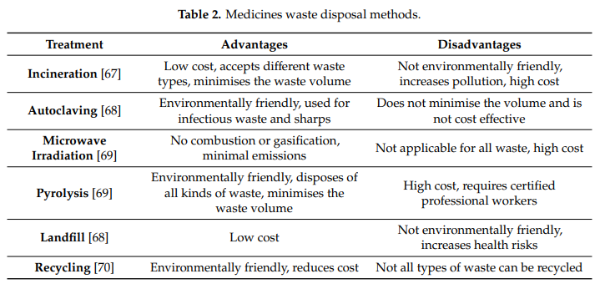

**7.1.4. Waste Reuse and Recycling**

Current methods of disposing of unused pharmaceuticals, including expired pharmaceuticals, have become a global issue. Take-back programmers for pharmaceuticals are eco-friendly and they have been implemented in many countries, as discussed by Alnahas et al. [48]. The objective of these programmers is to safely dispose of pharmaceuticals returned by patients who no longer need them. Many countries do not permit returned medications to be re-dispensed. For example, the UK requires disposal, even if the medications are in good condition and have not been used. However, a study of pharmaceutical reuse in the UK concluded that, based on the findings of the interviews data, reusing unused medicines would reduce NHS spending and lower manufacturing costs [46].

**7.1.5. Obstacles to the Safety and Quality of Returned Pharmaceuticals**

Regulatory agencies must have strict quality control and safety monitoring measures in order to affirm the appropriateness of medications for reuse. Such procedures include monitoring by specialists to confirm the capacity and limit any risk of damage, contamination, or infection. Moreover, the proper reuse and recycling of medications can reduce the environmental impacts of improper or illegal disposal of pharmaceuticals and reduce the associated carbon footprint. Table 3 identifies some barriers to the safety and quality of returned medications, which may affect redistribution. The safe disposal of medicines determines the standards of quality in the PSC. Health and safety are essential factors to consider in the PSC in order to protect consumers from infections, complications, and side effects from medications, as well as death due to improper medication usage.

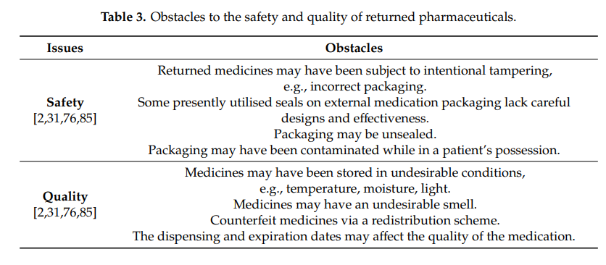

The decision to reuse returned pharmaceuticals depends on a safety confirmation process, whereby devoted analyzers at pharmacies can process unopened, intact, and authentic pharmaceuticals. Using technology and engaging arranged networks in smart pharmaceutical packaging will help to determine whether returned, unused, and unexpired medications are safe for reuse [57].

**7.2. Circular Economy and the Management of Pharmaceutical Waste**

When considering the application of CE principles to the PSC, the best methods for reducing pharmaceutical waste include reducing, reusing, and recycling disposable instruments and materials. CE offers several advantages to healthcare services, including cost savings, high quality of life, and continual service improvement [93]. Pachauri et al. [94] found that the CE promotes the use of sustainable products by replacing nonbiodegradable raw materials. The entire operational process is interlinked to accomplish sustainability, as the waste and products of one phase become the raw materials for other products or procedures.

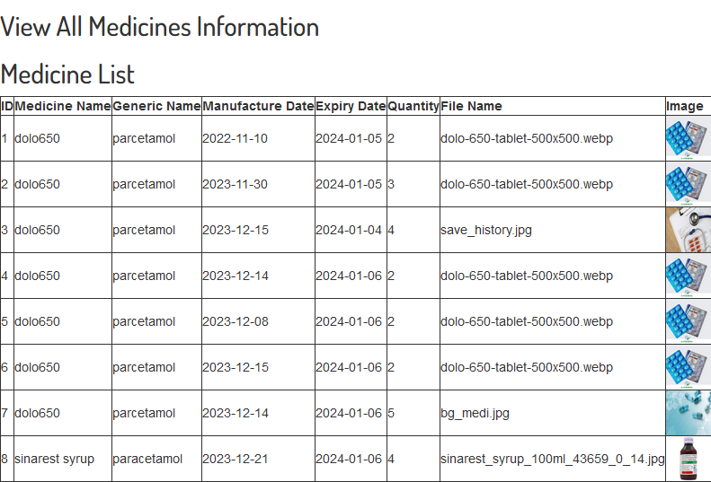

**Table 4. Result of Medicine information**

The results of a reuse of medicine system for both users and administrators can be diverse, covering various aspects such as improved patient outcomes, efficient medication management, user satisfaction, and streamlined administrative processes. Here are some potential results for both users and administrators:

### Results for Users:

1. **Improved Access to Medications:**
   * Users can quickly submit remedy requests and access necessary medications, leading to improved and timely access to healthcare.
2. **Convenience and Efficiency:**
   * Users experience a more convenient process for obtaining medications, reducing the need for multiple visits to healthcare facilities.
3. **Transparent Remedy Status:**
   * Users can easily track the status of their remedy requests, providing transparency and peace of mind about the progress of their medication needs.
4. **Reduced Medication Waste:**
   * Efficient medication management reduces the likelihood of medication waste, ensuring that medications are utilized before expiration.
5. **Timely Notifications:**
   * Users receive timely notifications about the status of their remedy requests, ensuring they stay informed about the progress of their medication dispensing.

### Results for Administrators:

1. **Streamlined Remedy Request Processing:**
   * Administrators can efficiently process and manage remedy requests, reducing manual effort and improving overall workflow.
2. **Effective Inventory Management:**
   * Administrators have better control over medication inventory, enabling them to track usage, monitor stock levels, and optimize ordering.
3. **Accurate Reporting and Analytics:**
   * The system provides administrators with accurate and real-time reports on medication usage, trends, and other relevant metrics, facilitating data-driven decision-making.
4. **Enhanced User Support:**
   * Administrators can provide better support to users by having access to comprehensive information about remedy requests and user interactions.
5. **Improved Compliance and Audit Trail:**
   * The system ensures better compliance with regulations and policies, with an audit trail that tracks administrator activities and changes made to the system.
6. **Efficient Communication:**
   * Administrators can efficiently communicate with users, addressing queries, providing updates, and ensuring a smooth interaction.
7. **Enhanced Security Measures:**
   * The system incorporates robust security measures to protect sensitive user and medication data, ensuring compliance with privacy regulations.
8. **Time and Cost Savings:**
   * Automated processes and efficient workflows contribute to time and cost savings for administrators, allowing them to focus on critical tasks.

The ultimate success of the reuse of medicine system is measured by its ability to provide effective and efficient healthcare services, improve patient outcomes, and streamline administrative processes. Regular assessments, feedback from users and administrators, and continuous improvement efforts contribute to the ongoing success and optimization of the system.

## Snapshots

The “main page” of Remidi of medicine is as shown in the figure 7.3.1. The user and Admin can register through the “main page” of User and Admin. First User has to register to Login to the User Panel.

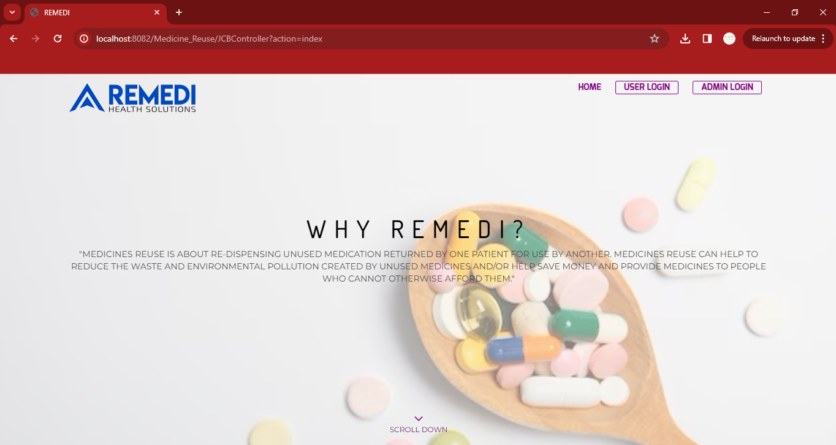

**Figure 7.3.1: Main page of ReMedi**

The User has to enter name, user name, Mail-id, Phone number, Password, Address, Location and pin code to register by click on the “Registration and continue” button.

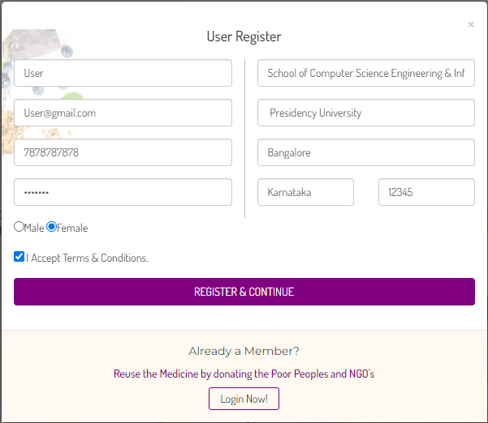

**Figure 7.3.2: User Register Page**

User after Registration Login with A login credential is a set of unique identifiers–such as a username and password–that enables a user to verify identity in order to log in to an online account.

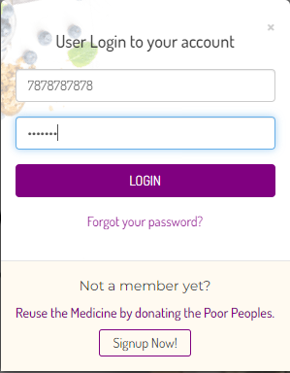

**Figure 7.3.3: User Login**

User enters into User Panel. User Panel has two services one is add medicine information and view medicine history.

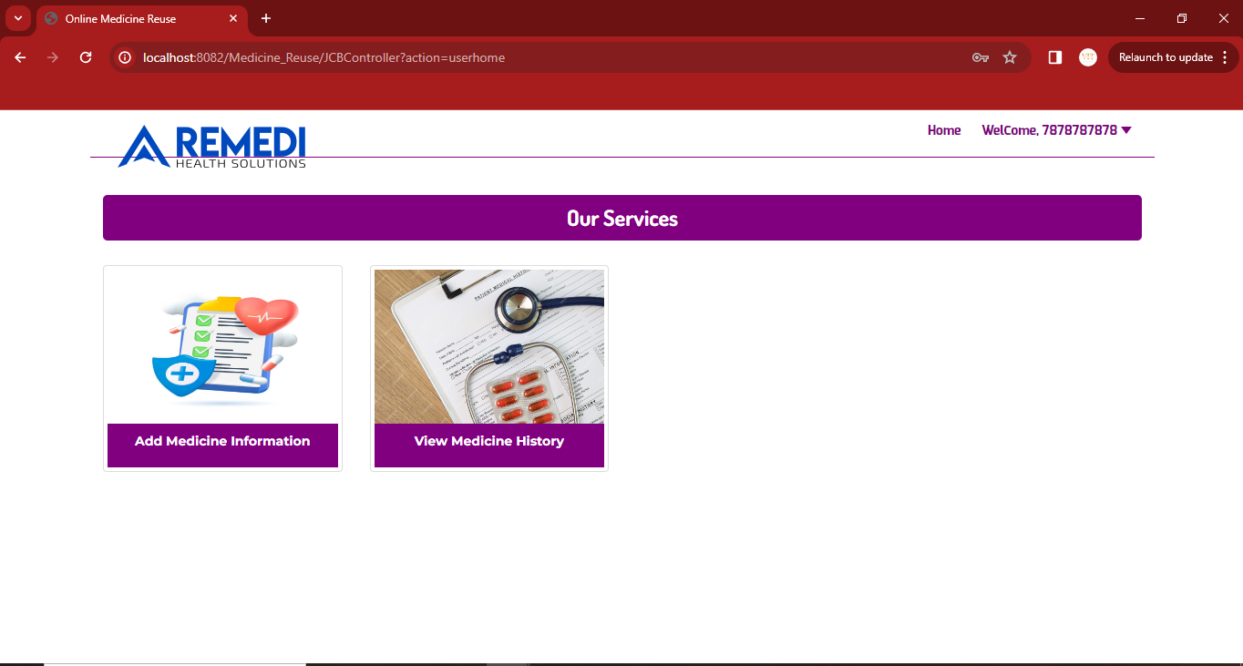

**Figure 7.3.4: User Panel**

User can view user Account details, user can change password, change address and change phone number.

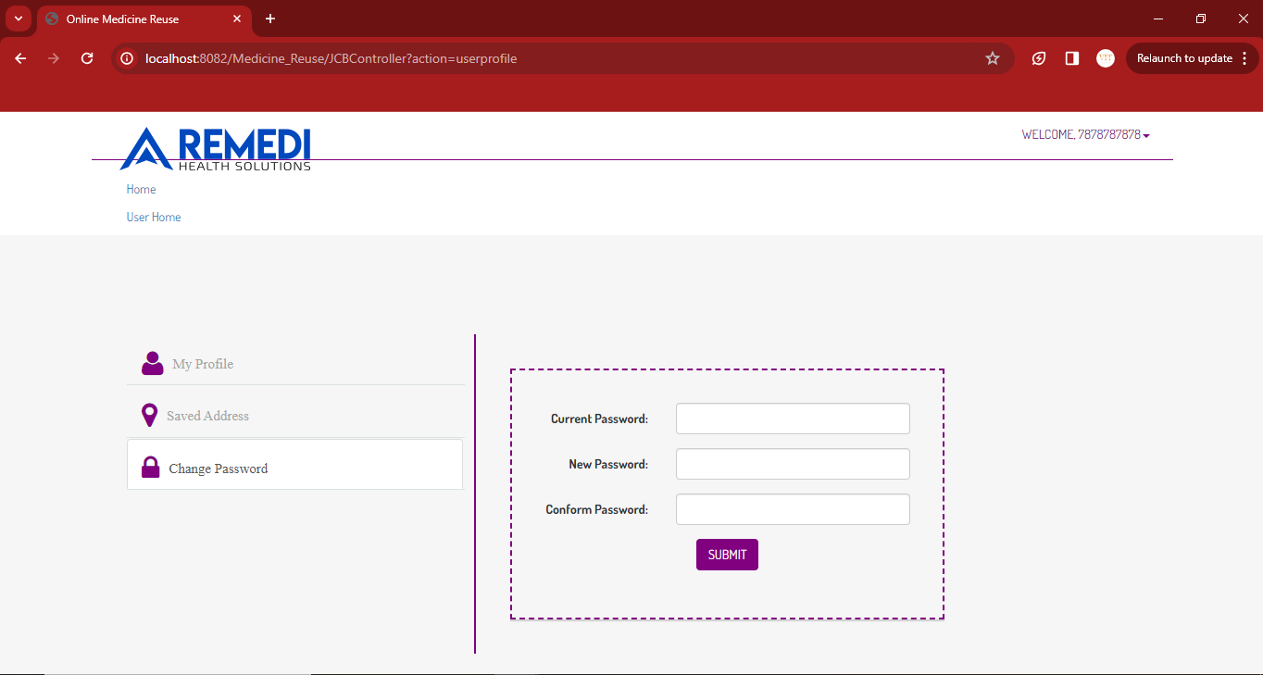

**Figure 7.3.4: User can Change Password**

User Click Button Add Medicine information. User add the medicine information of all medicine brand name, medicine generic name, Manufacture date, expiry date, Quantity and upload medicine packet upload all the information and save into the database. Medicine information sends to admin panel.

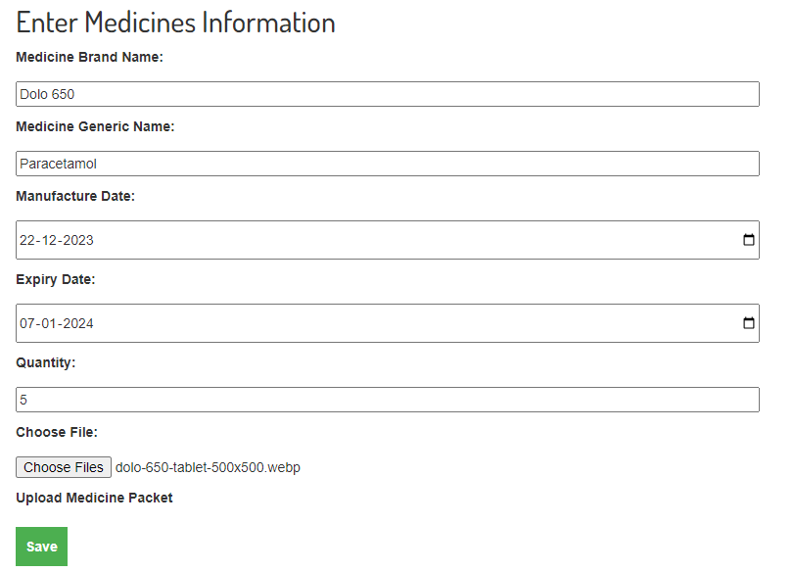

**Figure 7.3.5: User Panel Add Medicine Information**

User can view the medicine information of manufacture date, Expiry date, update used medicine packet is Updated.

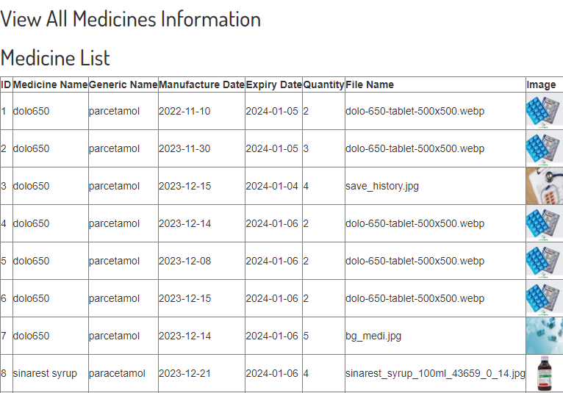

**Figure 7.3.6: User Panel View Medicine History**

**Admin Panel:**

The Admin has to enter name, admin name, Mail-id, Phone number, Password, Address, Location and pin code to register by click on the “Registration and continue” button.

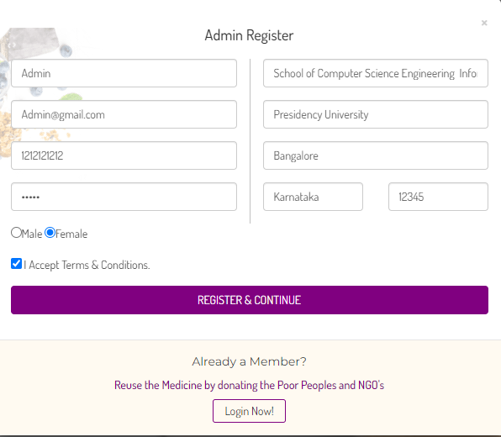

**Figure 7.3.7: Admin Register Page**

Admin after Registration Login with A login credential is a set of unique identifiers–such as an admin name and password–that enables a user to verify identity in order to log in to an online account.

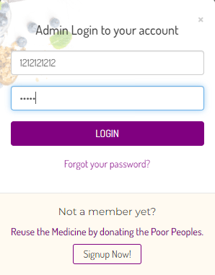

**Figure 7.3.8: User Login**

**CHAPTER 8**

**CONCLUSION**

In conclusion, developing and implementing a comprehensive remedy system for medicine, as illustrated in the ReMedi application, is crucial for enhancing healthcare experiences and outcomes. The systematic approach outlined in the algorithm and use-case diagram emphasizes user-centric design, efficiency, and safety considerations throughout the medicine lifecycle, from identification and prescription to administration and monitoring.

The algorithm for administering remedies incorporates best practices in patient assessment, medication selection, and monitoring, ensuring that healthcare providers make informed and personalized decisions. Collaboration with the broader healthcare team, clear communication with patients, and continuous learning are integral aspects of this process, contributing to a holistic and patient-centered approach to healthcare.

On the user side, the reuse of medicines, as discussed in the reuse algorithm, introduces a strategic approach to finding new therapeutic uses for existing drugs. Leveraging data mining, computational approaches and collaborative efforts can streamline the identification and validation of repurposed medications, potentially offering more accessible and cost-effective treatment options.

The ReMedi use-case diagram illustrates the user interactions with the application, emphasizing key functionalities such as searching for medicines, viewing details, and managing orders. The seamless integration of these features aims to provide a user-friendly and efficient platform for individuals seeking remedies, contributing to a positive and empowering healthcare experience.

In summary, a well-designed remedy system considers the complexities of medicine administration, repurposing, and user interactions. By incorporating evidence-based practices, embracing technological advancements, and fostering collaboration between healthcare providers and patients, such a system can contribute to improved healthcare outcomes, patient satisfaction, and overall efficiency in the delivery of medical remedies.