**Bachelor Thesis**

**Frameworkagnostic Design Systems**

**What restrictions do Web Components impose on an Angular & Tailwind Design System?**

Submitted in partial fulfilment of the requirements for the degree of:

Bachelor of Science in Computer Science

Supervisor: Fabian Gosebrink

If applicable: Co-supervisor: [First Name, last name]

Submitted by:

Remo Kessler

[Address]

Tel.: [telephone number]

E-Mail: [e-mail address]

Submission date: [xx.xx.xxxx]

**Table of Contents**

Abstract / Management Summary 2

1 Introduction 3

1.1 [Subtitle] 3

1.1.1 [Second order subtitle] 3

1.2 [Subtitle] 3

2 Theory 4

3 Method 5

4 Analysis / Results / Findings 6

5 Conclusion 7

References 8

List of Figures & Tables 9

Figures 9

Tables 9

Appendix 10

**Attention - these titles are only exemplary!**

**The declaration of academic integrity is not listed in the table of contents. It is always on the last page.**

# 

# Abstract / Management Summary

# Introduction

Your text, your text

## [Subtitle]

Your text, your text

### [Second order subtitle]

Your text, your text

## [Subtitle]

Your text, your text (Last name, year of publication, p. XY)

Please note our rules for correct citation, which are laid down in the guidelines for citing and referencing.

# Theory

## Tailwind

<https://jordanbrennan.hashnode.dev/8-ways-to-style-the-shadow-dom>

4 Ways to have external styles

1. Inherited Styles (e.g. css variables), watch out for all:initial
2. :root properties
3. ::part 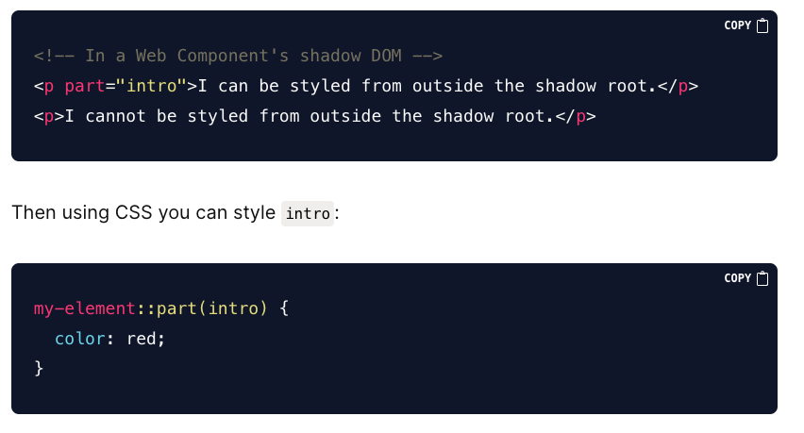
4. Global Stylesheet imports via @import

<https://medium.com/@yesmeno/css-resets-and-global-styles-in-web-components-c71fcea86dbd> Rollup Import

# Method

This chapter is necessary for empirical studies.

# Analysis / Results / Findings

# Conclusion

# References

Please note our rules for correct citation, which are laid down in the guidelines for citing and referencing.

# List of Figures & Tables

## Figures

## Tables

# Appendix

If necessary, Appendix with additional information and materials. If there are several appendices, these can be titled either with Appendix A, Appendix B etc. or with Appendix I, Appendix II etc. and each with a content description.

Declaration of Originality

I hereby declare that this assignment is my own work and that I have completed this work without the assistance of others. I have acknowledged all literature and sources used and have cited these in accordance with academic citation conventions. I have documented the use of AI tools transparently.

I have not previously submitted this assignment, or parts thereof, for credit on another course, unless this has been expressly agreed with the relevant instructor.

I am aware that this work may be checked for plagiarism and AI-generated text passages and works – including through the use of relevant software. I hereby specifically authorise Kalaidos University of Applied Sciences to perform such checks.

The work comprises the following number of characters: ________

*Character count: body of the text, excluding the title page, table of contents, preface, abstract/management summary, lists of figures, diagrams, tables, abbreviations and references, appendices and Declaration of Originality. Text fields, footnotes and endnotes need not be counted.*

____________________________ __________________________________

Place, date First name, Surname

__________________________________

Signature

*If the work was created as a piece of group work, this declaration must be submitted in we-form and specify the details of all authors in the section “Surname”, “First name” and “Date of birth”.*