Fine-Tuning Large Language Models for Bangladesh Labour Law: An HR-Oriented Legal QA System
Md. Rakibul Haque
Fabia Chowdhury
Nowshin Sayara Tamanna

Abstract
Human resource professionals in Bangladesh need reliable, citable answers to questions about the Bangladesh Labour Act 2006 (amended to 2018)[1]. General-purpose large language models lack reliable jurisdiction-specific knowledge and are known to hallucinate legal content[2, 3], while sending employee data to hosted APIs raises confidentiality concerns. We present an end-to-end, reproducible pipeline that converts the official PDF of the Act into a validated question-answering dataset, fine-tunes Llama 3.2 3B Instruct[17] with low-rank adaptation[14] using Unsloth[16], and deploys the result locally in GGUF (Q4_K_M) form via Ollama. To evaluate it we construct a leakage-free benchmark: a topic-stratified hold-out set carved out of the dataset before training, a set of hand-authored HR scenarios covering leave, overtime, termination, wages, maternity benefit, misconduct, probation and workplace safety, and a set of out-of-scope probes that the system should decline. Beyond BLEU[23] and ROUGE-L[24], which reward surface overlap rather than legal correctness, we report citation validity and citation F1 against gold sections, lexical grounding in the statute, and LLM-judged faithfulness, completeness, usefulness and harmfulness, together with an error analysis of the failure modes. We compare the fine-tuned model against the base model, retrieval-augmented generation over the Act, and their combination. The system is positioned as statute-grounded informational support for HR practice, not legal advice.

1. Introduction
Bangladesh's labour regime is governed principally by the Bangladesh Labour Act 2006, as amended to 2018[1]. HR practitioners consult it constantly - when calculating annual leave, deciding whether a termination follows the correct procedure, or determining maternity benefit entitlement - yet the Act is long, cross-referenced, and not written for quick lookup. General-purpose assistants answer such questions fluently but unreliably: studies of legal hallucination report high rates of fabricated authority in exactly this setting[2], and even purpose-built commercial legal research tools hallucinate materially[3]. A wrong but confident answer about a statutory notice period is worse than no answer, because it is actionable.
Two further constraints shape the problem. First, HR questions carry employee data, so routing them to a hosted API is often unacceptable on confidentiality grounds. Second, Bangladesh-specific labour law is poorly represented in general-purpose models, and the broader ecosystem of Bangla and Bangladesh-focused legal NLP resources remains thin[20, 21]. These push toward a small, locally deployable model specialised to a single statute.
This paper makes three contributions. (1) A reproducible pipeline from the Act's official PDF to a validated QA dataset, with the validation criteria and their pass rates reported rather than asserted. (2) A leakage-free evaluation benchmark for Bangladesh labour law consisting of a topic-stratified hold-out set, hand-authored HR scenarios with gold section labels, and out-of-scope probes - together with a metric suite appropriate to legal QA rather than to translation. (3) A comparison of domain fine-tuning against retrieval-augmented generation over the same statute and against their combination, with an error analysis that characterises how each configuration fails.
We are deliberately careful about what is claimed. The system provides statute-grounded informational support; it is not legal advice, and the evaluation measures agreement with the Act and with reference answers, not outcomes in practice.

2. Related Work
Domain-specific legal language models are well established. LEGAL-BERT[5] showed that in-domain pretraining helps legal tasks, and benchmarks such as LexGLUE[6], CUAD[7], JEC-QA[8] and LegalBench[4] have made legal capability measurable. More recently, instruction-tuned legal models have appeared for several jurisdictions: SaulLM-7B[9] for English-language law, ChatLaw[10], Lawyer LLaMA[11] and DISC-LawLLM[12] for Chinese law, and ALKAFI-LLaMA3[13] for Palestinian law. ALKAFI-LLaMA3 is the closest analogue to this work: a small model fine-tuned on a single jurisdiction's material for practical use under limited compute.
Work on Bangladesh is comparatively sparse. BanglaBERT[20] established general Bangla language understanding benchmarks, and recent studies have begun to examine AI legal assistance for Bangladesh[21] and the reliability of LLMs in the Bengali legal context using both LLM-as-judge and expert evaluation[22]. To our knowledge no prior work provides a leakage-free QA benchmark specific to the Bangladesh Labour Act together with a comparison of fine-tuning and retrieval over that statute.
Methodologically we rely on parameter-efficient fine-tuning - LoRA[14] and its quantized variant QLoRA[15] - which makes adapting a 3B model feasible on a single consumer GPU, and on self-instruct-style generation[18] to build QA pairs from source text. Because training data is generated from the statute, we also attend to the risk of verbatim memorisation[19], and evaluate on questions held out before training.

3. Methodology

3.1 Dataset creation and validation
The dataset is built from the official English text of the Bangladesh Labour Act 2006 as amended to 2018[1]. The Act is extracted from PDF, segmented, and used to generate question-answer pairs in ChatML form, which are then extended with paraphrases and applied scenarios and filtered for duplicates and degenerate items.
Validation is the step that determines whether the dataset can support any claim at all, so it is reported explicitly. Each generated answer is checked back against the source text: section numbers mentioned in an answer must exist in the Act, and answer content must be lexically supported by the Act's text. Items failing these checks are corrected or discarded; the pipeline reports a 99.7% verification rate against the source document for the retained set. Duplicate and near-duplicate questions are removed so that the hold-out set cannot be answered by memorising a paraphrase of a training item.
Because the model must also know the boundary of its competence, the training mix includes explicit refusal examples in which a question outside the Act is declined. Their contribution is measured directly in the ablation and in the out-of-scope results, rather than assumed.
Splitting happens before training, not after. An earlier version of this pipeline consumed the entire dataset and relied only on an internal random loss split, which leaves no untouched material for testing and risks reporting memorised answers as accuracy. We therefore carve a topic-stratified hold-out set out of the cleaned dataset first and train only on the remainder; disjointness is verified by hash-set intersection at both split time and training time.
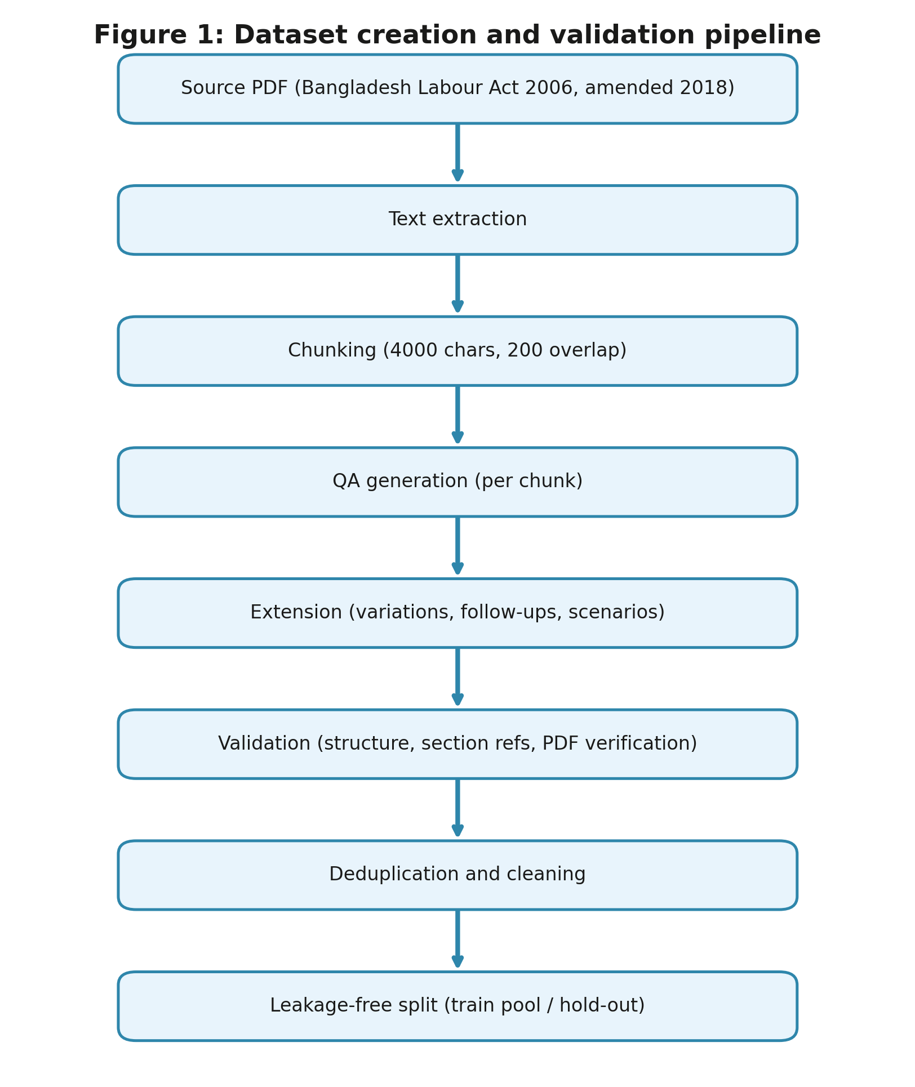
Figure 1: Dataset creation and validation pipeline.
Table 1: Dataset composition after leakage-free splitting.
Split | Items | Purpose
Training pool | 3119 | LoRA fine-tuning (includes refusal examples)
of which refusal examples | 50 | Teach declining out-of-scope questions
of which seen in training | 2964 | After the trainer's validation hold-out
of which validation split | 155 | Early stopping and model selection
Hold-out test | 146 | Leakage-free, topic-stratified evaluation
HR scenario test | 38 | Hand-authored realistic HR situations
Out-of-scope probes | 20 | Refusal behaviour

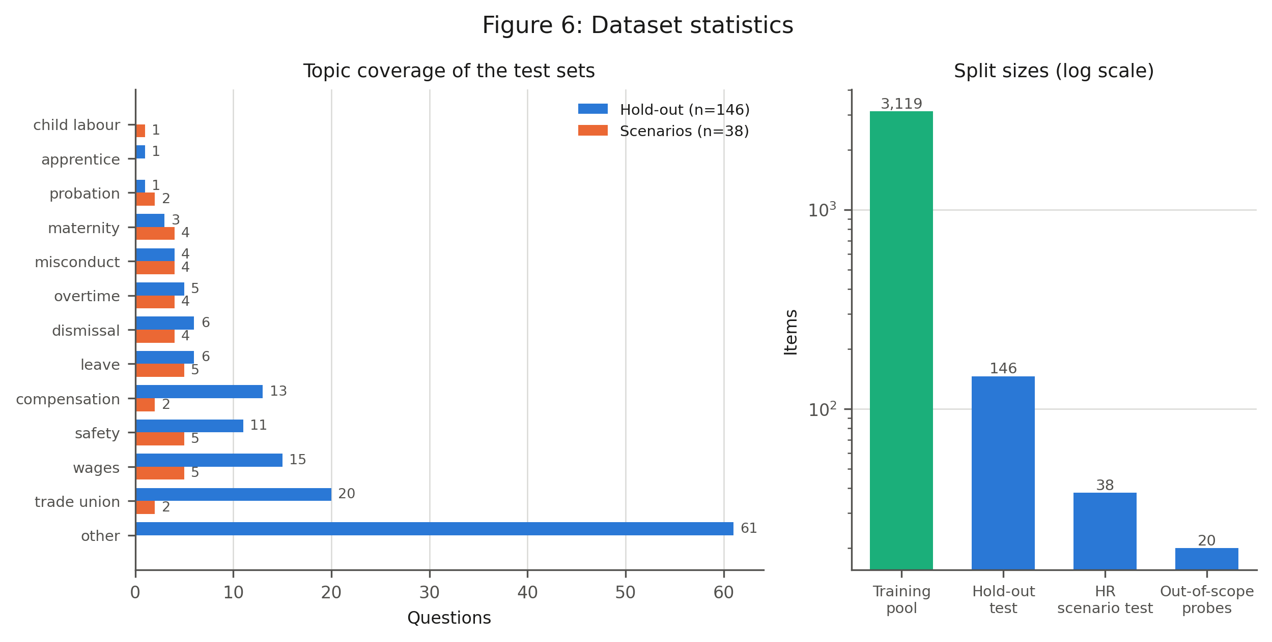
Figure 6: Dataset statistics.

3.2 Applied HR scenarios
Questions generated from statute text tend to mirror the statute's own phrasing, which flatters any model trained on it. To test the system the way an HR professional would actually use it, we additionally hand-authored a set of applied scenarios that state a concrete situation and ask what follows - for example, a worker who has completed twelve months of continuous service and worked 216 days, and what paid annual leave that yields and under which provision. Each scenario carries the section numbers that a correct answer must rely on, which is what makes citation F1 measurable. The scenarios span leave, overtime, wages, termination, maternity benefit, misconduct, probation, compensation, trade unions, workplace safety and child labour.
Table 2: Validation of the hand-authored scenario gold standard against the text of the Act.
Check | Result
Scenarios checked | 38
Gold sections resolving to a real section of the Act | 38/38
Numeric entitlements traceable to the cited section | 38/38
Mean lexical overlap with the cited section | 0.677
Verified automatically | 37/38
Accepted after manual review | 1
Verified in total | 38/38

Three representative items, one per topic:
[leave] An adult worker in a private textile factory has completed 12 months of continuous service. During the year he actually worked 216 days. How many days of paid annual leave has he earned, and under which provision?
Reference: Annual leave with wages for an adult worker accrues at one day for every 18 days of work performed during the previous 12 months (Section 117). For 216 days worked, that is 216/18 = 12 days of paid annual leave. Gold sections: 117
[overtime] A factory worker's ordinary hourly wage is 50 taka. He worked 3 hours of overtime. How much overtime pay is he owed and under what rule?
Reference: Overtime must be paid at twice the ordinary rate of basic wage plus dearness and ad-hoc allowances (Section 108). At an ordinary rate of 50 taka/hour, overtime is 100 taka/hour, so 3 hours = 300 taka. Gold sections: 108
[termination] A permanent monthly-rated worker is being terminated by the employer through simple notice (not for misconduct). What notice period or pay in lieu applies?
Reference: For termination of a permanent worker by the employer through notice, a monthly-rated worker must be given 120 days' written notice, or wages in lieu of that notice (Section 26). The worker is also entitled to compensation of 30 days' wages for every completed year of service (or gratuity, whichever is higher). Gold sections: 26, 27

3.3 Model and training
We fine-tune Llama 3.2 3B Instruct[17] with LoRA[14] adapters (rank 16, alpha 16, no dropout) applied to the attention and MLP projection matrices, using 4-bit base weights[15] and Unsloth[16] for memory-efficient training with gradient checkpointing at a 2048-token context. Optimisation uses AdamW (8-bit) at a 2e-4 learning rate with linear decay, an effective batch size of 8 (batch size 2, gradient accumulation 4), and a fixed seed of 3407 for data order, initialisation and sampling. Training runs for up to three epochs over the training pool with evaluation every 50 steps on a held-out 5% validation split, early stopping on validation loss with patience 3, and the best checkpoint restored at the end - so the reported model is selected on validation loss rather than by where a fixed step budget happened to stop. The seed, GPU model, Python version and the versions of every training library are recorded automatically into a run manifest alongside the trainer state, so the reported configuration is read from the run rather than transcribed from it.
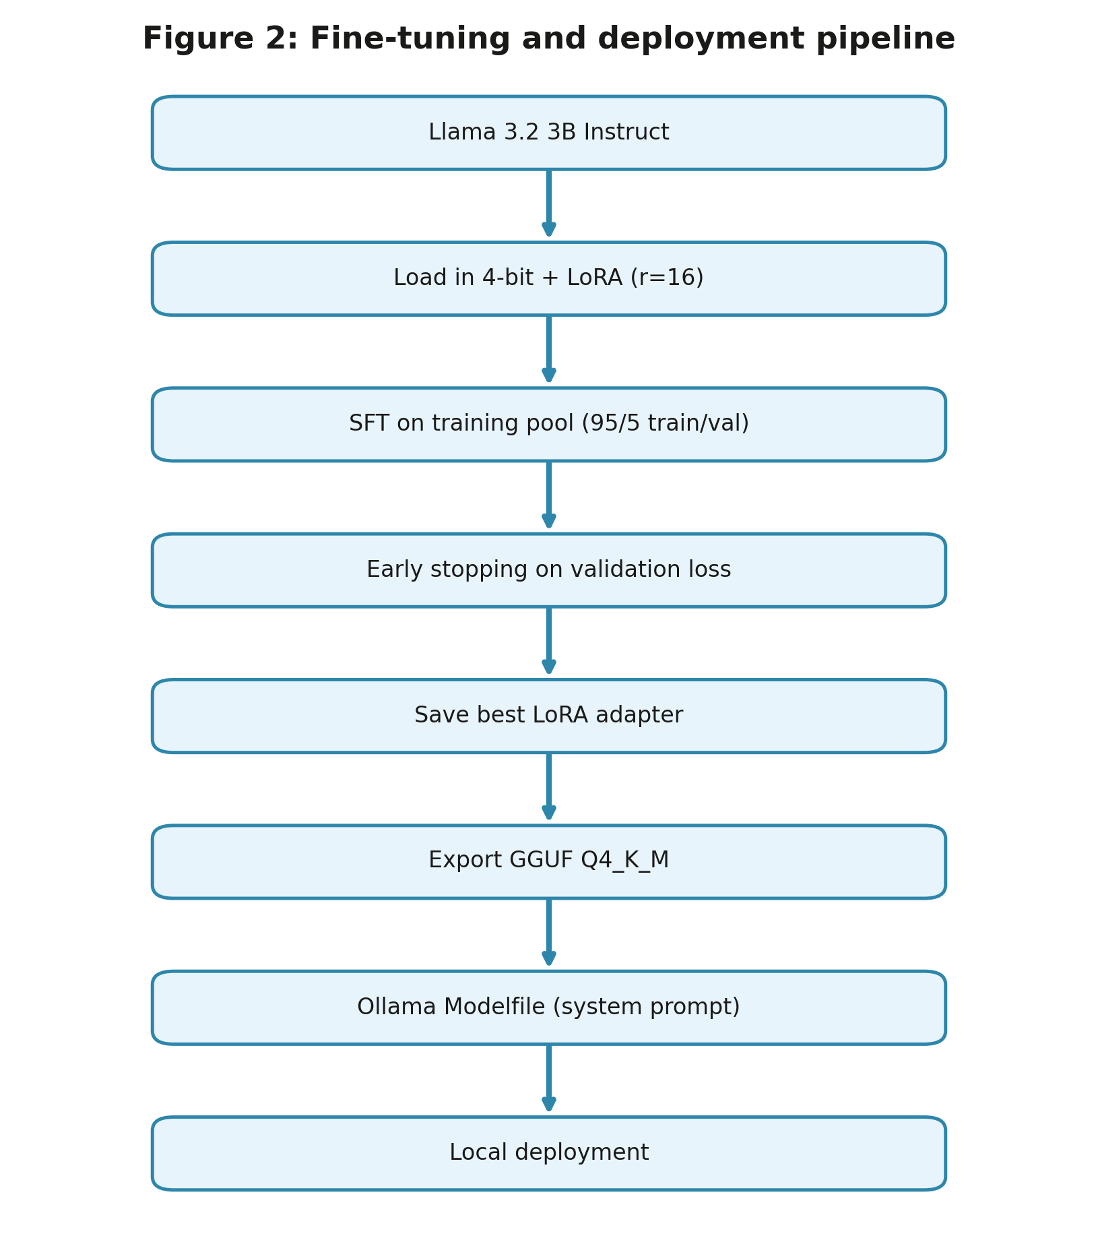
Figure 2: Fine-tuning and deployment pipeline.

3.4 Deployment
The trained adapter is exported to GGUF (Q4_K_M) and served locally through Ollama with a Modelfile that fixes the system prompt. The prompt defines an HR consultant persona scoped to the Bangladesh Labour Act, instructs the model to cite the relevant section, and instructs it to decline questions outside the Act. The whole system runs on commodity hardware with no network egress, which is what makes it usable on confidential HR material.

4. Experimental setup
Systems compared. We compare five configurations, all served locally through the same interface so that differences reflect the model rather than the harness: the base Llama 3.2 3B Instruct model; the fine-tuned model; a retrieval-augmented baseline in which the base model answers from the top-4 passages retrieved from the Act; the fine-tuned model with the same retrieval; and Qwen2.5 7B as a larger general-purpose reference point. Retrieval uses cosine similarity over 800-character chunks of the Act embedded with nomic-embed-text.
Comparison against commercial APIs (ChatGPT, Claude, Gemini) was not performed: no API access was available for this study. We report this as a limitation rather than estimating those numbers, and it is the most useful single extension of this work.
Test sets. Three sets are used. The hold-out set contains 146 QA pairs carved out of the cleaned dataset before training and stratified across HR topics. The scenario set contains 38 hand-authored applied HR situations, each labelled with the gold sections a correct answer must cite. The out-of-scope set contains 20 questions drawn from other domains, where the correct behaviour is to decline.
Disjointness is enforced on the normalised question text rather than on the full question-answer record. The distinction is not pedantic: the generator occasionally emitted the same question twice with different answers, so the two copies differ as records and a record-level check declares them distinct while the model has in fact been trained on a question it is later tested on. Four such items were found and removed from the hold-out set, three of them genuine duplicates -- one pair gives an adult working week as 48 hours in the test copy and 56 in the training copy -- and one an extraction artefact whose question text was the placeholder heading ``Scenario Question 2''. They were discarded rather than returned to the training pool, so the training data is exactly what the model was fine-tuned on.
Decoding and reproducibility. All systems are decoded greedily (temperature 0) with a fixed seed and a 384-token limit, under an identical system prompt, so that a re-run reproduces the reported numbers. Model digests, library versions and the exact system prompt are written to a run provenance record at generation time.
Metrics. BLEU[23] and ROUGE-L[24] are reported for continuity with prior work, but they measure surface overlap with a reference phrasing and a legally correct answer can score poorly on both. We therefore also report: citation validity, the fraction of sections cited by the model that exist in the Act, which detects fabricated authority directly; citation F1 against the gold sections, on the scenario set where gold labels are complete; grounding, the fraction of the answer's 5-grams occurring verbatim in the Act, a strict lexical support proxy; and refusal rate on in-scope and out-of-scope questions.
Refusal is scored as declining to answer, which we distinguish from appending a disclaimer. An answer that addresses an out-of-scope question in full and then advises the reader to consult a professional has not declined it, and counting such answers as refusals would overstate scope discipline precisely where the measurement matters. A referral therefore counts as a refusal only when it stands in place of an answer rather than following one. Because this is the safety-relevant metric and it is computed by a heuristic, we validated it against 20 out-of-scope answers labelled by hand: accuracy 0.90, precision 0.87, recall 1.00. The residual disagreements are answers that decline a request and then partly comply with it, which have no unambiguous label.
LLM-as-judge. Faithfulness, completeness, usefulness to an HR professional, and harmfulness are scored 1--5 (harm 0--1) by a local judge model from a different family than any system under test, at temperature 0. This is an automatic proxy and is labelled as such throughout; the fraction of judgements that parsed successfully is reported alongside the scores so that a silently failing judge cannot be mistaken for a low score. It is not a substitute for expert human evaluation, which is set out below as the primary remaining gap.
Statistical comparison. Because every system answers the same questions, systems are compared per item rather than by comparing two means. For each metric we report the mean paired difference against the base model, a 95% confidence interval from a paired bootstrap over items (10{,}000 resamples), and a Wilcoxon signed-rank test, Holm-corrected across the systems compared within that metric. The signed-rank test is used because the judge scores are ordinal rather than interval. We treat a difference as significant only when the adjusted $p$ is below 0.05 and the interval excludes zero, and we report the effect size alongside, since a small difference that is consistent across items can be significant without being important.
Human evaluation. A blind rating protocol and an offline rating application are provided with this work: each question is shown with one answer per system under neutral labels whose order is randomised per question, and raters score accuracy, citation correctness, completeness, usefulness and potential harm. The accompanying analysis script reports per-system means with bootstrap intervals and inter-annotator agreement as Krippendorff's $\alpha$ (ordinal for the rating scales, nominal for the harm flag), and reports the agreement first, since means drawn from raters who disagree are not interpretable. Ratings from qualified HR reviewers had not been collected at the time of writing, so no human numbers are reported here. We deliberately report no human column rather than an estimated one.
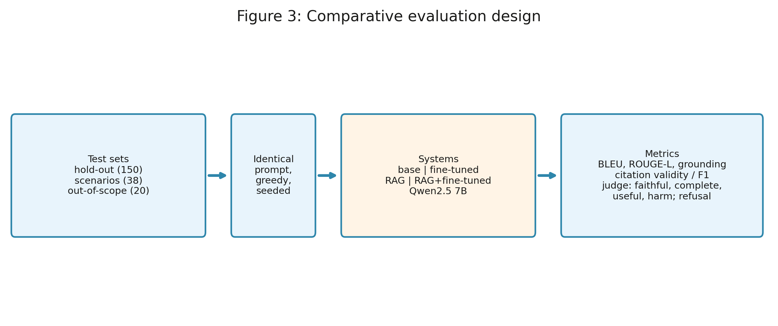
Figure 3: Comparative evaluation design.

5. Results

5.1 Training
Table 3: Training metrics for the full run. Early stopping monitored validation loss (patience 3, evaluated every 50 steps) and the best checkpoint was restored at the end, so the reported model is the one at the best step rather than the last.
Metric | Value
Final training loss | 0.4977
Best validation loss | 0.8047
Perplexity at best | 2.24
Best checkpoint step | 700
Steps run / budget | 850 / 1113
Stopped early | yes, at 2.29 epochs
Seed | 3407
GPU | Tesla T4 (14.56 GB)
Key versions | torch 2.11.0+cu128, transformers 4.56.2, peft 0.19.1, trl 0.22.2

Table 4: Loss at each evaluation step.
Step | Training loss | Validation loss
50 | 1.2940 | 1.2349
100 | 1.0571 | 1.0690
150 | 0.9852 | 1.0172
200 | 1.0035 | 0.9903
250 | 0.9505 | 0.9609
300 | 0.9420 | 0.9377
350 | 0.9180 | 0.9037
400 | 0.7676 | 0.8812
450 | 0.7657 | 0.8735
500 | 0.7385 | 0.8605
550 | 0.7341 | 0.8503
600 | 0.7393 | 0.8368
650 | 0.7467 | 0.8138
700 | 0.7299 | 0.8047
750 | 0.5394 | 0.8094
800 | 0.5697 | 0.8220
850 | 0.4977 | 0.8239

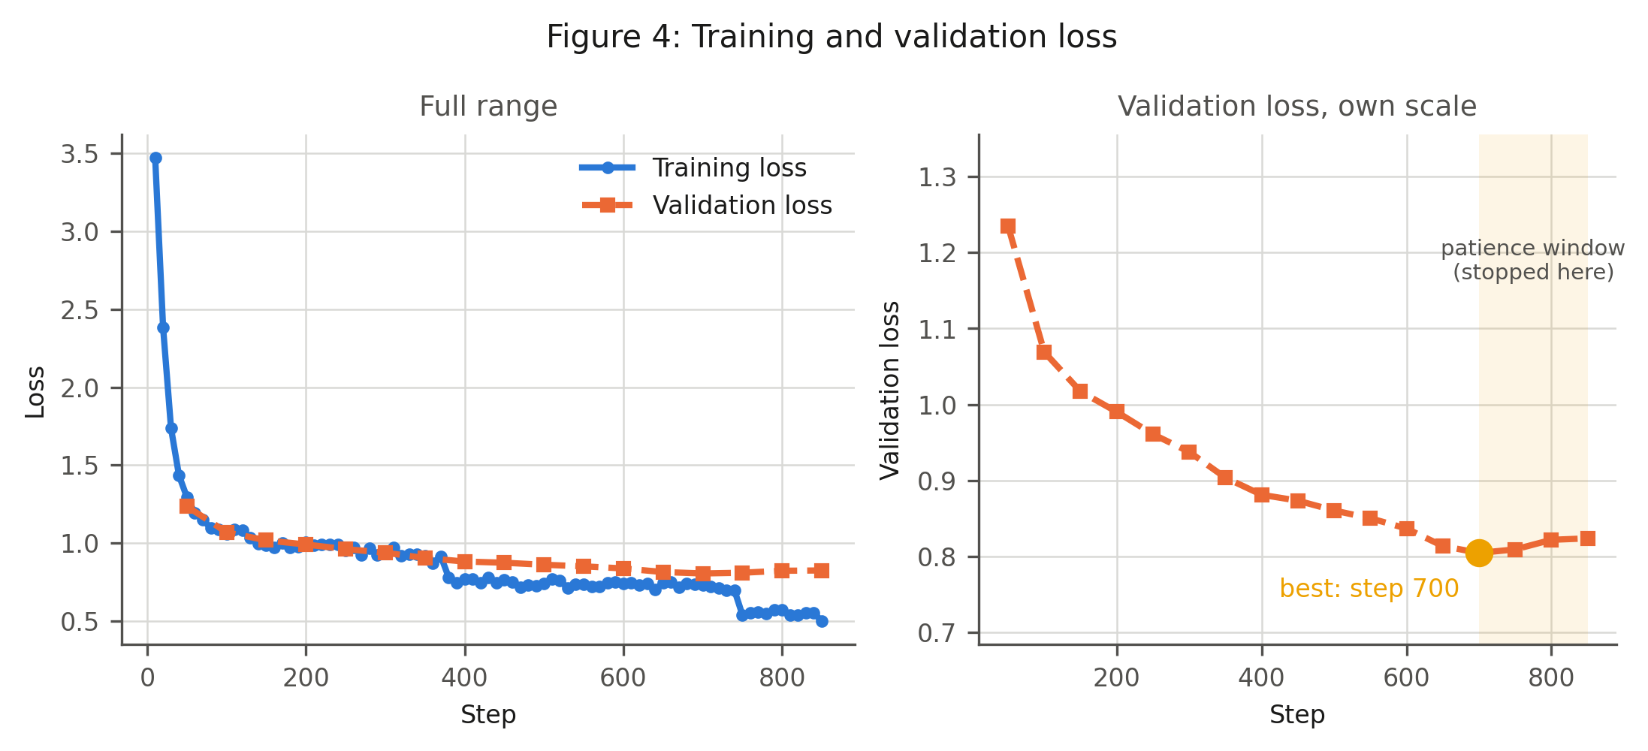
Figure 4: Training and validation loss.
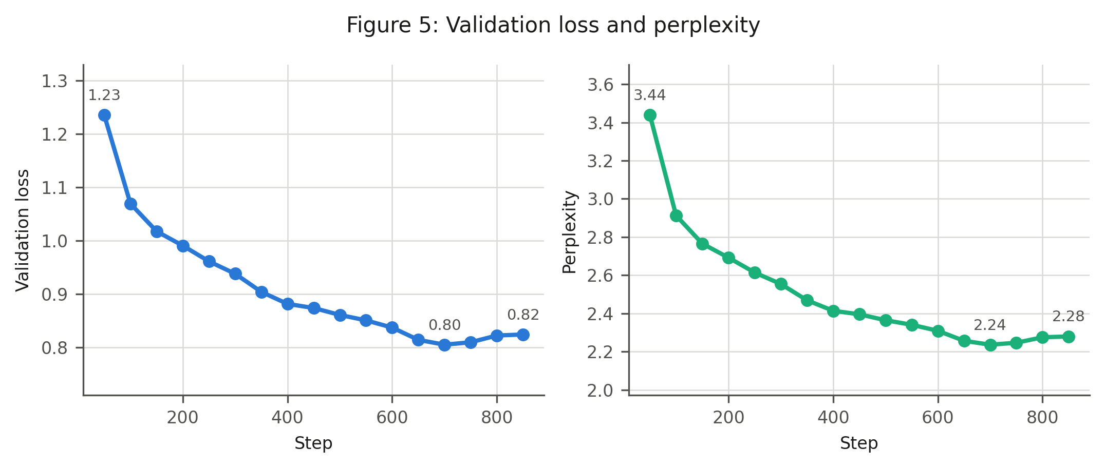
Figure 5: Validation loss and perplexity.

5.2 Answer quality
Table 5: Comparison on the 146-item leakage-free hold-out set. BLEU and ROUGE-L are 0--100; grounding and cited-valid are fractions; faithfulness, completeness and usefulness are 1--5 LLM-judge scores; harm is the rate of answers flagged misleading.
System | BLEU | ROUGE-L | Grounding | Cited valid | Faithful. | Complete. | Useful. | Harm
Base Llama 3.2 3B | 4.31 | 16.25 | 0.03 | 1.00 | 2.84 | 2.88 | 2.75 | 0.12
Fine-tuned Llama 3.2 3B | 8.94 | 24.07 | 0.05 | 1.00 | 2.95 | 2.99 | 2.88 | 0.19
RAG, base Llama 3.2 3B | 9.70 | 22.93 | 0.28 | 0.99 | 2.86 | 2.82 | 2.74 | 0.06
RAG + fine-tuned | 14.41 | 31.64 | 0.35 | 0.98 | 3.12 | 3.10 | 3.02 | 0.11

Table 6: Comparison on the 38 hand-authored HR scenarios (leave, overtime, termination, wages, maternity, misconduct, probation, safety, child labour).
System | BLEU | ROUGE-L | Grounding | Cited valid | Faithful. | Complete. | Useful. | Harm
Base Llama 3.2 3B | 3.33 | 18.86 | 0.02 | 1.00 | 1.45 | 1.71 | 1.42 | 0.39
Fine-tuned Llama 3.2 3B | 5.62 | 22.34 | 0.02 | 1.00 | 1.84 | 1.79 | 1.74 | 0.45
RAG, base Llama 3.2 3B | 6.70 | 23.85 | 0.32 | 1.00 | 2.82 | 2.74 | 2.71 | 0.11
RAG + fine-tuned | 7.11 | 26.13 | 0.35 | 1.00 | 2.92 | 2.82 | 2.74 | 0.18

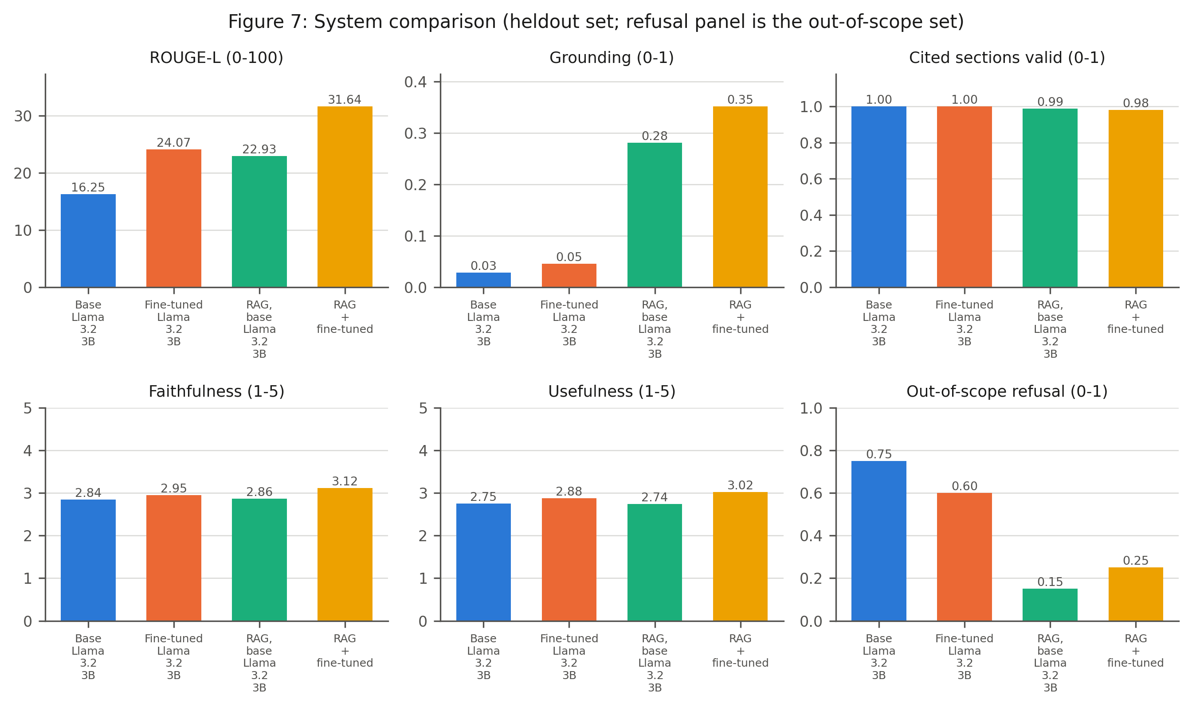
Figure 7: System comparison.

5.3 Statistical comparison
Table 7: Paired comparison against the base model on the 146-item hold-out set. Every system answers the same questions, so differences are computed per item; the CI is a paired bootstrap over items (10{,}000 resamples) and p is Wilcoxon signed-rank, Holm-corrected across the systems compared within each metric. A difference is marked significant only when the adjusted p is below 0.05 and the interval excludes zero.
Metric | System | Difference | 95% CI | p (Holm) | Sig.
Citation F1 | Fine-tuned Llama 3.2 3B | +0.01 | [-0.10, +0.13] | 0.655
Citation F1 | RAG, base Llama 3.2 3B | -0.16 | [-0.39, +0.08] | 0.587
Citation F1 | RAG + fine-tuned | -0.19 | [-0.43, +0.07] | 0.587
Refusal rate | Fine-tuned Llama 3.2 3B | -0.08 | [-0.13, -0.03] | 0.004 | yes
Refusal rate | RAG, base Llama 3.2 3B | -0.08 | [-0.12, -0.03] | 0.004 | yes
Refusal rate | RAG + fine-tuned | -0.08 | [-0.13, -0.03] | 0.004 | yes
ROUGE-L | Fine-tuned Llama 3.2 3B | +7.82 | [+6.39, +9.35] | 0.000 | yes
ROUGE-L | RAG, base Llama 3.2 3B | +6.68 | [+3.94, +9.53] | 0.000 | yes
ROUGE-L | RAG + fine-tuned | +15.39 | [+11.98, +19.05] | 0.000 | yes
Grounding | Fine-tuned Llama 3.2 3B | +0.02 | [+0.01, +0.03] | 0.003 | yes
Grounding | RAG, base Llama 3.2 3B | +0.25 | [+0.22, +0.29] | 0.000 | yes
Grounding | RAG + fine-tuned | +0.33 | [+0.28, +0.37] | 0.000 | yes
Cited sections valid | Fine-tuned Llama 3.2 3B | +0.00 | [+0.00, +0.00] | 1.000
Cited sections valid | RAG, base Llama 3.2 3B | -0.01 | [-0.04, +0.00] | 0.952
Cited sections valid | RAG + fine-tuned | -0.02 | [-0.06, +0.00] | 0.952
Faithfulness (judge) | Fine-tuned Llama 3.2 3B | +0.10 | [-0.21, +0.42] | 1.000
Faithfulness (judge) | RAG, base Llama 3.2 3B | +0.02 | [-0.37, +0.42] | 1.000
Faithfulness (judge) | RAG + fine-tuned | +0.27 | [-0.14, +0.68] | 0.523
Completeness (judge) | Fine-tuned Llama 3.2 3B | +0.12 | [-0.21, +0.45] | 0.996
Completeness (judge) | RAG, base Llama 3.2 3B | -0.06 | [-0.45, +0.33] | 0.996
Completeness (judge) | RAG + fine-tuned | +0.22 | [-0.18, +0.62] | 0.831
Usefulness (judge) | Fine-tuned Llama 3.2 3B | +0.13 | [-0.21, +0.47] | 0.913
Usefulness (judge) | RAG, base Llama 3.2 3B | -0.01 | [-0.39, +0.38] | 0.916
Usefulness (judge) | RAG + fine-tuned | +0.27 | [-0.14, +0.68] | 0.555

Table 8: Paired comparison against the base model on the 38 hand-authored HR scenarios. Every system answers the same questions, so differences are computed per item; the CI is a paired bootstrap over items (10{,}000 resamples) and p is Wilcoxon signed-rank, Holm-corrected across the systems compared within each metric. A difference is marked significant only when the adjusted p is below 0.05 and the interval excludes zero.
Metric | System | Difference | 95% CI | p (Holm) | Sig.
Citation F1 | Fine-tuned Llama 3.2 3B | +0.05 | [+0.00, +0.13] | 0.157
Citation F1 | RAG, base Llama 3.2 3B | +0.30 | [+0.18, +0.43] | 0.002 | yes
Citation F1 | RAG + fine-tuned | +0.26 | [+0.14, +0.39] | 0.004 | yes
Refusal rate | Fine-tuned Llama 3.2 3B | -0.11 | [-0.21, -0.03] | 0.137
Refusal rate | RAG, base Llama 3.2 3B | -0.08 | [-0.18, +0.03] | 0.359
Refusal rate | RAG + fine-tuned | -0.08 | [-0.21, +0.03] | 0.359
ROUGE-L | Fine-tuned Llama 3.2 3B | +3.48 | [+1.51, +5.49] | 0.008 | yes
ROUGE-L | RAG, base Llama 3.2 3B | +4.99 | [+1.60, +8.40] | 0.008 | yes
ROUGE-L | RAG + fine-tuned | +7.27 | [+4.62, +10.03] | 0.000 | yes
Grounding | Fine-tuned Llama 3.2 3B | +0.01 | [-0.00, +0.01] | 0.272
Grounding | RAG, base Llama 3.2 3B | +0.30 | [+0.23, +0.37] | 0.000 | yes
Grounding | RAG + fine-tuned | +0.34 | [+0.26, +0.42] | 0.000 | yes
Cited sections valid | Fine-tuned Llama 3.2 3B | +0.00 | [+0.00, +0.00] | 1.000
Cited sections valid | RAG, base Llama 3.2 3B | +0.00 | [+0.00, +0.00] | 1.000
Cited sections valid | RAG + fine-tuned | +0.00 | [+0.00, +0.00] | 1.000
Faithfulness (judge) | Fine-tuned Llama 3.2 3B | +0.39 | [-0.13, +0.92] | 0.134
Faithfulness (judge) | RAG, base Llama 3.2 3B | +1.37 | [+0.84, +1.92] | 0.000 | yes
Faithfulness (judge) | RAG + fine-tuned | +1.47 | [+0.89, +2.05] | 0.000 | yes
Completeness (judge) | Fine-tuned Llama 3.2 3B | +0.08 | [-0.47, +0.63] | 0.879
Completeness (judge) | RAG, base Llama 3.2 3B | +1.03 | [+0.47, +1.63] | 0.006 | yes
Completeness (judge) | RAG + fine-tuned | +1.11 | [+0.50, +1.71] | 0.006 | yes
Usefulness (judge) | Fine-tuned Llama 3.2 3B | +0.32 | [-0.21, +0.84] | 0.211
Usefulness (judge) | RAG, base Llama 3.2 3B | +1.29 | [+0.76, +1.84] | 0.001 | yes
Usefulness (judge) | RAG + fine-tuned | +1.32 | [+0.74, +1.92] | 0.001 | yes

5.4 Citation accuracy
Table 9: Citation behaviour on the scenario set, the subset for which gold section numbers are complete (38/38 items; only 15/146 hold-out items carry gold sections, so citation F1 is not reported there). ``Valid'' means the cited section exists in the Act; F1 is against the gold sections for the question.
System | Answers citing a section | Cited sections valid | Citation F1 vs. gold
Base Llama 3.2 3B | 0.95 | 1.00 | 0.00
Fine-tuned Llama 3.2 3B | 0.95 | 1.00 | 0.05
RAG, base Llama 3.2 3B | 0.71 | 1.00 | 0.30
RAG + fine-tuned | 0.45 | 1.00 | 0.26

5.5 Scope discipline
Table 10: Scope discipline. The out-of-scope probe set contains 20 questions from other domains (income tax, VAT, criminal law, immigration, foreign labour law, medicine, programming, general knowledge); the desired behaviour is to decline. The in-scope column is the over-refusal rate on the hold-out set, where declining is a failure.
System | Refusal rate, out of scope (higher is better) | Refusal rate, in scope (lower is better)
Base Llama 3.2 3B | 0.75 | 0.09
Fine-tuned Llama 3.2 3B | 0.60 | 0.01
RAG, base Llama 3.2 3B | 0.15 | 0.01
RAG + fine-tuned | 0.25 | 0.01

5.6 Error analysis
Table 11: Failure modes on the hold-out set (counts). Categories are not mutually exclusive: one answer can both cite a section that does not exist in the Act and omit a required condition.
System | n | Hallucinated section | Wrong section | No citation | Unfaithful | Incomplete | Harmful
Base Llama 3.2 3B | 146 | 0 | 10 | 2 | 63 | 76 | 17
Fine-tuned Llama 3.2 3B | 146 | 0 | 9 | 20 | 64 | 70 | 28
RAG, base Llama 3.2 3B | 146 | 1 | 6 | 62 | 68 | 82 | 9
RAG + fine-tuned | 146 | 1 | 5 | 93 | 63 | 70 | 16

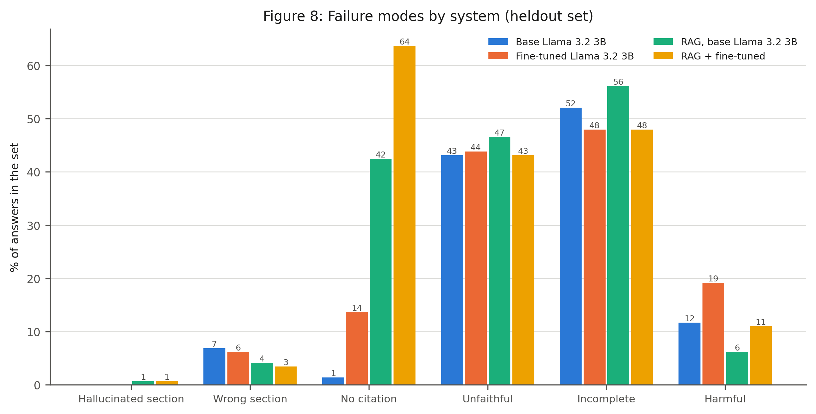
Figure 8: Failure modes by system.

5.7 Ablation
Table 12: Ablation over training-set size, LoRA rank, and the inclusion of the refusal examples. All arms share seed 3407 and the same schedule, and all use early stopping on validation loss (patience 3, evaluated every 50 steps) with the best checkpoint restored. Best step is where validation loss bottomed out and ran to is where training halted; the gap is the patience window. Rows marked ``same run'' are not a separate training run: one reference run serves as the 100%, rank-16 and with-refusals point on all three axes, so the table reports six training runs rather than eight.
Axis | Configuration | Train ex. | Rank | Best step | Ran to | Eval loss | Perplexity
Training-set size | 25% of pool | 741 | 16 | 250 | 279 | 1.0340 | 2.81
 | 50% of pool | 1482 | 16 | 550 | 558 | 0.9017 | 2.46
 | 100% of pool | 2964 | 16 | 700 | 850 | 0.8047 | 2.24
LoRA rank | rank 8 | 2964 | 8 | 700 | 850 | 0.8311 | 2.30
 | rank 16 (same run) | 2964 | 16 | 700 | 850 | 0.8047 | 2.24
 | rank 32 | 2964 | 32 | 700 | 850 | 0.7814 | 2.18
Refusal examples | without | 2919 | 16 | 700 | 850 | 0.8558 | 2.35
 | with (same run) | 2964 | 16 | 700 | 850 | 0.8047 | 2.24

Training does not benefit from the full three-epoch budget. Validation loss falls until step 700 and then rises for three consecutive evaluations while training loss keeps falling, which is overfitting rather than noise; early stopping halted the run at step 850 of a 1113-step budget, at 2.29 epochs, and the checkpoint from step 700 was restored. The evaluation in this paper measures that checkpoint. A fixed step budget without validation monitoring, as used in the pilot run, would have reported a strictly worse model.
Dataset size still pays. Validation loss improves monotonically from 1.034 at a quarter of the pool (741 examples) to 0.902 at half and 0.805 at the full pool (2964 examples), with no sign of a plateau. The curve is still descending at the largest size available, so the dataset is a bottleneck before the method is: more verified QA pairs would likely help more than further tuning of this recipe.
LoRA rank matters less. Going from rank 8 to 16 to 32 moves validation loss 0.831 to 0.805 to 0.781 -- a total span of 0.050, against 0.229 spanned by dataset size. Rank 32 is the best of the three, but the gain over the rank 16 used throughout this paper is small relative to its extra parameters, and an ordering in validation loss does not establish that the difference would survive on downstream answer quality, which is what the comparison in the results section measures.
The refusal examples are cheap. Removing all 45 of them changes validation loss from 0.805 to 0.856. This comparison should not be over-read in either direction: the two arms differ in training-set size as well as in content, and validation loss is computed over a split that contains refusal items, so an arm never trained on them is expected to score worse on exactly those items. What the refusal examples are for is out-of-scope behaviour, and that is measured directly on the out-of-scope set rather than here.

6. Discussion
The central result is a dissociation between fluency and citation accuracy. Fine-tuning clearly changes how the model writes: on the hold-out set it improves surface agreement with the reference answers and reduces unnecessary refusals. It does not, however, reliably improve the one thing an HR user must be able to check. On the hand-authored scenarios, the fine-tuned model's citation F1 differs from the base model's by +0.05 (p = 0.157), which is not significant after correction, whereas retrieval over the same statute improves it by +0.30 (p = 0.002) and retrieval combined with fine-tuning by +0.26 (p = 0.004). On this benchmark, supplying the statute at inference time is what makes the citation correct; training on statute-derived question-answer pairs mainly makes the answer sound correct. The LLM judge, which never sees the gold section labels and so measures something the citation metric does not, agrees: on the scenarios the fine-tuned model is not significantly better than the base model on any judged dimension (faithfulness, completeness, usefulness), while retrieval is significantly better on all of them. Two independent measurements pointing the same way is the reason we read this as a property of the systems rather than of one brittle metric.
This gap is invisible if the hold-out set is the only test. Citation F1 for the fine-tuned model is 0.31 on the hold-out set but 0.05 on the scenarios, and for the base model 0.30 against 0.00. Hold-out questions are generated from the statute and tend to name or paraphrase the provision they are about, so the citation is partly given away by the question. A practitioner's question describes a situation instead, and the model must find the provision itself. Any evaluation of a statute-tuned model that reports only in-distribution hold-out accuracy will therefore overstate how well it cites.
The third finding is a safety trade-off that runs against the other two. Every modification we make to the base model leaves it less willing to decline a question it should not answer. Out-of-scope refusal rates are: Base Llama 3.2 3B 0.75; Fine-tuned Llama 3.2 3B 0.60; RAG, base Llama 3.2 3B 0.15; RAG + fine-tuned 0.25. The untouched base model refuses most often (0.75); the retrieval-only configuration refuses least often (0.15). Retrieval is the larger contributor to this erosion, which is intuitive in hindsight - the retriever always returns its nearest passages, and a confidently retrieved chunk of the Act makes an unrelated question look answerable. The configurations that cite best are therefore among the least willing to say that a question is not about labour law, so a deployment would need an explicit scope check ahead of the model rather than relying on the model's own restraint.
These two safety results point in opposite directions and should be read together. On in-scope scenarios retrieval makes the system safer: the judge flags fewer misleading answers than for the base model, -0.29 (p = 0.014). On out-of-scope probes the same configuration is the least likely to decline. Retrieval helps when the question is within the statute and hurts when it is not, because nothing in the pipeline distinguishes the two cases - the retriever returns its nearest passages either way. Quoting only the first half would make retrieval look unambiguously safer than it is, and only the second would make it look unusable; the honest summary is that retrieval improves answer quality inside the scope it was built for and provides no signal at all about where that scope ends.
Taken together these results argue against fine-tuning as the primary intervention for this problem, and against the framing of our own earlier draft. Retrieval over the Act supplies the statute's own words at inference time, and that is what the citation metrics reward, because the provision the answer needs is usually present verbatim in a retrieved passage. What fine-tuning contributes is different in kind: it sets the model's default behaviour - its persona, its habit of citing a section at all, and its register - and it does so without requiring an index at serving time. Those are real benefits for deployment, but they are not the same as being right about which section applies, and reporting them as though they were is how a system evaluation overstates its case.
The error profiles show the two failure modes are also different in kind, not merely in size. On the scenarios, the base and fine-tuned models fail almost entirely by citing a section that exists but does not govern the question; the cited section is nearly always real, so the error is invisible to any check that only verifies a citation resolves. The retrieval configurations fail instead by declining to cite at all - answering out of the retrieved text without naming the provision - which is their dominant failure mode on the hold-out set. These call for opposite fixes: the first needs better section selection, the second only needs the citation enforced in the output format. The second is much the easier problem, which is a further practical argument for the retrieval configurations.
Interpreting the metrics requires care. High lexical grounding indicates the answer reuses the Act's language, which is desirable for a statutory assistant but can also be achieved by quoting irrelevant text, which is why grounding is read together with citation validity and judged completeness. Retrieval raises grounding almost by construction, since the retrieved passage is in the context window, so grounding should not be read as evidence that retrieval understands the question better. Conversely, BLEU and ROUGE-L against a single reference phrasing understate answers that are correct but worded differently; we report them for comparability, not as the primary evidence. Citation F1 against hand-assigned gold sections is the metric we would defend as closest to what an HR user needs, and it is also the one on which the fine-tuned model's advantage disappears.

7. Limitations
Single statute, single language. The system covers only the Bangladesh Labour Act 2006 as amended to 2018, in English. Bangladeshi labour questions routinely involve subsidiary rules, notably the Bangladesh Labour Rules 2015, and adjacent instruments the model has never seen; it has no way to signal that a question depends on material outside its scope rather than outside the Act. Most HR practice in Bangladesh is also conducted in Bangla, and the dataset is English-only.
Statutory amendment. The model encodes the Act at a fixed amendment state. Any subsequent amendment silently invalidates the affected answers, and the model will continue to answer with unchanged confidence. A deployed system needs a review process tied to legislative updates; the retrieval configuration degrades more gracefully here, since re-indexing an amended text is cheaper than retraining.
Synthetic training data. Training questions were generated from the Act's own text, so they inherit its phrasing and emphasis and under-represent how practitioners actually ask questions - which is why the hand-authored scenario set exists, and why results on it should be weighted more heavily than hold-out results. Validation checks that answers are supported by the Act, but a systematically skewed question distribution is not something answer-level validation can detect.
Residual hallucination. Fine-tuning reduces but does not eliminate fabricated section references; the error analysis reports the residual rate rather than claiming it is zero. For any consequential decision the cited section must be read in the Act itself. The system provides statute-grounded informational support and is not legal advice.
Evaluation is automatic. All reported quality numbers are automatic metrics or LLM-judge proxies. Expert human ratings, for which the protocol and tooling are provided here, had not been collected at the time of writing. Comparison against commercial APIs was not possible without API access. Both gaps bound how strongly the results can be read.
Scale. The evaluation covers 204 questions across three sets and a 3B model on a single GPU. Differences are tested with paired statistics, but a 146-item hold-out set has limited power: a comparison reported as not significant is evidence of an undetermined difference, not of no difference, and small effects would need a larger benchmark to resolve. The significance tests also treat the LLM judge's scores as data, so they inherit whatever bias that judge has; they quantify sampling noise, not measurement validity.

8. Conclusion
We presented a reproducible pipeline that turns the official PDF of the Bangladesh Labour Act 2006 into a validated QA dataset, fine-tunes a 3B model on it with LoRA, and deploys the result locally, together with a leakage-free benchmark and a metric suite appropriate to legal QA. The benchmark - a topic-stratified hold-out set, hand-authored HR scenarios with gold section labels, and out-of-scope probes - and the accompanying evaluation code are the part of this work most reusable by others, since they make claims about Bangladesh labour-law QA checkable rather than assertable.
The results characterise what domain fine-tuning buys relative to retrieval over the same statute, where each configuration fails, and how reliably each stays within its scope. The most valuable extensions are the two gaps named above: expert human evaluation, for which the blind protocol and tooling are already provided, and comparison against commercial APIs. Beyond those, extending to the Bangladesh Labour Rules 2015 and to Bangla would address the limitations that most constrain practical use.

Appendix: reproducibility
All systems were decoded greedily (temperature 0.0) with seed 3407 and a 384-token limit, under an identical system prompt. Serving used Ollama ollama version is 0.20.2 on Linux-6.17.0-40-generic-x86_64-with-glibc2.39 with Python 3.12.8. Model identifiers: hr-persona-bd:latest, llama3.2:3b-instruct-q4_K_M. Exact model digests, the full system prompt and the generation timestamp are recorded in results/run_provenance.json, and the evaluation is resumable and idempotent so a re-run reproduces these numbers.

References
[1] Government of Bangladesh. The Bangladesh Labour Act, 2006 (Act No. XLII of 2006), amended to 2018.
[2] M. Dahl, V. Magesh, M. Suzgun, and D. E. Ho. Large Legal Fictions: Profiling Legal Hallucinations in Large Language Models. Journal of Legal Analysis, 16(1):64--93, 2024.
[3] V. Magesh, F. Surani, M. Dahl, M. Suzgun, C. D. Manning, and D. E. Ho. Hallucination-Free? Assessing the Reliability of Leading AI Legal Research Tools. arXiv:2405.20362, 2024.
[4] N. Guha, J. Nyarko, D. Ho, C. R\'{e}, A. Chilton, et al. LegalBench: A Collaboratively Built Benchmark for Measuring Legal Reasoning in Large Language Models. NeurIPS Datasets and Benchmarks, 2023.
[5] I. Chalkidis, M. Fergadiotis, P. Malakasiotis, N. Aletras, and I. Androutsopoulos. LEGAL-BERT: The Muppets Straight Out of Law School. In Findings of EMNLP, 2020, pp. 2898--2904.
[6] I. Chalkidis, A. Jana, D. Hartung, M. Bommarito, I. Androutsopoulos, D. M. Katz, and N. Aletras. LexGLUE: A Benchmark Dataset for Legal Language Understanding in English. In Proc. ACL, 2022, pp. 4310--4330.
[7] D. Hendrycks, C. Burns, A. Chen, and S. Ball. CUAD: An Expert-Annotated NLP Dataset for Legal Contract Review. NeurIPS Datasets and Benchmarks, 2021.
[8] H. Zhong, C. Xiao, C. Tu, T. Zhang, Z. Liu, and M. Sun. JEC-QA: A Legal-Domain Question Answering Dataset. In Proc. AAAI, 2020, pp. 9701--9708.
[9] P. Colombo, T. P. Pires, M. Boudiaf, et al. SaulLM-7B: A Pioneering Large Language Model for Law. arXiv:2403.03883, 2024.
[10] J. Cui, Z. Li, Y. Yan, B. Chen, and L. Yuan. ChatLaw: Open-Source Legal Large Language Model with Integrated External Knowledge Bases. arXiv:2306.16092, 2023.
[11] Q. Huang, M. Tao, C. Zhang, et al. Lawyer LLaMA Technical Report. arXiv:2305.15062, 2023.
[12] S. Yue, W. Chen, S. Wang, et al. DISC-LawLLM: Fine-tuning Large Language Models for Intelligent Legal Services. arXiv:2309.11325, 2023.
[13] R. Qasem, M. Hendi, and B. Tantour. ALKAFI-LLAMA3: Fine-Tuning LLMs for Precise Legal Understanding in Palestine. arXiv:2412.14771, 2024.
[14] E. J. Hu, Y. Shen, P. Wallis, Z. Allen-Zhu, Y. Li, S. Wang, L. Wang, and W. Chen. LoRA: Low-Rank Adaptation of Large Language Models. ICLR, 2022. arXiv:2106.09685.
[15] T. Dettmers, A. Pagnoni, A. Holtzman, and L. Zettlemoyer. QLoRA: Efficient Finetuning of Quantized LLMs. NeurIPS, 2023.
[16] Unsloth. Efficient fine-tuning and inference for LLMs. \url{https://github.com/unslothai/unsloth}, 2024.
[17] A. Grattafiori, A. Dubey, et al. The Llama 3 Herd of Models. arXiv:2407.21783, 2024.
[18] Y. Wang, Y. Kordi, S. Mishra, A. Liu, N. A. Smith, D. Khashabi, and H. Hajishirzi. Self-Instruct: Aligning Language Models with Self-Generated Instructions. In Proc. ACL, 2023, pp. 13484--13508.
[19] N. Carlini, F. Tram\`{e}r, E. Wallace, et al. Extracting Training Data from Large Language Models. In Proc. USENIX Security Symposium, 2021, pp. 2633--2650.
[20] A. Bhattacharjee, T. Hasan, W. U. Ahmad, K. Samin, et al. BanglaBERT: Language Model Pretraining and Benchmarks for Low-Resource Language Understanding Evaluation in Bangla. In Findings of NAACL, 2022, pp. 1318--1327.
[21] A. T. Wasi, W. Faisal, M. R. Islam, and M. M. Bappy. Exploring Possibilities of AI-Powered Legal Assistance in Bangladesh through Large Language Modeling. arXiv:2410.17210, 2024.
[22] S. Aftahee, A. F. M. Farhad, A. Mallik, R. Dhar, J. Karim, N. B. Noor, and I. A. Solaiman. Assessing the Reliability of Large Language Models in the Bengali Legal Context: A Comparative Evaluation Using LLM-as-Judge and Legal Experts. arXiv:2511.05627, 2025.
[23] K. Papineni, S. Roukos, T. Ward, and W.-J. Zhu. BLEU: a Method for Automatic Evaluation of Machine Translation. In Proc. ACL, 2002, pp. 311--318.
[24] C.-Y. Lin. ROUGE: A Package for Automatic Evaluation of Summaries. In Text Summarization Branches Out, ACL Workshop, 2004, pp. 74--81.

