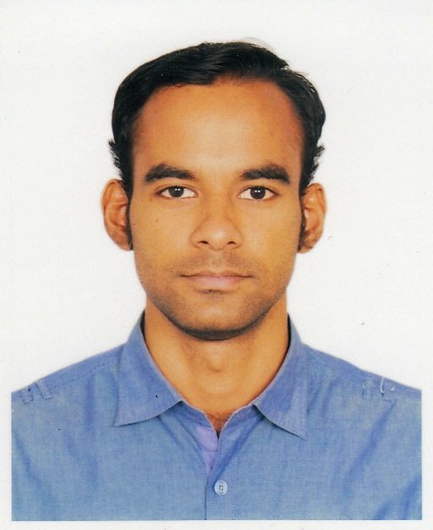
MOHAMMAD KHAN
Contact: House#91/C, Road#7A, Dhanmondi, Dhaka-1209
Tel: 02-8122042(res), Cell: 01818-480613
E-mail: mdkhan218@gmail.com

Career Objective:

I am now looking to build on my extensive range of educational and professional skills within a suitably challenging role and I am keen to achieve further professional development.

Employment History:

Area Sales Manager – Modern Trade & IS (January 01, 2015 – Continuing)
Bangladesh Edible Oil Ltd.
Land View Commercial Centre, 28 Gulshan North C/A, Dhaka-1212, Bangladesh

Duties/Responsibilities:
- Develop sales and marketing strategies to drive sales growth in the assigned area.
- Develop and manage an efficient distribution network to improve sales performance.
- Manage the sales team for sales growth and revenue enhancement
- Conduct market research to understand competitors and market trends.
- Regular market visit and market development.
- Managing systems and compliances of MT accounts and Institutes.

Senior Territory Manager (December 17, 2012 – December 31, 2014)
Bangladesh Edible Oil Ltd.
Land View Commercial Centre, 28 Gulshan North C/A, Dhaka-1212, Bangladesh

Duties/Responsibilities:
- Distribution activity monitoring of distributor’s within the assigned territory.
- Regular market visit and market development.
- Handling retail and distributor commission & other queries.
- Managing systems and compliances of distributors and retailers.
- Distribution Management
- Ensure product quality & customer service
- Administration & Communication

Territory Sales Manager (January 15, 2011 – December 15, 2012)
Reckitt Benckiser Bangladesh Ltd.
Plot 2 (B), Block SE (C), Road 138, Gulshan-1, Dhaka-1212, Bangladesh

Duties/Responsibilities:
- Regular market visit and market development.
- Training and development of distributor sales and service force.
- Ensuring proper customer service from distributors and assigned service desks.
- Coordination and monitor distributor staffs daily activities.
- Analyzing and solving territory operational issues.

Professional Qualification:

Professional Qualification 01:

Training on “Merchandising, Distribution, Promotion management & Product

Knowledge”

Institute: Reckitt Benckiser Bangladesh Limited
Location: Dhaka

Date: March 03, 2012
Professional Qualification 02:

Training on “Distribution & Sales Management Techniques”

Institute: Reckitt Benckiser Bangladesh Limited

Location: Dhaka
Date: March 12 & 13, 2011

Educational Qualifications:

Bachelor of Business Administration (BBA)
Major in Marketing

CGPA-3.51(Out of 4.0)
Spring 2007 - Summer 2010
American International University –Bangladesh (AIUB)

Higher Secondary School Certificate (HSC)
Science Group, GPA 3.20

Ideal College, Dhaka
Dhaka Board -2005

Secondary School Certificate (SSC)
Science Group, GPA 4.25

Pabna Zilla School, Pabna
Rajshahi Board -2003

Communication Skills:

Have fluency in English both oral and written. Also have knowledge in report writing and multimedia presentation.

Personal Details:

Father’s Name: MD. Enamul Haque
Mother’s Name: Mahjevin Haque
Permanent Address: House#91/C, Road#7/A, Dhanmondi, Dhaka-1209
Date of Birth: 01/01/1988

References:
AHM Ehsanul Huda S.M. Abdul Karim
Assistant Professor & Director (MBA) Regional Sales Manager,

American International University- Reckitt Benckiser Bangladesh Ltd.
Bangladesh Plot 2 (B), Block SE (C), Road 138,

Tel (off): 9890804, 8814462 Gulshan-1, Dhaka-1212, Bangladesh
Mob- 0181-9495552 Tel (off): 02-9887209, Mob: 01777759013

E-mail:ehsanul@aiub.edu Email:smabdul.karim@rb.com

