Lab1

1- Create your tables with their columns in PostgreSQL

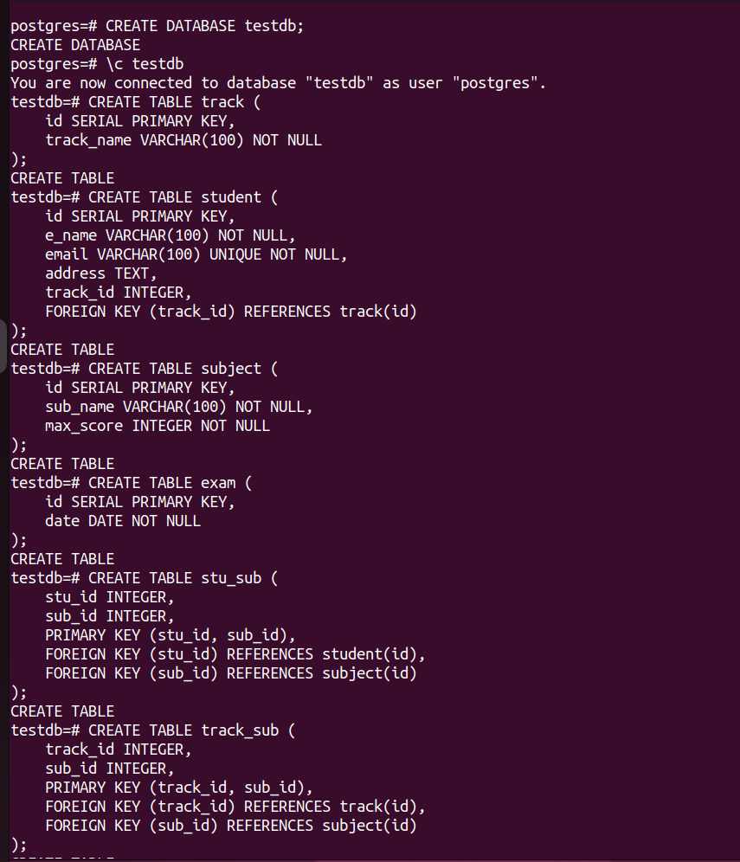

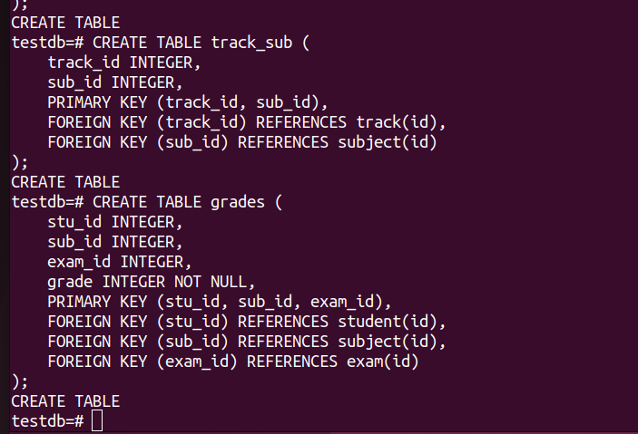

2- Insert at minimum 3 Rows at each table.

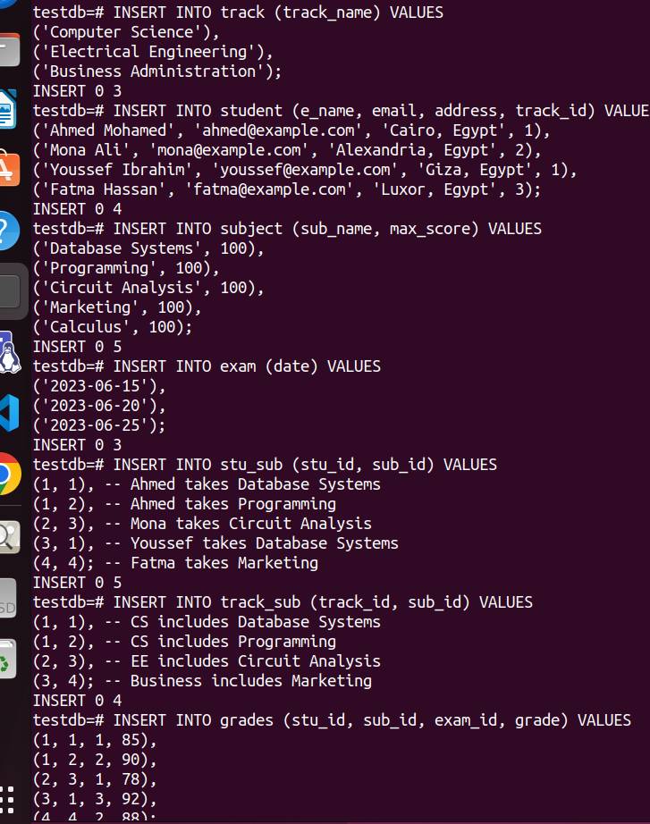

3-Add birth date column for the student table.



4-Add gender column which hold only 2 values (Male or
Female)

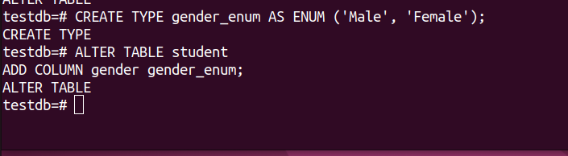
5- Add/Alter foreign key constrains in your tables

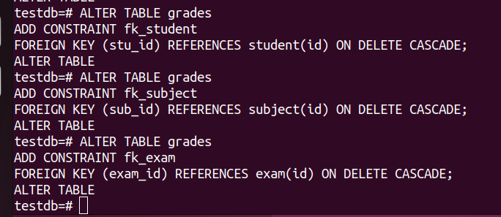

6- Display male students who are born before 1991-10-01.
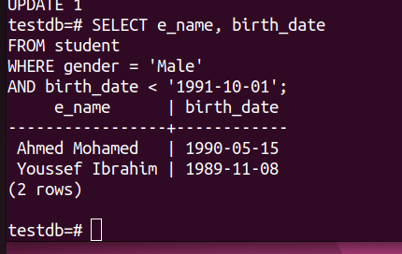

7- Display students’ names that begin with A.

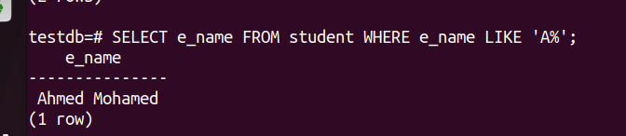

8- Display subjects and their max score sorted by max score.

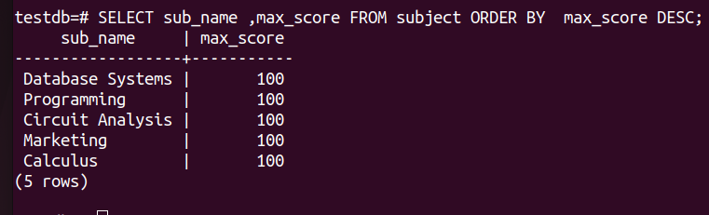

9- Display the subject with highest max score

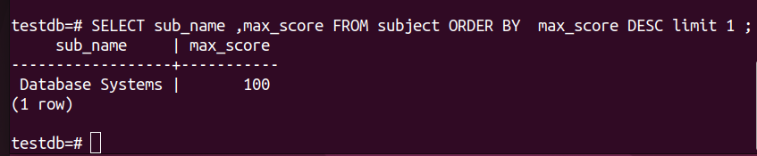

lab2

1- Display the number of students their name is “Mohammed”

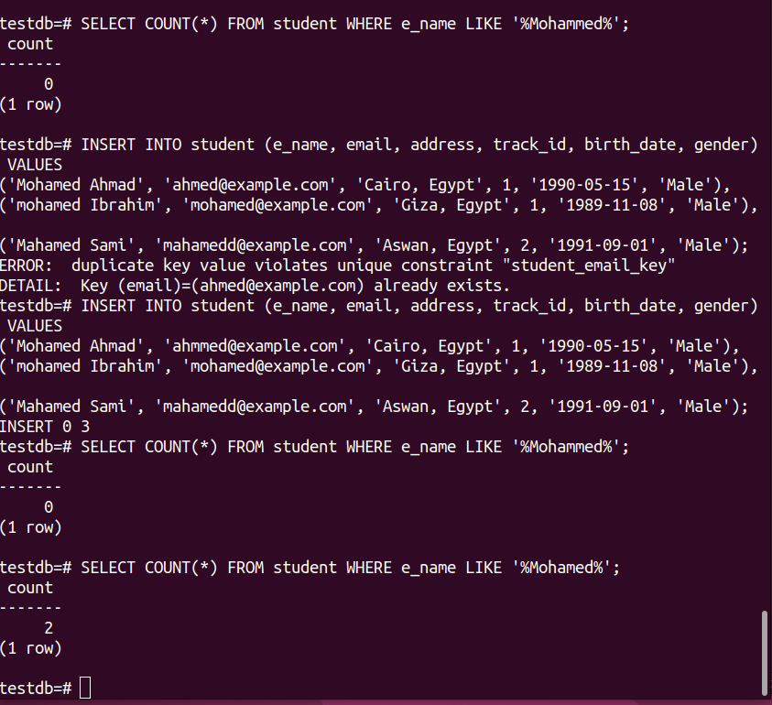

2- Display the number of males and females.

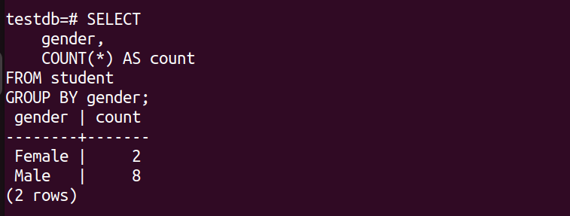

3- Display the repeated first names and their counts if higher
than 2.
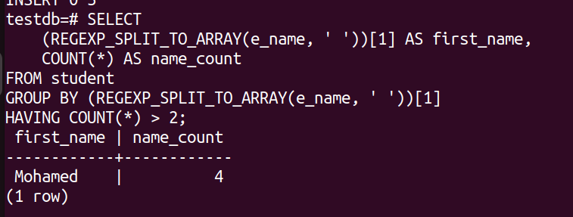

4- Display all students and track name they belong to.

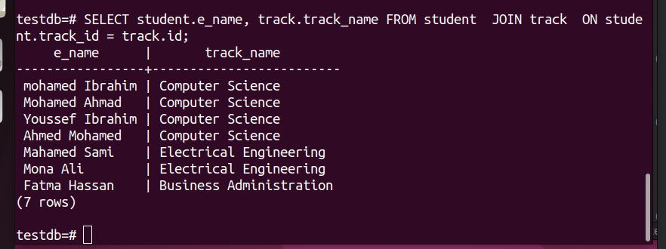

5- Display all students except those who are in OS track

