AWS EC2
Step-by-Step Setup Guide on AWS EC2

What You Will Need
Before you start, make sure you have:

- An AWS account with permission to create EC2 instances
- Access to the CrowdStrike Falcon console
- The CrowdStrike Customer ID (CID)
- Basic familiarity with the Linux terminal .

Part 1 — Launch an EC2 Instance on AWS

Step 1 — Log in to AWS
Go to https://aws.amazon.com and sign into your account.
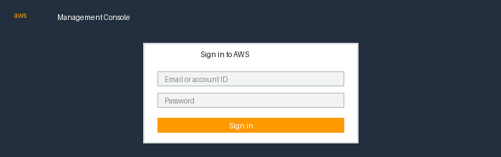
The AWS login screen

⚠️ Important: Set Your AWS Region Before Starting
AWS has multiple regions around the world to provide fault tolerance, low latency, and regional compliance. Each region operates independently, meaning resources like Security Groups and EC2 instances created in one region are not visible in another. For Triangle Cyber intern work, us-east-1 (N. Virginia) is our primary region. After logging in to AWS, before proceeding with AWS, make sure your region is set to us-east-1 (N. Virginia) — this is where Triangle Cyber's main resources (Security Groups, Splunk SIEM, etc.) are located.
How to check and switch your region:
- After logging in, look at the top-right corner of the AWS Console — you will see the current region name (e.g. United States (N. Virginia)). Click it and make sure that US East (N. Virginia) / us-east-1 is selected.
Note: Triangle Cyber's current policy restricts intern accounts to us-east-1 (N. Virginia) only. Attempting to access other regions such as us-east-2 (Ohio) will result in an Access Denied error. If access to an additional region is needed for a specific project, please request permission from Will or Jim and explain your use case.

Step 2 — Search for EC2
In the search bar at the top of the page, type EC2 and click on the EC2 result.
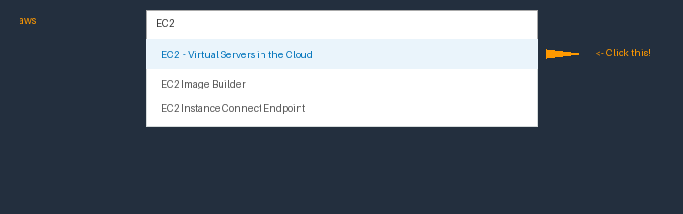
Type 'EC2' in the search bar and click the first result

Step 3 — Click 'Launch Instance'
Once inside the EC2 console, click the orange Launch instances button near the top right.
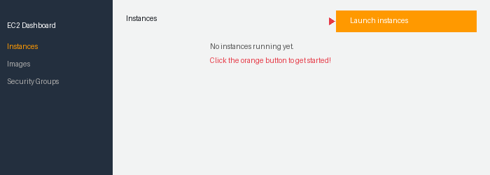
Click the orange 'Launch instances' button

Step 4 — Choose Amazon Linux 2023
Under 'Application and OS Images', click Quick Start, then select Amazon Linux 2023 (64-bit x86). This is the version that works best with CrowdStrike.
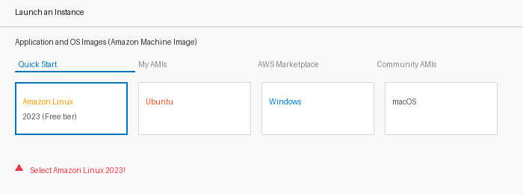
Select 'Amazon Linux 2023' from the Quick Start options

Step 5 — Choose Instance Type
In the Instance type section, look for an instance type labeled "Free tier eligible". Either t2.micro or t3.micro will work — use whichever one is available in your region. In us-east-1 (Northern Virginia), t3.micro is the current default free tier option. t3.micro is newer and more powerful than t2.micro, so either one is great for testing.
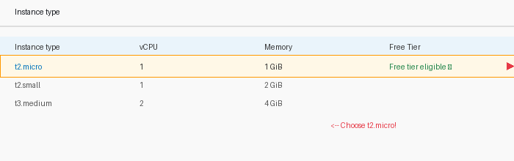
Select 't2.micro' — it's free!

Step 6 — Create a Key Pair
A key pair is what lets you connect to your server. Click 'Create new key pair', give it a name (like my-ec2-key), and download the .pem file. Save it somewhere safe — you'll need it!
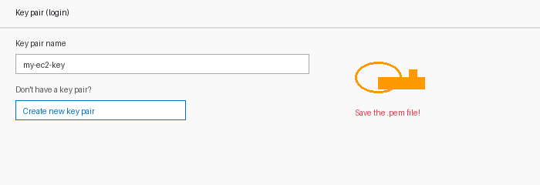
Create a new key pair and save the .pem file

Step 7 — Launch the Instance
Click Launch Instance at the bottom. Wait 1–2 minutes, then check your instance list. Wait until the status shows Running (green dot) before moving on.
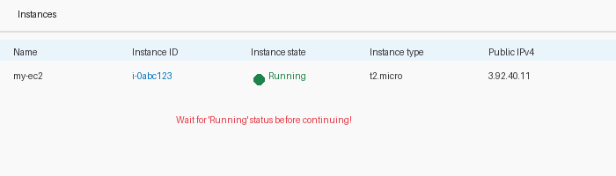
Wait for the status to show 'Running' (green dot)
💡 Tip: If the instance says 'Pending', just wait a minute and refresh the page.

Part 2 — Connect to Your EC2 Instance

Step 8 — Click the 'Connect' Button
In the EC2 Instances list, select your instance by clicking on it, then click the Connect button at the top of the page.
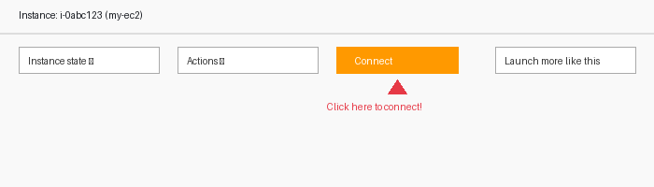
Select your instance and click 'Connect'

Step 9 — Use EC2 Instance Connect
In the Connect dialog, the EC2 Instance Connect tab should already be selected. Leave everything as default and click Connect. A black terminal window will open in your browser — that's your server!
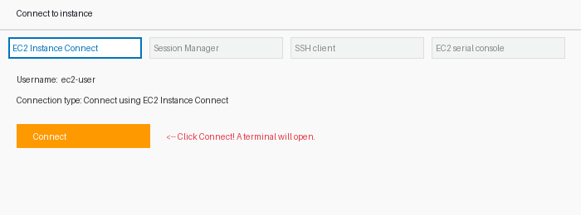
Click ‘Connect’ to open the browser terminal
AWS also offers 3 other ways to connect to your EC2 instance. These are useful for RHEL, Ubuntu, and other Linux-based EC2s.

Other Connection Method 1 — SSH Client
Works with Amazon Linux, RHEL, Ubuntu and most Linux EC2s. Requires your .pem key file. Use this when EC2 Instance Connect is not available.
- Set permissions on your key file — In your terminal, run:
chmod 400 your-key-name.pem
- Connect via SSH — Replace with your key name and EC2 public IP:
ssh -i "your-key-name.pem" ec2-user@YOUR_EC2_PUBLIC_IP

Other Connection Method 2 — Session Manager
No SSH key or open ports needed. Great for troubleshooting. Requires the SSM Agent on the EC2 (Amazon Linux 2023 has it pre-installed).
- In EC2 → Instances, select your instance → click Connect → choose Session Manager tab → click Connect.
- Use case: Best when SSH is blocked or the instance has no public IP.

Other Connection Method 3 — EC2 Serial Console
Used mainly for troubleshooting when the instance is unreachable. Not for regular use.
- Enable it first: EC2 Dashboard → Account attributes → EC2 Serial Console → Manage → Enable.
- Then: select your instance → Connect → EC2 Serial Console tab → Connect.
- Use case: Best when the instance has network issues or you are locked out.

Security Groups & SSH Access
CrowdStrike does not require any new inbound or outbound rules. However, you should make sure port 22 (SSH) is correctly configured in your EC2 Security Group.
- Default (less secure): EC2 allows SSH from anywhere (0.0.0.0/0) by default. This is fine for testing but not recommended for production.
- Best practice: Restrict SSH access to specific IP addresses using a /32 CIDR block (e.g. 203.0.113.5/32). Ask your manager for the correct IP to use.
- How to update: EC2 → Instances → Security tab → click the Security Group link → Edit inbound rules → change port 22 Source from Anywhere to your specific IP/32.

Part 3 — Install the CrowdStrike Falcon Sensor

Now we'll install CrowdStrike on your EC2 instance. Type (or copy-paste) each command into the terminal, then press Enter.

Step 10 — Install the Falcon Sensor
Run this command to install the sensor .
sudo rpm -ivh falcon-sensor-*.x86_64.rpm

Then set the CID (Customer ID) to link the sensor to your company's account:
sudo /opt/CrowdStrike/falconctl -s --cid=YOUR_CID_HERE

Then start the sensor service:
sudo systemctl start falcon-sensor

And enable it to start automatically on reboot:
sudo systemctl enable falcon-sensor

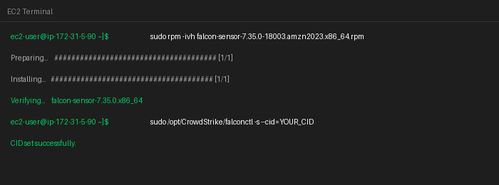
Running the install commands in the terminal
💡 Tip: Replace YOUR_CID_HERE with the actual CID .

Part 4 — Verify the Sensor is Running

Step 11 — Check Sensor Status
Run this command to confirm the sensor is active:
sudo systemctl status falcon-sensor

You should see:
- Active: active (running) — the sensor is ON ✅
- Lines mentioning CrowdStrike connections — it's talking to the cloud ✅

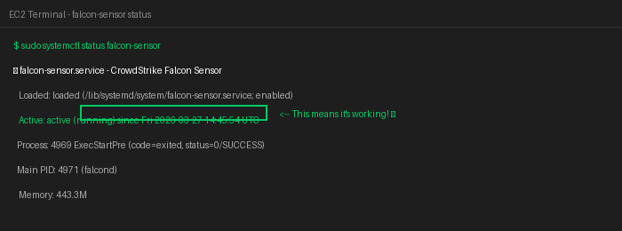
The terminal showing the sensor is 'active (running)'

Part 5 — Confirm the Host in CrowdStrike Console

Step 12 — Log in to CrowdStrike Falcon
Go to https://falcon.crowdstrike.com and log in with your credentials.
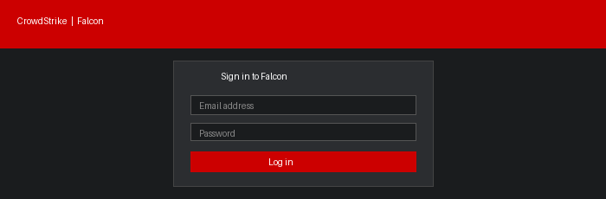
Log in to the CrowdStrike Falcon console

Step 13 — Go to Host Management
In the left menu, navigate to: Host Setup and Management > Host Management
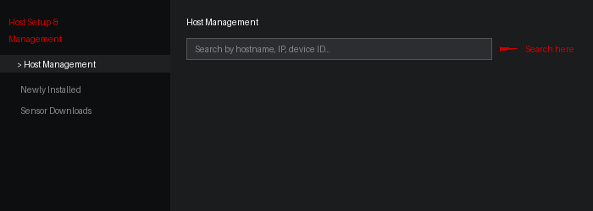
Navigate to Host Management in the left sidebar

Step 14 — Find Your EC2 and Confirm it's Online
Use the search bar to find your EC2 instance by hostname or IP address. You should see it listed with a green Online status.
Look for:
- Status: Online (green dot)
- OS: Amazon Linux 2023
- Local IP address matching your EC2

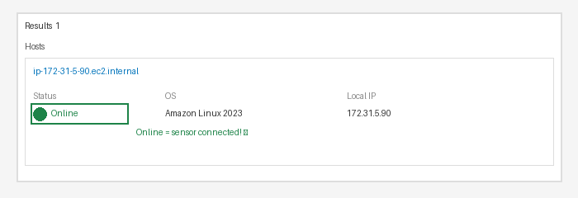
Your EC2 instance showing as 'Online' in CrowdStrike

Part 6 — Generate Activity and Check Telemetry

Step 15 — Run Commands on Your EC2
Go back to your EC2 terminal and run a few commands to generate activity:
ls -la
whoami
ps aux

Step 16 — Check Event Search in CrowdStrike
In the Falcon console, go to Investigate > Event Search. Search for your hostname. You should see events appearing — this confirms telemetry is being captured!
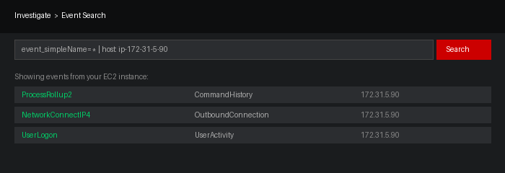
Events from your EC2 appearing in CrowdStrike Event Search
💡 Tip: It may take a minute or two for events to appear after you run commands.

Summary — What You Did

Congratulations! 🎉 Here is a quick recap of everything you accomplished:

- Launched an EC2 instance on AWS running Amazon Linux 2023
- Connected to the instance using the browser-based terminal
- Installed the CrowdStrike Falcon sensor
- Configured the CID to link the sensor to your company's account
- Verified the sensor is active and communicating with the CrowdStrike cloud
- Confirmed the host appears in CrowdStrike Host Management
- Generated activity and confirmed telemetry is being captured

