TRIANGLE CYBER

Splunk
Setup & Operations Guide

1. Overview

The Splunk Universal Forwarder is a lightweight agent that collects logs from your EC2 instance and sends them to Triangle Cyber's Splunk SIEM. This guide walks you through the full setup from start to finish.

Splunk Web URL | https://splunksiem.bluewave-redbird.com/
SIEM Hostname | ip-172-31-96-6.ec2.internal
Receiving Port | 9997 (TCP)
Forwarder Version | 10.2.3
Target OS | Amazon Linux 2023 (x86_64)

2. Prerequisites

- Your EC2 instance is Running with 3/3 status checks passed
- You have access to EC2 Instance Connect
- You know your instance's private IP (find it in EC2 console)
- You have your TC Splunk Enterprise SIEM login, this is your internal Triangle Cyber account used to access splunksiem.bluewave-redbird.com. This is NOT a Splunk.com account.
- You have your Splunk.com account (a separate login from TC’s Splunk Enterprise SIEM), which you can use to obtain the latest version of the Splunk Universal Forwarder when needed.

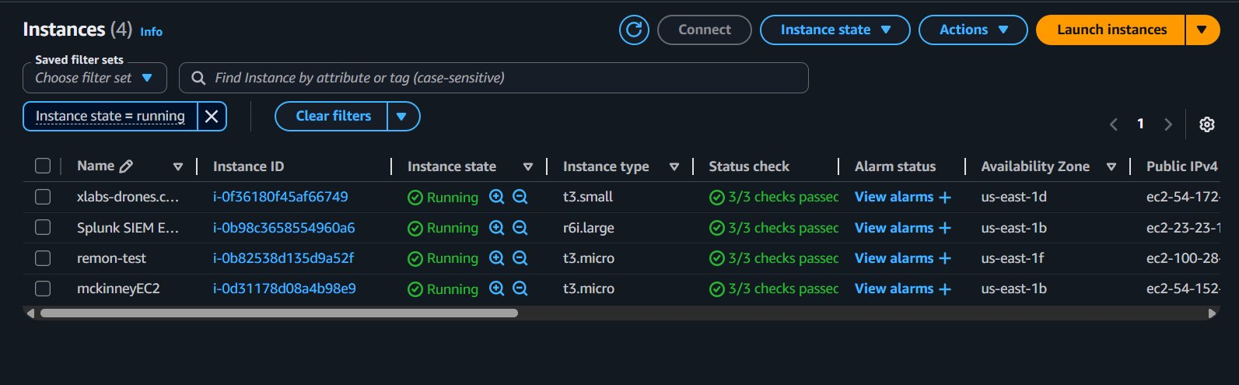
Your EC2 instance should show Running — 3/3 checks passed

3. Connect to Your EC2 Instance

Step 1: In the AWS Console, go to EC2 → Instances and select your instance.
Step 2: Click Connect → EC2 Instance Connect tab.

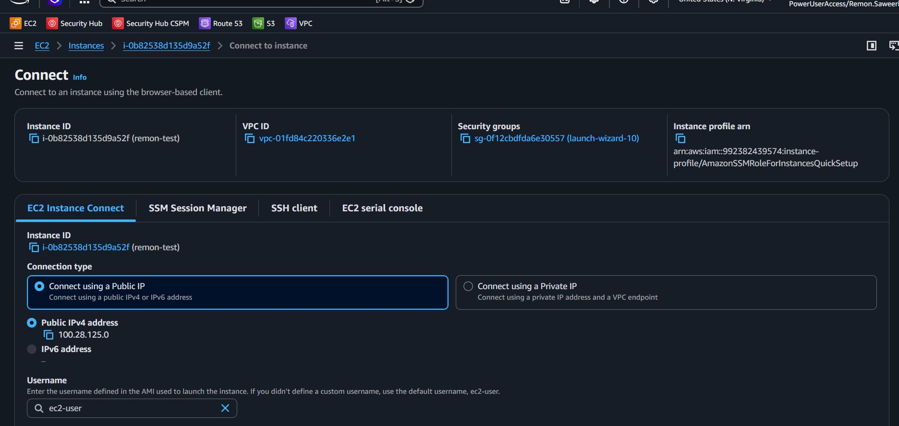
Select your instance and click Connect

Step 3: Scroll down and click the Connect button.

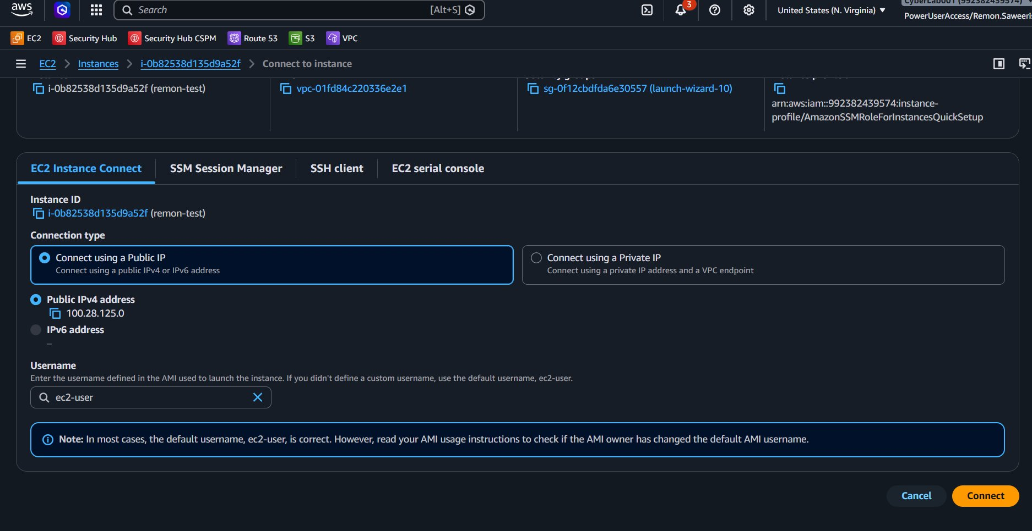
Click the Connect button at the bottom

Step 4: A browser terminal opens you are now inside your instance.

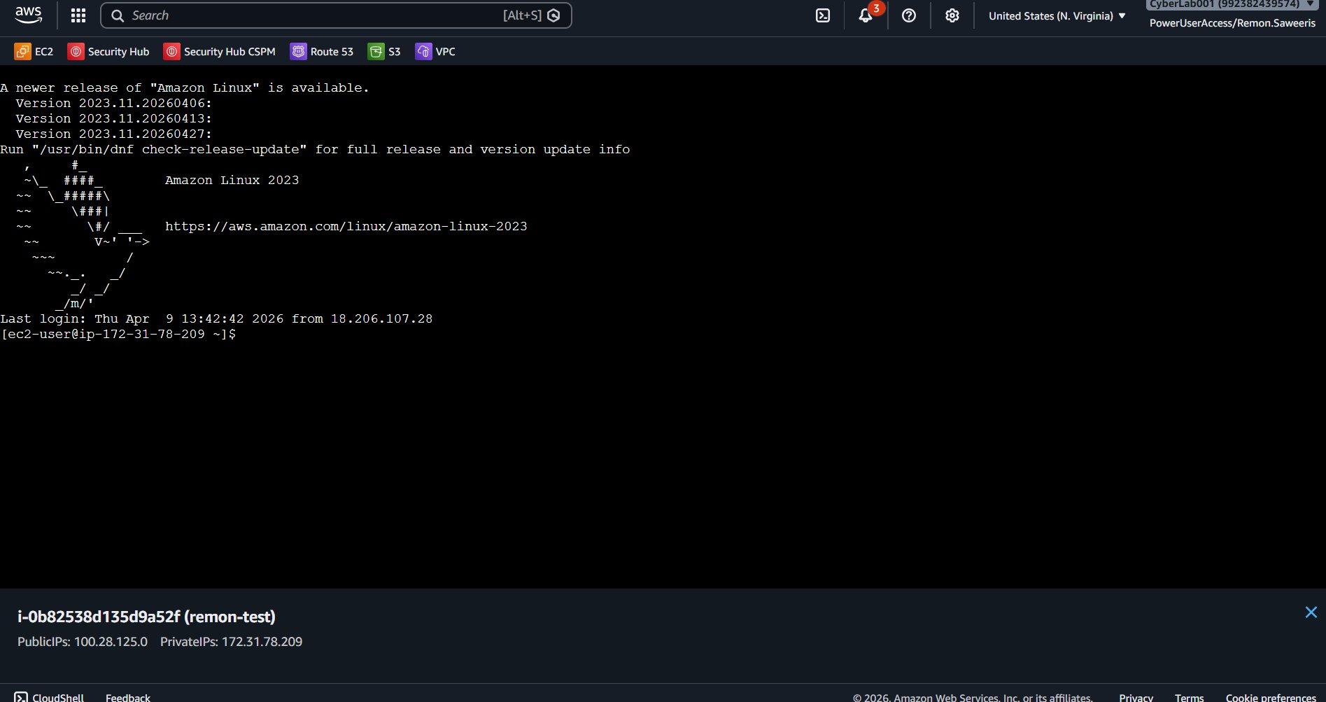
Terminal connected to your EC2 instance (Amazon Linux 2023)

4. Download the Splunk Forwarder
Step 1: Go to https://www.splunk.com/en_us/download/universal-forwarder.html, log in with your Splunk.com account, click the Linux tab, scroll to 64-bit and click Copy wget link next to .tgz. Then paste and run the copied command in your EC2 terminal. As of this writing the command is:
wget -O splunkforwarder-10.2.3-4d61cf8a5c0c-linux-amd64.tgz \
"https://download.splunk.com/products/universalforwarder/releases/10.2.3/linux/splunkforwarder-10.2.3-4d61cf8a5c0c-linux-amd64.tgz"

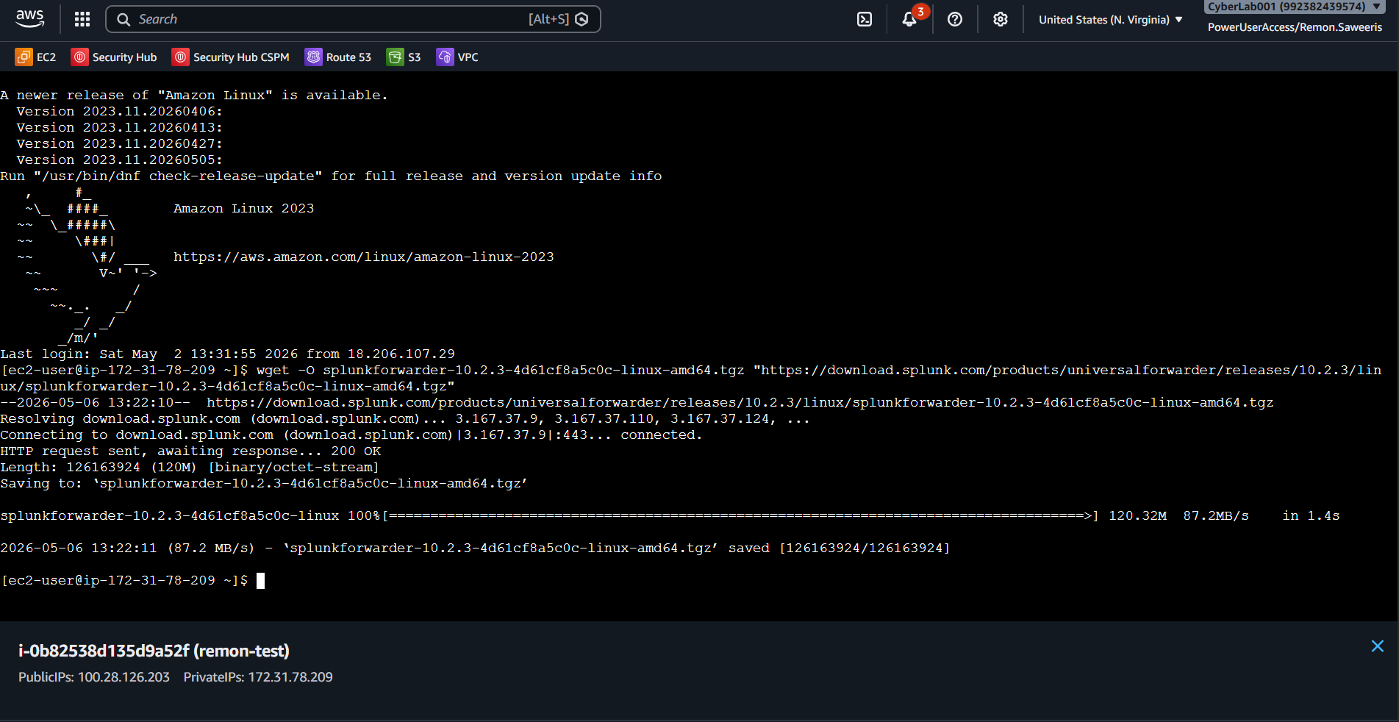
Running the wget download command

ℹ VERSION NOTE — ALWAYS USE THE SPLUNK.COM DOWNLOAD METHOD
Always download from Splunk.com using the Copy wget link method — this ensures you always get the latest available version.
The command shown above is for version 10.2.3 (current as of May 2026). The wget link from Splunk.com will always reflect the latest version.

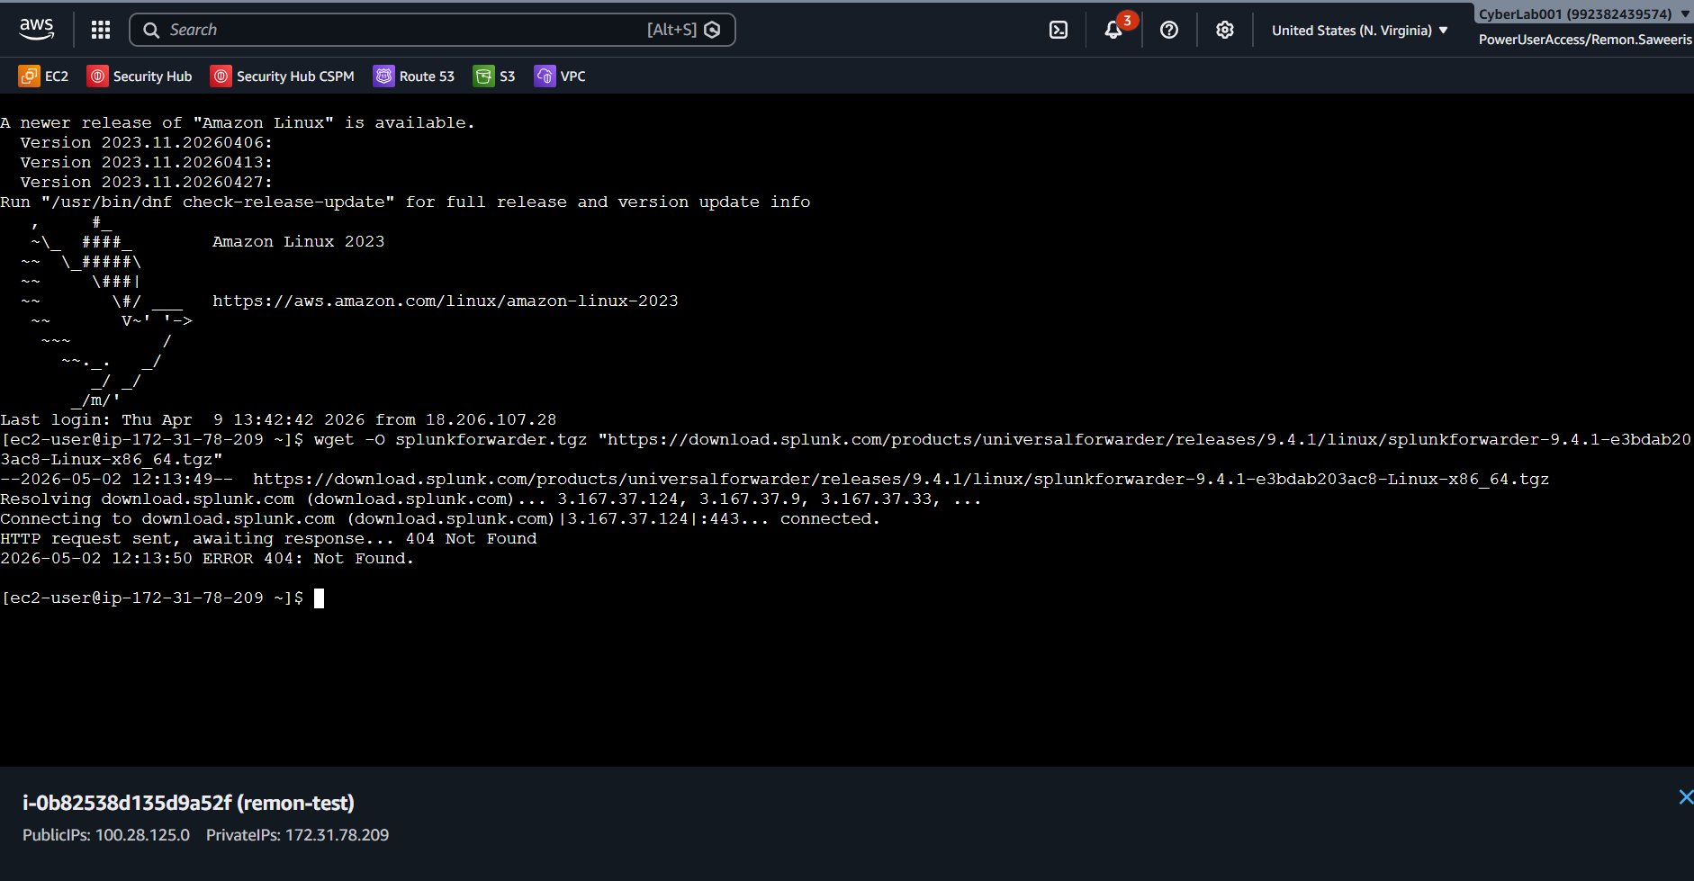
404 error from wrong version attempt (9.3.2 reference) — always use the Splunk.com download method for the latest version

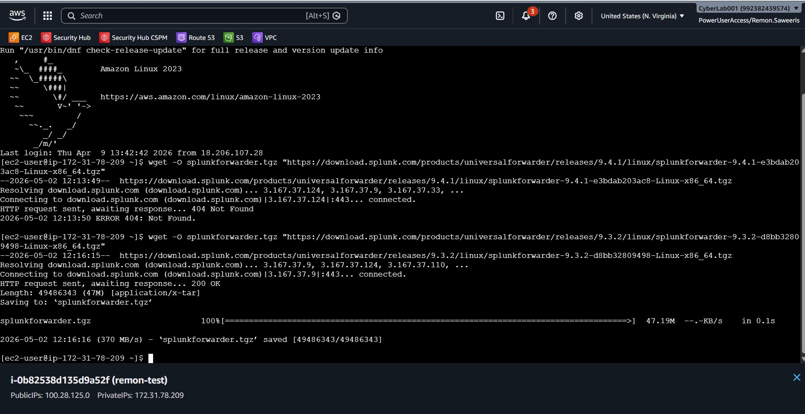
Download complete — splunkforwarder-10.2.3-4d61cf8a5c0c-linux-amd64.tgz saved (120MB)

5. Extract and Install
Step 1: Extract the downloaded file:
tar -xvzf splunkforwarder-10.2.3-4d61cf8a5c0c-linux-amd64.tgz

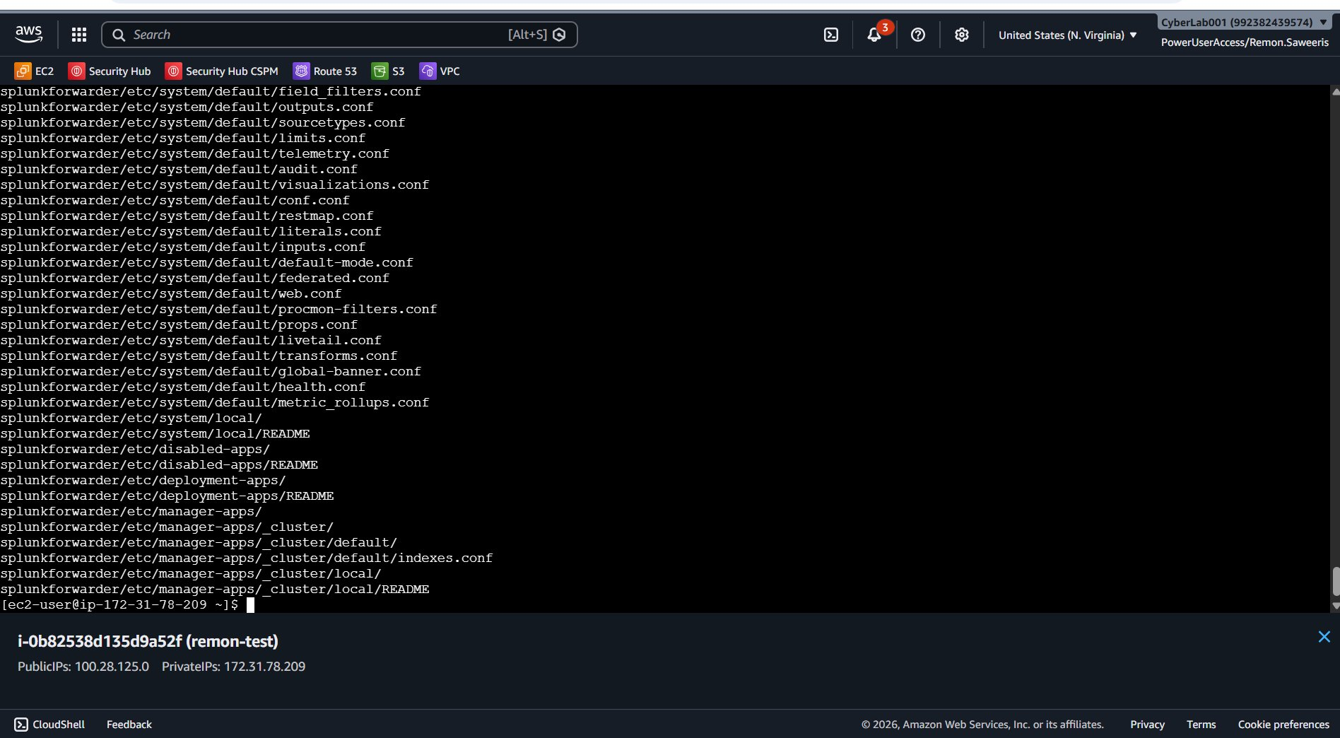
Extraction output — creates the splunkforwarder/ folder
Step 2: Start the forwarder and accept the license:
./splunkforwarder/bin/splunk start --accept-license --answer-yes

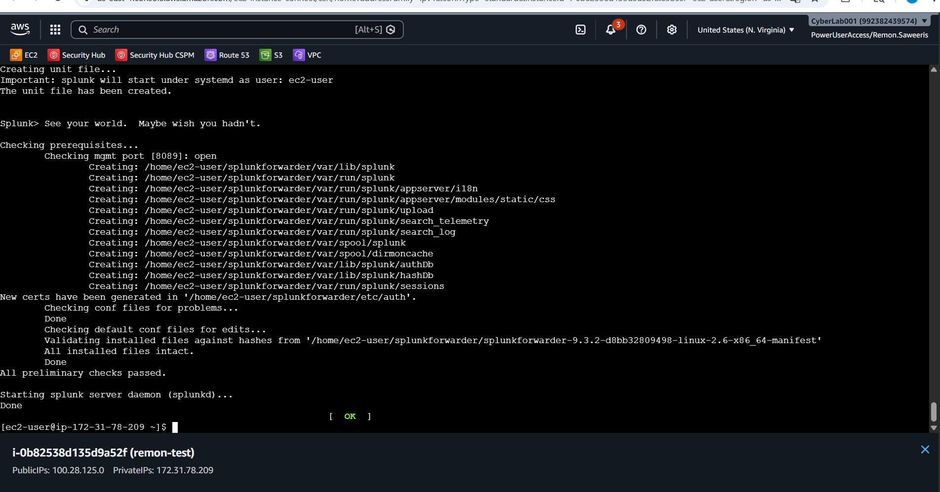
Splunk forwarder starts successfully — [ OK ] shown at the bottom

When prompted, create an admin username and password. Write it down you will need it for the next steps.

Step 3: Enable auto-start so the forwarder restarts automatically on reboot:
./splunkforwarder/bin/splunk enable boot-start
sudo systemctl enable SplunkForwarder

6. Configure the Forwarder

6.1 Point to the TC SIEM
Step 1: Run this command to tell the forwarder where to send logs:
./splunkforwarder/bin/splunk add forward-server \
ip-172-31-96-6.ec2.internal:9997 \
-auth admin:<your-password>

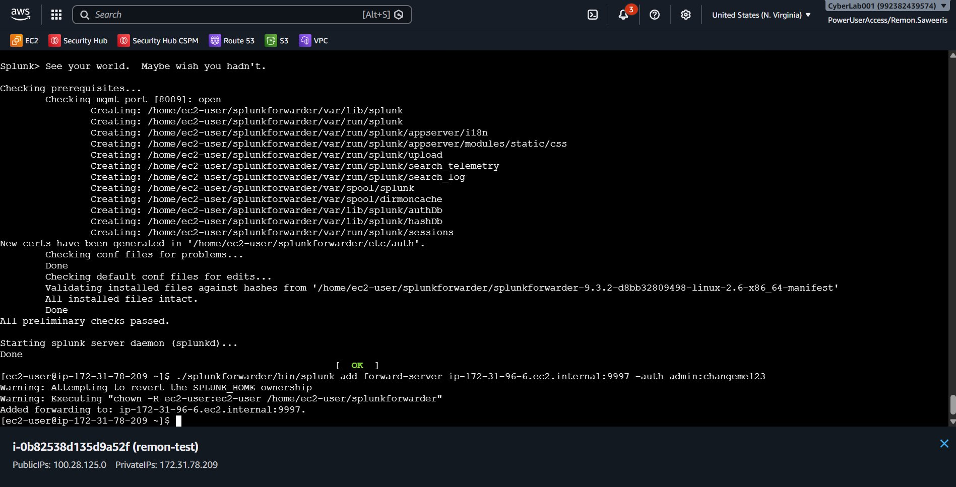
Forward-server added: 'Added forwarding to: ip-172-31-96-6.ec2.internal:9997'

6.2 Add Log Sources
Step 2: Monitor all logs in /var/log:
./splunkforwarder/bin/splunk add monitor /var/log \
-auth admin:<your-password>

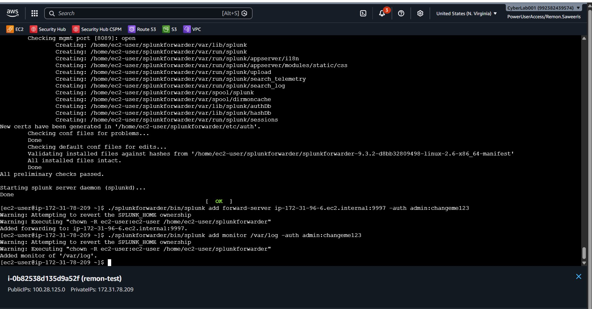
Monitor added: 'Added monitor of /var/log'

6.3 Restart the Forwarder
Step 3: Restart using systemctl (do NOT use the splunk binary directly — it will fail):
sudo systemctl restart SplunkForwarder

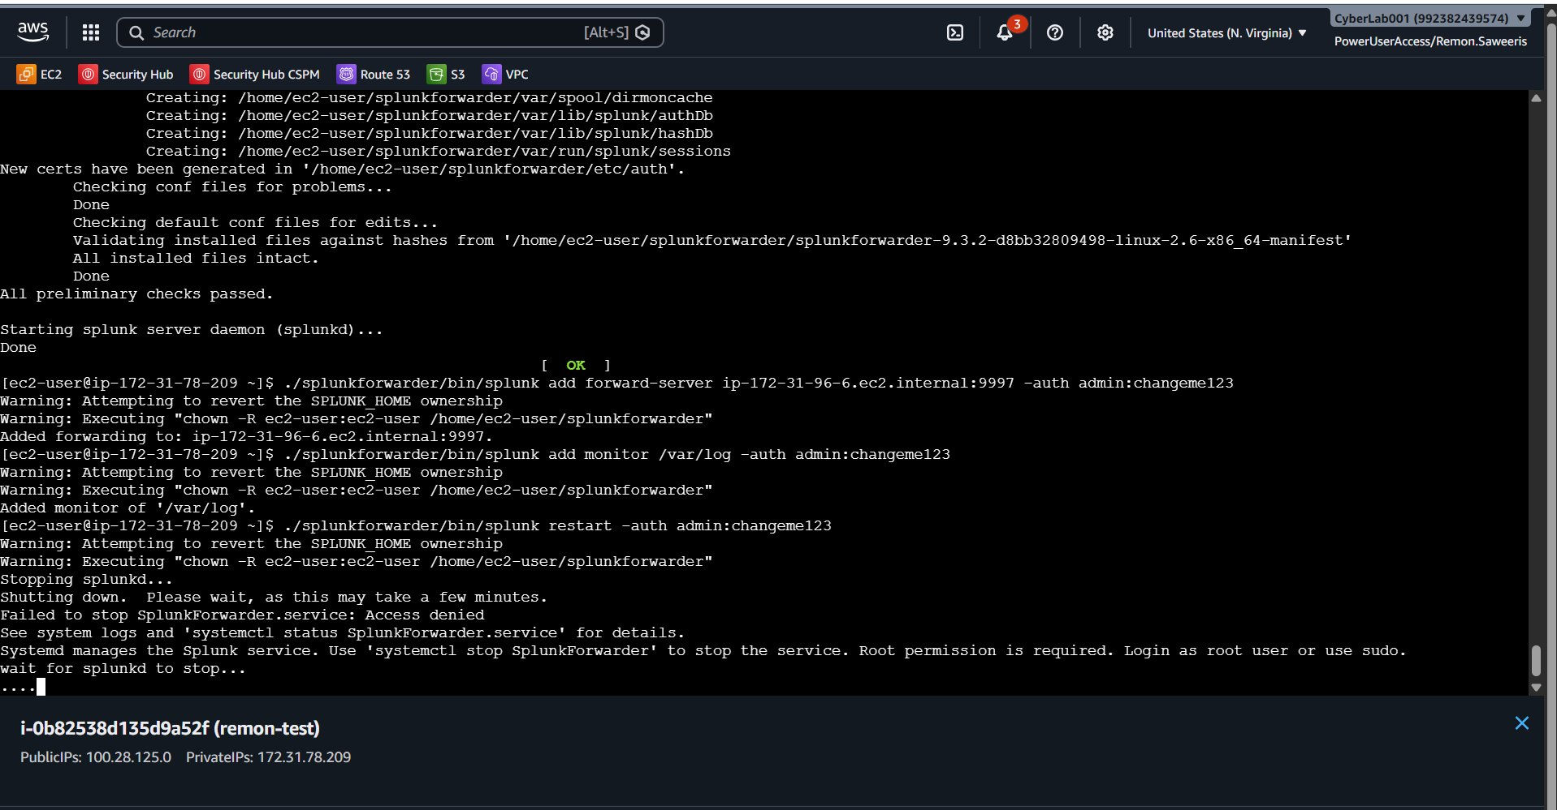
Common mistake: running restart without sudo causes 'Access denied'

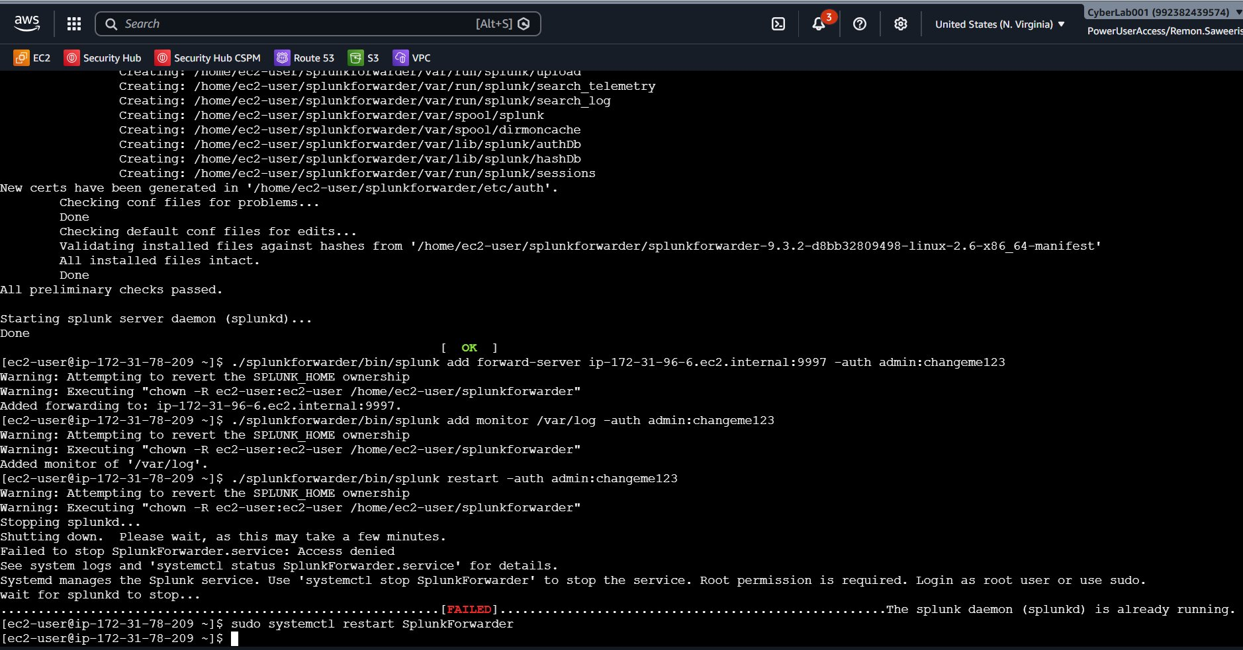
Correct: sudo systemctl restart SplunkForwarder — no errors

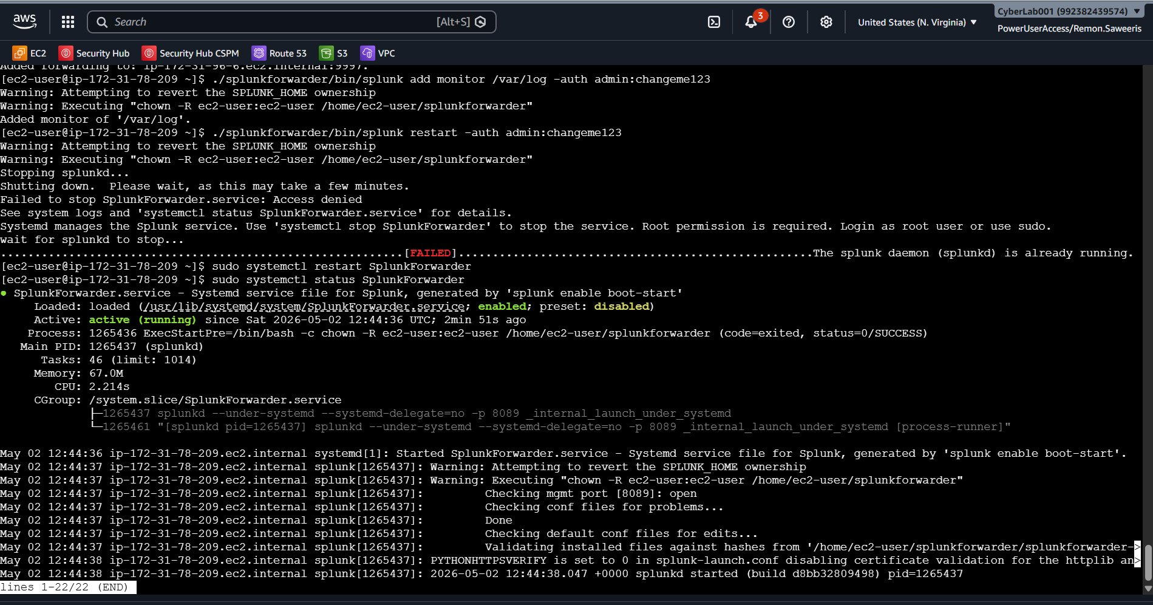
sudo systemctl status SplunkForwarder — shows Active (running) ✅

7. Open Port 9997 in the Security Group

The SIEM must allow your instance to connect on port 9997. This is a one-time setup.

Step 1: First, get your instance's private IP:
curl -s http://169.254.169.254/latest/meta-data/local-ipv4

Step 2: In AWS Console → EC2 → Security Groups, find the group named 'Splunk SIEM'.

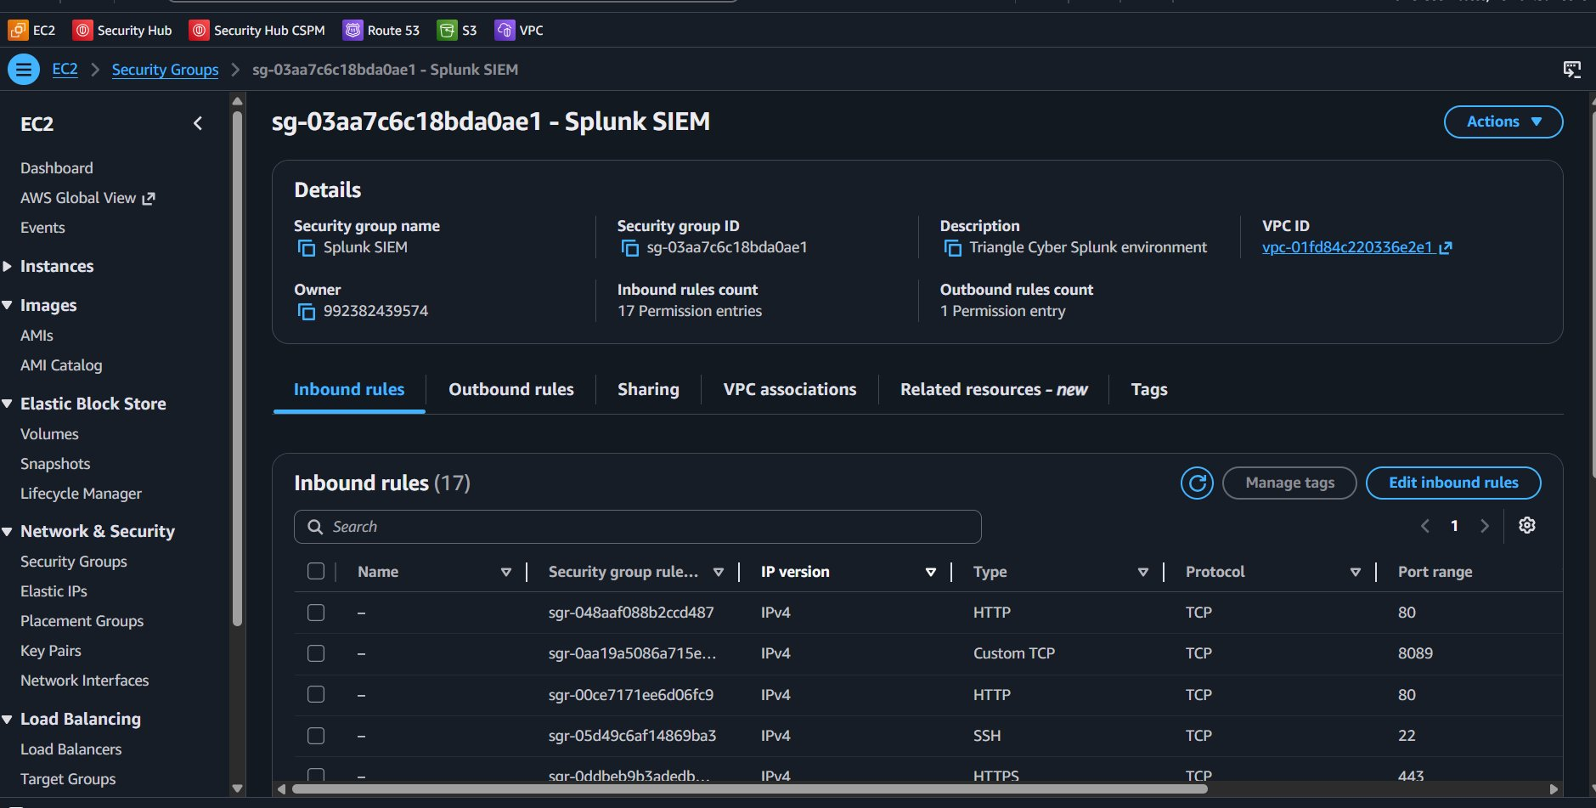
Existing inbound rules — other interns already have port 9997 rules

Step 3: Click Edit inbound rules → Add rule:
- Type: Custom TCP
- Port: 9997
- Source: your-private-ip/32 (e.g., 172.31.78.209/32)
- Description: your-name-test Splunkfwd

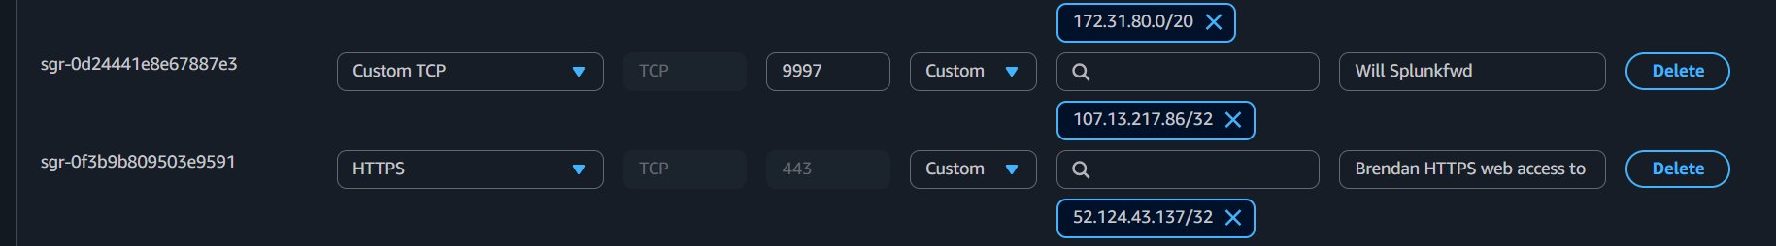
Adding the new rule — Custom TCP port 9997, source 172.31.78.209/32

Step 4: Click Save rules. You should see a green success banner.
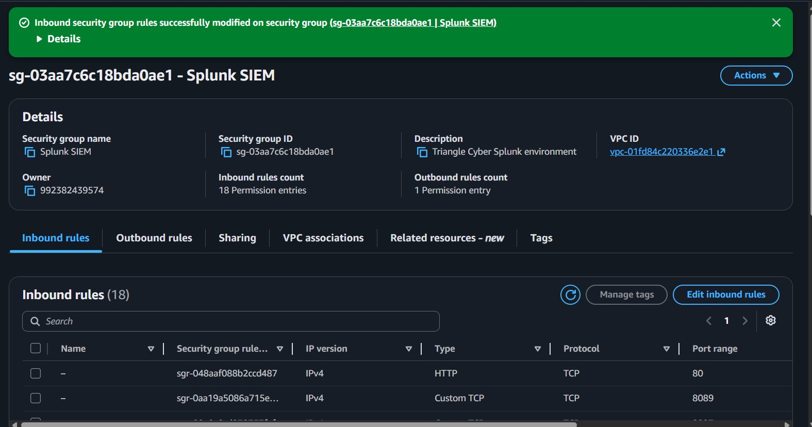
Success: 'Inbound security group rules successfully modified'
⚠ DO NOT TOUCH EXISTING RULES
Only ADD your own rule. Never edit or delete rules that belong to others.

8. Verify the Connection

8.1 Check Forward-Server Status
Step 1: Confirm the forward-server is now Active (not just Configured):
./splunkforwarder/bin/splunk list forward-server \
-auth admin:<your-password>
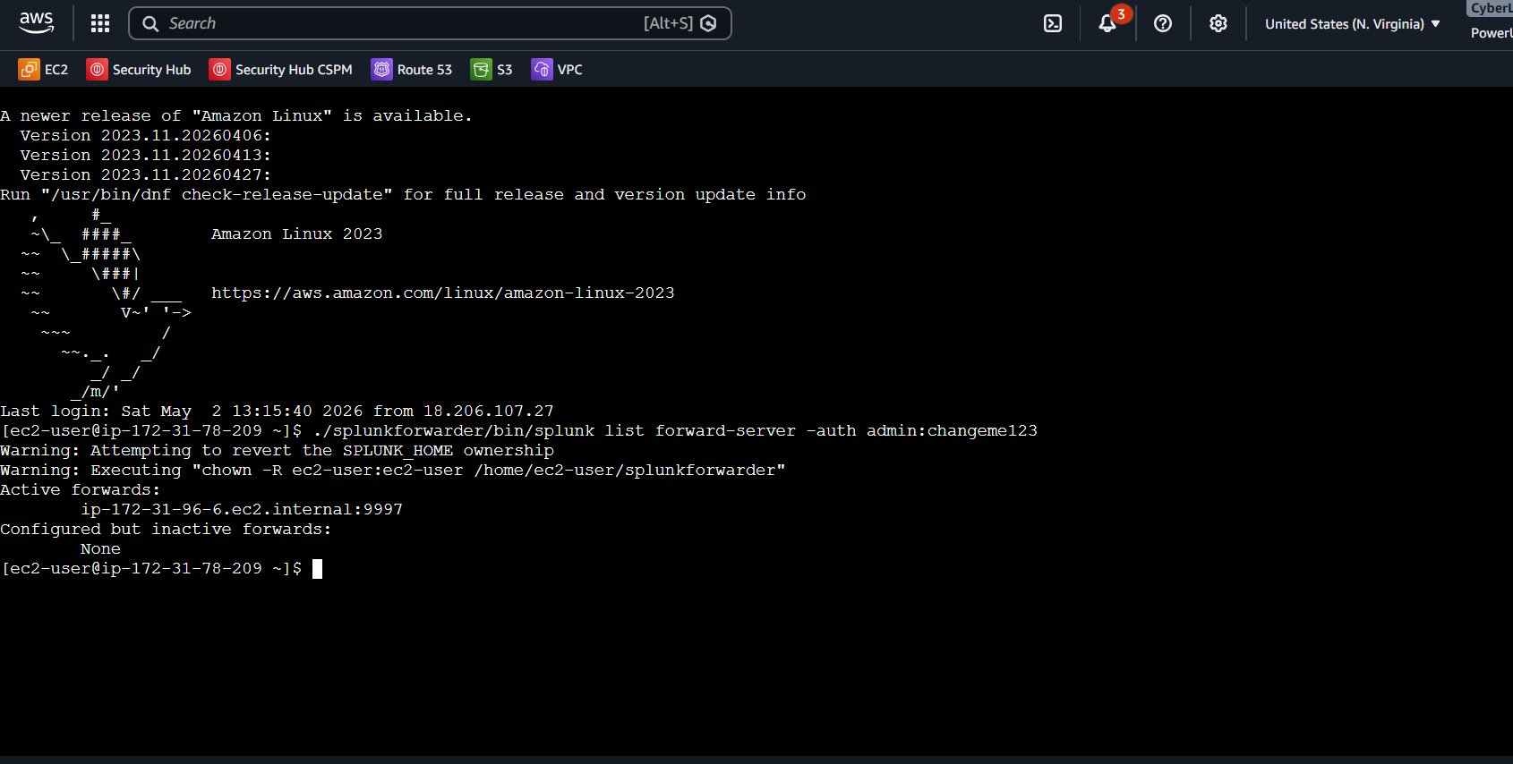
Active forwards: ip-172-31-96-6.ec2.internal:9997 ✅

Before the security group rule was added, it showed 'Active forwards: None'. Once the rule is saved it moves to Active.

8.2 Check for Events in Splunk
Step 2: Log in to Splunk Web → Search & Reporting and run:
index=* host="<your-private-ip>.ec2.internal*"

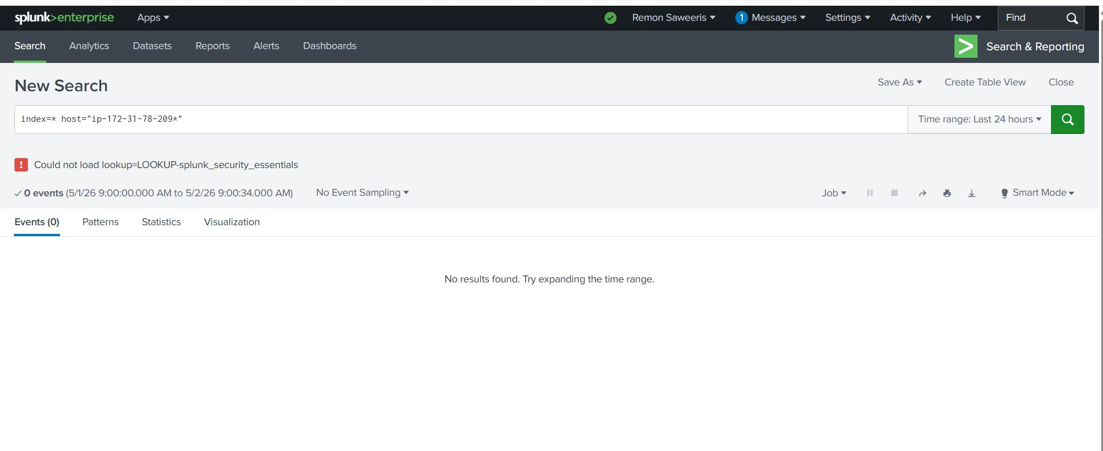
Before the security group fix — 0 events returned

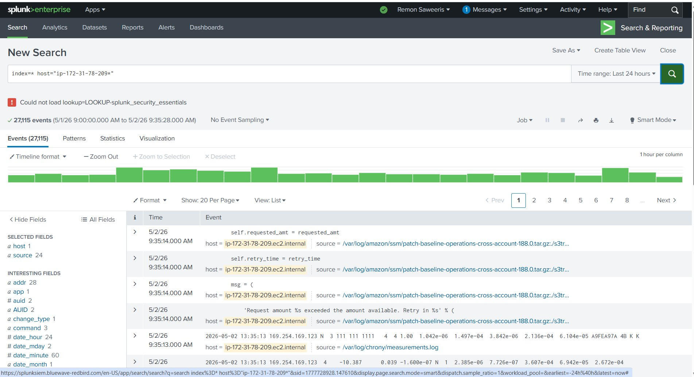
After the fix — 27,115 events flowing into Splunk ✅

8.3 Confirm 24 Log Sources
Step 3: Run this search to see all log sources being collected:
index=* host="<your-private-ip>.ec2.internal*" | stats count by source

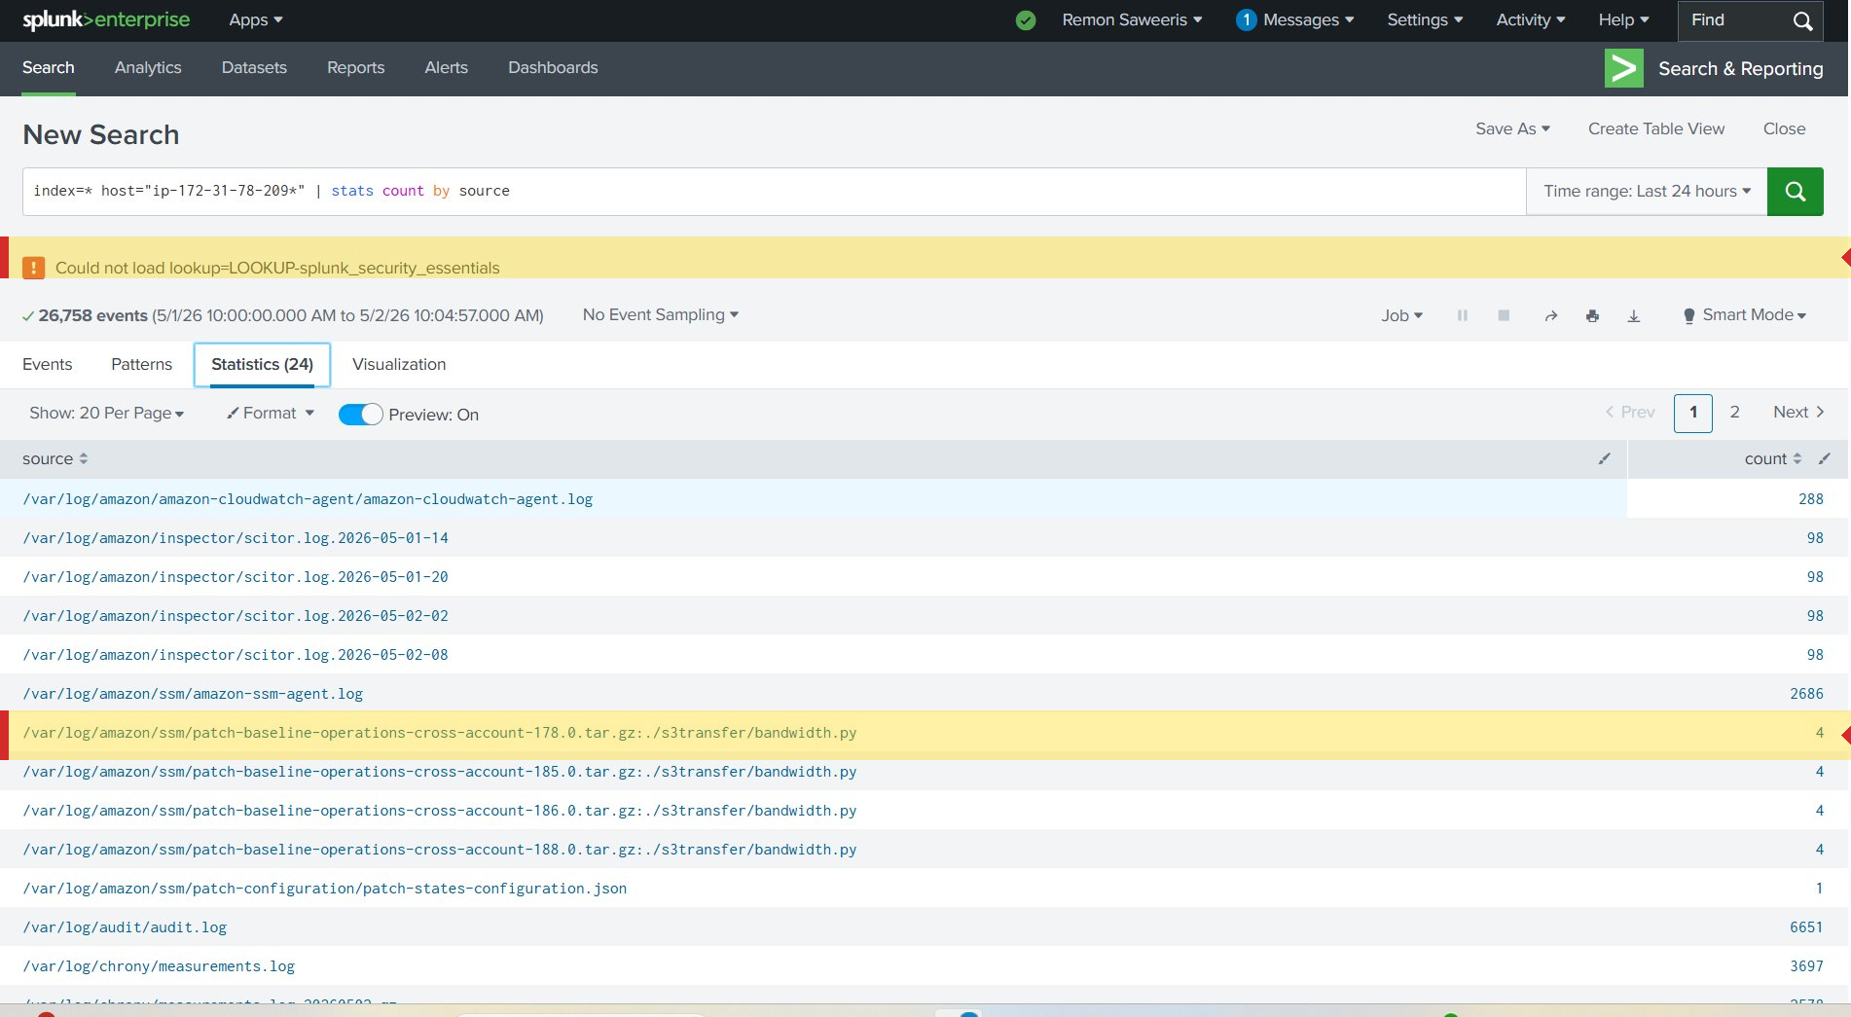
24 log sources confirmed — including audit.log, SSM, chrony, and more

✔ SETUP COMPLETE ✅
If you see 20+ sources and thousands of events, your forwarder is working correctly.
If you see 0 events, double-check: (1) security group rule saved, (2) forwarder restarted.

9. Basic Splunk Searches
Use these searches in Splunk Web → Search & Reporting. Set the time range to 'Last 24 hours'.

9.1 View All Events
index=* host="<your-private-ip>.ec2.internal*"
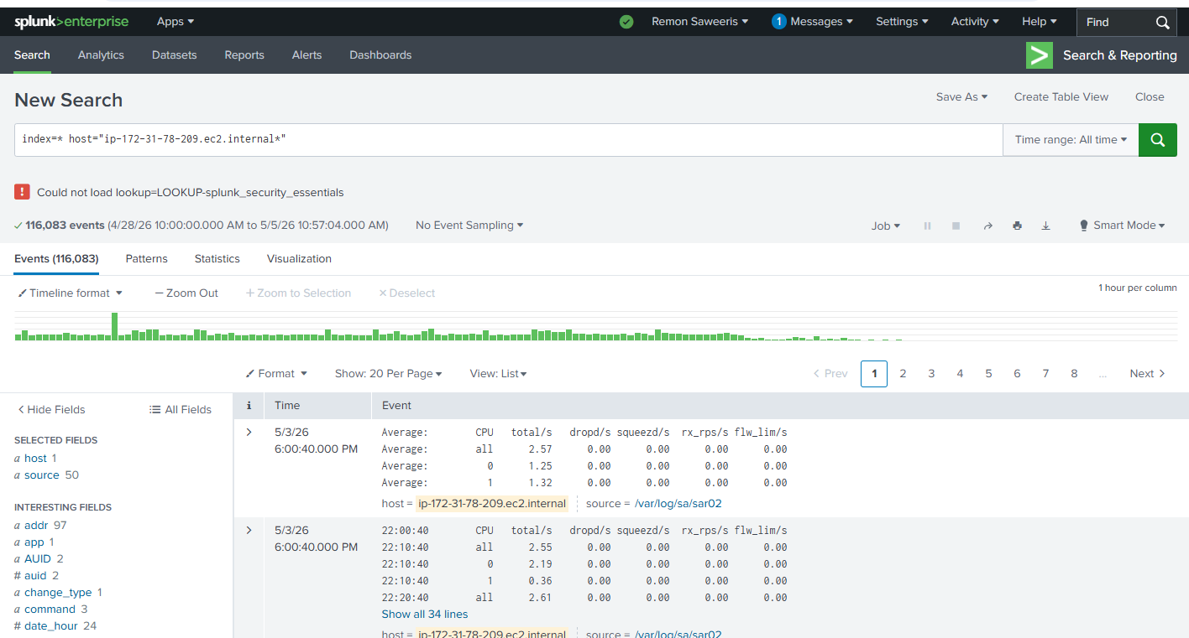

9.2 Events Over Time (Chart)
index=* host="<your-private-ip>.ec2.internal*" | timechart count

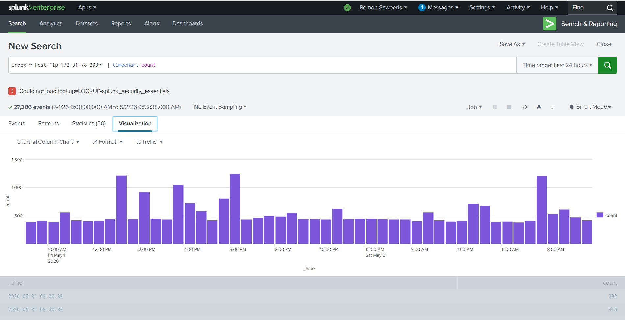
Column chart showing event count per 30-minute window over 24 hours

9.3 Failed SSH Login Attempts — Security Check
index=* host="<your-private-ip>.ec2.internal*"
source="/var/log/audit/audit.log" "failed"
| stats count by addr | sort -count
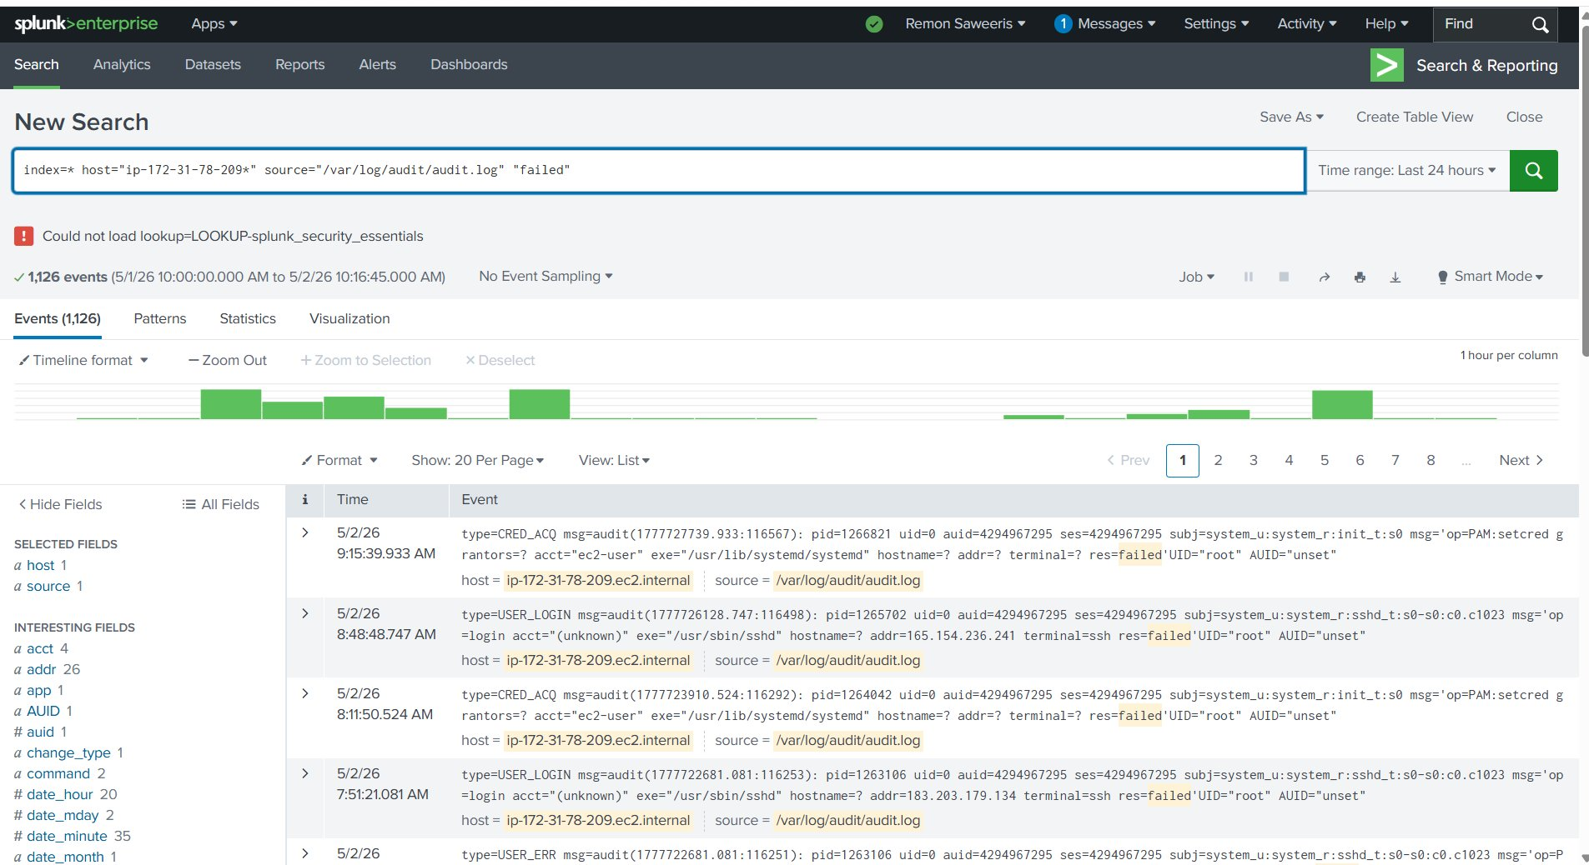
1,126 failed SSH login attempts detected — external IPs attempting brute-force

A high count from external IPs means attackers are trying to break into your instance. This is very common on public EC2 instances.

9.4 Sudo and Root Activity
index=* host="<your-private-ip>.ec2.internal*" "sudo" "root"

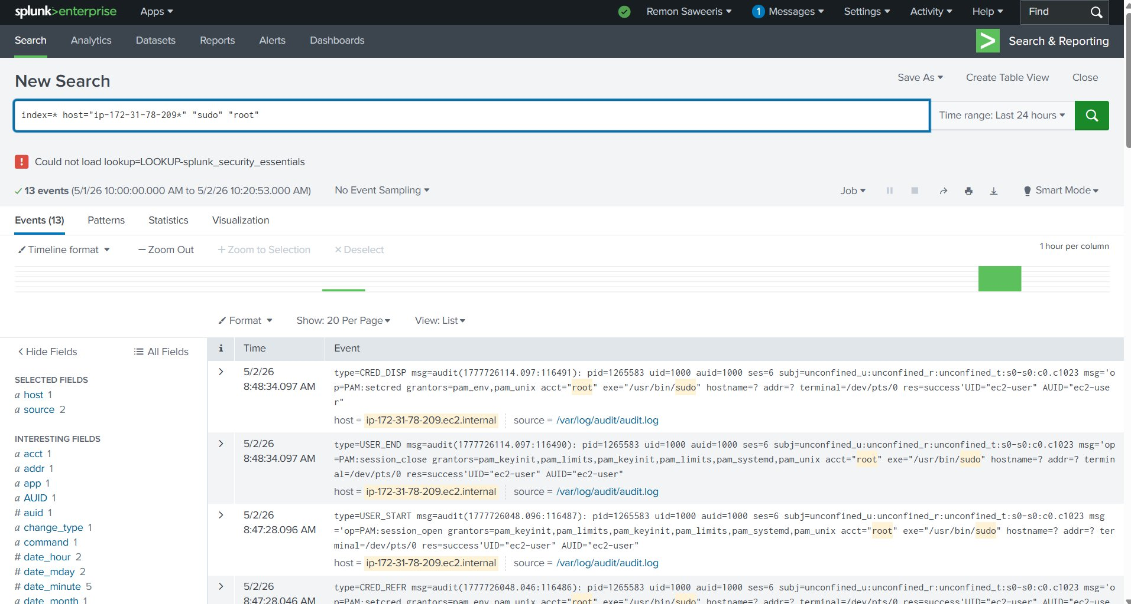
13 events showing legitimate ec2-user sudo activity

9.5 Splunk Receiving Port (Admin Reference)
For reference only the TC SIEM is configured to receive on port 9997:

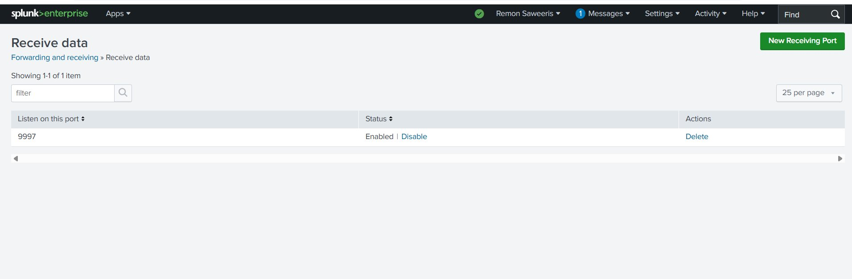

10. Troubleshooting

0 events in Splunk | Security group port 9997 rule missing or not saved
Active forwards: None | Add the security group rule, then restart the forwarder
'Access denied' on restart | Use: sudo systemctl restart SplunkForwarder
Forwarder not starting | Check disk space: df -h and memory: free -m
Can't log into Splunk Web | Contact Will Matthews — do not reset your own password

