Tenable Nessus Agent
Step-by-Step Setup Guide on AWS EC2
Triangle Cyber | Intern Guide

How This Works — Overview
Before starting, here is a quick visual of what you are setting up and how all the pieces connect.

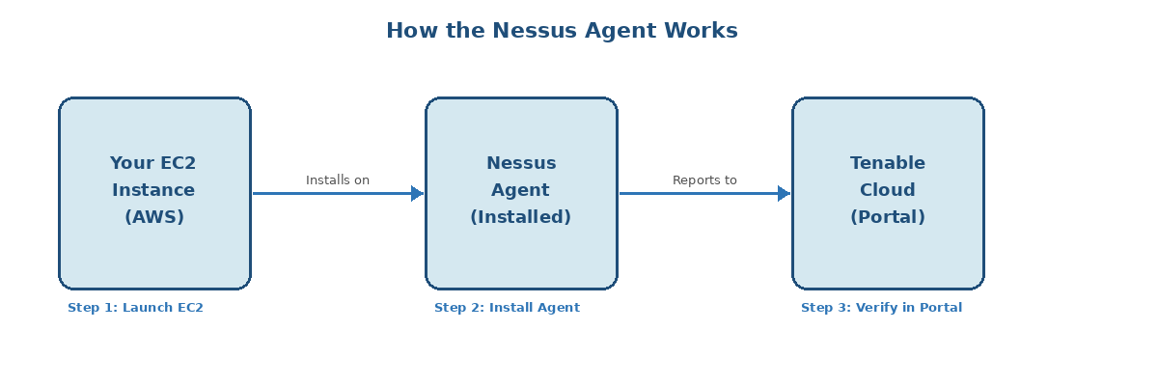
How the Nessus Agent connects your EC2 to Tenable

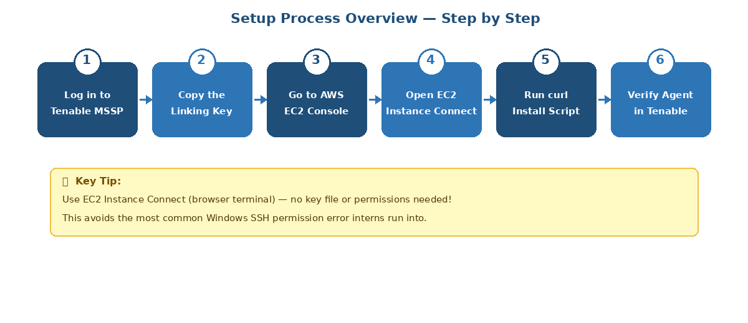
The 6 steps you will follow in this guide

What You Will Need
Before you start, make sure you have:
- An AWS account with permission to create and connect to EC2 instances
- Access to the Tenable Vulnerability Management (Tenable.io) console
- The Tenable Linking Key (found in Sensors > Nessus Agents > Settings tab)
- Basic familiarity with the Linux terminal

Part 1 — Log in to Tenable and Get the Linking Key

Step 1 — Log in to Tenable MSSP
Go to https://mssp.tenable.com and sign in with your credentials. After logging in, the portal will show the Accounts page. Scroll down past the Overview section to find Triangle Cyber under Licensing Data or Scan Results, then click on the account name to switch into it.
⚠ WARNING — Do NOT do any of the following on the MSSP page:
Do NOT check the checkbox next to any account and click the 3 dots (More) menu
Do NOT click the 3 dots under the Actions column on any account row
Do NOT click “Convert to Paid Account” or “Unlink/Delete Account”
Clicking these options could convert, unlink, or delete the Triangle Cyber tenant account. Only click directly on the Triangle Cyber account name to sign in.
⚠ WARNING — How to Properly Exit the Tenant (IMPORTANT)
When you are done working in the Triangle Cyber tenant, do NOT click the Sign Out button inside the tenant. Signing out directly from the tenant can trigger failed login attempts and lock your account.
Instead, click the blue “Impersonating as...” banner at the top of the page to return to MSSP. This is the correct and safe way to exit the tenant.

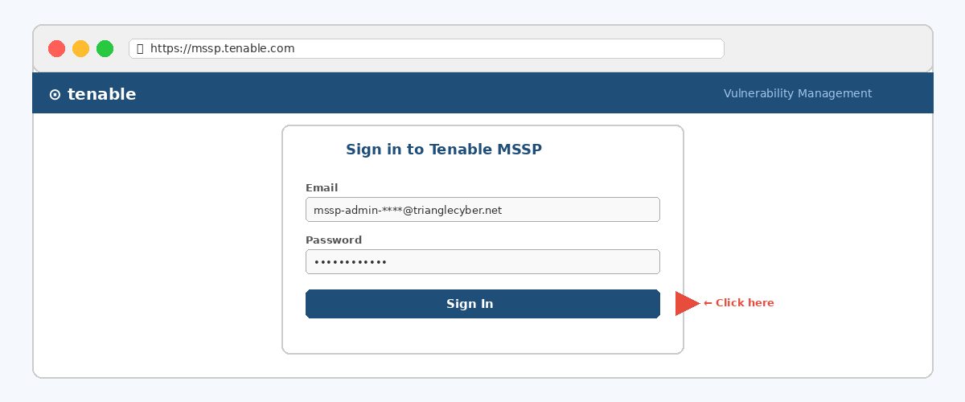

Step 2 — Navigate to Nessus Agents
Click the Settings icon (top right), then navigate to:
Sensors > Nessus Agents
You will see the Linked Agents page. This is where your EC2 agent will appear after setup.
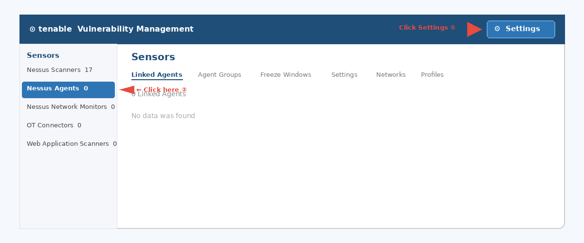

Step 3 — Get the Linking Key
Click the + Add Nessus Agent button in the top right. A panel opens on the right side showing your Linking Key. Copy the full key — you will need it in Part 3.

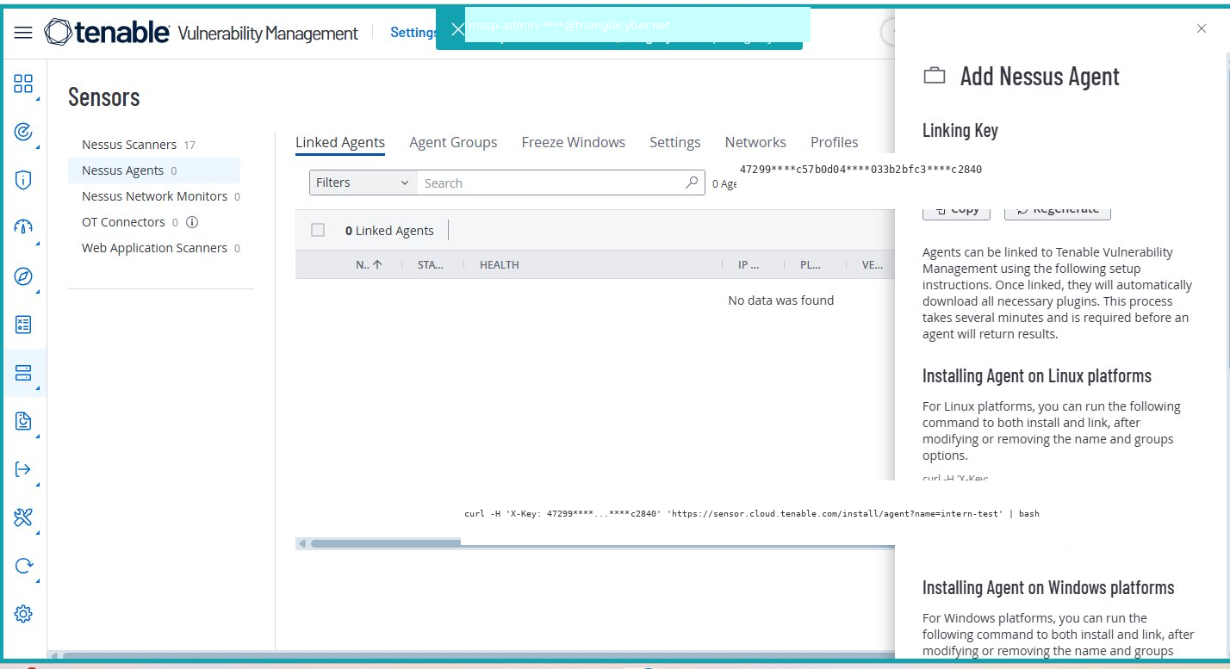
Tenable — Add Nessus Agent panel showing the Linking Key (sensitive data masked with ****)

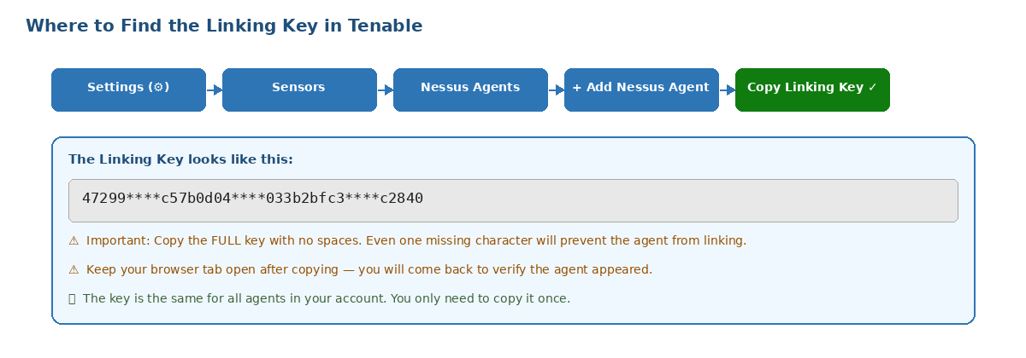
Where to find the Linking Key — navigation path and what it looks like

💡 Tip:
Copy the full linking key with no extra spaces — even one missing character will prevent the agent from linking.
Keep this browser tab open. You will come back here in Part 4 to verify the agent connected.

Part 2 — Connect to Your EC2 Instance

Step 4 — Find Your EC2 in AWS
Go to https://aws.amazon.com and sign in. Search EC2 in the top bar, click Instances, find your EC2 and click on it, then click the Connect button at the top.

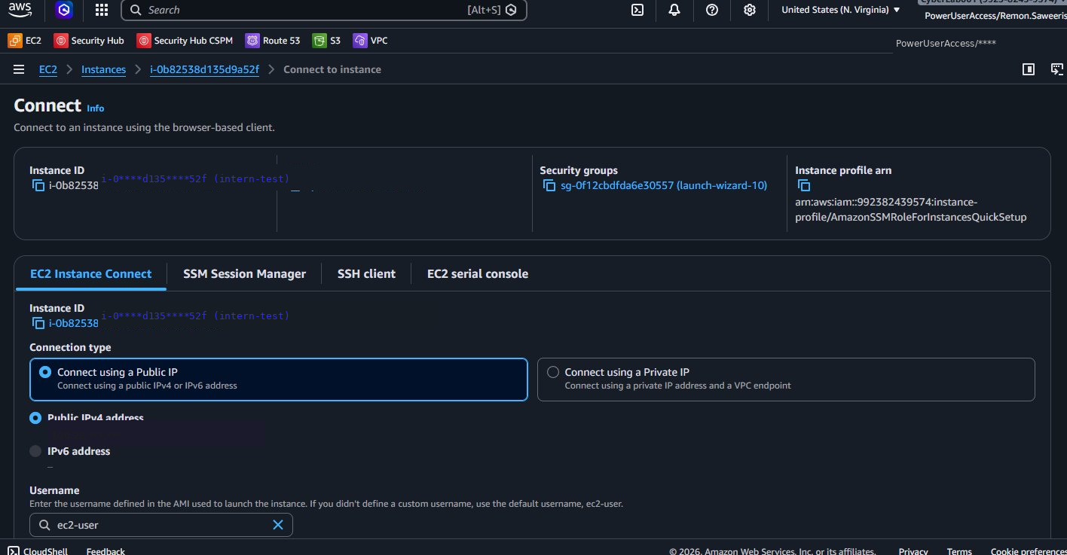
AWS EC2 — Connect to Instance page with EC2 Instance Connect tab selected

Step 5 — Open the Browser Terminal
In the Connect dialog, the EC2 Instance Connect tab should already be selected. Leave everything as default and click Connect. A black terminal window will open in your browser — that is your EC2!

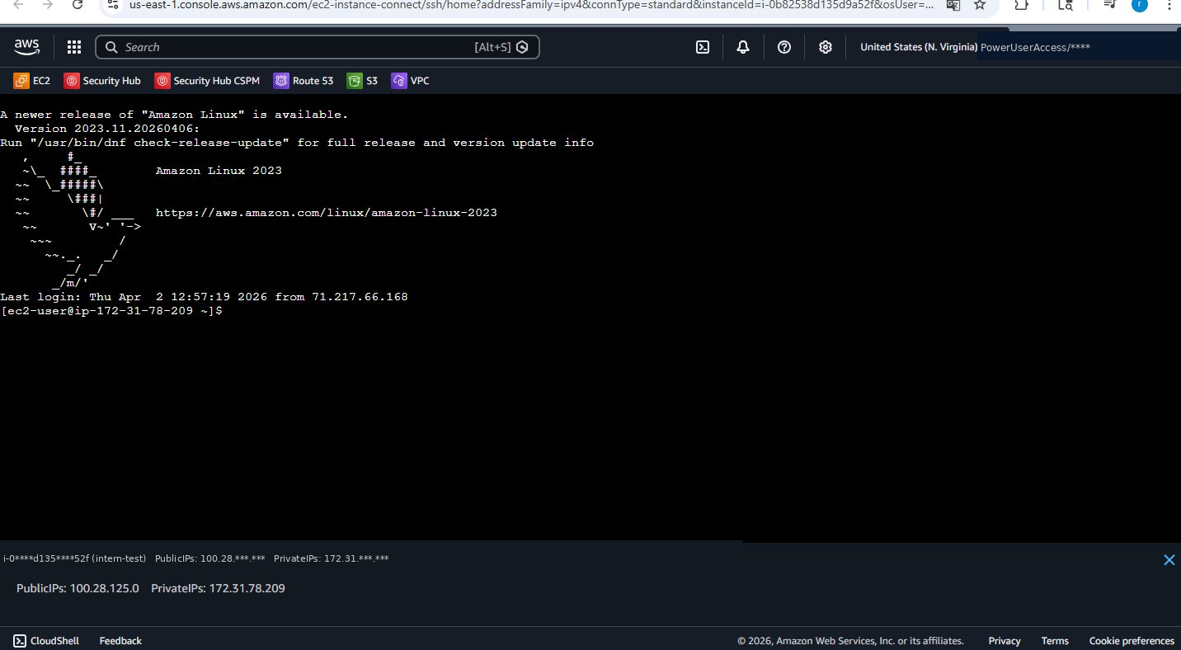
Browser terminal connected to EC2 showing Amazon Linux prompt

💡 Tip:
EC2 Instance Connect is the easiest way to connect — no key file or permission setup needed.
This avoids the most common Windows SSH error that first-time users run into (see FAQ at the end).

Other Connection Method — SSH from Windows PowerShell
If EC2 Instance Connect is not available, you can connect from PowerShell using your .pem key file.
⚠ Windows Users — Common Problem:
You may get: WARNING: UNPROTECTED PRIVATE KEY FILE
This means the .pem file permissions are too open on Windows. Fix it by running:
icacls "C:\Users\YourUsername\Downloads\****.pem" /inheritance:r /grant:r "domain\username:(R)"
Run whoami in PowerShell first to find your exact domain\username.

Once permissions are fixed, connect with:
ssh -i "C:\Users\YourUsername\Downloads\YourKey.pem" ec2-user@YOUR_EC2_PUBLIC_IP

Part 3 — Install the Nessus Agent

Nessus Agent Compatibility Table
Use this table to find the correct install method for your operating system before starting.

Operating System | File Type | Install Command | Notes
Amazon Linux 2023 | .rpm (x86_64) | curl install script (recommended) | This guide uses this OS
Amazon Linux 2 | .rpm (x86_64) | sudo rpm -ivh NessusAgent*.rpm | Use EC2 Instance Connect
RHEL / CentOS 7-9 | .rpm (x86_64) | sudo rpm -ivh NessusAgent*.rpm | Use SSH to connect
Ubuntu 16.04-22.04 | .deb (amd64) | sudo dpkg -i NessusAgent*.deb | SSH user: ubuntu
Windows Server | .msi installer | Run .msi as Administrator | Use RDP to connect
Windows 10 / 11 | .msi installer | Run .msi as Administrator | Local machine install

Step 6 — Run the Tenable Cloud Install Script
This is the recommended method. It automatically downloads and installs the correct agent version for your OS — no file transfer needed.
In your EC2 terminal, run this command (replace the values shown):

sudo curl -H 'X-Key: YOUR LINKING KEY HERE' \
'https://sensor.cloud.tenable.com/install/agent?name=YOUR-AGENT-NAME&groups=agent-group' | sudo bash

💡 What to replace:
YOUR_LINKING_KEY_HERE — paste the full linking key you copied from Tenable in Step 3
YOUR AGENT NAME — give your agent a name that will appear in Tenable (e.g. intern-test)
agent-group — you can change this or remove &groups=agent-group if not needed

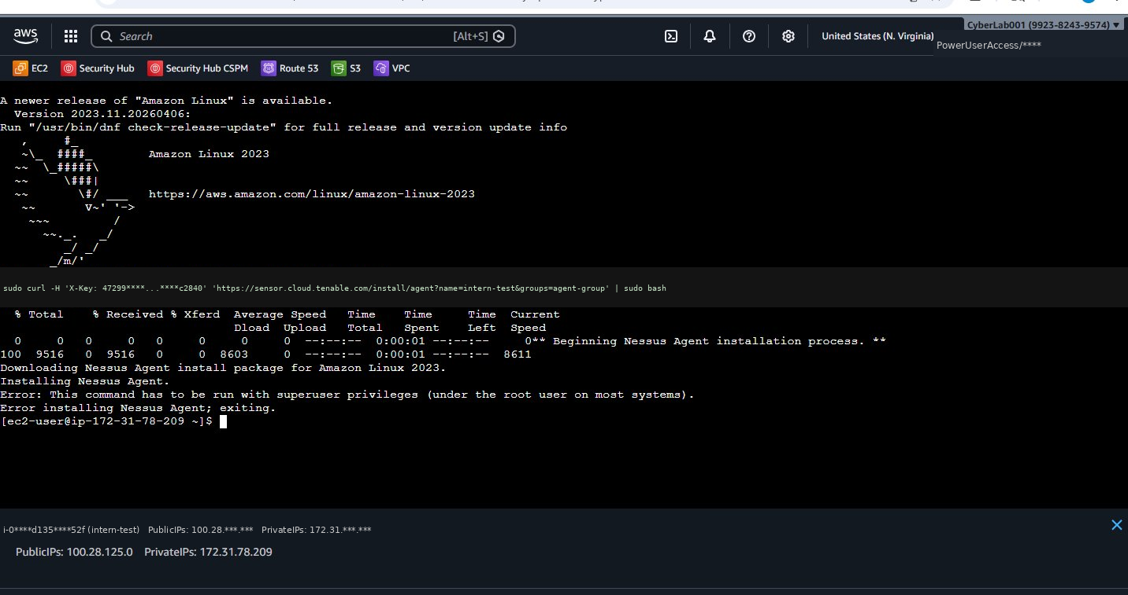
Terminal — Tenable install script downloading and running

Step 7 — Wait for Installation to Complete
Watch the terminal output. You will see it go through these stages:
- Downloading Nessus Agent install package for Amazon Linux 2023
- Installing Nessus Agent
- Complete!
- Applying auto-configuration
- Starting Nessus Agent
- Waiting for Nessus Agent to start and link...

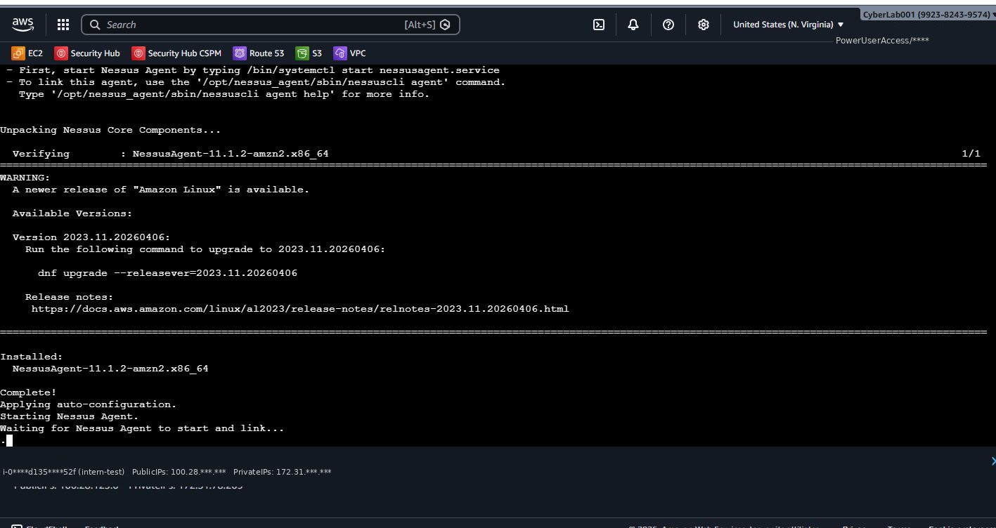
Terminal — Installation complete, agent starting and linking

Part 4 — Verify the Agent in Tenable

Step 8 — Check the Linked Agents List
Go back to your Tenable browser tab. Navigate to Settings > Sensors > Nessus Agents and refresh. Your EC2 should appear under Linked Agents with a green Online status. It may take up to 5 minutes.

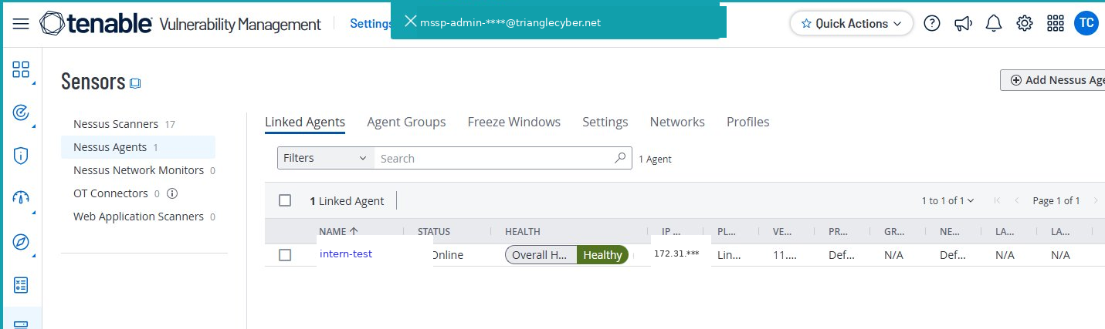
Tenable — Nessus Agents page showing agent with Online status

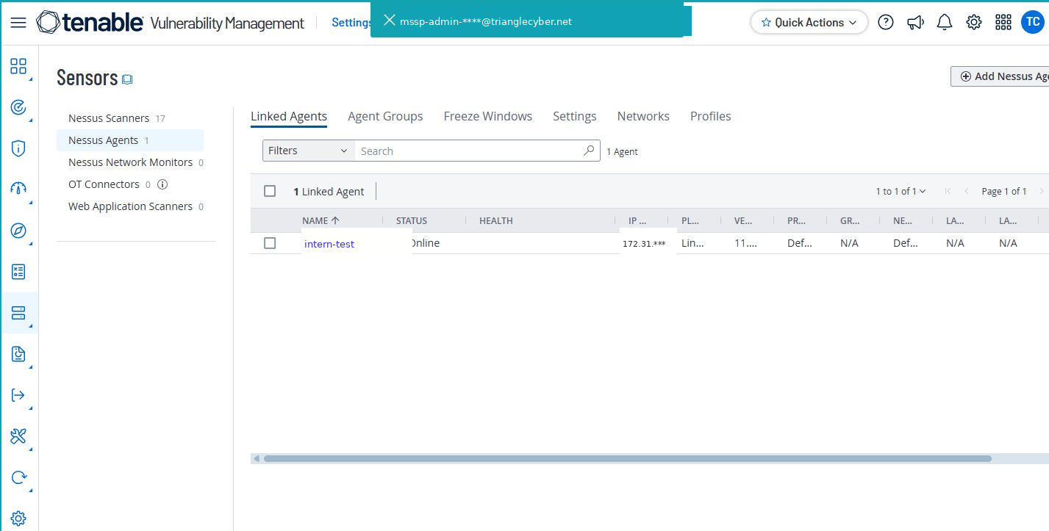
Tenable — Agent showing Online status and Overall Health: Healthy

Step 9 — Review Agent Details
Click your agent name to open the details. In the Overview tab, confirm:
- Status: Online (green dot)
- Platform: Linux (amzn2-x86-64)
- Version: 11.1.2 or later
- AWS Instance ID matching your EC2
- Linked On: today’s date and time

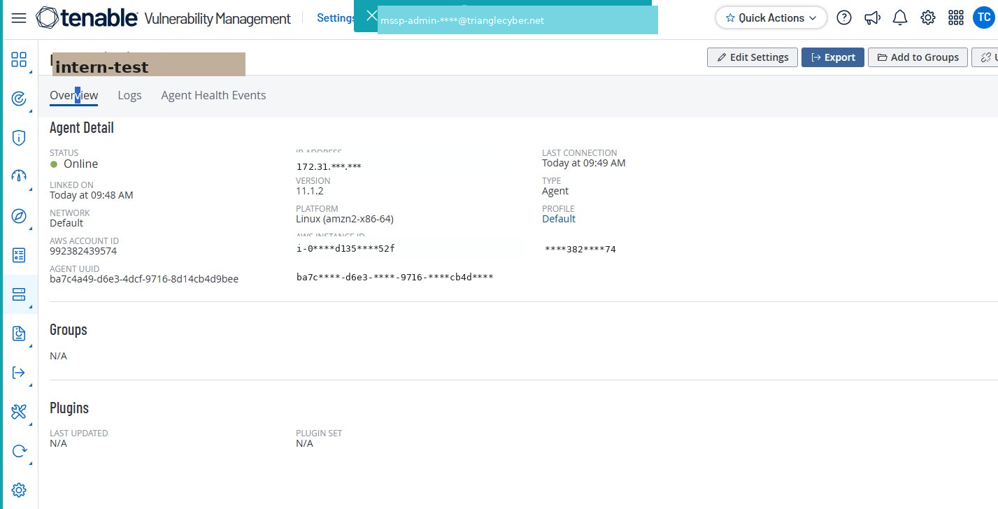
Tenable — Agent Overview showing details (sensitive data masked with ****)

Step 10 — Check Agent Health
Click the Agent Health Events tab. All 4 checks should show Healthy:
- System Disk Usage — Healthy
- Plugin Disk Usage — Healthy
- Plugin Integrity — Healthy
- Plugin Compilation — Healthy

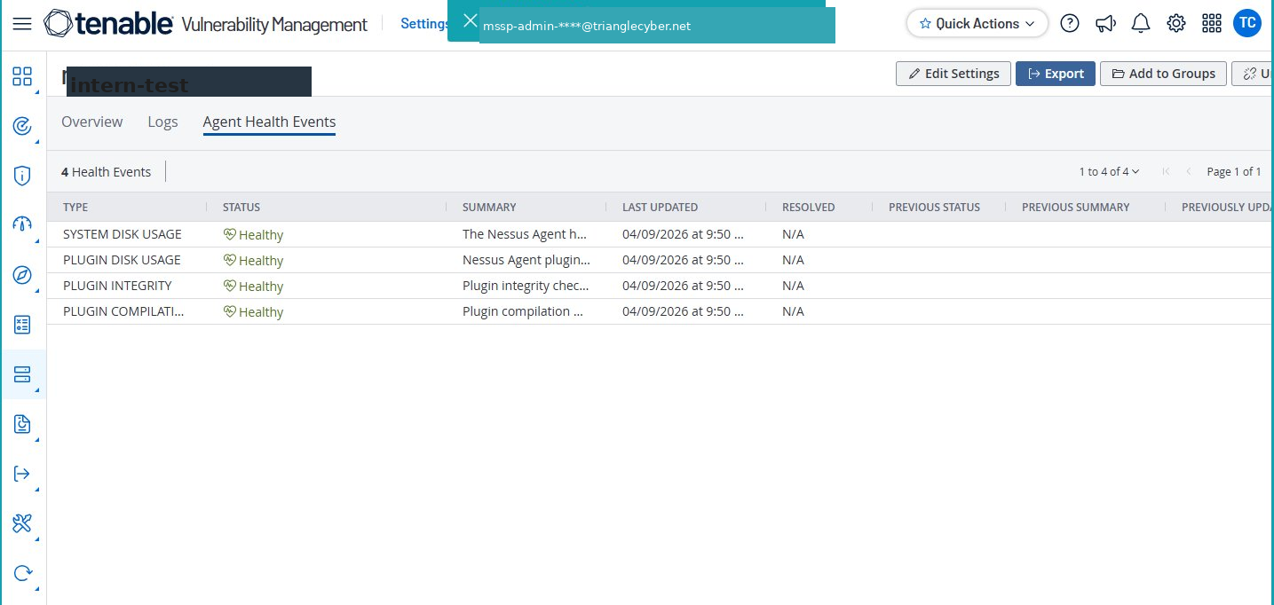
Tenable — Agent Health Events tab showing all 4 checks as Healthy

Part 5 — Web Application Scanning (WAS)
Tenable Web App Scanning (WAS) is a separate tool from the Nessus Agent. While the Nessus Agent scans your server infrastructure, WAS scans websites for vulnerabilities like SQL injection, XSS, and misconfigurations.

⚠ Important — Authorization Required:
Before scanning any website you do not own, you must get written authorization from the owner first.
Scanning without permission is unauthorized access, even if the intent is to help.

Step 1 — Access Web App Scanning
Log into Tenable MSSP at https://mssp.tenable.com. On the Accounts page, right-click on Triangle Cyber and click Sign In.

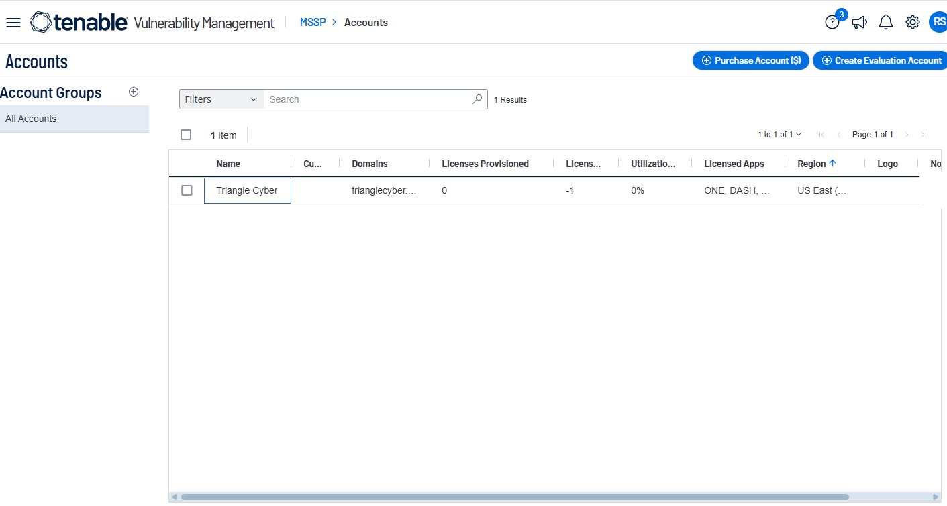
MSSP Accounts page — right-click Triangle Cyber
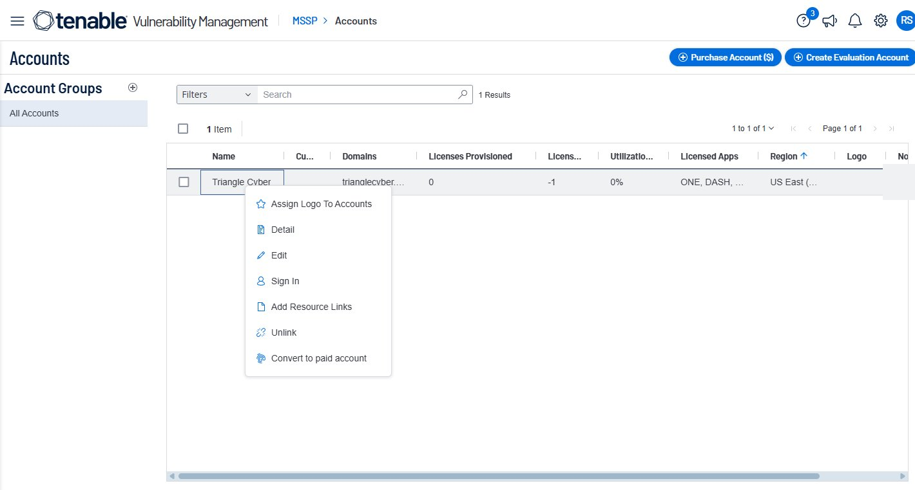
Click Sign In from the menu to switch into the account

On the Workspace page that opens, scroll down and click Web App Scanning (IN TRIAL) to open it.

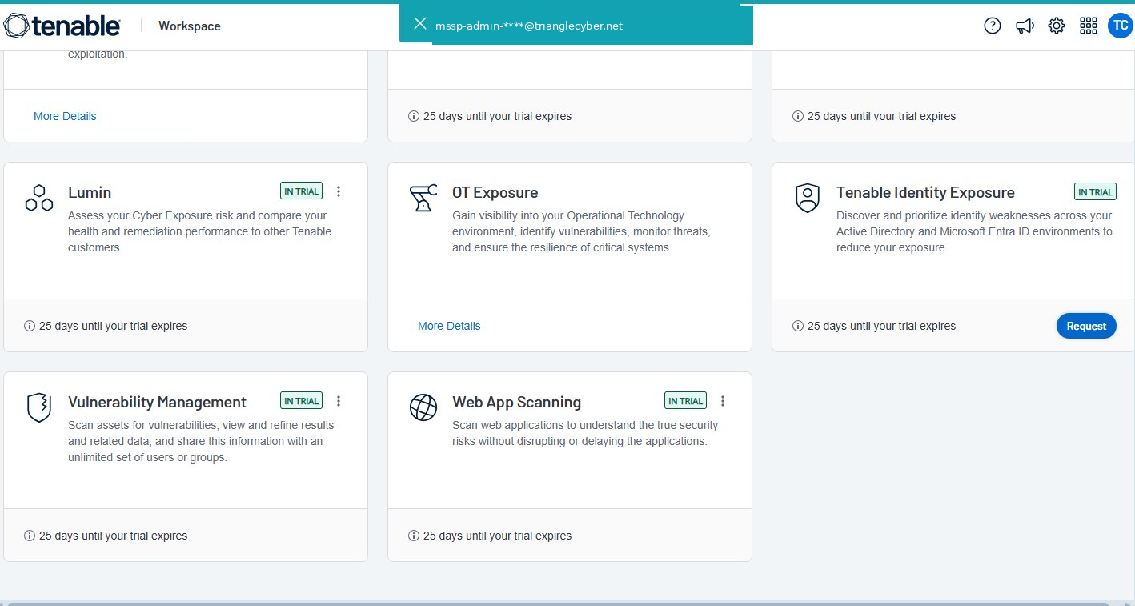
Tenable Workspace — click Web App Scanning to open it

Step 2 — Add Your Website as an Application
Inside Web App Scanning, click the Applications icon in the left sidebar. Then click + Add Application in the top right and fill in the form:
- Name: Give the site a name (e.g. trianglecyber.net)
- URL: Enter the full URL (e.g. https://www.trianglecyber.net)
- Tags: Leave empty for now
Then click Add Application.

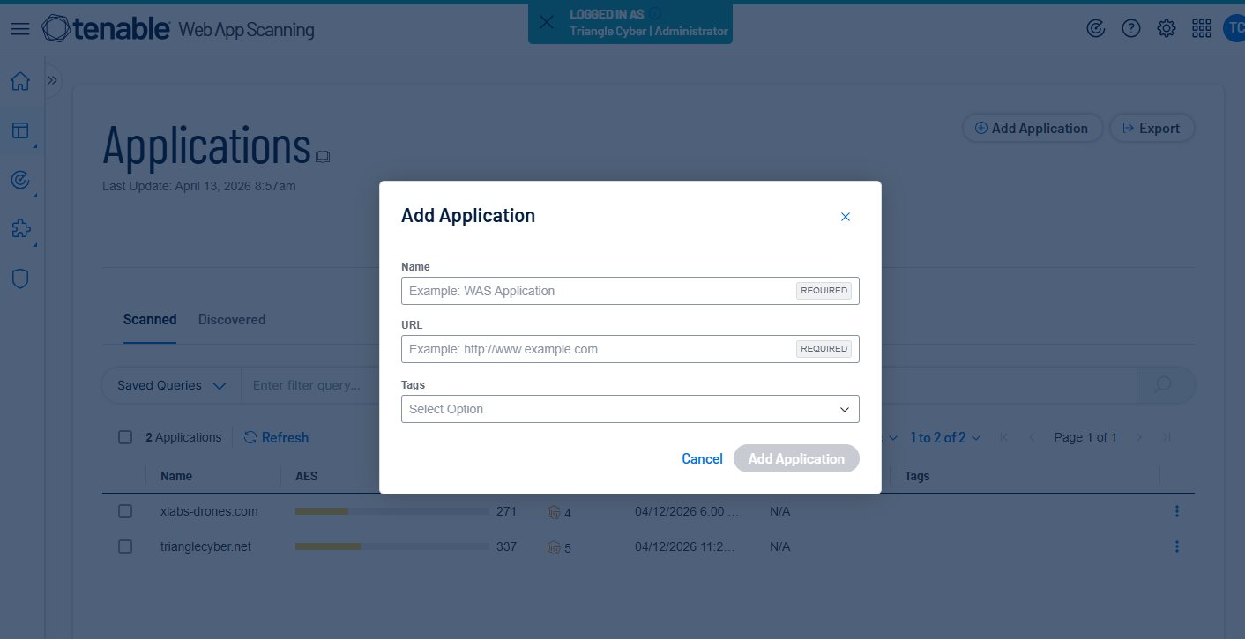
Add Application form — fill in Name and URL then click Add Application
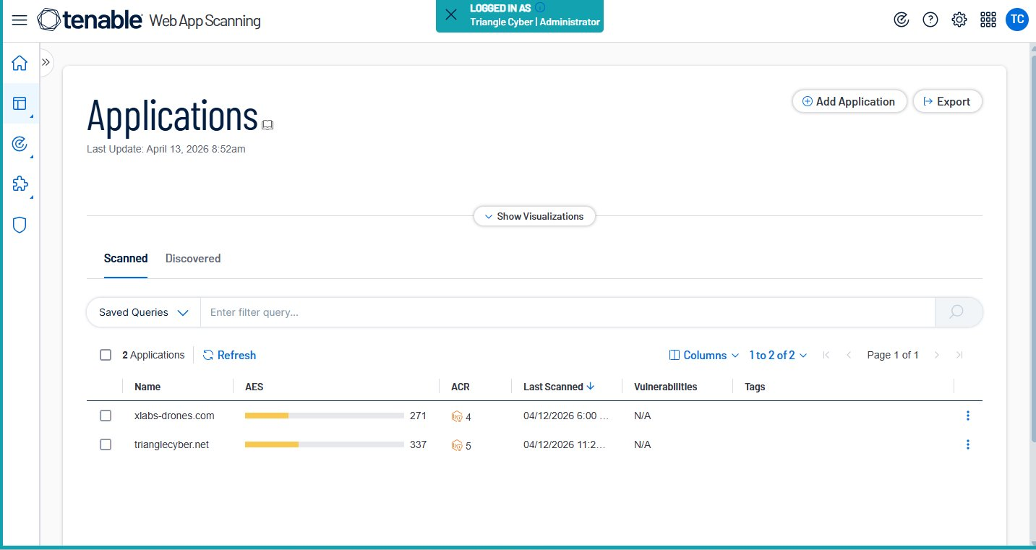
Applications page showing both sites added and ready to scan

Step 3 — Create and Run a Scan
Go to Scans in the left sidebar and click + Create Scan. You will see scan template options on the left side. Choose the right one for your situation (see table below).

Scan Type | Duration | What it checks | When to use
Quick Scan | Few minutes | SSL/TLS and HTTP security headers | ✅ Best for first time
Basic Scan | Under 1 hour | Misconfigurations and component vulnerabilities | Good for regular checks
Standard Scan | Few hours | Full scan including common generic vulnerabilities | Most thorough
Custom Scan | Variable | Full control over all settings and plugins | Advanced users only

💡 Tip for first time:
Start with Quick Scan — it takes only a few minutes and checks SSL/TLS and HTTP security headers.
This is the safest option for production sites as it has the lowest impact.

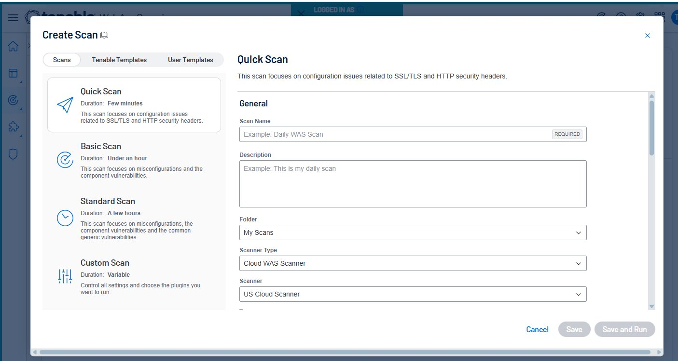
Create Scan page — choose scan type from left, fill in Scan Name and target URL

Fill in the Scan Name, scroll down to Targets, select your application from the dropdown, click Add to Targets list, then click Save and Run.

Step 4 — Monitor the Scan
Go to Scans → My Scans to monitor the status. The scan goes through these stages:
- Queued — waiting to start
- Running — scan is in progress
- Completed — results are ready ✅
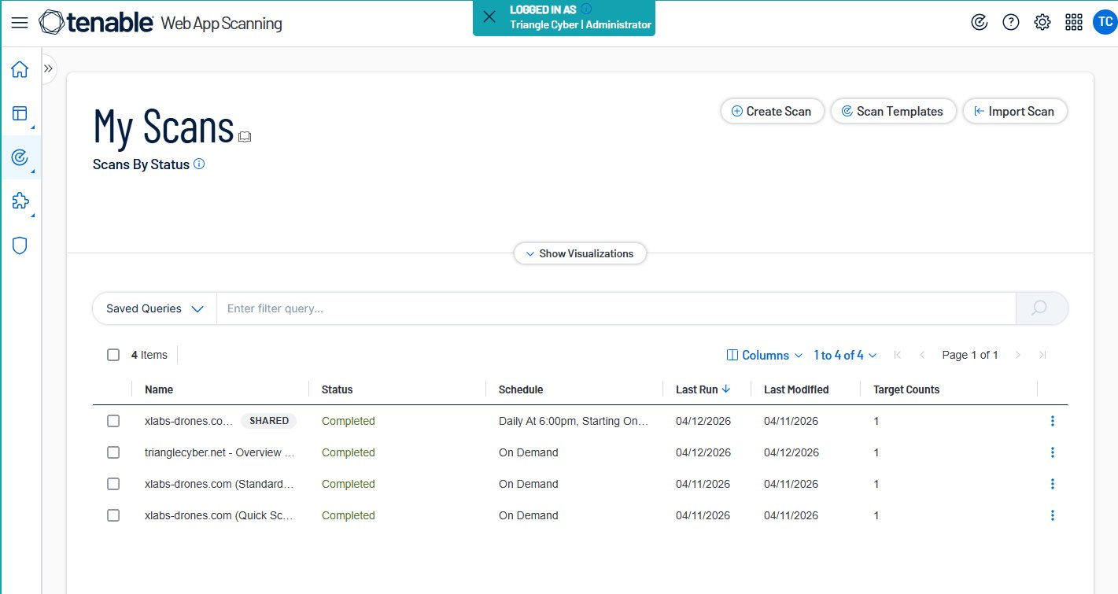
My Scans page showing all scans Completed
💡 How long does it take?
Quick Scan: a few minutes
Basic Scan: under 1 hour
Standard Scan: a few hours — leave it running and come back later

Step 5 — Review the Results
Click on the completed scan name to view the findings. Results are organized by severity — focus on Critical and High first, then work down to Medium and Low.

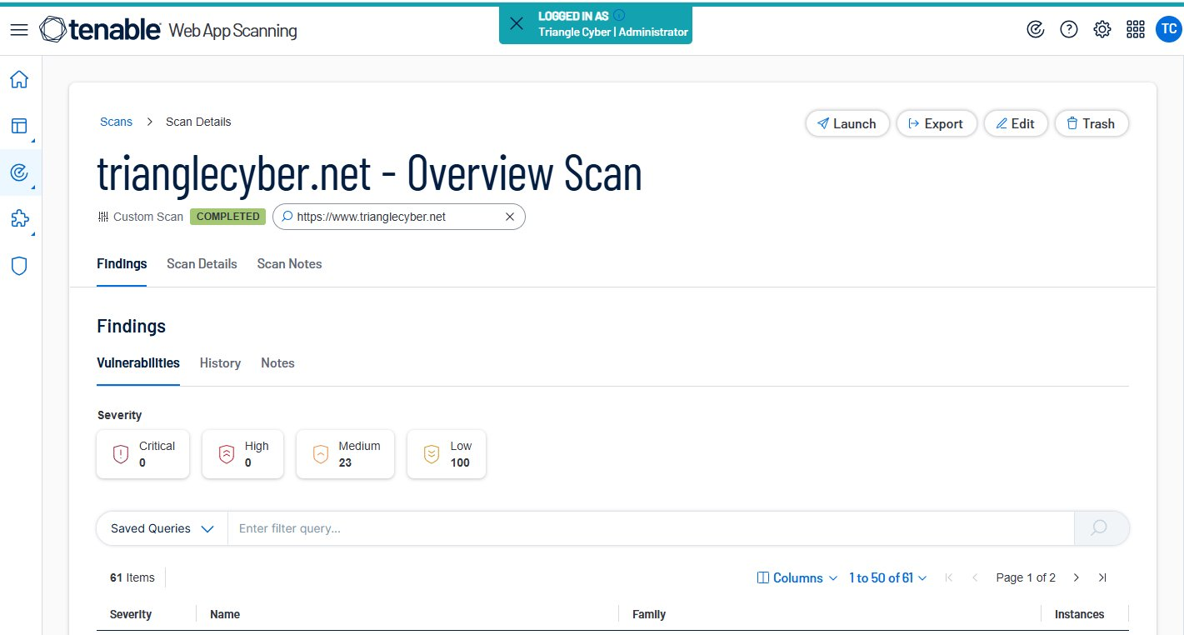
trianglecyber.net scan results — 0 Critical, 0 High, 23 Medium, 100 Low

🎉 trianglecyber.net Results Summary:
Critical: 0 — No critical vulnerabilities found
High: 0 — No high vulnerabilities found
Medium: 23 — Should be reviewed (e.g. HTTP security headers)
Low: 100 — Lower priority findings
Overall Grade: B (337/1000)

Part 6: User Roles & Access Control
Tenable Vulnerability Management provides several user roles to control what actions each user can perform. Currently, the MSSP portal only exposes two roles in the UI (Administrator and Basic User),The table below summarizes all available roles.
Role | Permissions
Basic User | Can only view scan results and manage their own user profile. No ability to create or run scans.
Scan Operator | Can create and run scans based on templates that the company has already authorized. Cannot create new templates or modify scan targets beyond what is pre-approved. ⭐ Recommended role for interns.
Standard | Can create scans, templates, and user target groups. More flexibility than Scan Operator but less control over who scans what.
Scan Manager | Has all Standard user privileges plus the ability to manage agents, exclusions, and scanners.
Administrator | Full access — can manage users, groups, system target groups, and access groups. Can also view scans created by all users. Should be reserved for senior staff only.
Disabled | Account cannot be used to log in to Tenable Vulnerability Management. Used for deactivated accounts.

Summary
Here is a quick recap of everything you accomplished:

- Logged into Tenable Vulnerability Management via MSSP portal
- Navigated to Sensors > Nessus Agents and copied the Linking Key
- Connected to your EC2 instance using EC2 Instance Connect (browser terminal)
- Installed the Nessus Agent using the Tenable cloud curl install script
- Verified the agent is Online and Healthy in the Tenable portal
- Accessed Web App Scanning (WAS) from the Tenable Workspace
- Added trianglecyber.net and xlabs-drones.com as applications in WAS
- Created and ran an Overview scan on both websites
- Reviewed scan findings and vulnerability results for both sites

Frequently Asked Questions (FAQ)

Q: The agent installed but I don’t see it in Tenable. What do I do?
it can take up to 10 minutes to appear. Check the service is running:
sudo systemctl status nessusagent
If inactive, start it with: sudo systemctl start nessusagent
Also double-check that your Linking Key was copied in full with no missing characters.

Q: I got WARNING: UNPROTECTED PRIVATE KEY FILE. What do I do?
This is a Windows permissions issue on your .pem key file. Fix it with:
icacls "YourKey.pem" /inheritance:r /grant:r "domain\username:(R)"
Run whoami in PowerShell to find your exact domain\username. Or avoid this entirely by using EC2 Instance Connect (browser terminal) instead of SSH.

Q: My agent shows Offline in Tenable. What should I check?
Check the service is running: sudo systemctl status nessusagent
Also verify your EC2 has outbound internet access on port 443 (HTTPS). Check the Security Group outbound rules in AWS.

Q: Health checks show N/A instead of Healthy. Is that a problem?
N/A is normal for a brand new agent. Plugins take 10-15 minutes to download automatically. Refresh the page after waiting and you should see Healthy.

Q: Can I install on Ubuntu instead of Amazon Linux?
Yes! Download the .deb file from Tenable and run:
sudo dpkg -i NessusAgent-*.amd64.deb
Note: The SSH username for Ubuntu EC2 is ubuntu, not ec2-user.

Q: What port does the Nessus Agent need to communicate with Tenable?
The agent communicates outbound on port 443 (HTTPS). Most default EC2 Security Groups allow all outbound traffic so this should not be an issue.

Q: How do I check if the agent service is running on the EC2?
Run this command in your EC2 terminal:
sudo systemctl status nessusagent
You should see Active: active (running). If stopped, start it with: sudo systemctl start nessusagent

Q: What is the difference between Nessus Agent and Web App Scanning?
The Nessus Agent scans your server infrastructure (EC2 instances, operating systems, software) for vulnerabilities. Web App Scanning (WAS) scans websites for web-specific vulnerabilities like SQL injection, XSS, and HTTP misconfigurations. You need both for full coverage.

Q: Can I scan any website with Web App Scanning?
Technically yes — Tenable WAS can scan any internet-facing website regardless of domain. However, you must always have written authorization from the website owner before scanning. Scanning without permission is unauthorized access even if the intent is to help.

Q: Which scan template should I use for a first-time scan?
Start with Quick Scan. It takes only a few minutes and focuses on SSL/TLS and HTTP security headers. It has the lowest impact on the site. Once you are comfortable, you can run a Basic or Standard scan for more detailed results.

Q: My WAS scan is taking a long time. Is that normal?
Yes — it depends on the scan type. Quick Scan takes a few minutes, Basic Scan under an hour, and Standard Scan can take a few hours. Just leave it running and check back later. The default timeout is 8 hours.

Q: What do the WAS scan results mean?
Results are organized by severity: Critical and High need immediate attention, Medium should be reviewed soon, and Low are lower priority. The AES score (0-1000) gives an overall rating — higher is better. A grade of A means 0-199, B means 200-399, and so on.

Q: What is the difference between a role and a group? A role controls what actions a user can perform. A group controls what targets they can scan. Both need to be configured together to properly restrict user access .

