CrowdStrike Falcon Sensor
Step-by-Step Setup Guide on AWS EC2

What You Will Need
Before you start, make sure you have:

- An AWS account with permission to create EC2 instances
- Access to the CrowdStrike Falcon console
- The CrowdStrike Customer ID (CID)
- Basic familiarity with the Linux terminal .

Part 1 — Launch an EC2 Instance on AWS

Step 1 — Log in to AWS
Go to https://aws.amazon.com and sign into your account.
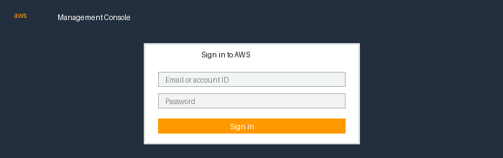
The AWS login screen

Step 2 — Search for EC2
In the search bar at the top of the page, type EC2 and click on the EC2 result.
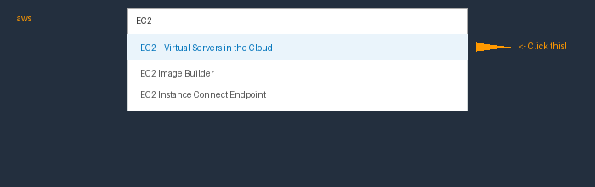
Type 'EC2' in the search bar and click the first result

Step 3 — Click 'Launch Instance'
Once inside the EC2 console, click the orange Launch instances button near the top right.
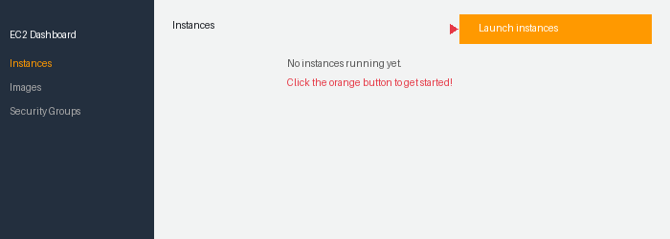
Click the orange 'Launch instances' button

Step 4 — Choose Amazon Linux 2023
Name your instance so that you can easily keep track of it. The instance name is a tag, where the key is Name, and the value is the name that you specify.
Under 'Application and OS Images', click Quick Start, then select Amazon Linux 2023 (64-bit x86). This is the version that works best with CrowdStrike.
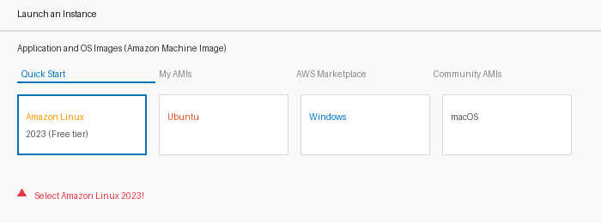
Select 'Amazon Linux 2023' from the Quick Start options

Step 5 — Choose Instance Type
In the Instance type section, look for an instance type labeled "Free tier eligible". Either t2.micro or t3.micro will work — use whichever one is available in your region. In us-east-1 (Northern Virginia), t3.micro is the current default free tier option. t3.micro is newer and more powerful than t2.micro, so either one is great for testing.
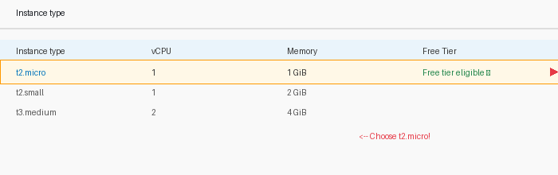
Select 't2.micro' — it's free!

Step 6 — Create a Key Pair
A key pair is what lets you connect to your server. Click 'Create new key pair', give it a name (like my-ec2-key), and download the .pem file. Save it somewhere safe — you'll need it!
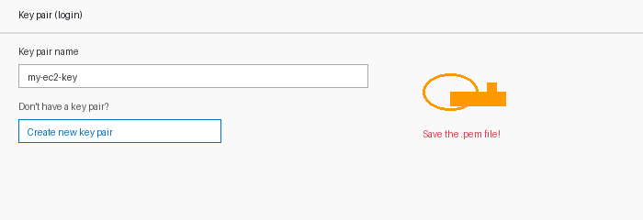
Create a new key pair and save the .pem file

Step 7 — Launch the Instance
Click Launch Instance at the bottom. Wait 1–2 minutes, then check your instance list. Wait until the status shows Running (green dot) before moving on.
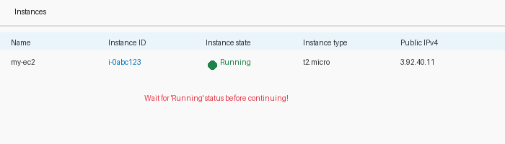
Wait for the status to show 'Running' (green dot)
💡 Tip: If the instance says 'Pending', just wait a minute and refresh the page.

Part 2 — Connect to Your EC2 Instance

Step 8 — Click the 'Connect' Button
In the EC2 Instances list, select your instance by clicking on it, then click the Connect button at the top of the page.
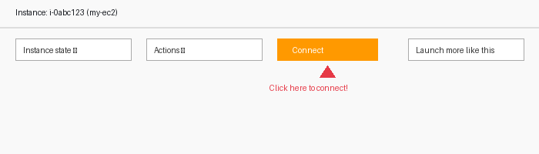
Select your instance and click 'Connect'

Step 9 — Use EC2 Instance Connect
In the Connect dialog, the EC2 Instance Connect tab should already be selected. Leave everything as default and click Connect. A black terminal window will open in your browser — that's your server!
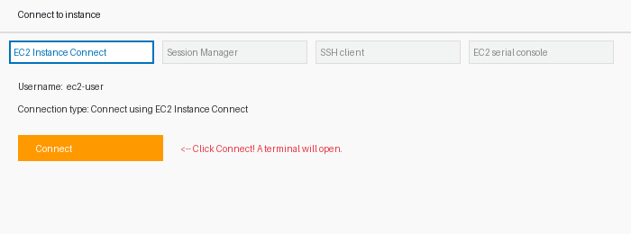
Click 'Connect' to open the browser terminal
AWS also offers 3 other ways to connect to your EC2 instance. These are useful for RHEL, Ubuntu, and other Linux-based EC2s.

Other Connection Method 1 — SSH Client
Works with Amazon Linux, RHEL, Ubuntu and most Linux EC2s. Requires your .pem key file. Use this when EC2 Instance Connect is not available.
⚠ Important first step: Before running any SSH commands, make sure your terminal is in the same folder where your .pem file is saved. If you saved it in Downloads, run this first:
cd C:\Users\YourWindowsUsername\Downloads
Replace YourWindowsUsername with your actual username (…….). Once you are in the right folder you can continue with the steps below.

- Set permissions on your key file — In your terminal, run:
chmod 400 your-key-name.pem
⚠ Windows users: chmod does not work in PowerShell. You have two options: (1) Use Git Bash instead of PowerShell and run the same chmod command, or (2) Skip chmod entirely — Windows handles the key permissions automatically, so just go straight to the SSH command below.

- Connect via SSH — Replace with your key name and EC2 public IP:
ssh -i "your-key-name.pem" ec2-user@YOUR_EC2_PUBLIC_IP
💡 Where to find your EC2 Public IP: Go to AWS Console → EC2 → Instances → click on your instance → look for Public IPv4 address in the details panel at the bottom. Copy that number and paste it in place of YOUR_EC2_PUBLIC_IP in the command above.

Other Connection Method 2 — Session Manager
No SSH key or open ports needed. Great for troubleshooting. Requires the SSM Agent on the EC2 (Amazon Linux 2023 has it pre-installed).
- In EC2 → Instances, select your instance → click Connect → choose Session Manager tab → click Connect.
- Use case: Best when SSH is blocked or the instance has no public IP.

Other Connection Method 3 — EC2 Serial Console
Used mainly for troubleshooting when the instance is unreachable. Not for regular use.
- Enable it first: EC2 Dashboard → Account attributes → EC2 Serial Console → Manage → Enable.
- Then: select your instance → Connect → EC2 Serial Console tab → Connect.
- Use case: Best when the instance has network issues or you are locked out.

Security Groups & SSH Access
CrowdStrike does not require any new inbound or outbound rules. However, you should make sure port 22 (SSH) is correctly configured in your EC2 Security Group.
- Default (less secure): EC2 allows SSH from anywhere (0.0.0.0/0) by default. This is fine for testing but not recommended for production.
- Best practice: Restrict SSH access to specific IP addresses using a /32 CIDR block (e.g. 203.0.113.5/32). Ask your manager for the correct IP to use.
- How to update: EC2 → Instances → Security tab → click the Security Group link → Edit inbound rules → change port 22 Source from Anywhere to your specific IP/32.

Part 3 — Install the CrowdStrike Falcon Sensor

Now we'll install CrowdStrike on your EC2 instance. Type (or copy-paste) each command into the terminal, then press Enter.

Step 10 — Install the Falcon Sensor

Before installing, you need to download the sensor file from CrowdStrike and transfer it to your EC2. Do NOT skip this step — running the install command without the file will fail. Follow these steps in order:
- Part A — Download the sensor file: Go to https://falcon.crowdstrike.com → Host Setup and Management → Deploy → Sensor Downloads → download the Amazon Linux sensor (.rpm file) to your computer.

CrowdStrike Sensor Compatibility Table
Use this table to find the correct sensor and install command for your operating system before starting the guide.
Operating System | Sensor File Type | Install Command | Notes
Amazon Linux 2023 | .rpm (x86_64) | sudo rpm -ivh falcon-sensor-*.x86_64.rpm | ✅ This guide uses this OS
RHEL 7.4 – 9.x | .rpm (x86_64) | sudo rpm -ivh falcon-sensor-*.x86_64.rpm | Use SSH to connect (not EC2 Instance Connect)
CentOS 7.4 – 8.x | .rpm (x86_64) | sudo rpm -ivh falcon-sensor-*.x86_64.rpm | Same as RHEL — use SSH to connect
Ubuntu 16.04 – 22.04 | .deb (amd64) | sudo dpkg -i falcon-sensor-*.amd64.deb | Default SSH user: ubuntu
Windows Server 2016 – 2022 | .exe installer | Run .exe as Administrator | Use RDP to connect to Windows EC2
Windows 10 / 11 | .exe installer | Run .exe as Administrator | Local machine install
macOS Ventura / Sonoma | .pkg installer | sudo installer -pkg falcon-sensor-*.pkg -target / | Local machine install

- Part B — Transfer the file to your EC2: Open a NEW terminal window (keep your EC2 terminal open). Navigate to your Downloads folder and run this command:
scp -i "your-key-name.pem" falcon-sensor-*.x86_64.rpm ec2-user@YOUR_EC2_PUBLIC_IP:~
- Part C — Go back to your EC2 terminal and now run the install command below.

Run this command to install the sensor .
sudo rpm -ivh falcon-sensor-*.x86_64.rpm

Then set the CID (Customer ID) to link the sensor to your company's account. To find your CID in the CrowdStrike Falcon console: go to Host Setup and Management > Deploy > Sensor Downloads. Your CID is displayed at the top of that page — it is a long string of letters and numbers (e.g. 1234ABCD...XY). Copy the full CID and paste it into the command below:
sudo /opt/CrowdStrike/falconctl -s --cid=YOUR_CID_HERE

Then start the sensor service:
sudo systemctl start falcon-sensor

And enable it to start automatically on reboot:
sudo systemctl enable falcon-sensor

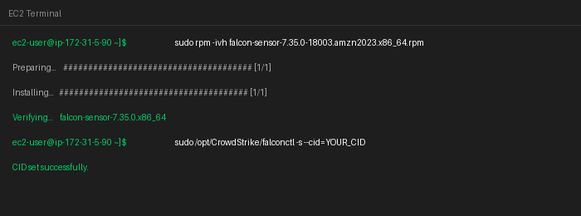
Running the install commands in the terminal
💡 Tip: Replace YOUR_CID_HERE with the actual CID .

Part 4 — Verify the Sensor is Running

Step 11 — Check Sensor Status
Run this command to confirm the sensor is active:
sudo systemctl status falcon-sensor

You should see:
- Active: active (running) — the sensor is ON ✅
- Lines mentioning CrowdStrike connections — it's talking to the cloud ✅

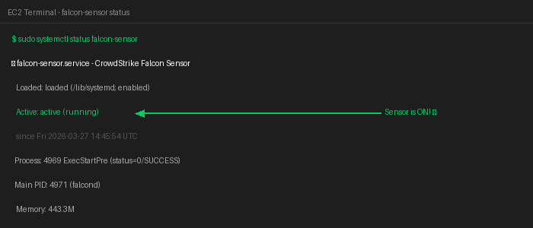
The terminal showing the sensor is 'active (running)'

Part 5 — Confirm the Host in CrowdStrike Console

Step 12 — Log in to CrowdStrike Falcon
Go to https://falcon.crowdstrike.com and log in with your credentials.
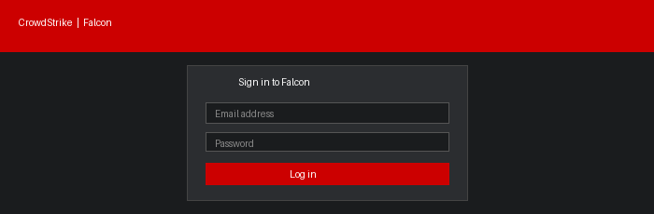
Log in to the CrowdStrike Falcon console

Step 13 — Go to Host Management
In the left menu, navigate to: Host Setup and Management > Host Management
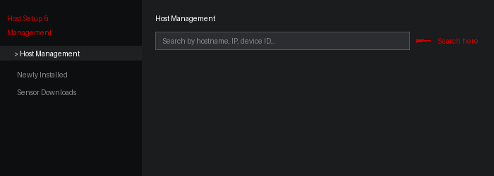
Navigate to Host Management in the left sidebar

Step 14 — Find Your EC2 and Confirm it's Online
Use the search bar to find your EC2 instance by hostname or IP address. You should see it listed with a green Online status.
Look for:
- Status: Online (green dot)
- OS: Amazon Linux 2023
- Local IP address matching your EC2

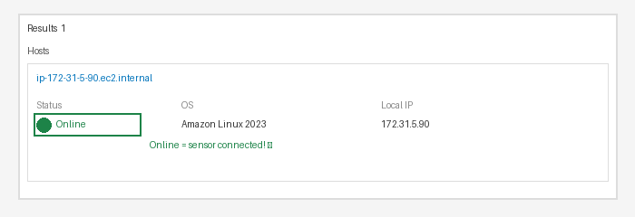
Your EC2 instance showing as 'Online' in CrowdStrike

Part 6 — Generate Activity and Check Telemetry

Step 15 — Run Commands on Your EC2
Go back to your EC2 terminal and run a few commands to generate activity:
ls -la
whoami
ps aux

Step 16 — Check Event Search in CrowdStrike
In the Falcon console, go to Investigate > Event Search. Search for your hostname. You should see events appearing — this confirms telemetry is being captured!
NEW — How to use Event Search filters to verify telemetry:
- Filter by your hostname: In the Event Search bar type this and press Search:
ComputerName=YOUR_HOSTNAME
- Filter by event type: To see process activity (commands you ran), use this filter:
event_simpleName=ProcessRollup2
- Filter by network activity: To see network connections the EC2 made, use:
event_simpleName=NetworkConnectIP4
- Combine filters: You can combine filters to narrow results, for example:
event_simpleName=ProcessRollup2 ComputerName=YOUR_HOSTNAME
💡 Tip: Replace YOUR_HOSTNAME with your EC2 hostname (e.g. ip-172-31-5-90). You can find it by running the command hostname in your EC2 terminal. If events appear in the results, your sensor is working correctly!
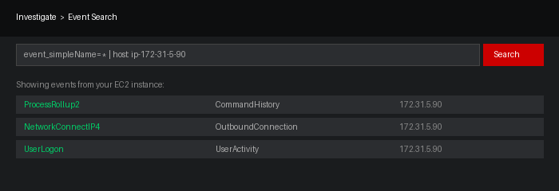
Events from your EC2 appearing in CrowdStrike Event Search
💡 Tip: It may take a minute or two for events to appear after you run commands.

Summary — What You Did

Congratulations! 🎉 Here is a quick recap of everything you accomplished:

- Launched an EC2 instance on AWS running Amazon Linux 2023
- Connected to the instance using the browser-based terminal
- Installed the CrowdStrike Falcon sensor
- Configured the CID to link the sensor to your company's account
- Verified the sensor is active and communicating with the CrowdStrike cloud
- Confirmed the host appears in CrowdStrike Host Management
- Generated activity and confirmed telemetry is being captured

NEW — Frequently Asked Questions (FAQ)
Common questions interns have asked during setup:

Q: The sensor installed but I don’t see my host in CrowdStrike. What do I do?
A: Be patient — it can take up to 15 minutes for the host to appear. Make sure the sensor is running by checking:
sudo systemctl status falcon-sensor
If it says inactive, start it again with: sudo systemctl start falcon-sensor. Also double-check your CID was set correctly.

Q: What specific filters can I use in Event Search to confirm telemetry is working?
A: Use these filters in Investigate → Event Search:
- ProcessRollup2 — shows commands and processes that ran on your EC2
- NetworkConnectIP4 — shows network connections made by your EC2
- UserLogon — shows when someone logged in to the EC2
If any of these return results for your EC2, the sensor is successfully sending data to CrowdStrike.

Q: I got a ‘Permission denied’ error when trying to SSH. What’s wrong?
A: This usually means one of three things:
- Your terminal is not in the same folder as your .pem file — run cd to navigate to the correct folder first
- You are using the wrong username — use ec2-user for Amazon Linux and RHEL, ubuntu for Ubuntu
- Port 22 is not open in your Security Group — check your EC2 inbound rules

Q: chmod doesn’t work on my Windows computer. What should I do?
A: chmod is a Linux command and does not work in Windows PowerShell. You have two options: (1) Use Git Bash instead of PowerShell and run the same command, or (2) Skip chmod entirely — Windows handles key permissions automatically, so just go straight to the SSH command.

Q: The rpm install command says ‘File not found’. What’s wrong?
A: The sensor file has not been transferred to your EC2 yet. You need to download it from the Falcon console first (Host Setup and Management → Deploy → Sensor Downloads), then use the scp command to transfer it to your EC2 before running the install command.

Q: How do I find my EC2 hostname to use in Event Search?
A: In your EC2 terminal, run this command:
hostname
It will return something like ip-172-31-5-90. Use that in your Event Search filter.

Q: My EC2 instance shows as ‘Offline’ in CrowdStrike. What should I check?
A: Check that the falcon-sensor service is running (sudo systemctl status falcon-sensor). Also make sure your EC2 is running and has internet access — the sensor needs to communicate with the CrowdStrike cloud on port 443 (HTTPS outbound).
Questions? Reach out to your manager or the Triangle Cyber team.

