Students Grading Dataset Analysis Report

Introduction
This report provides a detailed analysis of the Students Grading Dataset. The objective was to clean, preprocess, and analyze the dataset to extract meaningful insights related to students' academic performance. The analysis covers data cleaning, visualization, encoding, and correlation analysis.

Methodology

1. Data Loading and Initial Exploration
- The dataset was loaded using Pandas.
- The first few records and column data types were examined.
- The dataset contains 5,000 entries with 23 columns, including student demographics, academic performance, and external factors.

2. Data Cleaning and Preprocessing
- Missing Values:
  - Columns Attendance (%) and Assignments_Avg had missing values.
  - Median imputation was used for highly skewed data, while mean imputation was used otherwise.
  - Parent_Education_Level was removed due to excessive missing values.
- Duplicate Entries:
  - No exact duplicates were found, but duplicates based on First_Name, Last_Name, Total_Score, Grade, and Attendance (%) were checked to identify redundant records.
- Irrelevant Columns Removal:
  - Non-essential identification columns (Student_ID, First_Name, Last_Name, Email) were removed as they do not contribute to analysis.

3. Data Visualization
- Numerical Features:
  - Histograms and boxplots were generated to assess distributions and detect outliers in key numerical features.
  - 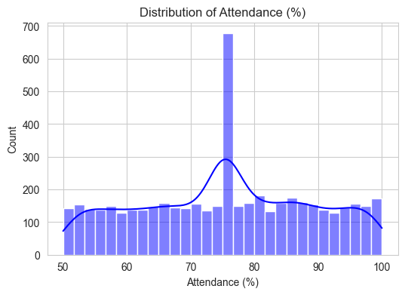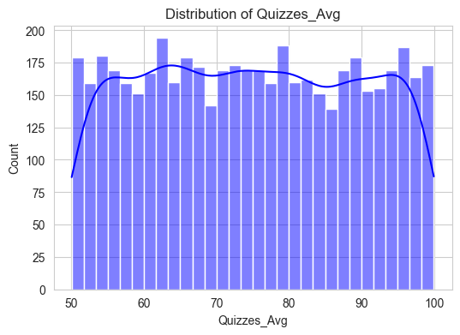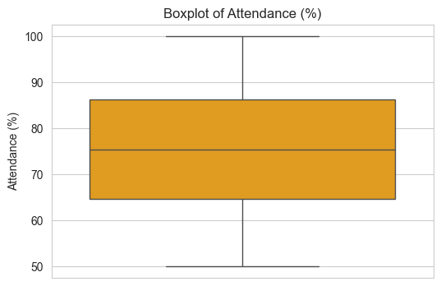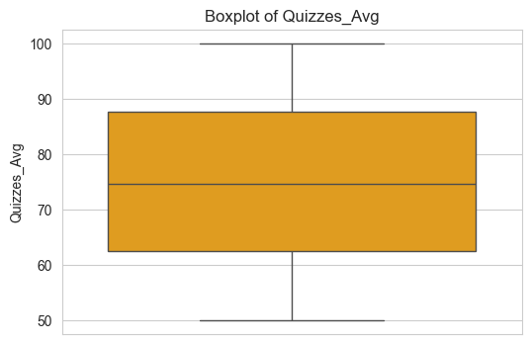

- Categorical Features:
  - Count plots were used to visualize the frequency distribution of categorical variables.
  - Bar plots were generated for better interpretation of categorical attributes.
  - 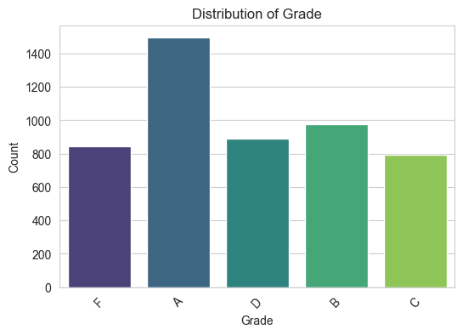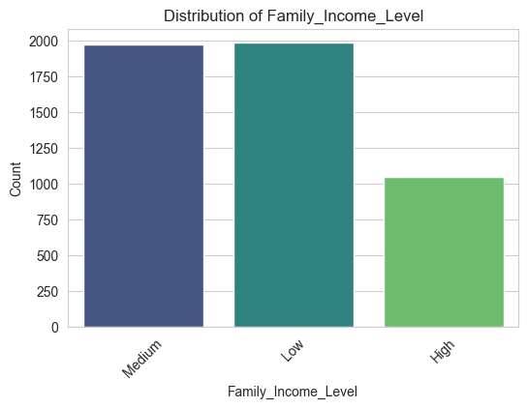
- Feature Relationships:
  - Boxplots were used to analyze relationships between categorical variables and numerical features.
  - A pair plot was generated to understand relationships between numerical variables with a focus on Grade.
  - 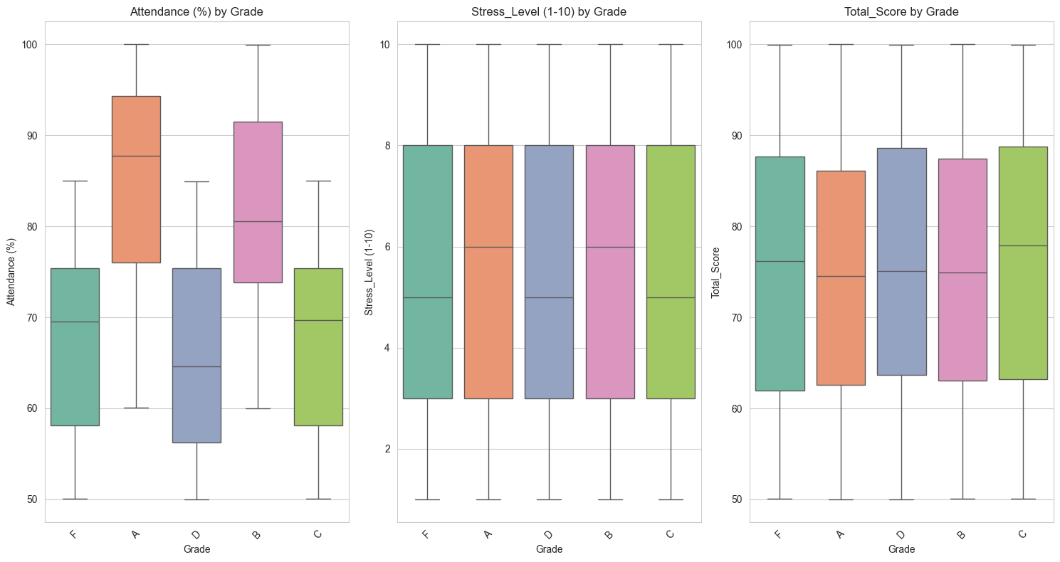

4. Encoding Categorical Variables
- One-hot encoding was applied to categorical features such as Gender, Department, Extracurricular_Activities, and Internet_Access_at_Home.
- Manual label encoding was used for Grade and Family_Income_Level:
  - Grade: A=4, B=3, C=2, D=1, F=0
  - Family_Income_Level: High=2, Medium=1, Low=0

5. Correlation Analysis
- A heatmap of numerical feature correlations was generated.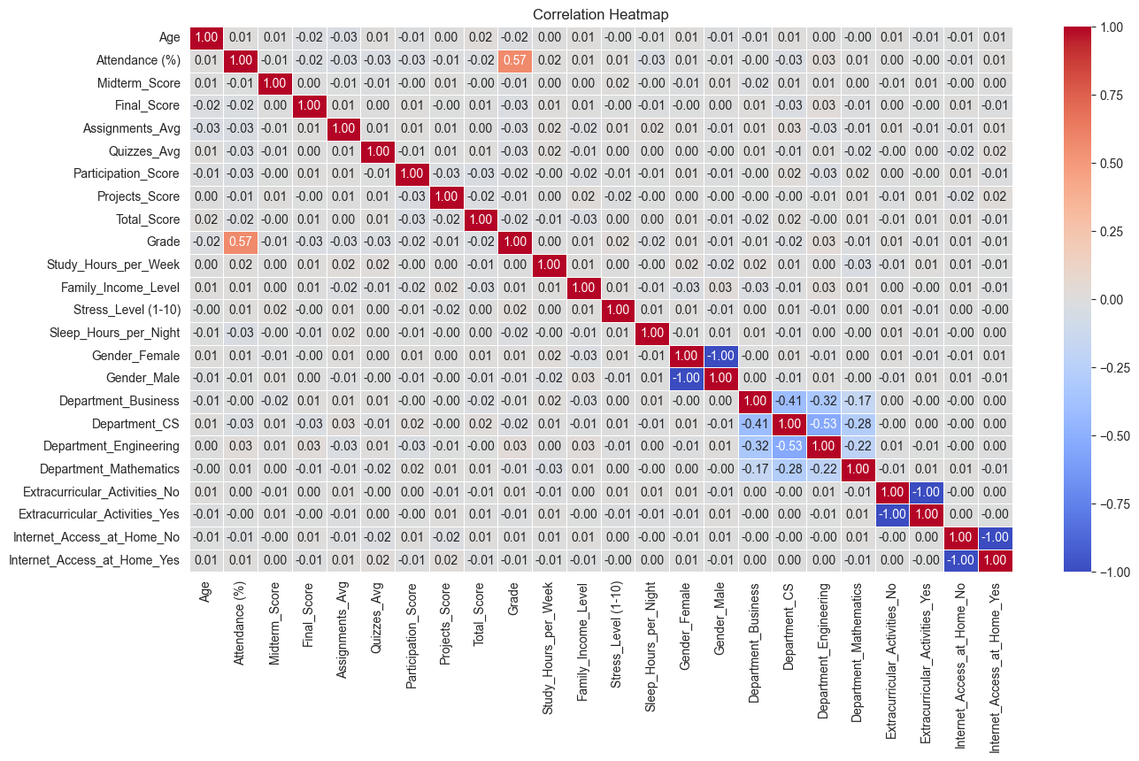
- The most correlated features with Grade were identified. { Attendance (%) }
- A bar plot was created to highlight key features influencing Grade.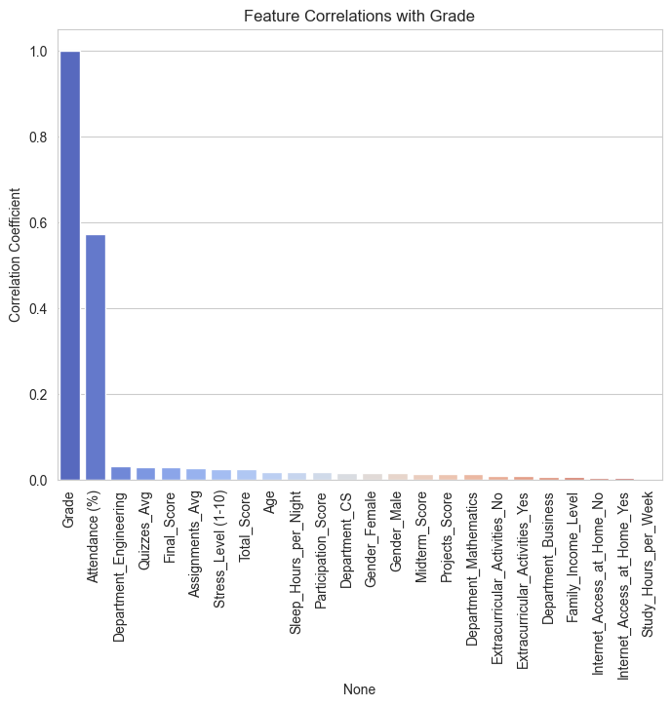
- A pair plot was generated to visualize relationships between highly correlated features.
- 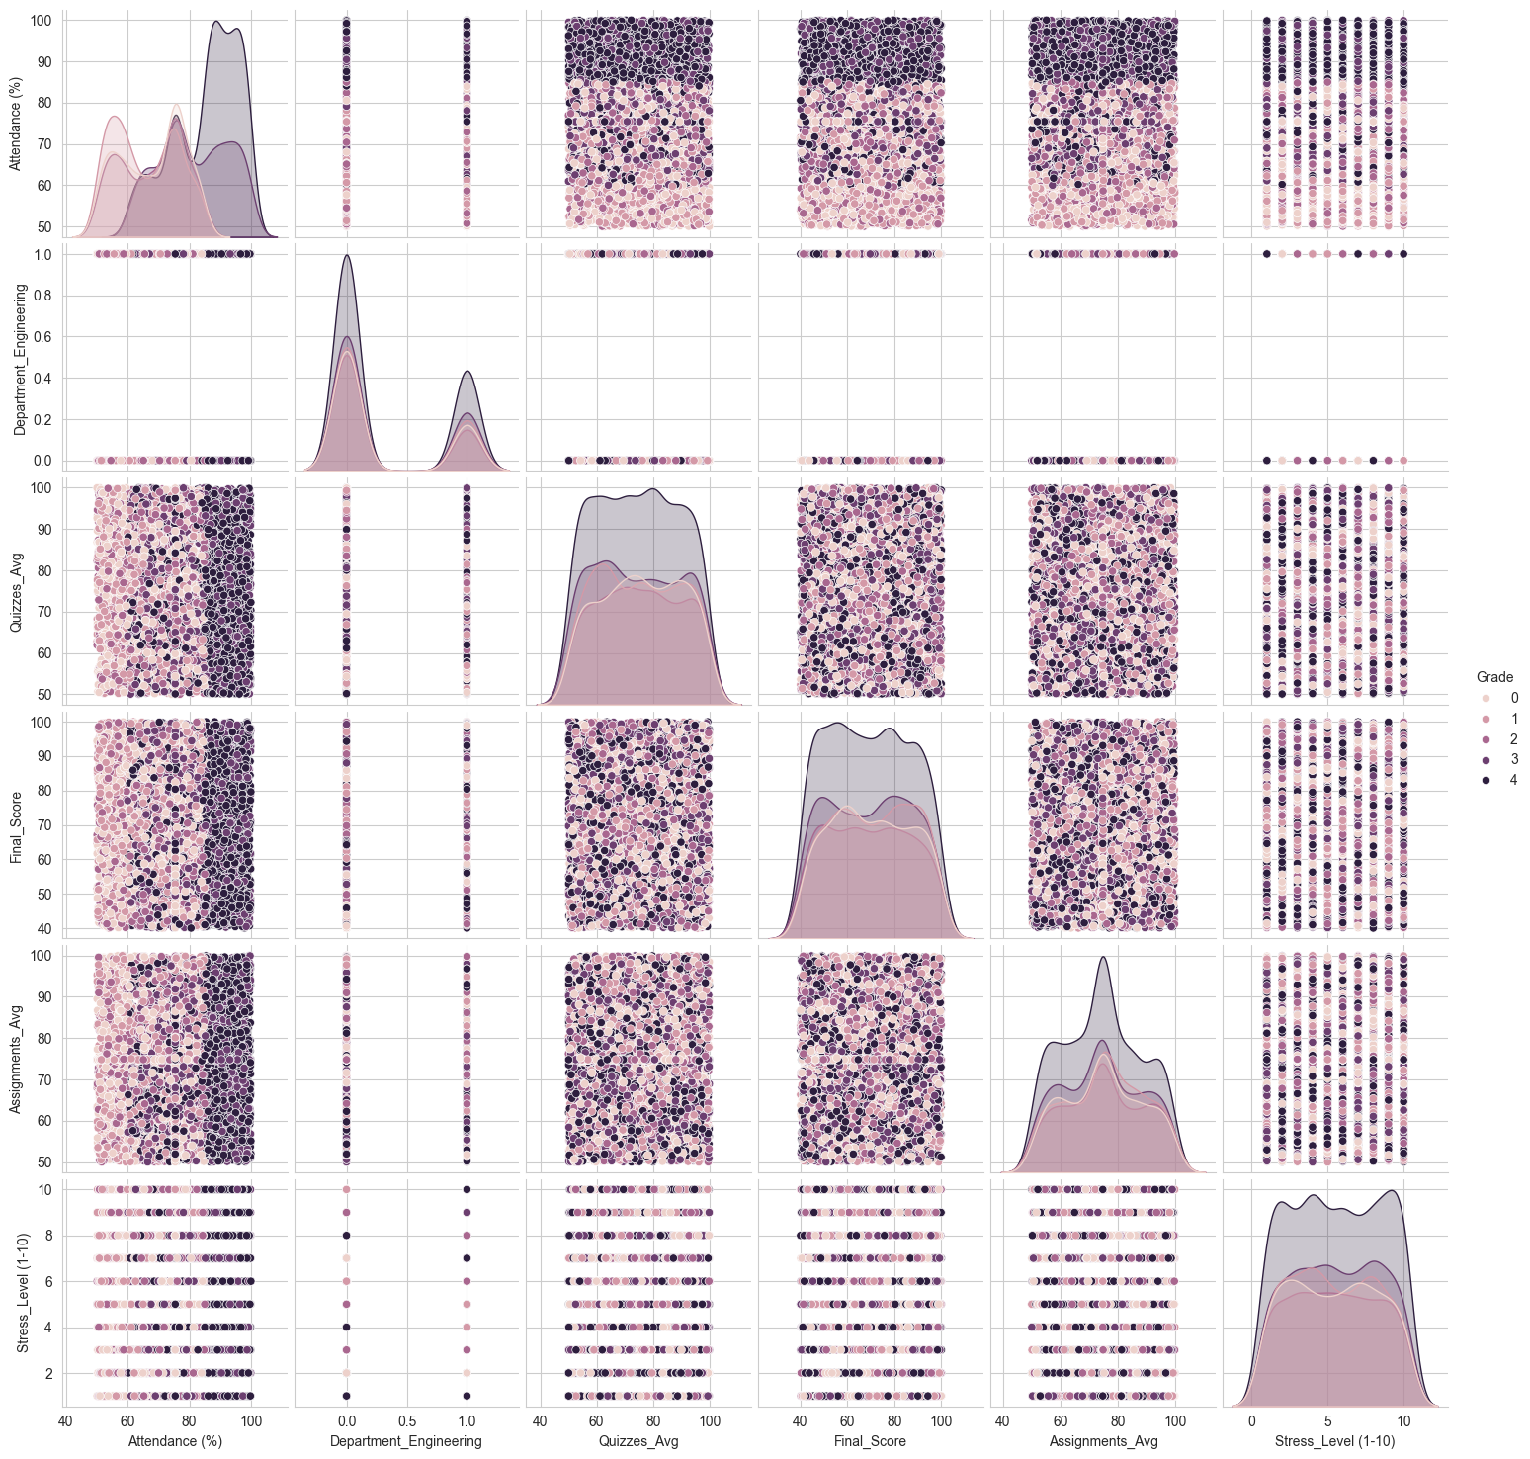

6. Exporting Cleaned Data
- The processed dataset was saved as data_cleaned.csv for further analysis and model building.

Findings and Conclusions
- Key Influencing Factors on Student Performance:
  - Higher attendance and study hours showed strong positive correlations with better grades.
  - Stress levels had a moderate negative correlation with academic performance.
  - Family income and parent education level had a minor impact on grades.
- Data Cleaning Outcomes:
  - Handling missing values and duplicates ensured the dataset was more reliable for analysis.
  - Removing irrelevant columns reduced noise in the dataset.
- Categorical Encoding:
  - Converting categorical variables into numerical values made the dataset suitable for machine learning applications.
- Feature Correlations:
  - The correlation heatmap revealed strong dependencies between total scores and final grades.
  - Study habits and participation had a moderate impact on student performance.

Recommendations
- Encourage students to maintain higher attendance and study hours to improve grades.
- Address student stress levels through better academic support programs.
- Future analysis could explore predictive modeling to forecast student performance based on historical data.

