6/11/25, 10:17 AM
Aizawl || District

POCSO Case Detail
UPDATE
BACK (index.php?page=pocso_case_list)
MSCPS : POCSO CASE DETAIL
SN Particulars
Output
Case Record Date
2
025-06-09
Victim Related Info
1
2
3
Name of Child
Sex
H.Vanlalzaithangpuii
Female
Age with date of birth
Date of Birth
Age
1
1
2.07.2006
7
4
Complete official address of the RD Block
Child
NA
Rural/Urban
Rural
Address
North Khawbung, Champhai District
Present Add: Chhinga Veng , Aizawl
5
No of Accused
1
https://cpsmizoram.in/monitoring_report/aizawl/index.php?page=pocso_case_detail1&main_id=74
1/7
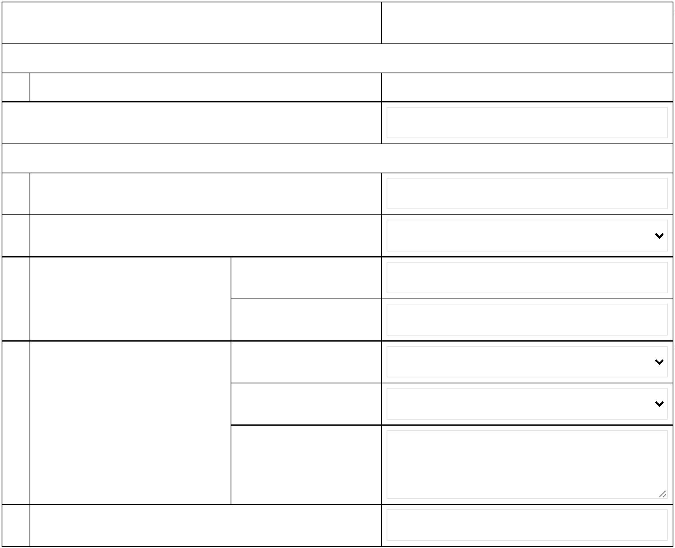

6/11/25, 10:17 AM
Aizawl || District
6
Details of incidence
Frequency
Once
One-Time incident
Date of incidence
0
9.09.2023
Repeated incident
Date of first incidence
Date of last incidence
Time & Place of incidence
Time of incidence
Happens at the child
official address
(hometown or not)
Place of incidence
If Others, specify
Victim residence
7
8
Relationship with accused
Relationship
Others
If Others, specify
Mother's cousin
Whether living in same household with accused?
No
https://cpsmizoram.in/monitoring_report/aizawl/index.php?page=pocso_case_detail1&main_id=74
2/7
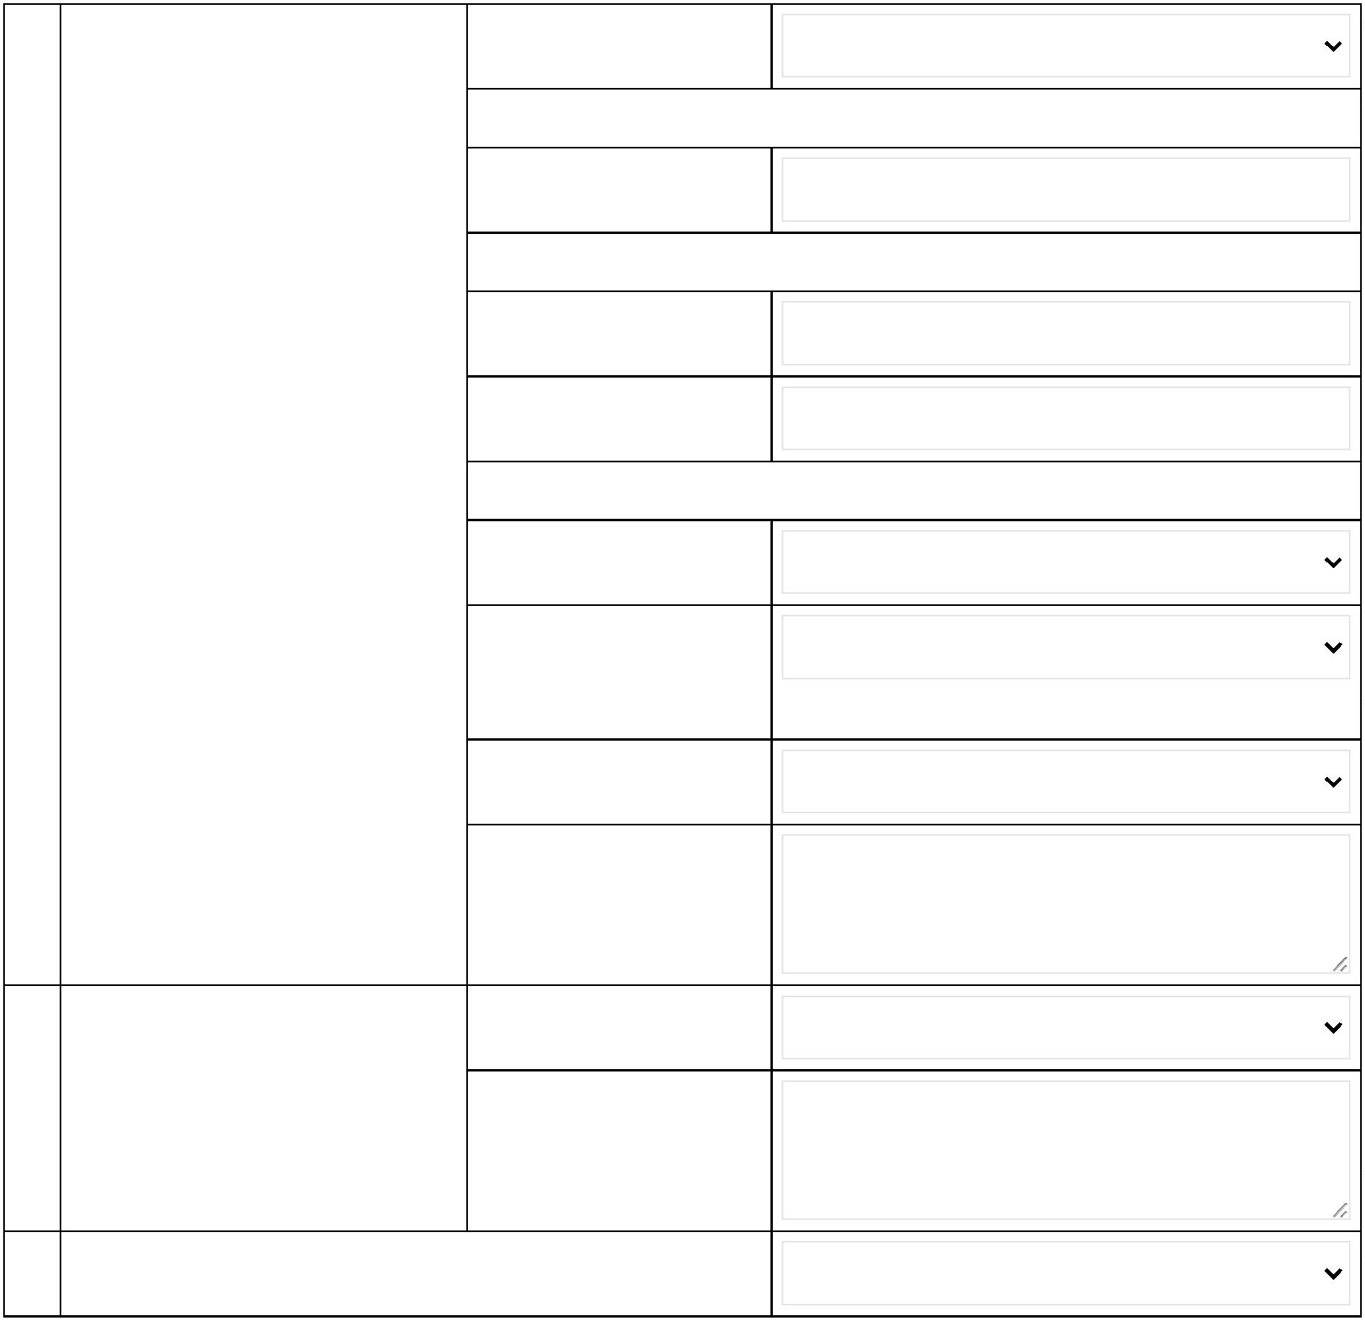

6/11/25, 10:17 AM
Aizawl || District
9
Family status, life style, living
Marital status of victim's
Married
conditions and social life of
victim and family
parents
Family Structure
Nuclear Family (with 2 parents and biolog
No of Siblings
4
Type of housing
If others, specify
Owned
Involvement of family in
church
Attend regularly
Participate regularly
Attend regularly
Participation of family in
CBO
Involvement of child in
church
1
0
Family Details:
Name & Relationship
Age
Sex
Education
Occupation
Health
Status
Addictions
H.Vanlalthara, father
Niangthangi, mother
Malsawmkima, borth
Lalnunpuia, brother
Lalrinkimi, sister
M
Class IV
Class IV
Class V
Class V
Nursery
Class V
Agricult
Agricult
Studen
Studen
Studen
Others
G
G
G
G
G
G
None
None
None
None
None
F
M
M
F
H.Vanlalzaithangpuii
F
Gutkha - Irre
11
Migrants - from other states/districts of victim and family
Migrant from other District
https://cpsmizoram.in/monitoring_report/aizawl/index.php?page=pocso_case_detail1&main_id=74
3/7
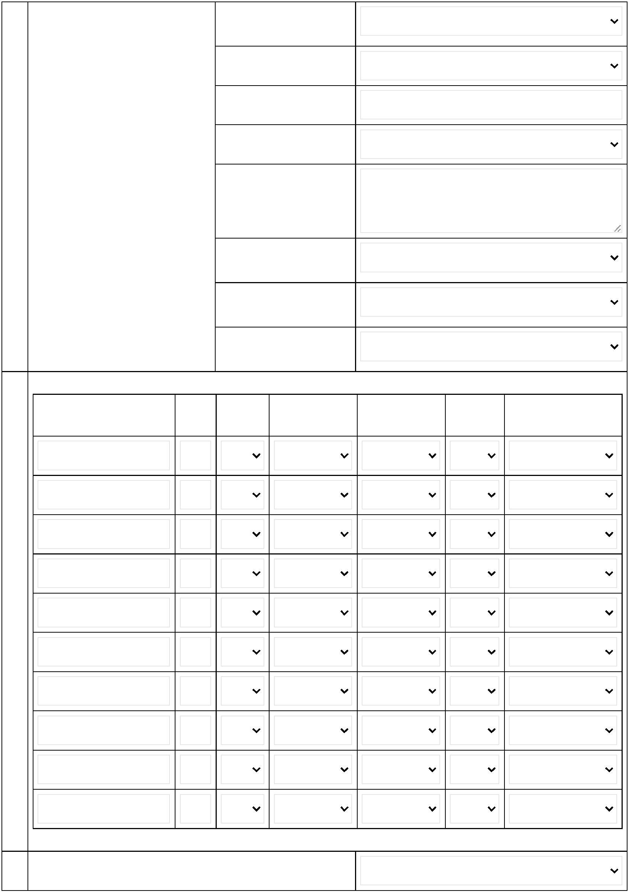

6/11/25, 10:17 AM
Aizawl || District
1
1
2
3
Economic status of victim and family
BPL
Education of victim
Education Level
Class VII
If Drop-Out, specify
reasons
Drop out , studied upto class 7. She worked
at Gov
1
1
4
5
History of offence committed by victim, if any
Does the child have any history Yes/No
as victim under "crime against
children", specify
No
No
If Yes, specify
1
6
History of Institutinaisation of the Yes/No
chuld, if any
If Yes, specify (name of
institution and year and
duration)
Accused Related Info
1
1
1
2
7
8
9
0
Name of accused
Gender of accused
Age of accused
Male
2
5
Complete official address of the RD Block
accused
Tlangnuam
Rural/Urban
Rural
Address
Ramhlun Veng, Aizawl
https://cpsmizoram.in/monitoring_report/aizawl/index.php?page=pocso_case_detail1&main_id=74
4/7
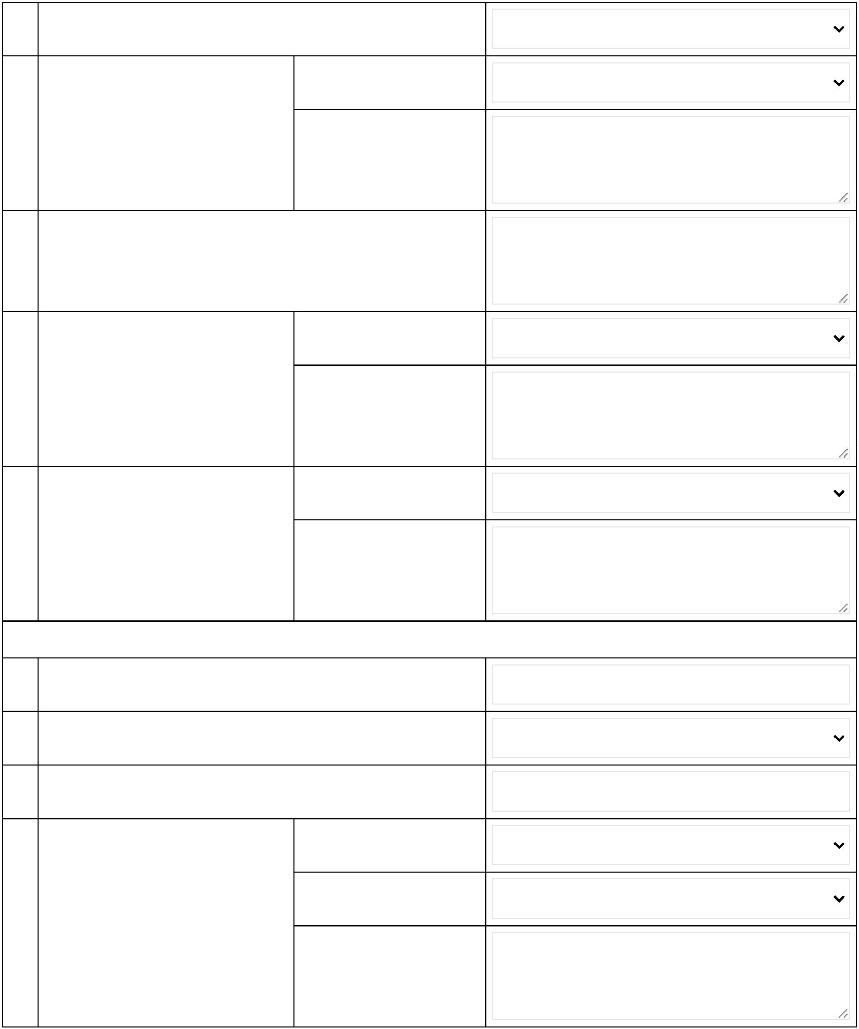

6/11/25, 10:17 AM
Aizawl || District
2
1
Family status, life style, living
conditions and social life of
accused and family
Marital status of
accused
Never Married
Family Structure
No of Siblings
Nuclear Family (with 2 parents and biolog
Type of housing
If others, specify
Rented
Involvement of accused
in church
Attend irregularly
Participation of accused
in CBO
Participate irregularly
2
2
Family Details:
Name & Relationship
Age
Sex
Education
Occupation
Health
Status
Addictions
James Laithansanga
M
Class V
Mechan
G
Alcohol - Occ
2
2
3
4
Migrants from other states/districts
Migrant from other District
AAY
Economic status of accused and family
https://cpsmizoram.in/monitoring_report/aizawl/index.php?page=pocso_case_detail1&main_id=74
5/7
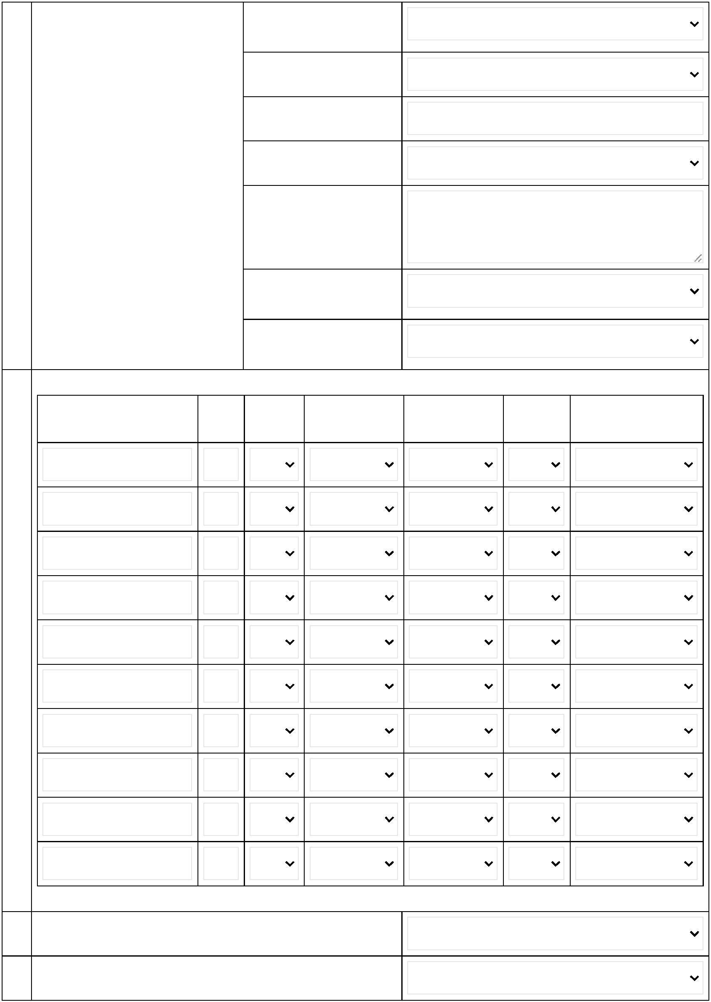

6/11/25, 10:17 AM
Aizawl || District
2
5
Education of accused
Education Level
Class VIII
If Drop-out, specify
reasons
2
2
6
7
History of offence committed by accused, if any
History of Institutinaisation of the Yes/No
accused, if any.
If Yes, specify (name of
institution and year and
duration)
Case Proceeding - I (Pre-Trial)
2
2
8
9
Whether FIR is filed
Who filed FIR
Yes
Filed by
Others
Cousin
If Others, specify
3
3
0
1
FIR No with date
FIR No
AWPS c.no.36/2023
FIR Date
1
6
2.09.2023
POCSO section under which the POCSO Section
accused is booked
POCSO Act
If r/w (IPC)
If r/w (BNS)
3
3
2
3
Date of arrest of accused.
Date of Arrest
If No, specify
1
2.09.2023
Location of accused
Location
In Custody
If Others, specify
https://cpsmizoram.in/monitoring_report/aizawl/index.php?page=pocso_case_detail1&main_id=74
6/7
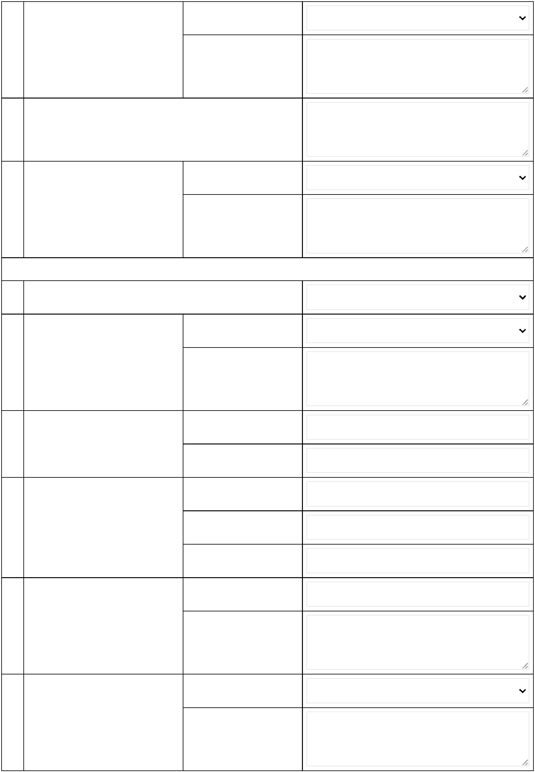

6/11/25, 10:17 AM
Aizawl || District
3
4
Whether medical exam is being Yes/No
conducted for victim.
Yes
If Yes, date of medical
1
2.09.2023
If Yes, summary of
medical report
3
5
Whether medical exam is being Yes/No
conducted for accused.
No
If Yes, date of medical
If Yes, summary of
medical report
https://cpsmizoram.in/monitoring_report/aizawl/index.php?page=pocso_case_detail1&main_id=74
7/7
