H a c k a t h o n 2 0 2 2: C o d i n g f o r a B e t t e r C o m m u n i t y

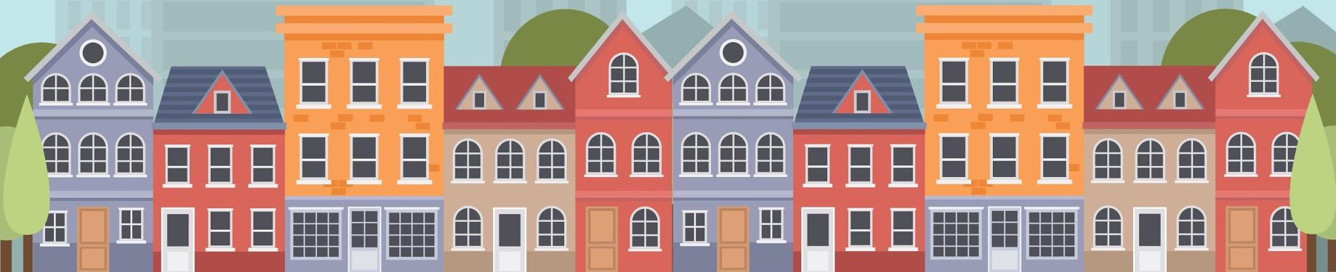

What Did You Think?

## [1] What is your role (circle one):

* Youth Track Participant (aged ~12-18)
* Advanced Track Participant (aged 18+)
* Mentor
* Volunteer
* Judge
* Parent/Guardian of Participant
* Other: Please describe: _________________

## [2] What did you like most about the hackathon event?

## [3] What did you like least about the hackathon event?

## [4] How can we improve this event for future participants?

*More Questions on Back!*

## [5] What other events do you desire from local organizations (like UWG) for your fun, learning, and/or career exploration?

## [6] Is there anything else you would like to tell us, whether the Hackathon planners or UWG at large? (Use the table below for ideas.)

## Finished Feed-backing?

*Hand this paper to an event volunteer or mentor, or leave it on the table, and we’ll pick it up! Thank you!*

| Reference: Parts of the Event | | |
| --- | --- | --- |
| * Food * Presentations * Awards * Icebreakers * Team Formation * Marketing | * Introducing the Topic * The Theme or Challenge * Mentoring Support * Communication | * Check In * Registration * Payment * Facilities (classrooms, parking, accessibility) * Tech Support |