## **Walkthrough Notes, 1.23.20**

| **About**  At least one week before an event (and ideally three weeks before), two or more of the event planners should walk through the entire event from start to finish (chronologically), with an eye on each space’s planned activities. Planners should investigate the technology (hardware and software) and the infrastructure. They should make sure they know how to turn on and/or use any technologies in the room, from computing technologies to miscellaneous tools such as electric window shades and room partitions. If furniture needs to be moved to accommodate specific activities, planning for this is advised. Planners should take notes and identify follow-ups. This activity is eminently useful for activating planners’ memories for the fine details of an event. It is also necessary for any co-planners who are new to the event.  The notes below are but a sample of the kinds of things one might write on a walk-through. They are not necessarily useful beyond that. |
| --- |

[Starting 101](https://drive.google.com/open?id=1BRg-VVp_YxfMaMwxu9BVZ-2m_xlZPU61)

[TEALS 117](https://drive.google.com/open?id=1g1NDnUDjtAM0uo44YrQ46z9Hj_Q3_zAH)

[Finishing 125](https://drive.google.com/open?id=1KWiIM_yzfGBZNqXKH-HnOmeK4ANlldFq)

[Conference 120](https://drive.google.com/open?id=11jy5Wcl6wAirmLywzCed-wju0zJGyiAE)

**101 Starting Room**

Goal: Arrange room for an interactive, discussion-oriented presentation from [Presenter 1]. Probably remove first row, and make aisles through the table rows. Put mentors to far right (when facing whiteboards). Create a space for student groups to “check out” on their way to TEAL.

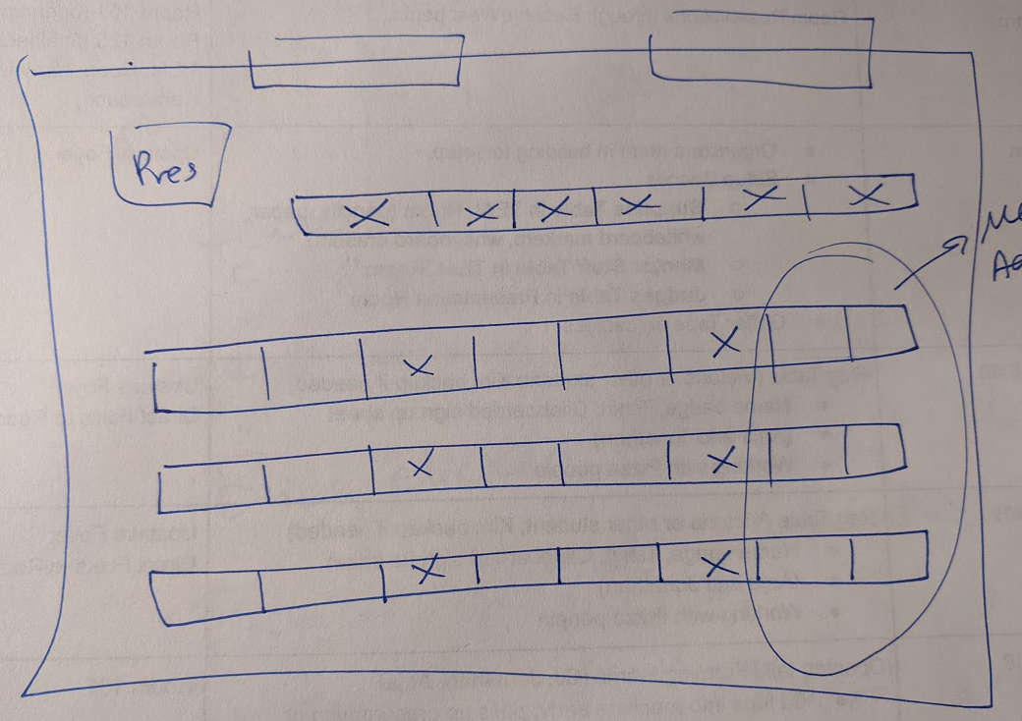

**120 Conference Room**

Goal: Set up the room to have the judging paperwork.

**TEAL**

No login information written on boards.

Partition was enacted, and tech was not tethered on 1/23.

How do we remove partition and tether technology?

TEAL room is room 117. The bigger half of the room is 01 (on west side) and the smaller is 03 (on east side).

In small03, there are 5 workstations (with 5 TVs, 4 whiteboards, 2 projector screens, 1 presentation space), and in big01, there are 8 workstations (with 8 TVs, 5 whiteboards, 2 projector screens, 1 presentation space).

At each station, there is a control system that says Laptop-Wireless-Instructor.

There are 5-6 erasers total and 6-8 markers across the two room sides.

**125 Finishing Room**

110 seats

9 rows

Teens in first 3 rows

Advanced in row 4

Test the clicker.

Provide picture of presentation area.