H a c k a t h o n 2 0 2 0: C o d i n g f o r a B e t t e r C o m m u n i t y

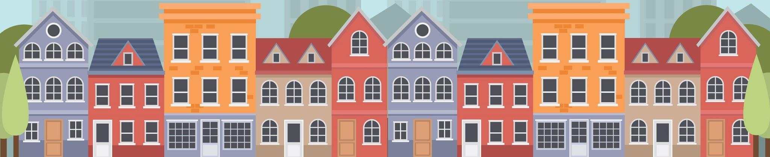

Schedule - Novice Track

| 9:00–9:25am | Registration and greeting | Lobby |
| --- | --- | --- |
| 9:30–10:30am | Introduction, opening talks, forming teams | Small Classroom |
| 10:30am | Code start | TEAL Room |
| 12:30–1:00pm | Lunch | Lobby |
| 3:00pm | Code stop | TEAL Room |
| 3:15–4:15pm | Presentations | Lecture Hall |
| 5:00–5:30pm | Awards Ceremony | Lecture Hall |