Development of IoT platform for online milk quality and cow health and welfare monitoring

|  |  |  |
| --- | --- | --- |
| **Group II,** |  | |
| **Prepared by:** | Mbabazi Niyo Ishimwe Valentin | 221025460 |
|  | Nishimwe Elyse Prince | 221017550 |
|  | Mugisha Remy | 221008577 |
|  | Iribori Murielle | 221012607 |
|  | Uwase Marie Claire | 221021988 |
|  | Ntakirutimana Angelique | 221009236 |
|  | Nyiransabimana Dorothee | 221009287 |
| **Introduction** |  |  |

Taking care of cows and ensuring their good health is very important in dairy farming. Healthy cows produce better-quality milk, which is safe for people to drink. Many farmers face challenges in maintaining the quality of milk and keeping cows disease- free.

One of the most common diseases affecting dairy cows is **mastitis**. This disease causes inflammation in the udder and affects the milk quality. If not detected early, it can lead to milk spoilage, loss of production, and economic problems for farmers.

Currently, most farmers test milk quality manually. This means that they take a sample of milk and check it in a laboratory. This process takes time, and mistakes can happen. Also, some diseases go unnoticed until they become serious. To solve this issue, we need a system that can monitor milk quality and cow health automatically.

# Problem Statement

The traditional way of checking milk quality has several issues:

* It is **slow** and **time-consuming**.
* It can have **human errors** that lead to incorrect results.
* Some problems, like bacterial infections, are **not detected early**, leading to spoiled milk.
* Farmers **lose money** due to wasted milk and unhealthy cows.

To improve dairy farming, we need an automated system that continuously monitors milk quality and cow health in **real-time**. This system should provide quick results and help farmers take immediate action to prevent milk spoilage and cow diseases.

# Proposed Solution

We propose developing an **Internet of Things (IoT)-based system** that will use sensors to check milk quality and cow health **automatically**. These sensors will be attached to milking machines to collect real-time data. The system will measure important factors such as:

* **Milk composition** (fat)  
  eg: 3.3-5V Turbidity Sensor (expected result 2.8%)  
  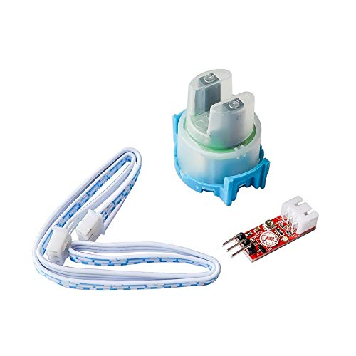
* **Temperature** (to ensure proper milk storage)
* **pH levels** (to detect milk freshness)
* **Somatic cell count** (to identify infections like mastitis)

| **Component** | **Function** |
| --- | --- |
| **Gravity Analog TDS/EC Sensor**  **Gravity Analog TDSEC Sensor**  Price: 24,000Rwf | Measures electrical conductivity (increased SCC → increased Na⁺ and Cl⁻ ions) |
| **3.3-5V Turbidity Sensor**  **3.3-5V Turbidity Sensor**  Price: 22,000Rwf | Detects changes in milk turbidity (higher SCC → more cloudy milk) |
| **OPT101 Light Intensity Sensor (CJMCU-101)**  **OPT101 Light Intensity Sensor** | Measures optical density (higher SCC → less light transmission)  Price: 13,000Rwf |
| **HD-U6A LED Controller**  **HD-U6A LED Controller** | Displays SCC values on an LED screen  Price: 18,000Rwf |
| Arduino Uno R3 With USB Cable. **arduino_usb** Price: 9,400Rwf | Collects sensor data and sends it to the IoT platform |
| Liquid PH Value Detection Sensor with Electrode Probe **ph-sensor** | It measures the acidity level of milk to ensure it is fresh and safe to consume.  And also it can measures fat Price: 36,500 Rwf |
| DS18B20 Digital Temperature Sensor **digital Temperature** | It monitors milk temperature to ensure it is stored properly and remains fresh.  Price: 4000Rwf |
|  |  |
| **Calibration System** | Machine Learning model or predefined SCC calibration table |

## ****Hardware Connection Diagram****

* **Turbidity Sensor** → **Analog Input** on **ESP32/Arduino**
* **TDS/EC Sensor** → **Analog Input** on **ESP32/Arduino**
* **OPT101 Light Sensor** → **Analog Input** on **ESP32/Arduino**
* **Microcontroller (ESP32/Arduino)** → **WiFi Module** (for IoT connection)
* **ESP32/Arduino** → **HD-U6A LED Display** (to show SCC values)
* **ESP32/Arduino** → **Django Web App** (via WiFi)

## ****Software Architecture****

### ****Backend: Django + Database****

| **Component** | **Description** |
| --- | --- |
| **Django Framework** | Backend processing and API for sensor data |
| **Database (MySQL/MongoDB)** | Stores sensor readings and SCC history |
| **Machine Learning Model** | Predicts SCC based on sensor data (optional) |
| **REST API** | Connects frontend to sensor data |

### ****Frontend: Web Dashboard****

| **Feature** | **Description** |
| --- | --- |
| **Dashboard (React/HTML+CSS+JS)** | Displays real-time SCC data |
| **Alerts System** | Sends SMS/Email if SCC > 400,000 cells/ml |
| **Graph Visualization** | Shows SCC trends over time |

## ****Data Flow: How It Works?****

1. **Milk Sample Testing:**

* The **milking machine** collects **milk samples** and passes them through **sensors**.

2. **Data Collection:**

* The **Turbidity, TDS, and OPT101 sensors** measure **milk properties**.
* The **ESP32/Arduino** reads sensor values and processes them.

1. **Data Transmission:**

* The ESP32/Arduino **sends data** to the **Django web platform** via WiFi.

4. **Data Analysis & Prediction:**

* The **Django backend** compares sensor values with **predefined SCC calibration tables** or an **ML model**.
* If SCC **> 400,000 cells/ml**, an **alert is triggered**.

5. **Results Display:**

* The **HD-U6A LED screen** shows **real-time SCC** at the farm.
* Farmers can check SCC levels via the **web dashboard.**

# Somatic Cell Count (SCC) and California Mastitis Test (CMT) Results

The California Mastitis Test (CMT) is a quick, easy, and economical test for detecting subclinical infection in milk. It provides an indication of the number of somatic cells found in milk. The CMT will only trigger a visible reaction if the concentration of somatic cells is 400,000 cells/ml or more.

## Calculation Steps:

1. Sensor Measurement – The sensor reads the SCC value in cells/ml.

2. Comparison with CMT Threshold – The CMT test triggers a visible reaction only if SCC ≥ 400,000 cells/ml.

3. Categorization of Results:

## CMT Categorization Based on SCC Levels

|  |  |
| --- | --- |
| SCC Value (cells/ml) | CMT Result |
| < 200,000 | Negative (Healthy Milk) |
| 200,000 - 400,000 | Trace (Mild Infection) |
| 400,000 - 800,000 | Weak Positive |
| 800,000 - 1,200,000 | Distinct Positive |
| > 1,200,000 | Definite Positive (Severe Infection) |

The collected data will be sent to a central system, where it will be analyzed. Farmers will receive updates through a **computer dashboard**, allowing them to take quick action if any issues are detected.  
  
**Milk quality test circuit  
  
URL:**https://www.tinkercad.com/things/3UeF5wQxZng/editel?sharecode=D-DMwW75OPstyyGQUWVYlasPsSYDHo4QHDXowvM8XZ0

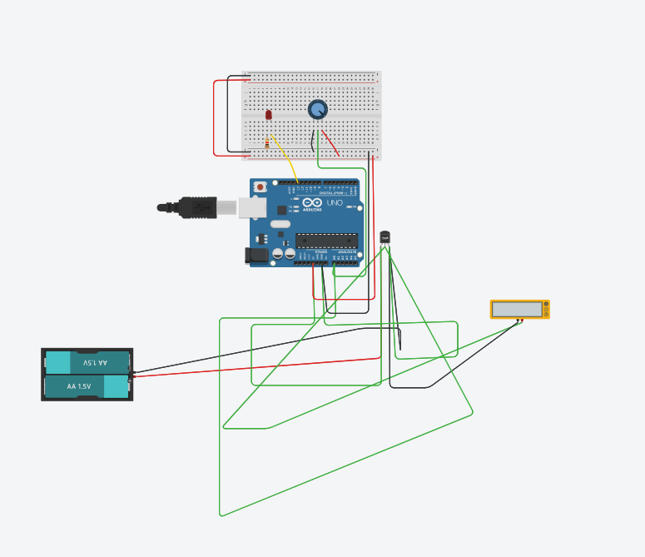

# Technology Stack

To build this system, we will use the following technologies:

* **Backend (Server Side):** Python with Django Framework
* **Database:** MySQL or MongoDB (to store milk and cow health data)
* **IoT Sensors:** Arduino Uno, pH sensors, temperature sensors
* **Communication Protocol:** MQTT / HTTP API (to send data from sensors to the system)

## Implementation Plan

The project will be developed in different phases:

* 1. **Research and Sensor Selection:** Identify and choose the best sensors for the system.
  2. **Backend Development:** Build the server using Django and set up the database.
  3. **Sensor Integration:** Connect the sensors to the system and ensure they work correctly.
  4. **Testing and Data Analysis:** Check if the system correctly detects milk quality issues and cow diseases.
  5. **Deployment and Evaluation:** Install the system on dairy farms and monitor its performance.

# Expected Outcomes

By developing this system, we expect the following benefits:

* + - **Early Disease Detection:** Farmers can identify mastitis and other diseases quickly, preventing further health problems.
    - **Better Milk Quality:** The system ensures that only **safe and high-quality milk** reaches the market.
    - **Reduced Milk Wastage:** Quick detection of contamination prevents milk from being wasted.
    - **Improved Farm Efficiency:** Automating milk quality checks saves time and reduces human errors.

# Conclusion

The **IoT-based milk quality and cow health monitoring system** will bring a major improvement in dairy farming. By using smart sensors and real-time analysis, farmers can take better care of their cows and ensure milk safety. This system will help reduce milk wastage, increase profits, and improve overall farm management.

With this technology, dairy farmers will have an **easy-to-use and reliable** method to monitor milk quality, ensuring that people get safe and high-quality milk.

# Refference:

[https://nyerekatech.com/?s=Mettler+Toledo+InLab+738+ISM&product\_cat=0&post\_](https://nyerekatech.com/?s=Mettler%2BToledo%2BInLab%2B738%2BISM&product_cat=0&post_type=product) [type=product](https://nyerekatech.com/?s=Mettler%2BToledo%2BInLab%2B738%2BISM&product_cat=0&post_type=product)

<https://www.faranux.com/product/arduino-uno/>