**Abstract**

**Introduction**

The capacities of working memory are something that psychologists have investigated extensively in order to better define its function and limitations. Working memory is the aspect of short-term memory that is utilized in memory recall tasks. Understanding how working memory is improved and hindered is important for improving learning strategies. A fundamental understanding of the working memory capacity is

* General intro to topic/why it’s interesting
* Previous research on this topic
* Theory being studied
* How this study is related to past investigations of the problem
* Research question that you hope to answer w this sudy
* Hypothesis (derived from theory)

**Method**

13 participants consisting of 12 undergraduate students and one graduate teaching assistant participated in this experiment. They were invited to participate in the study for class credit. The independent variable was the different word length conditions that were manipulated within participants. The dependent variable was the number of words recalled from each condition. Qualtrics survey and laptop were the only materials required. Four lists of words were randomly generated. Two lists had one-syllable words. Some examples include, “dry, soft, change, push, and gate”. The other two consisted of four to five-syllable words. Some examples include, “elevator, competition, possibility, humanity”. The word order was randomized for each participant and each word was shown to the participant for 1.5 seconds via a Qualtrics survey. All participants received all words from the four lists. Once all stimuli were shown to the participants, they were asked to recall as many words as they could remember. There was no time limit on how long a participant could create their list of recalled words.

**Results**

We hypothesized that participants would have more correct words recalled from the one-syllable word lists in comparison with words from the four to five-syllable word lists. Participants recalled 4.231 +/- 1.111 words on average in the short word condition (one syllable long) and 3.538 +/- 3.538 words on average in the long (4-5 syllable long) word length condition. On average, participants recalled more words from the short word list compared to the long word list. This difference was statistically significant (df = 12) p-value = 0.02, p-value < 0.05. Therefore, the hypothesis was supported.

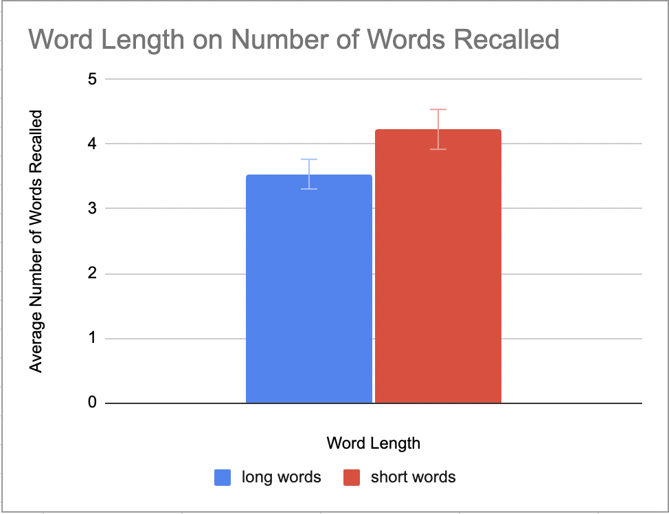

**Discussion**

The results supported our hypothesis that shorter words are better recalled than longer words when shown for an equal amount of time. These results support Baddeley’s theory of working memory. This theory indicates that there is a connection in how words are coded in memory between how the word both looks and sounds.

* Theoretical implications : Support for Baddeley theory of articulatory loop
* Practical implications
* Limitations
* Issues for future
* Strong take home message