WATCHSMART
Library & Friends
Update Specification
A development-ready plan for the new Watchlist/Watched experience, TV progress tracking, viewing statistics and Compare Friends redesign.
2  Core pages | 1  Shared data model | 8  Acceptance tests

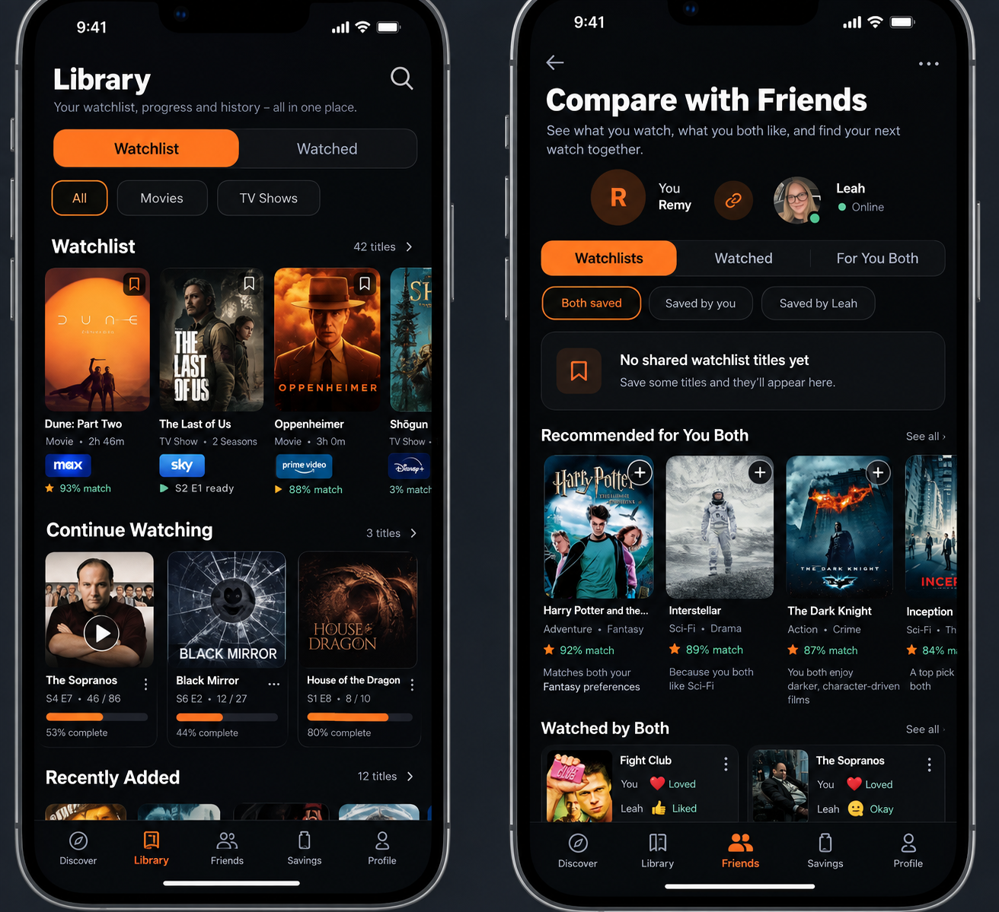
Concept direction: Library on the left, Compare Friends on the right. Final implementation should follow WatchSmart’s existing visual language.

Goal
Make WatchSmart feel like a personal viewing library, not just a saved-poster grid. Users should be able to save titles, record what they have watched, track TV-series progress, see total viewing time, compare activity with friends, and receive better shared recommendations.

1. Update scope
This update covers two connected product areas: the user Library (currently Watchlist) and Compare Friends. Both should use the same watchlist, watched-history, sentiment and TV-progress data so the app does not create duplicate systems.
Priority | Change | Area | Status
P0 | Fix automatic page jumping / unwanted scrolling | Friends + Library | Required
P1 | Redesign Watchlist into Watchlist + Watched Library | Library | Required
P1 | Separate Movies and TV Shows | Library | Required
P1 | Add TV season / episode progress tracking | Library | Required
P1 | Show watched sentiment on title cards | Library + Friends | Required
P1 | Restructure Compare Friends filters and sections | Friends | Required
P2 | Calculate total watched time and completion stats | Library | Recommended
P2 | Use shared history to improve For You Both | Friends | Recommended
2. Product principles
- One source of truth. A title saved, watched, rated or progressed in one place must update everywhere else.
- Fast to use. A user should be able to record TV progress in seconds without ticking every previous episode.
- No clutter. Primary navigation stays simple; secondary filters are only shown when useful.
- Preserve data. Existing watchlists, watched flags and sentiment must be migrated rather than reset.
- No surprise movement. Screens must never scroll vertically unless the user scrolls or explicitly taps an action that requires navigation.
- Useful friend comparison. The Friends page should answer what we both saved, what we each watched, what we thought of it and what we should watch next.
3. Library page - target experience
Recommended bottom-navigation label: Library. Inside the page, keep Watchlist and Watched as the two primary states. This is clearer once the page contains saved titles, history, progress and statistics.
Area | Behaviour | Purpose
Primary tabs | Watchlist | Watched | Separates future viewing from history.
Content filters | All | Movies | TV Shows | Lets users filter without creating separate pages.
Watchlist | Saved titles | Shows what the user intends to watch.
Watched | Viewing history + sentiment | Shows completed or started titles and what the user thought.
Continue Watching | Started TV shows | Surfaces active series with season/episode progress.
Stats | Time, movies, shows, episodes | Creates a useful personal viewing summary.
4. Library - Watchlist tab
The Watchlist tab contains titles the user wants to watch. The layout should be poster-led, but cards can show a small amount of useful metadata without becoming visually heavy.
- All, Movies and TV Shows filters directly below the Watchlist / Watched control.
- Movie cards: poster, title, provider where known, runtime and optional match/recommendation indicator.
- TV cards: poster, title, provider, seasons/episodes and progress if the user has already started the series.
- Saved state should remain obvious and be removable from the card or title-details screen.
- If a saved show has viewing progress, it can also appear in Continue Watching without being removed from the Library.
Example TV card
The Sopranos • S4 E7 • 46 / 86 episodes • 53% complete

5. Library - Watched tab
Watched should become a proper history view rather than a binary watched flag. The page should show the user’s reaction and TV progress where relevant.
- Movies display the existing reaction: Loved, Liked, Okay or Didn’t like.
- TV shows display reaction plus current progress or Completed status.
- Partially watched TV shows count as started and can appear in Watched / Continue Watching depending on the final information architecture.
- Cards should be tap-through to the normal title-details page, with a quick progress action for TV shows.
- Sort options can be added later (recently watched, title, rating, completion), but are not required for the first implementation.
6. TV-series progress tracking
TV tracking is a key data change. The user should be able to set a current point quickly, while the system keeps enough episode-level information to calculate progress and viewing time accurately.
Area | Behaviour | Purpose
Set current progress | Choose season + episode | Assume earlier episodes are watched, with manual correction available.
Mark season watched | One tap | Marks all episodes in that season as watched.
Mark series watched | One tap | Marks all currently available episodes as watched.
Episode override | Manual tick / untick | Lets users correct skipped or rewatched episodes.
Completion | Watched episodes / known episodes | Feeds progress bars and friend comparison.
Future episodes | Do not count as unwatched debt | Only released / known episodes should affect current completion where possible.
Important data rule
Do not store only “53% complete”. Store watched episode identifiers (or an equivalent reliable episode-progress model) and calculate percentage from the underlying data. This avoids losing detail and supports future features.

7. Viewing statistics and total watched time
Add a compact stats area to the Watched section. The first version should focus on trustworthy totals rather than a large analytics dashboard.
- Total movies watched.
- Total TV shows started / completed.
- Total episodes watched.
- Total watched time in hours; optionally also show the equivalent in days.
- Later extensions: monthly/yearly time, favourite genres, most watched actor, longest completed series and WatchSmart Wrapped.
Runtime calculation: movies use movie runtime. TV uses the runtime of watched episodes. If an individual episode runtime is unavailable, fall back to the show/season average runtime. Do not multiply total series runtime simply because the show has been opened or marked started.
8. Compare Friends - target experience
Compare Friends should be driven by the same Library data. Its purpose is not just to show overlap; it should help two people understand their shared library and decide what to watch together.
Area | Behaviour | Purpose
Watchlists | Both saved | Saved by you | Saved by friend | Compares future viewing.
Watched | Watched by both | You | Friend | Compares viewing history.
For You Both | Joint recommendations | Uses both taste profiles and history.
Reactions | Show each person’s sentiment | Makes watched overlap meaningful.
TV progress | Show each person’s season/episode | Useful when one person is ahead.
Empty states | Specific, contextual messages | Avoid vague “No overlap” wording.
9. Compare Friends - page structure
- Header: friend avatars, names and existing live/online state if this is already real functionality.
- Primary controls: Watchlists | Watched | For You Both.
- Secondary controls inside Watchlists: Both saved | Saved by you | Saved by [friend].
- Secondary controls inside Watched: Watched by both | Watched by you | Watched by [friend].
- Do not allow a selected pill/tab to be cut off at the edge of the screen.
- For You Both should prioritise titles neither person has watched and should use both profiles rather than a generic recommendation feed.
Better empty state
Instead of “No overlap — yet.” use “No shared watchlist titles yet” when the specific empty state is shared saved titles. The users may still overlap in watched history or taste.

10. Friend title-card information
When a title has been watched, show each person’s reaction directly on or directly beneath the card in a compact format.
Movie example
Fight Club
You — ❤️ Loved
Leah — 👍 Liked

TV example
The Sopranos
You — ❤️ Loved · Completed
Leah — 👍 Liked · S3 E7

The Friends view should read existing sentiment and TV progress; it should not maintain a second friend-specific copy of that information.
11. For You Both recommendation behaviour
- Combine both users’ taste profiles.
- Prioritise titles neither user has watched.
- Exclude or heavily penalise titles either user strongly disliked.
- Consider both users’ streaming services / UK availability where that data is reliable.
- Use shared genres, actors, creators, themes and tone signals already available in WatchSmart.
- Where possible show a short explanation such as “Because you both like Crime & Thriller” or “Matches both of your tastes”.
- Do not invent a precise match percentage unless the recommendation model already produces one with a defined meaning.
12. Automatic scrolling / jumping bug - P0
The current Compare Friends screen has been observed moving down / jumping without user input. Treat this as a P0 usability defect. Also audit the Library/Watchlist screens during this work so the same issue does not exist there or get introduced by the redesign.
The fix must identify the cause rather than hiding it by repeatedly forcing the view back to the top.
- Search for scrollTo, scrollToOffset, scrollToIndex, scrollToEnd, scrollIntoView and initialScrollIndex.
- Audit autoFocus, onLayout, onContentSizeChange and useEffect hooks that run after data or image loading.
- Check whether changing key values remounts the parent ScrollView/FlatList.
- Check nested vertical ScrollViews / FlatLists and layout-height changes caused by posters loading.
- Check whether LIVE polling or data refetches replace the entire screen or list data source.
- Switching a filter must not move the vertical scroll position.
- Returning from title details should restore the user’s prior position where practical.
Do not use this workaround
Do not repeatedly call scrollTo(0) to mask the problem. That simply creates a different jump and can make the screen feel broken.

13. Backend / data-model audit before coding
Before implementation, inspect what already exists in the FastAPI/backend and reuse it wherever possible. The exact schema names may differ; the important requirement is to avoid parallel duplicate models.
Area | Behaviour | Purpose
Watchlist membership | user + TMDB/content ID + type + timestamps | Existing saves must survive.
Watched state | user + title + watched/completed state | Migrate existing binary watched data.
Sentiment | Loved / Liked / Okay / Didn’t like / unfinished | Reuse current feedback values.
TV progress | show/season/episode watched state | New or extended model likely required.
Runtime | movie / episode minutes | Used for stats.
Friend relationship | user pair / permissions | Reuse current friends system.
Recommendation profile | existing taste vectors / affinity data | Use for For You Both.
14. Suggested API capabilities
- GET library/watchlist with type filters.
- GET library/watched with type filters and sentiment/progress.
- PUT TV progress for a show, season or episode.
- GET viewing statistics / total watched minutes.
- GET friend comparison for watchlists and watched history.
- GET For You Both recommendations based on both users.
- Existing endpoints can be extended instead of creating these exact routes if that is cleaner.
15. Data migration rules
- Do not delete or reset any existing watchlist items.
- Existing “watched” titles must appear in the new Watched section.
- Existing sentiment should be preserved and displayed.
- If a TV title is already marked fully watched but no episode records exist, migrate it to an appropriate completed state and backfill episode state only if reliable metadata is available.
- Do not manufacture exact historic watched dates, episodes or viewing time when the app never captured them. Historical totals may need to be labelled as estimates if old data lacks episode-level detail.
16. Implementation order
- Audit current Friends, Watchlist, watched, sentiment and TV metadata code; identify the exact cause of the scrolling bug.
- Fix scrolling / remount issue first and regression-test it.
- Extend the data model for TV progress and watched statistics while preserving existing data.
- Build the Library primary tabs and All / Movies / TV Shows filters.
- Add Watched history, sentiment display and Continue Watching.
- Add TV progress controls and progress bars.
- Add reliable viewing-time statistics.
- Refactor Compare Friends to use Watchlists / Watched / For You Both.
- Add friend sentiment + TV progress display.
- Update joint recommendation logic and recommendation explanations.
- Run iPhone-size UI tests and API/data regression tests before the next TestFlight build.
17. Acceptance criteria
- Neither Compare Friends nor Library moves vertically without user input while idle, loading posters or refreshing data.
- Watchlist and Watched are clearly separated and both can be filtered by All, Movies and TV Shows.
- Existing saves and watched history remain intact after migration.
- A user can set TV progress by season and episode without manually ticking every earlier episode.
- TV cards show a correct episode count / completion state based on stored progress.
- Watched cards show the user’s existing reaction where available.
- Viewing-time totals only count movies/episodes recorded as watched, with documented runtime fallback behaviour.
- Friends can compare shared saves, individual saves, shared watched history and individual watched history without clipped tabs.
- Friend cards show each user’s reaction and TV progress where available.
- For You Both avoids already-watched titles where possible and is based on both users rather than a single user.
- Empty states describe the actual missing data instead of using a generic “No overlap” message.
- The UI works on normal iPhone widths and respects safe-area / bottom-navigation spacing.
18. QA checklist before TestFlight
Area | Behaviour | Purpose
Scrolling | Leave screen open during refresh/image loads | No jump.
Tabs | Tap every primary/secondary filter | No clipping; vertical position stable.
Movies | Save, unsave, mark watched, rate | All views update consistently.
TV progress | Set S3 E6, mark season, undo episode | Counts and progress update correctly.
Stats | Compare known test account history to calculation | Minutes/hours are sensible.
Friends | Use accounts with overlap and no overlap | Correct lists and empty states.
Sentiment | Different reactions for same title | Both show correctly.
Navigation | Open details then go back | Prior state/position preserved where intended.
19. Developer handoff instruction
Use this document as the implementation source of truth for the Library + Compare Friends update. Before changing code, report the current relevant components/endpoints/models and the confirmed cause of the automatic scrolling bug. Then implement in the order above. Do not replace working backend systems unnecessarily, and do not remove or reset production/test user data.
Definition of done
The update is done when the acceptance criteria pass on an iPhone-size build, existing data is preserved, the scrolling bug is confirmed fixed, and Library / Friends read from the same underlying watchlist, history, sentiment and TV-progress data.

20. Future extensions - not required for this update
- Continue Watching on Discover.
- Viewing streaks and month/year summaries.
- WatchSmart Wrapped / shareable yearly recap.
- Friend progress alerts (“Leah is 2 episodes behind you”).
- Rewatch tracking and multiple watch dates.
- Calendar/reminders for upcoming episodes.
- More advanced compatibility insights between friends.

