HOME NETWORK LIVE TRAFFIC ANALYSIS
Authorized Home-Lab Network Security Assessment
Prepared as a cybersecurity portfolio project

Assessment Scope | Authorized home LAN and Kali analysis workstation
Network | 192.168.100.0/24
Primary Sensor | Kali Linux VM / VirtualBox bridged networking
Primary Tool | Wireshark

1. Executive Summary
This project documents an authorized live network analysis of a home LAN using a Kali Linux virtual machine and a Windows host connected through the same 192.168.100.0/24 network. The assessment combined host discovery, service enumeration, live packet capture, DNS analysis, ARP analysis, TCP conversation analysis, TLS/SNI inspection, and IPv4 endpoint analysis.
The capture established a baseline of normal network behavior, including DNS resolution through the home router, ARP resolution, encrypted HTTPS/TLS traffic, QUIC traffic, and communications with multiple external endpoints. Repeated DNS requests for two trycloudflare.com subdomains returned NXDOMAIN and were treated as an item requiring investigation rather than evidence of compromise.
No definitive evidence of malicious activity was identified within the captured traffic. The conclusion is limited by the short capture period and by the fact that the Kali VM was the primary observation point; bridged Wi-Fi virtualization does not automatically provide complete visibility into every wireless client's traffic.

2. Objectives
- Place Kali Linux and Windows on the same authorized home LAN.
- Identify active hosts within the local subnet.
- Establish service exposure baselines for known lab systems.
- Capture and analyze live network traffic with Wireshark.
- Analyze DNS, ARP, TCP, TLS, QUIC, and endpoint behavior.
- Investigate unusual DNS activity using packet-level correlation.
- Document findings, limitations, and recommendations in a repeatable format.

3. Scope and Authorization
The assessment was limited to the user's own home network and systems under their control. Network discovery and service enumeration were performed against the local 192.168.100.0/24 subnet for the purpose of this authorized lab project. No exploitation, credential attacks, persistence, or attempts to access third-party systems were performed.

4. Lab Architecture
Internet
|
Home Router — 192.168.100.1
|
+---- Windows Host — 192.168.100.8
|
+---- Kali Linux VM — 192.168.100.108
|
+---- Wireshark capture interface: eth0
Windows was connected over Wi-Fi and Kali was configured with a bridged VirtualBox adapter. Both systems were assigned addresses in the 192.168.100.0/24 subnet.

5. Network Configuration
Windows observed:
IPv4: 192.168.100.8
Subnet mask: 255.255.255.0
Default gateway: 192.168.100.1
Kali observed:
IPv4: 192.168.100.108/24
Default route: via 192.168.100.1 dev eth0
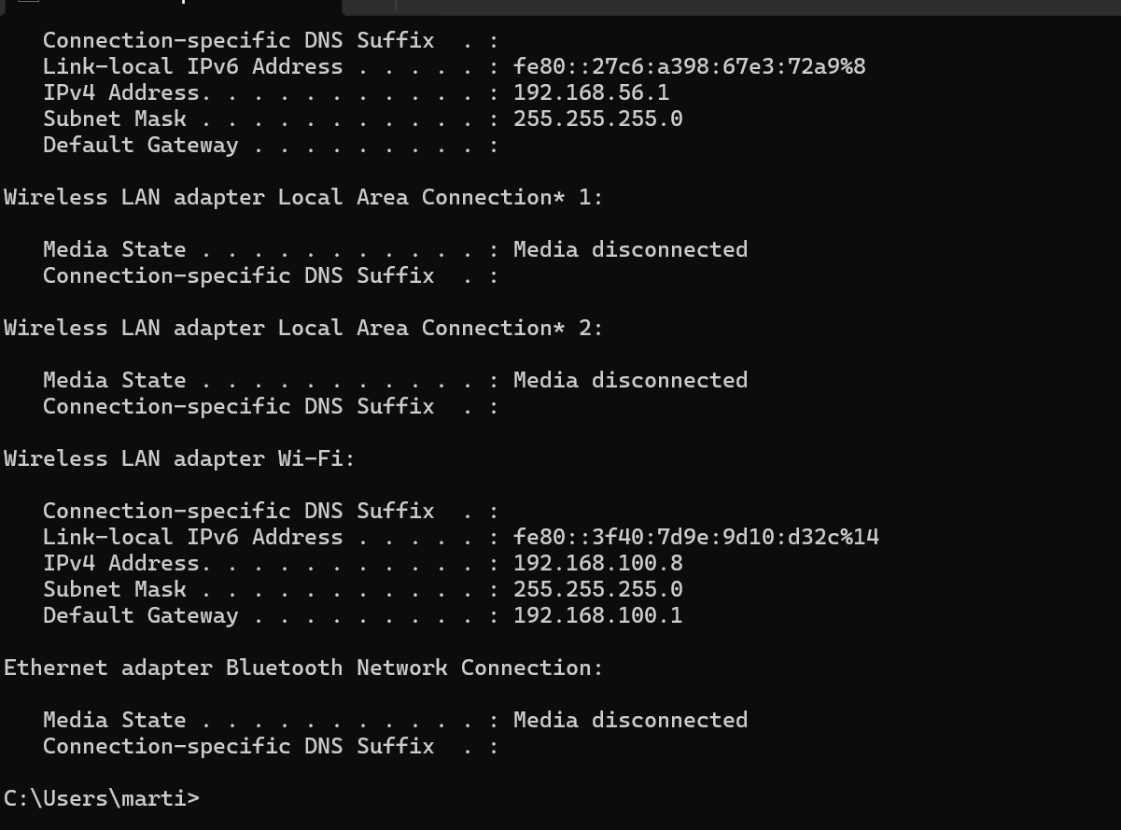
Evidence 01 — Windows IP configuration
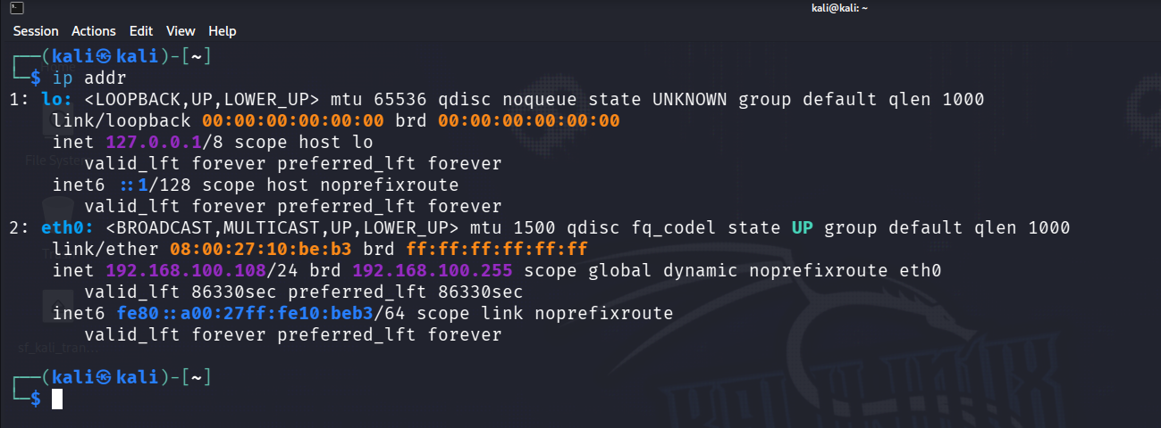
Evidence 02 — Kali IP configuration

6. Connectivity Verification
Initial ICMP testing required correction of a Windows IP-address typo. After correction, the connectivity test completed with 0% packet loss, confirming host-to-host communication across the LAN.
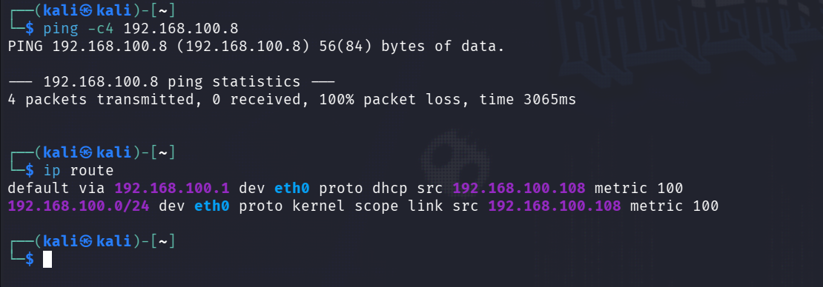
Evidence 03 — Connectivity/routing verification

7. Host Discovery
sudo nmap -sn 192.168.100.0/24
Nmap identified 13 active hosts. Vendor information included Huawei, Intel, Nintendo, and Espressif associations, while several hosts remained vendor-unknown.
IP Address | Observed Vendor | Assessment Role
192.168.100.1 | Huawei Technologies | Likely home router
192.168.100.8 | Intel Corporate | Windows host
192.168.100.42 | Nintendo | Observed LAN device
192.168.100.73 | Espressif | Observed IoT-associated device
192.168.100.108 | — | Kali analysis workstation
Several additional active addresses were observed but were not positively identified from the discovery scan alone.
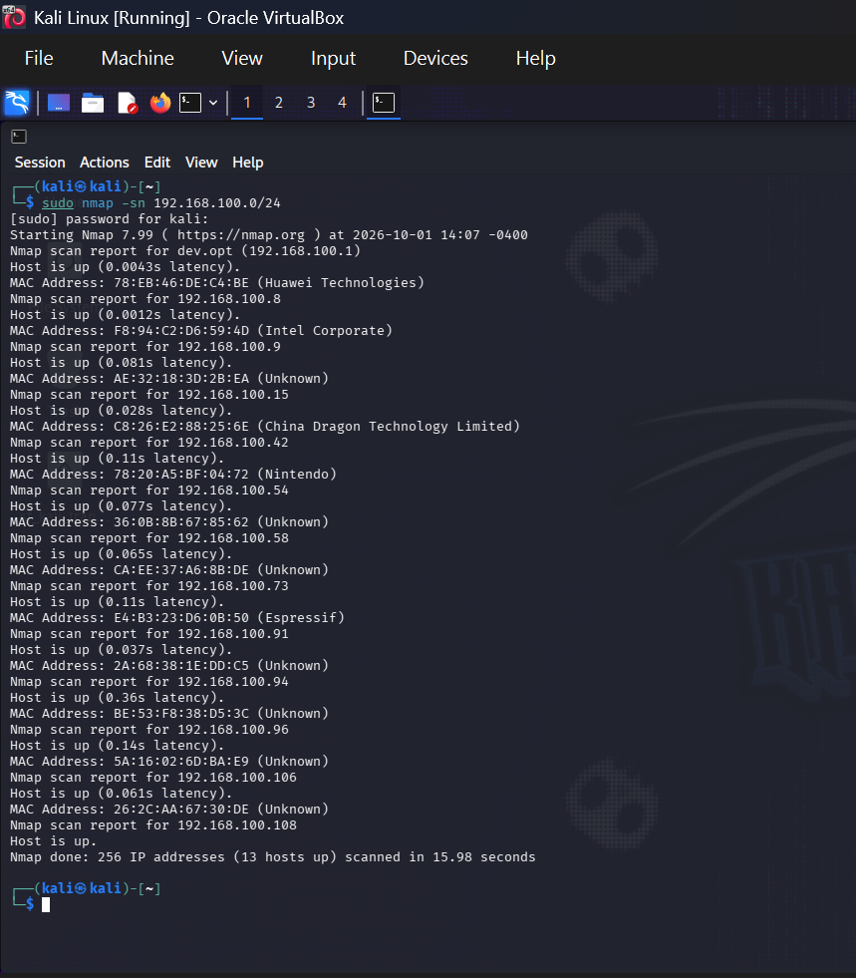
Evidence 05 — Authorized host discovery

8. Service Enumeration
Router 192.168.100.1:
21/tcp filtered ftp
22/tcp filtered ssh
23/tcp filtered telnet
53/tcp open domain
80/tcp open http
1900/tcp open tcpwrapped
8022/tcp filtered oa-system
The open/filtered states establish an exposure baseline; they do not by themselves demonstrate a vulnerability.
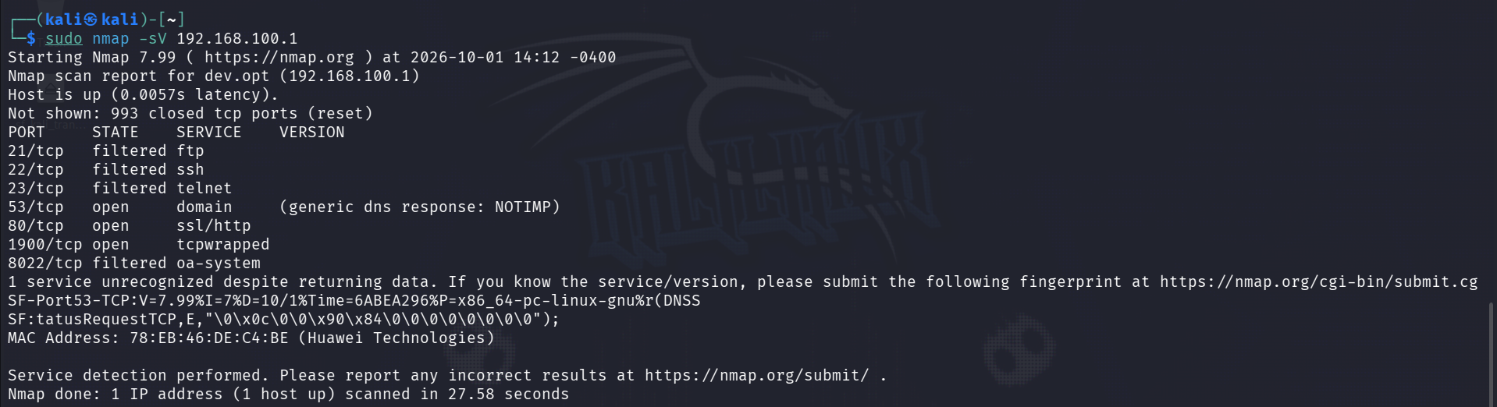
Evidence 06 — Router service enumeration
Windows 192.168.100.8:
7070/tcp open ssl/realserver?
Nmap did not positively identify the application behind port 7070. The exact service should be validated separately if required.
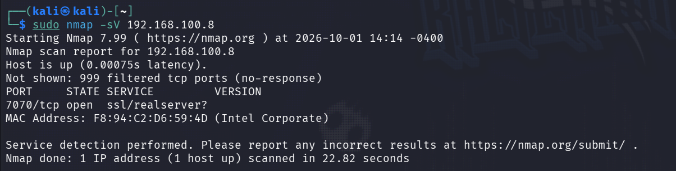
Evidence 07 — Windows service enumeration
Kali 192.168.100.108:
1000 scanned TCP ports; 1000 filtered / no response
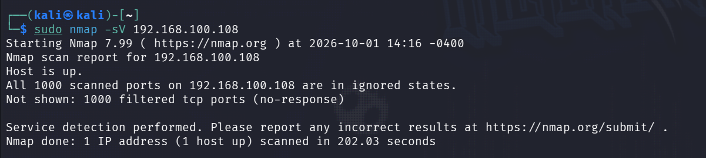
Evidence 08 — Kali service baseline

9. Live Packet Capture
A baseline capture named live.pcapng was created on Kali's eth0 interface. The capture contained 2,592 packets with 0 dropped packets according to the Wireshark status bar.
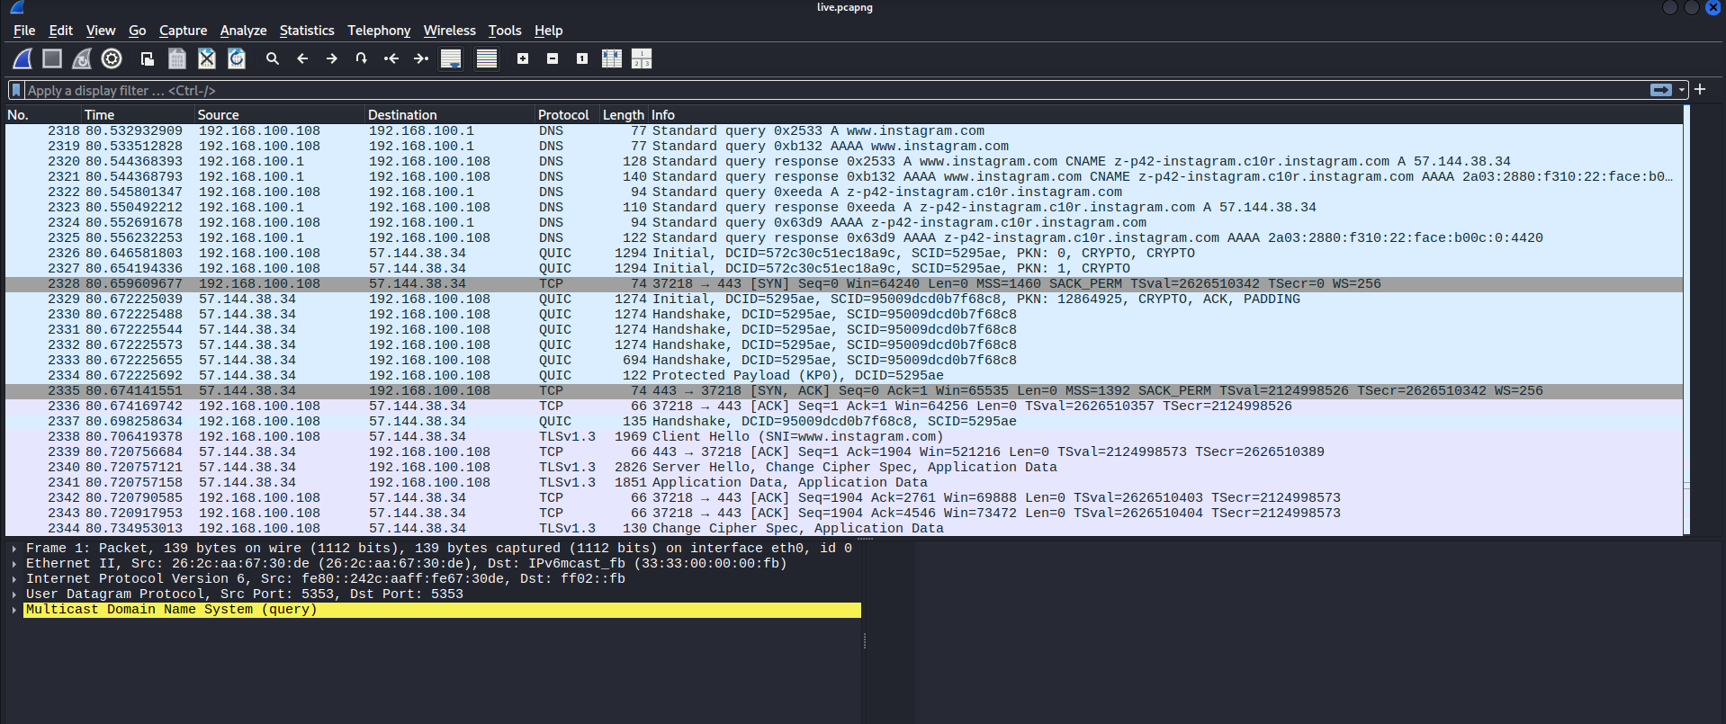
Evidence 09 — Live traffic capture

10. DNS Analysis
DNS traffic showed Kali using the home router at 192.168.100.1 as its resolver. Observed domains included Mozilla and Google services. The capture also showed repeated requests for two trycloudflare.com subdomains.
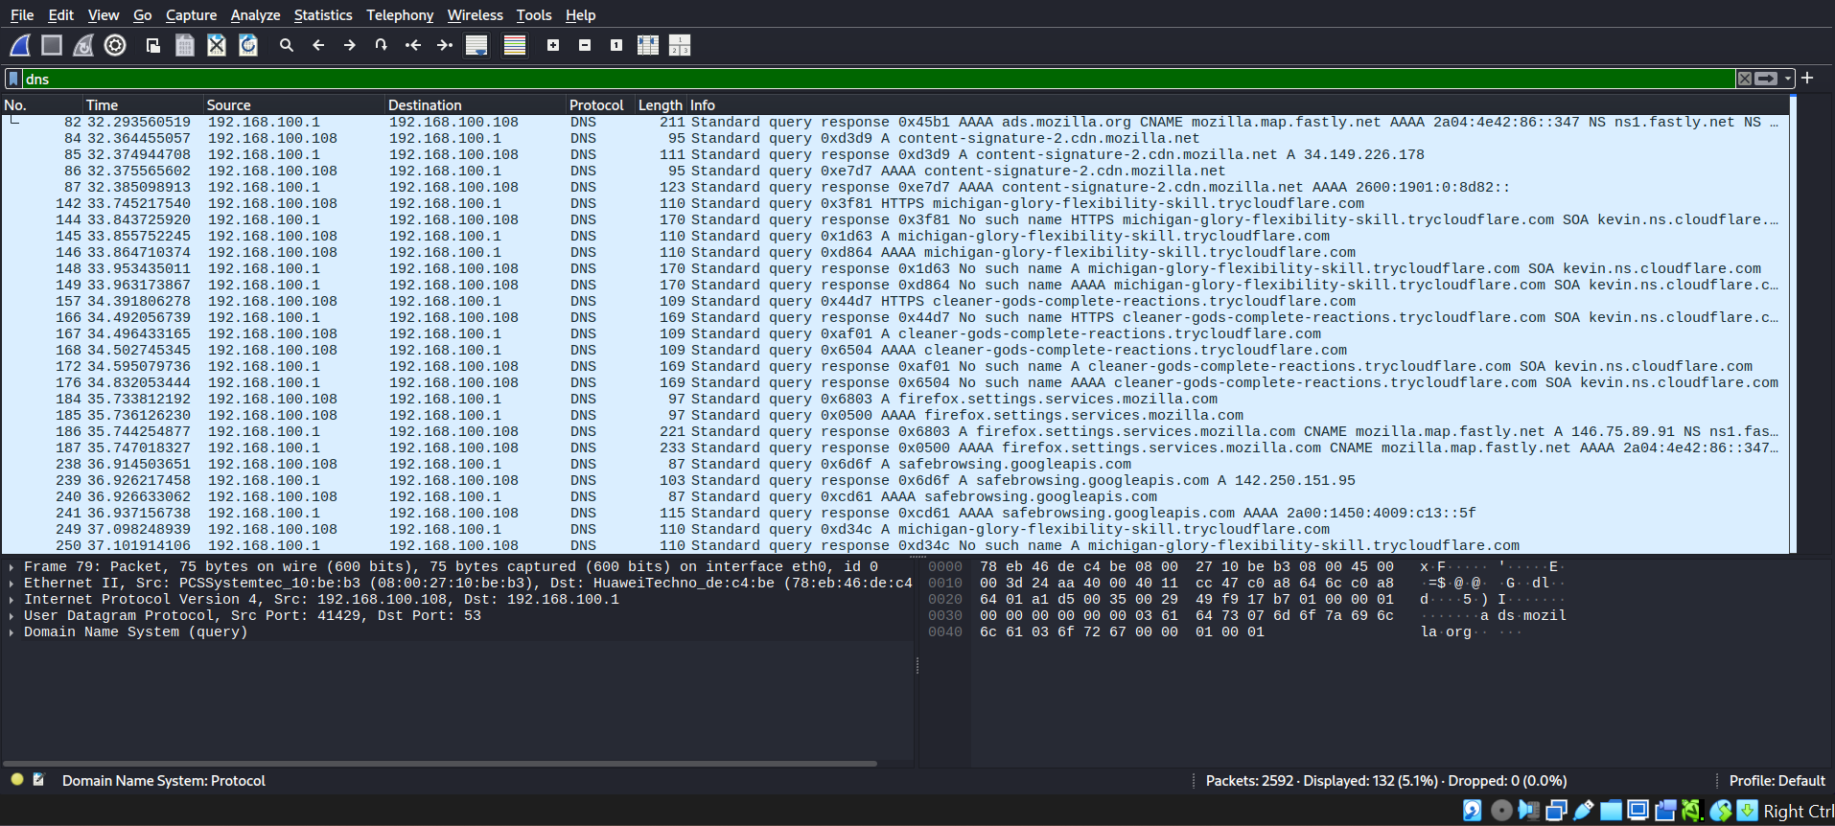
Evidence 10 — DNS traffic filter
The trycloudflare.com requests included A and AAAA lookups. The responses shown in the capture were NXDOMAIN (No such name). The repeated requests were recorded as an anomaly requiring correlation, not as proof of malicious activity.
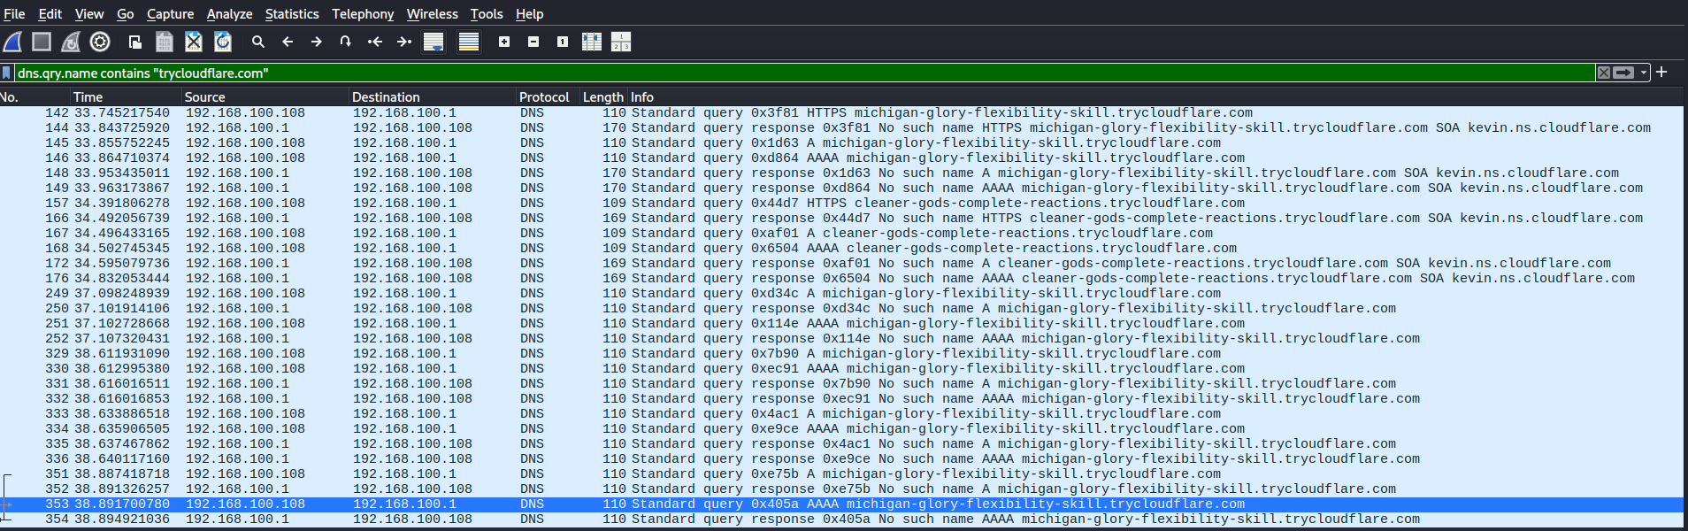
Evidence 11 — Repeated trycloudflare.com DNS activity

11. TLS/SNI Correlation
A separate TCP/443 connection from Kali to 104.26.13.205 contained TLS handshake data. Packet inspection exposed api.ipify.org in the captured handshake data. This was not a successful correlation to either of the NXDOMAIN trycloudflare.com queries.
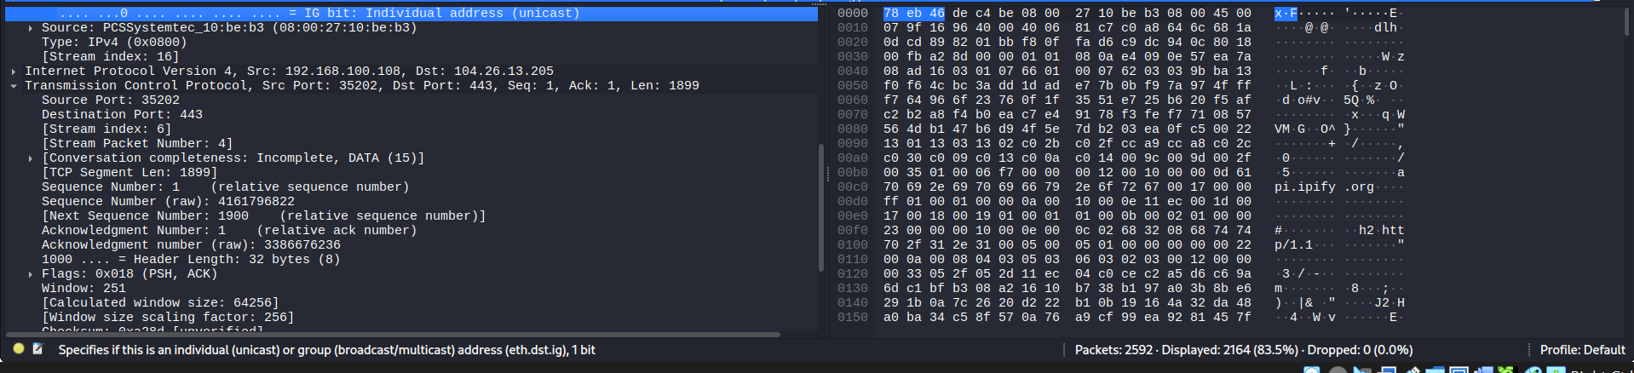
Evidence 12 — TLS handshake inspection

12. ARP Analysis
ARP traffic showed normal local address resolution, including the router resolving 192.168.100.8 and 192.168.100.108. Kali's observed MAC address was consistent with its VirtualBox network interface. An ARP announcement for 192.168.100.73 was also observed.
No duplicate IP/MAC ownership was demonstrated in the captured ARP evidence.
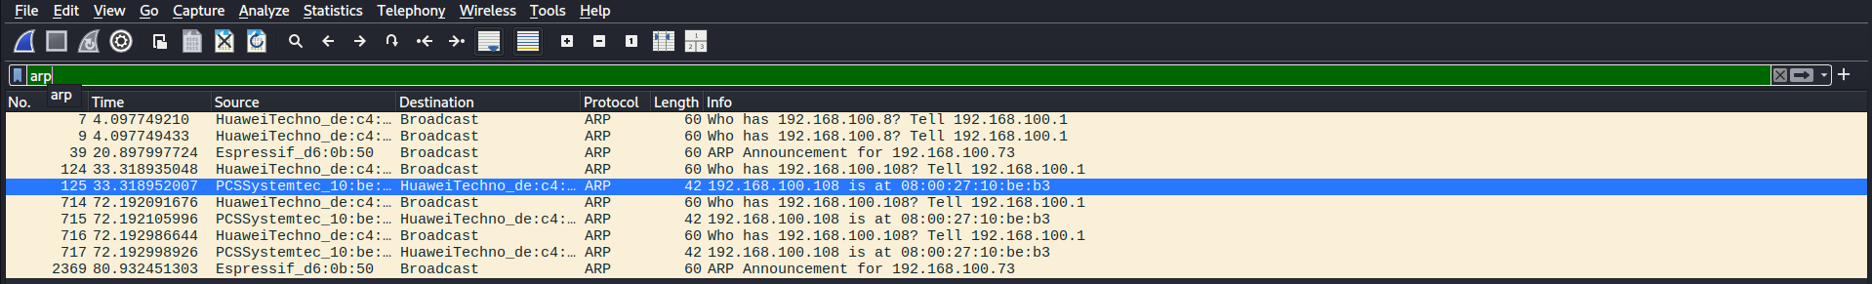
Evidence 13 — ARP analysis

13. TCP Conversation Analysis
The TCP conversation table showed multiple TCP/443 connections to external endpoints. HTTPS/TLS traffic accounted for the dominant TCP communications observed. A local connection from Kali to 192.168.100.1:80 was also observed, consistent with the router's HTTP service identified during enumeration.
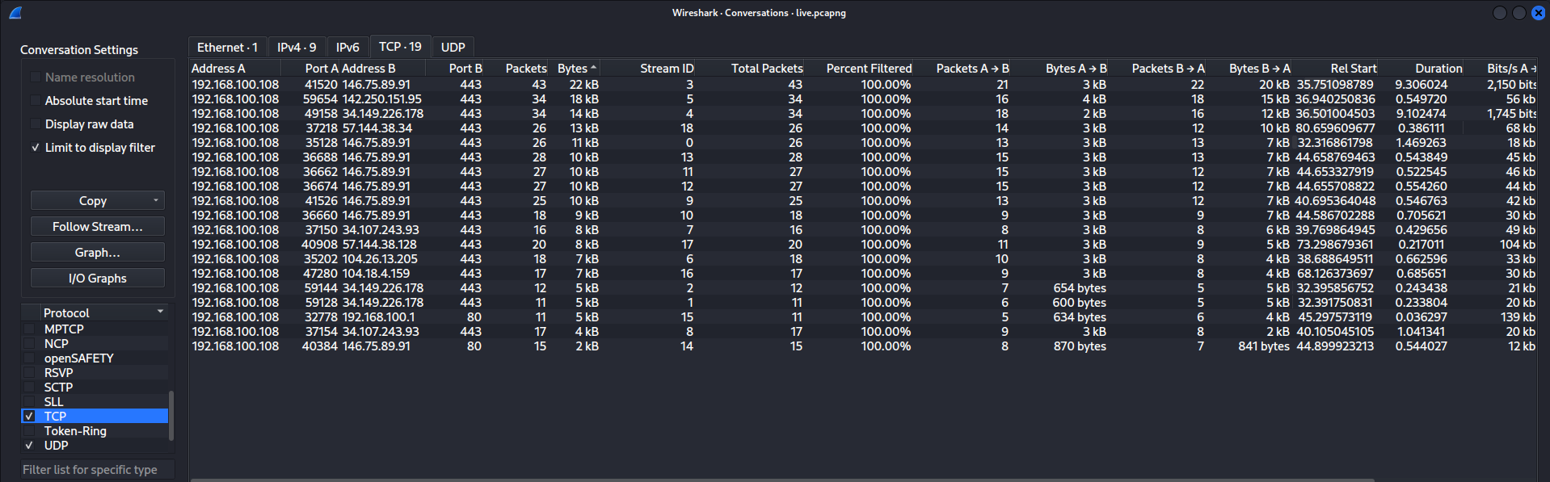
Evidence 14 — TCP conversations

14. IPv4 Endpoint Analysis
The unfiltered IPv4 endpoint view identified 20 IPv4 endpoints. The Kali workstation generated approximately 2 MB of observed traffic in the capture. The largest external endpoint by packet count was 57.144.38.128, with approximately 1,519 packets and about 2 MB of traffic.
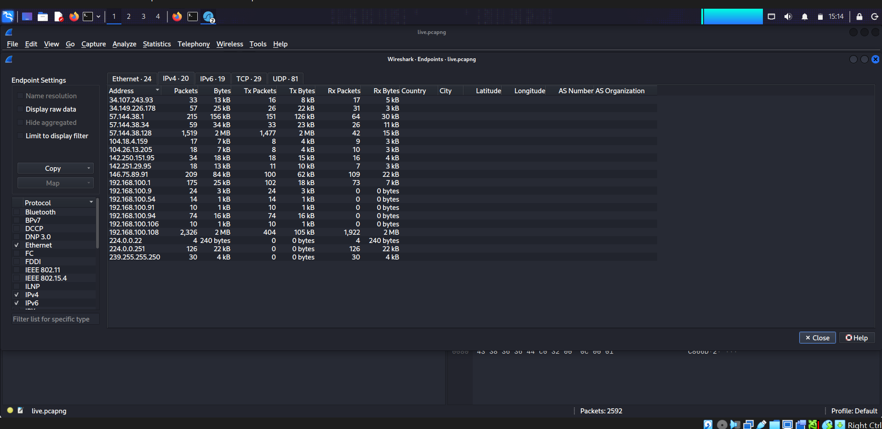
Evidence 16 — Unfiltered IPv4 endpoints

15. Findings Summary
ID | Finding | Status | Summary
F-001 | Same-LAN configuration | Confirmed | Windows 192.168.100.8 and Kali 192.168.100.108 were in 192.168.100.0/24.
F-002 | Host-to-host connectivity | Confirmed | Corrected ICMP testing completed with 0% packet loss.
F-003 | Active hosts | 13 hosts | Nmap host discovery identified 13 active hosts.
F-004 | Router services | Baseline | DNS/53 and HTTP/80 were open; other tested services were filtered/open as documented.
F-005 | Windows 7070/tcp | Requires validation | Service was reported as ssl/realserver? by Nmap.
F-006 | Kali TCP exposure | Baseline | No responsive TCP service among the 1,000 ports scanned.
F-007 | DNS resolution | Normal | Kali used 192.168.100.1 for DNS resolution.
F-008 | Encrypted traffic | Normal | TLS 1.2/1.3 and QUIC traffic were observed.
F-009 | Capture visibility | Limitation | Kali capture did not provide complete visibility into all wireless clients.
F-010/F-011 | trycloudflare.com lookups | Requires investigation | Repeated A/AAAA requests returned NXDOMAIN.
F-012/F-013 | TLS correlation | Identified | A separate TLS connection exposed api.ipify.org; it was not tied to the NXDOMAIN requests.
F-014 | ARP behavior | Baseline | No demonstrated duplicate IP/MAC ownership.
F-015/F-016 | TCP conversations | Baseline | Multiple encrypted external connections and router HTTP communication were observed.
F-017 | IPv4 endpoints | Baseline | 20 IPv4 endpoints were observed in the unfiltered endpoint view.

16. Limitations
- The capture was a short baseline capture rather than continuous monitoring.
- Kali was the primary capture point; bridged Wi-Fi virtualization does not automatically expose every other wireless client's unicast traffic.
- Encrypted protocols limited application-payload visibility.
- Vendor identification from MAC addresses is not definitive proof of device type or ownership.
- NXDOMAIN responses for trycloudflare.com names were anomalous but were not sufficient to classify the activity as malicious.
- No exploit or malware analysis was performed.

17. Recommendations
- Identify the remaining unknown devices from the Nmap inventory using the router's client list and device ownership records.
- Review the Windows host for the application listening on TCP/7070 and confirm whether it is expected.
- Review the router administration interface and disable unnecessary management services where appropriate.
- Prefer HTTPS for router administration when supported and restrict management access to trusted LAN hosts.
- Continue periodic baseline captures and compare DNS, endpoint, and service behavior over time.
- For full LAN-wide monitoring, deploy a dedicated network sensor at an appropriate observation point such as a mirrored switch port, gateway, or dedicated monitoring appliance.
- Preserve original PCAP files as evidence and generate hashes when publishing or archiving project artifacts.

18. Conclusion
The assessment successfully demonstrated an end-to-end home-network security monitoring workflow. The project established the LAN topology, discovered active hosts, enumerated selected services, captured live traffic, and analyzed DNS, ARP, TCP, TLS, QUIC, and IPv4 endpoint behavior. The resulting evidence supports a network-traffic baseline and identifies specific areas for follow-up without overstating the evidence. No definitive malicious activity was established within the captured traffic.

19. Evidence Index
- 01_windows_ip_configuration.png
- 02_kali_ip_configuration.png
- 03_connectivity_test.png
- 05_network_discovery_nmap.png
- 06_router_service_scan.png
- 07_windows_service_scan.png
- 08_kali_service_scan.png
- 09_live_traffic_capture.png
- 10_dns_traffic_analysis.png
- 11_trycloudflare_dns_activity.png
- 12_tls_sni_correlation.png
- 13_arp_analysis.png
- 14_tcp_conversations.png
- 16_ipv4_endpoints.png

