INPUT File (example: 3DUS_1.txt)

method 1 方法1名稱
Large 1 為 positive
0.00076
0.0062
* 良性結束
0.8
0.7
* 惡性結束

執行 rockit.exe

Binormal Parameters and Area Under the Estimated ROC :
a = 2.3961
b = .7607
Area (Az) = .9717
Area (Wilc) = .9723

Asymmetric 95% Confidence Interval
For Az: ( .9356, .9891)

Az = 0.972 (95% confidence interval, 0.936-0.989)

利用PlotROC.xls畫roc curves

按此Button
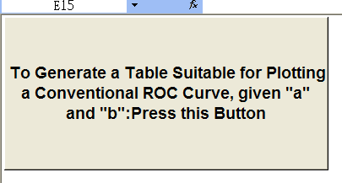

填入 a及 b之值
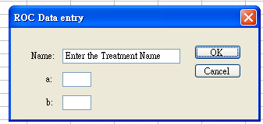

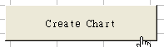
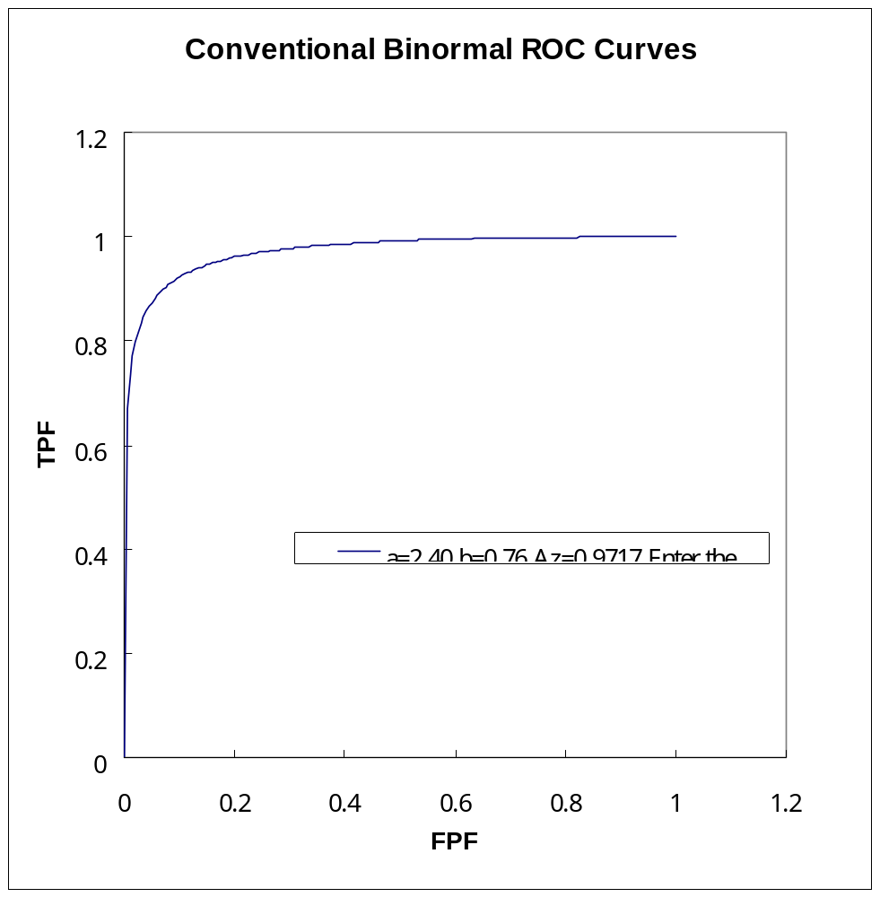修改如下
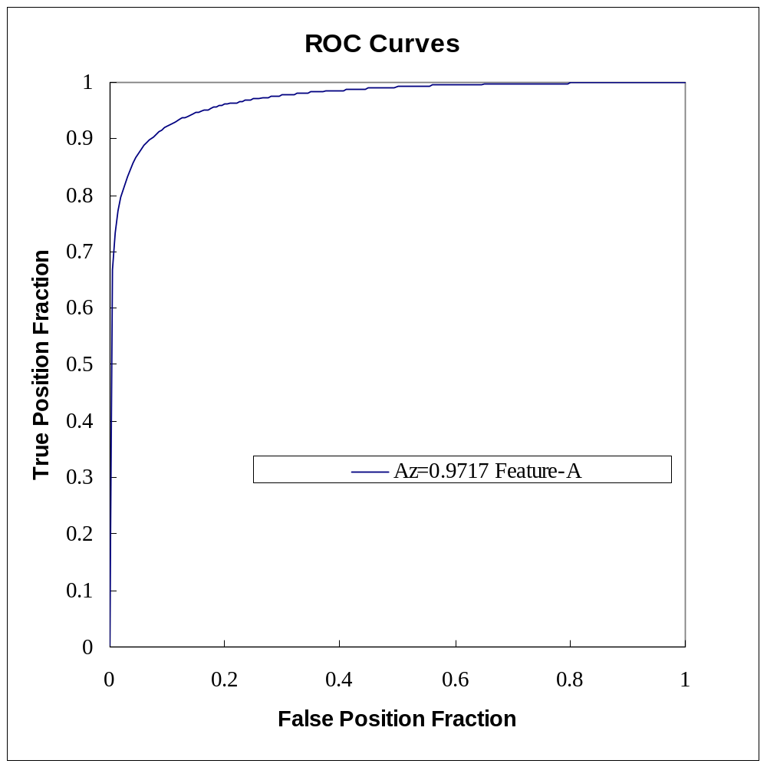
字型Times New Roman

修改圖例方法
