INPUT File (範例: 3DUS.txt)

method 1 方法1名稱
Large 1 為 positive
method 2 方法1名稱
Large
0.00076 0.002 第一個值為方法一的output第2個值為方法2的output
0.0062 0.02
* 良性結束
0.8 0.6
0.7 0.8
* 惡性結束

原程式說明
to calculate the statistical significance of the difference between two ROC curve estimates using any one of three distinct statistical tests:
(i) The Bivariate Test: A bivariate Chi-square test of the simultaneous differences between the “a” parameters and between the “b” parameters of the two ROC curves. (Null hypothesis: the data sets arose from the same binormal ROC curve.)
(ii) The Area Test: A univariate z-score test of the difference between the areas under the two ROC curves. (Null hypothesis: the data sets arose from binormal ROC curves with equal areas beneath them.)
(iii) The TFP Test: A univariate z-score test of the difference between the true-positive fractions (TPFs) on the two ROC curves at a selected false-positive fraction (FPF). (Null hypothesis: the data sets arose from binormal ROC curves having the same TPF at the selected FPF.)

結果
Statistical Significance of the Difference between the Two
*CORRELATED* ROC Curve Estimates According to the Selected Test:
***********************************************************

The computed *CORRELATED* Area test statistic
has a value of = 0.0000

with corresponding two-tailed p-value = 1.0000 <= p-value
and corresponding one-tailed p-value = .5000.

文章寫法
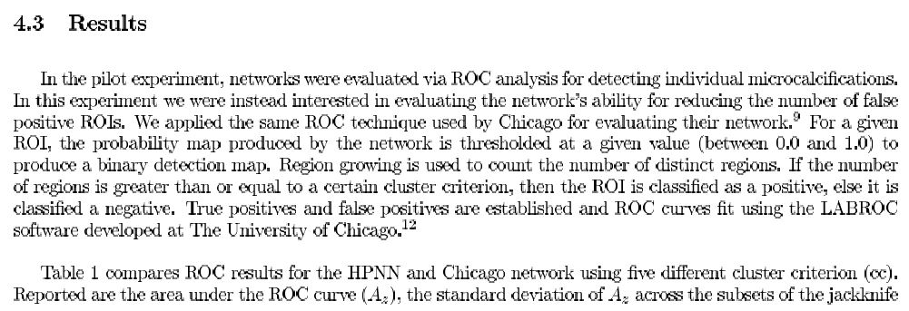
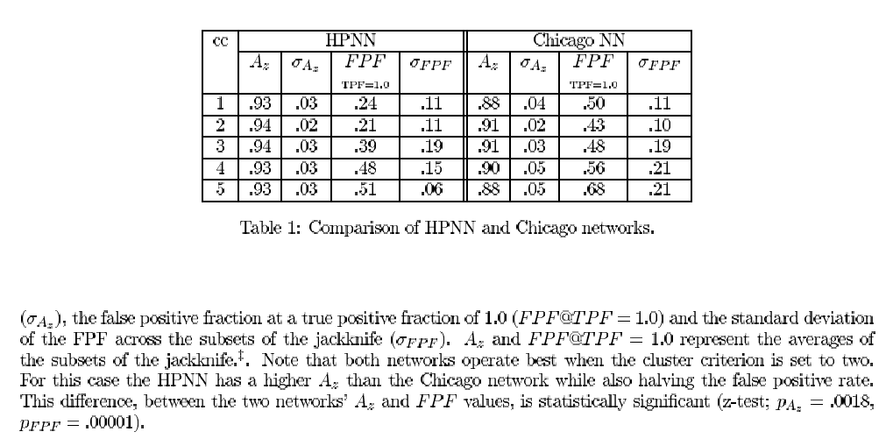

利用PlotROC.xls畫roc curves

按此Button
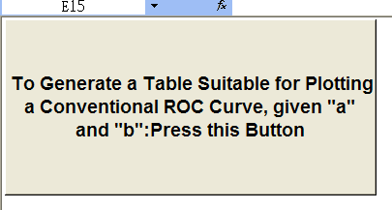

填入 a及 b之值
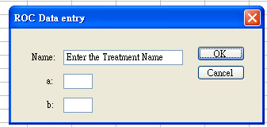
加入第二方法之a及b
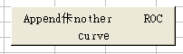
後再
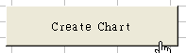
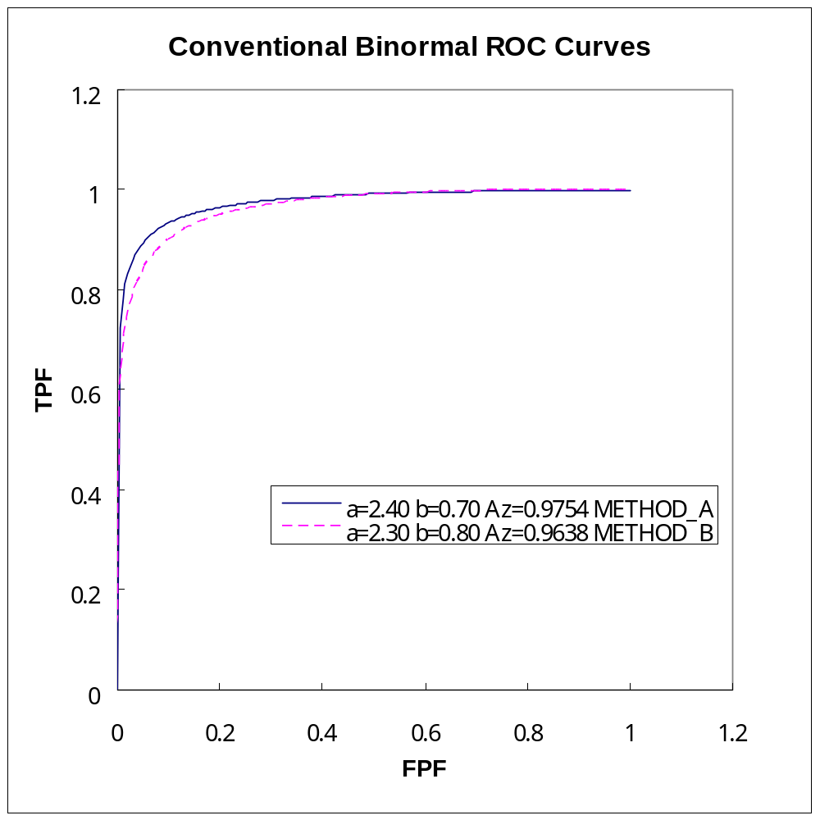
上圖必須修改

修改圖例方法
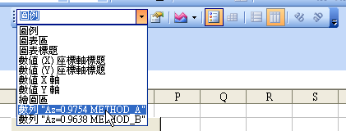

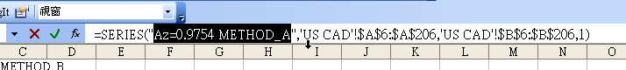

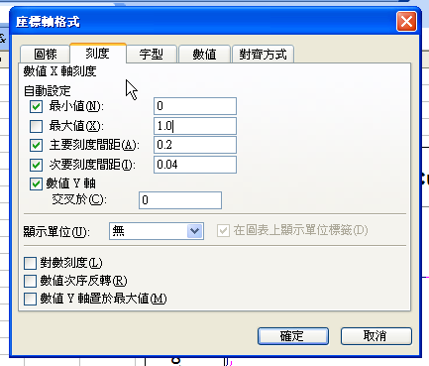
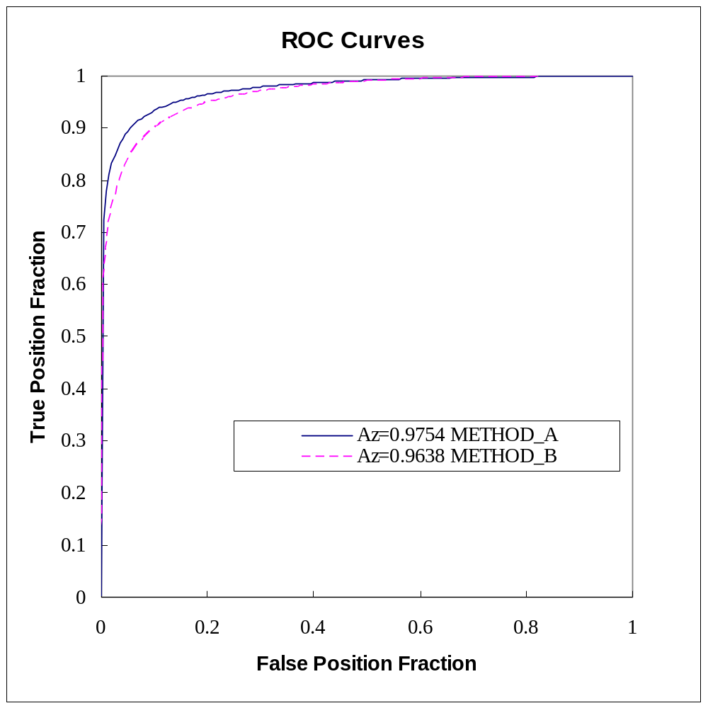
字型Times New Roman
必須維持正方形

