BOARD QUESTION PAPER: DECEMBER 2020
Science and Technology – Part 2
Time: 2 Hours Max Marks: 40

Note:
i. All questions must be attempted.
ii. Wherever necessary, scientifically correct diagrams with correct labelling should be drawn.
iii. Start every main question on a new page.
iv. Numbers to the right indicate full marks.
v. For Question No.1(A) MCQ marks will be given only for the first attempt.
vi. The answer to every MCQ should be written as shown:
Example – Q. No. 1(A) (i) (b).

Q.1. (A) Choose the correct alternative from the given options: [5]

i. Water reservoir possesses _______ energy.
(A) Nuclear (B) Thermal (C) Kinetic (D) Potential

ii. In mitotic division, nuclear membrane completely disappears in _______ phase.
(A) Telophase (B) Prophase (C) Metaphase (D) Anaphase

iii. Genetic changes occur due to _______ pollution.
(A) Radioactive (B) Air (C) Water (D) Soil

iv. In human, sperm production occurs in the _______ organ.
(A) Seminal vesicle (B) Testes (C) Prostate gland (D) Cowper’s gland

v. Which sanctuary of Assam is under threat due to dams and indiscriminate use of water?
(A) Tadoba (B) Kaziranga (C) Manas (D) Sundarban

Q.1. (B) Answer the following sub-questions as per given instruction: [5]
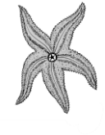

i. Name the locomotory organ of animal shown in the above figure.

ii. Find the correct co-relation:
Spirogyra : Fragmentation :: Planaria : _______.

iii. Write whether the following statement is True or False:
DNA fingerprinting is mainly useful in Forensic Sciences.

iv. Write the molecular formula:
4% acetic acid (Vinegar).

v. Which molecules are necessary for the formation of plasma membrane?

Q.2. (A) Give scientific reasons (any two): [4]

i. While performing the exercise, we feel tired.
ii. Hydroelectric energy, solar energy and wind energy are called renewable energies.
iii. Microbial enzymes are used instead of chemical catalysts in chemical industry.

Q.2. (B) Answer the following questions (any three): [6]

i. Distinguish between Aerobic respiration and Anaerobic respiration (any two points).
ii. Write a short note on Sacred groves.
iii. Explain the term: Modern technology of reproduction IVF.
iv. How is Balanoglossus connecting link between chordates and non-chordates?
v. Explain Darwin’s theory of natural selection.

Q.3. Answer any five questions from the following: [15]
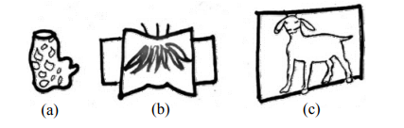

i. Identify and explain the above different types of symmetry.
ii. Write any six factors affecting the social health.

iii. Complete the following chart:
Substance obtained by microbial processing | Roles
(a) Citric acid | _______
(b) Ascorbic acid | _______
(c) Beta carotene | _______
(d) Glycolipids | _______
(e) Vanillin | _______
(f) Xylitol | _______

iv. Explain the three different levels of Biodiversity.
v. Observe the following figure and answer the questions:
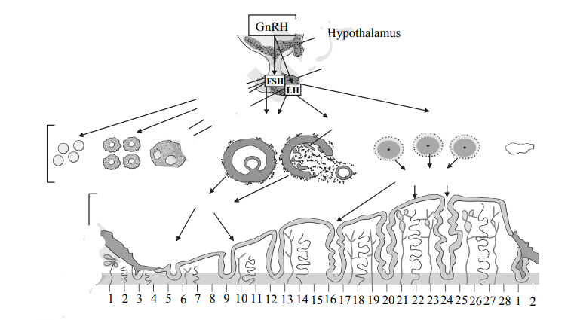

a. Identify the process in above figure and after how many days it will repeat again?
b. Write the names of hormones involved in this process.
vi. What are the advantages of hydroelectric power generation?
vii. a. Define vestigial organs.
b. Write name of any two vestigial organs in human body.
c. Explain how one human vestigial organ is functional in another animal.
viii. What will you do in the following cases and why?
a. Child of your neighbour is addicted to tobacco chewing.
b. You have to use free space around your home for good purpose.
c. Your friend has developed the hobby of snapping selfies.

Q.4. Solve any one of the following: [5]
i. a. What is meant by disaster management? [1]
b. Classify the following activities into pre-disaster management and post-disaster management: [2]
(i) Identifying the pro-disaster areas.

(ii) Quick establishment of help centre.
(iii) Participation of preferably local people saved from the disaster in arranging the help to victims.
(iv) Getting special training for disaster management.
c. Complete the diagram: [2]
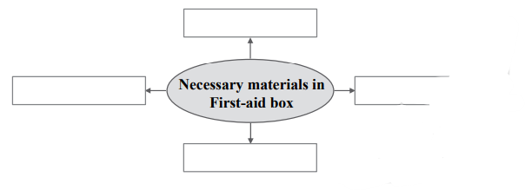

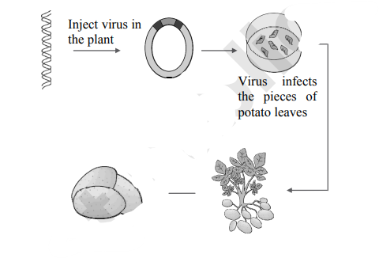
ii. Observe the figure and answer the following questions:

a. Identify the process given in the above figure. [1]
b. Write the importance of above process. [2]
c. Write any two benefits of Biotechnology. [2]

