BOARD ACTIVITY SHEET: JULY 2022
Science and Technology – Part 2
Time: 2 Hours Total Marks: 40

NOTE:
i. All questions are compulsory.
ii. Use of a calculator is not allowed.
iii. The numbers to the right of the questions indicate full marks.
iv. In case of MCQs [Q. No. 1(A)], only the first attempt will be evaluated.
v. For each MCQ, write the correct option (A), (B), (C) or (D) with subquestion number.
Example: (i) (A), (ii) (B), (iii) (C)
vi. Draw scientifically correct, labelled diagrams whenever necessary.
------------------------------------------------------------
Q.1 (A) Choose the correct option and write its number: [5]

i. Glycolysis and ________ are two steps of anaerobic respiration.
(A) Kreb’s cycle (B) Electron transfer chain reaction
(C) Fermentation (D) Reduction

ii. _______ is used in thermal power plant.
(A) Coal (B) Uranium (C) Natural gas (D) Water

iii. Chemically, vinegar is 4% _______.
(A) Gluconic acid (B) Amino acid
(C) Citric acid (D) Acetic acid

iv. Government of India has encouraged the _______ for improving the production by launching NKM-16.
(A) Apiculture (B) Vermiculture
(C) Pisciculture (D) Sericulture

v. Alcohol consumption mainly affects _______ system.
(A) Respiratory (B) Nervous
(C) Digestive (D) Circulatory

------------------------------------------------------------

Q.1 (B) Answer the following: [5]

i. Write the scientific name of human being.
ii. Find the odd man out: Actin, Ossein, Myosin, Aldosterone
iii. State True or False: The power available from the solar cell is AC.
iv. I have calcareous spines and move with tube feet. Which phylum do I belong to?
v. Write any one example of natural disasters.

Q.2 (A) Give scientific reasons (any two): [4]

i. Water is an essential nutrient.
ii. Tobacco chewing is injurious to health.
iii. It is absolutely necessary to control the fission reaction in nuclear power plants.

Q.2 (B) Answer the following (any three): [6]

i. Complete the chart:
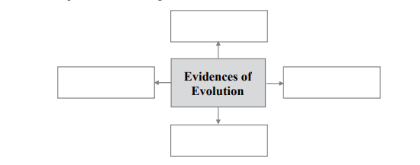

ii. What is environment? Write two types of environment.

iii. Observe the diagram and fill the blocks:
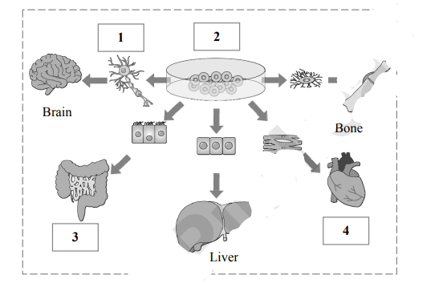

iv. Which precautions should be followed to maintain reproductive health?
v. Distinguish between butterfly and bat (any two points).

Q.3 Answer the following (any five): [15]

i. Redraw the following table by matching correctly:
Column I | Column II | Column III
Coal | Kinetic energy | Nuclear power plant
Uranium | Thermal energy | Wind electricity plant
Wind | Nuclear energy | Thermal plant

ii.
(a) Identify the class of the animals shown in the figure.
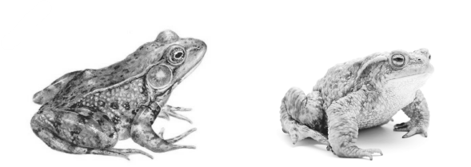
(b) Write two characteristics of that class.

iii. Which precautions are necessary for proper decomposition of domestic waste?
iv. Write the importance of medicinal plants.
v. What will you do? Why?
(a) You spend too much time on Internet/mobile games.
(b) You want to properly use free space around your house.
(c) Your brother in Std. XII has developed stress.

vi. Pictures of disasters are given. Which precautions would you take?
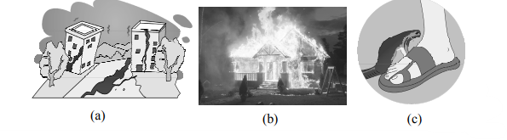

vii. Explain the concept of connecting links with two examples.
viii.
(1) Write two sources of lipids.
(2) How much energy is obtained from lipids?
(3) What is produced after digestion of lipids?

Q.4 Answer the following (any one): [5]

i. Draw a neat and labelled diagram of the female reproductive system and state functions of:
(a) Oviduct
(b) Ovary
(c) Uterus

ii. Explain the meanings of the following symbols:
