BOARD ACTIVITY SHEET: July 2023
Science and Technology Part – 2
Time: 2 Hours Max Marks: 40

Note:
i. All questions are compulsory.
ii. The numbers to the right of the questions indicate full marks.
iii. Answer to every main question must start on a new page.
iv. In case of MCQs (Q. No.1(A)) only the first attempt will be evaluated.
v. For every MCQ, write the correct option letter (A/B/C/D) with sub-question number.
vi. Scientifically correct and labelled diagrams should be drawn wherever necessary.
vii. Each answer must have correct question number and sub-question number.

Q.1. (A) Choose the correct alternative and write correct option number as answer: [5]
i. Genetic disorder like sickle cell anaemia may be caused due to ________.
(A) mutation (B) translation (C) translocation (D) transcription

ii. Protein like interleukin produced by biotechnology is used against ________ disease.
(A) anemia (B) cancer (C) diabetes (D) haemophilia

iii. We get ________ of energy from one gram of lipid.
(A) 9 cal (B) 4 kcal (C) 4 cal (D) 9 kcal
iv. The _______ bacteria are useful for cleaning hydrocarbons and oil pollutants from soil and water.
(A) Lactobacilli (B) Acidobacillus (C) Pseudomonas (D) Streptococcus

v. Human males have _________ numbers of chromosomes.
(A) 44 + XX (B) 44 + XY (C) 22 + XY (D) 22 + XX

(B) Answer the following: [5]
i. Pick the odd man out: β-carotene, lycopenes, xylitol, lutein.
ii. Identify the phylum of the given animal.
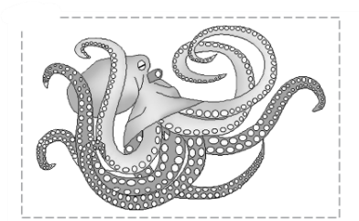

iii. Complete the flow chart.
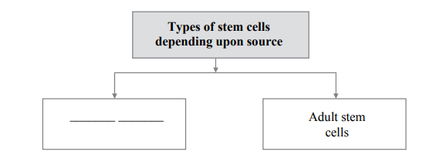

iv. State True or False: Communication media like mobile phone, television, internet should be used often.
v. Write the co-relation: Ovary : Estrogen :: Testes : ________.

Q.2. (A) Give scientific reasons (any two): [4]
i. Duck-billed platypus is a connecting link.
ii. Biofuel is important among renewable sources of energy.
iii. Humans have a crucial role in maintaining environmental balance.

(B) Answer the following (any three): [6]
i. Draw a neat and labelled diagram of mitochondria and tri-carboxylic acid cycle.
ii. Write any two objections raised against Darwin’s Theory of Natural Selection.
iii. Observe the given animal and answer:
(a) Identify the animal and its phylum.
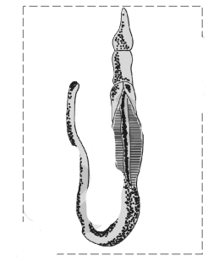
(b) Write any two characteristics of that phylum.

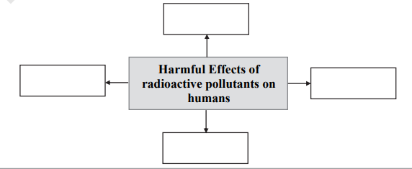
iv. Write any two objectives of disaster management.
v. Complete the conceptual chart:

Q.3. Answer the following (any five): [15]
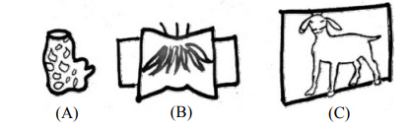
i. Observe the figures and answer:

Identify types of body symmetry and give one example of each apart from the given figure.
ii. Write a short note on types of Biodiversity.
iii. Complete the chart:
Sr.No | Body Constituents | Proteins/Amino Acids
1. | Blood | ________
2. | ________ | Ossein
3. | Skin | ________
4. | ________ | Insulin
5. | Muscle | ________
6. | ________ | Various proteins of cell membrane

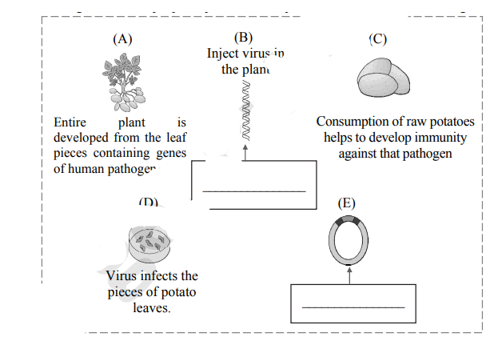
iv. Rearrange and write proper alphabetical sequence only and complete blanks:

v. (a) Complete the flow chart for electrical energy production (thermal power plant).
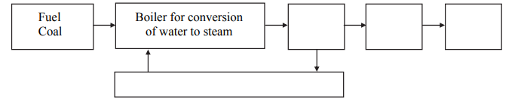

(b) Complete the flow chart for energy transformation in thermal power plant.

vi. Complete the paragraph with help of the words: (nutritive, ethanol, salt, actinomycetes, fermentation, carbon dioxide, lactic acid, Saccharomyces cerevisiae)
Different types of breads are produced from flour of cereals. Dough is formed by mixin
of baker's yeast - …………, water, ……….. and other necessary materials with flour. Due to ………… of carbohydrates by yeast, sugar is converted into ………… and ………… Dough rises up due to CO2 and the bread becomes spongy. Bread and other products produced with the help of yeast become ……… .

vii. Fill in the blanks in the structure of Disaster Management Authority.
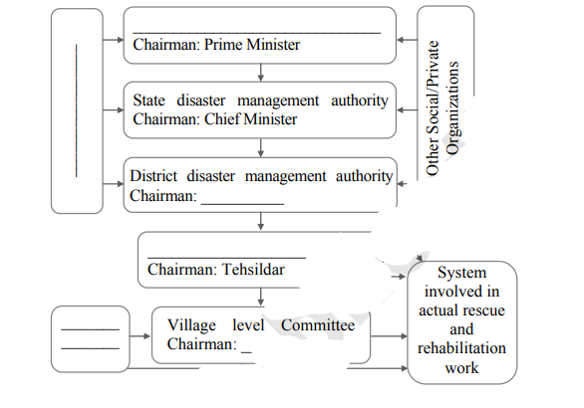

viii. (a) Write any two advantages and two problems of hydroelectric power plant.
(b) Is hydroelectric power generation environment-friendly? Give your opinion.

Q.4. Answer any one: [5]
i. Based on female reproductive system:
(a) How many immature oocytes are present at birth in the ovary of female foetus?
(b) What is ovulation?
(c) What is menopause?
(d) Draw diagram of female reproductive system.
(e) Label: (i) Ovary (ii) Uterus

ii. (a) Complete the flow chart:
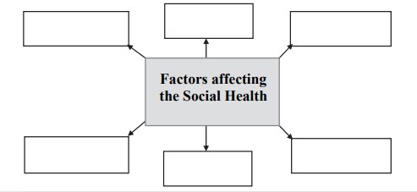

(b) Observe the pictures and answer:
(i) Whether the incidence is rational or irrational? Justify.
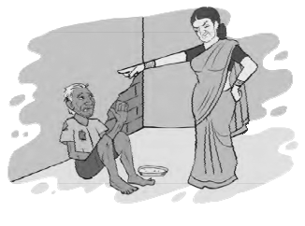


(ii) Identify the picture. What is the punishment given to the person shown?

