BOARD QUESTION PAPER: MARCH 2022
Science and Technology – Part 2
Time: 2 Hours Max Marks: 40

Note:
- All questions are compulsory.
ii. Use of a calculator is not allowed.
iii. The numbers to the right of questions indicate full marks.
iv. In MCQs only the first attempt will be evaluated.
v. For each MCQ, write the correct alternative with subquestion number. (i)(A), (ii)(B)
vi. Draw scientifically correct labelled diagrams wherever necessary.

Q.1 (A) Choose the correct option: [5]

i. Bones contain ______ amino acids.
(A) Melanin (B) Haemoglobin (C) Ossein (D) Insulin

ii. Giant squirrel is an example of ______ threatened species.
(A) Endangered (B) Rare (C) Vulnerable (D) Indeterminate

iii. Human being belongs to ______ class.
(A) Mammalia (B) Amphibia (C) Reptilia (D) Cyclostomata

iv. Organs like ______ can be donated after death.
(A) Skin (B) Heart (C) Lungs (D) Bones

v. Volcano is a ______ disaster.
(A) Social (B) Political (C) Biological (D) Geological

Q.1 (B) Answer the following: [5]

i. Find the odd one out: Earthquake, Flooding, Tsunami, War
ii. True/False: Oxidation of proteins is carried out in aerobic respiration.
iii. Complete the correlation: Western ghat : Asiatic lion :: Sunderban sanctuary : ______
iv. Which type of fuel is used in thermal power plant?

v. Identify the picture and name it.
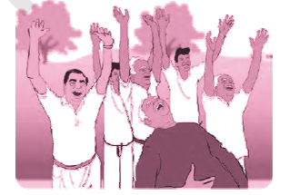

Q.2 (A) Give scientific reasons (any two): [4]

i. Cell division is one of the important properties of cell and organisms.
ii. Cockroach belongs to phylum Arthropoda.
iii. Power generation plant based on natural gas is eco-friendly.

Q.2 (B) Answer the following (any three): [6]
i. Complete the diagram:
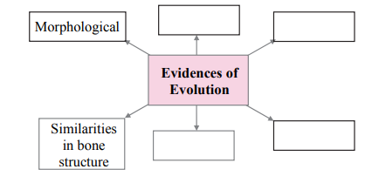

ii. What do we learn from the story of Jadav Molai Payeng?
iii. Distinguish between sexual and asexual reproduction. (two points)
iv. Define genetically modified crops and give any two examples.
v. What are vitamins? Write two types of vitamins.

Q.3 Answer the following (any five): [15]
i. Explain the meanings of the symbols
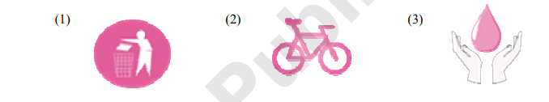

ii. Write any three characteristics of class Reptilia.

iii. (1) Which substance is used to produce cheese? (2) Earlier enzyme? (3) Enzyme for vegetarian cheese?
iv. (1) Which process is shown in the diagram?
(2) Importance?
(3) Which organs can be transplanted?
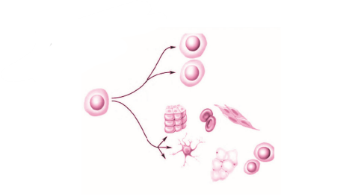

v. What is disaster? Write two examples each of natural and man-made disasters.
vi. Write the objections raised against Darwin’s theory of natural selection.
vii. (1) Which process is shown in the picture?
(2) Two liquid fuels and two solid fuels obtained by this process.
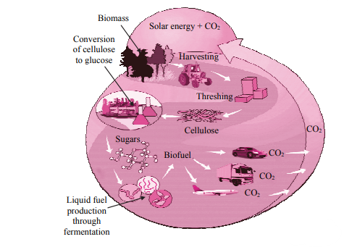

viii. (1) Complete the stages in electric generator using wind energy.
(2) Write limitations of wind energy generator.

Q.4 Answer any one: [5]

i. (a) Sketch and label essential and accessory whorls of flower.
(b) What is pollination?
(c) Two agents of pollination.

ii. What will you do?
(1) You are spending more time on internet.
(2) Neighbour’s child addicted to tobacco chewing.
(3) Sister is incommunicative.
(4) Free space around home must be used for good purpose.
(5) Brother studying in XII has developed stress.

