SCIENCE AND TECHNOLOGY PART – 1: MARCH 2024
Time: 2 Hours Max. Marks: 40
Note:
i. All questions are compulsory.
ii. Use of a calculator is not allowed.
iii. The numbers to the right of the questions indicate full marks.
iv. In case of MCQs (Q. No. 1(A)) only the first attempt will be evaluated.
v. Scientifically correct, labelled diagrams should be drawn wherever necessary.
---------------------------------------------------------------------
Q.1. (A) Write the correct alternative: [5]
i. The SI unit of heat is _______.
(A) calorie (B) joule (C) kcal/kg °C (D) cal/g °C

ii. We can see the sun even when it is little below the horizon because of _______.
(A) Reflection of light (B) Refraction of light
(C) Dispersion of light (D) Absorption of light

iii. _______ is the functional group of carboxylic acid.
(A) –COOH– (B) –CO– (C) –CHO– (D) –OH–

iv. In simple microscope ________ lens is used.
(A) Concave (B) Plano concave (C) Plano convex (D) Convex

v. In ________ process a layer of molten tin is deposited on metals.
(A) Anodization (B) Tinning (C) Galvanizing (D) Alloying
---------------------------------------------------------------------
Q.1. (B) Answer the following: [5]
i. Write the name of the atom having the smallest size.
ii. Write the molecular formula of calcium carbonate.
iii. Write the use of ‘Calorimeter’.
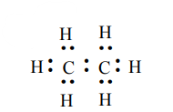
iv. Identify the hydrocarbon from the given electron–dot structure:
v. Match the columns:
Column A — Refractive index of water
(a) 1.31
(b) 1.36
(c) 1.33
---------------------------------------------------------------------

Q.2. (A) Give scientific reasons (any two): [4]
i. When the gas formed on heating limestone is passed through freshly prepared lime water, the lime water turns milky.
ii. Tungsten metal is used to make a solenoid type coil in an electric bulb.
iii. On exposure to air, silver articles turn blackish after some time.
---------------------------------------------------------------------
Q.2. (B) Answer the following (any three): [6]

i. State Dobereiner’s law of triad. Give one example.
ii. Identify the figure and explain its use:
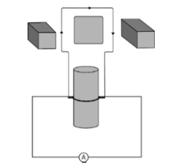

iii. What is meant by satellite launch vehicle? Name any one Indian satellite launch vehicle.
iv. What is free fall? When is it possible?
v. The focal length of a convex lens is 20 cm. What is its power?
---------------------------------------------------------------------
Q.3. Answer the following (any five): [15]
i. Select the appropriate option and complete the paragraph:
(Metals, non-metals, metalloids, four, seven, s-block, p-block, d-block, f-block.)

On the basis of electronic configuration, elements in the modern periodic table
are classified into ________ blocks. Group 1 and 2 elements are included in ________ and all these elements are metals (except hydrogen). Group 13 to 18 elements are included in ________. This block contains metals, non-metals and metalloids. Group 3 to 12 elements are included in ________ and all the elements are ________. Elements shown at the bottom of the periodic table, i.e. lanthanides and actinides constitute ________ and all these elements are metals.

ii. (a) What are the factors affecting the rate of chemical reaction?
(b) Explain any one factor.

iii. Observe the following graph and answer:
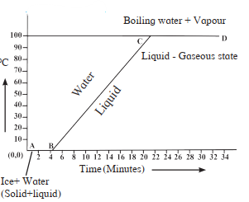

(a) What does the graph represent?
(b) What does line AB represent?
(c) What does line BC represent?

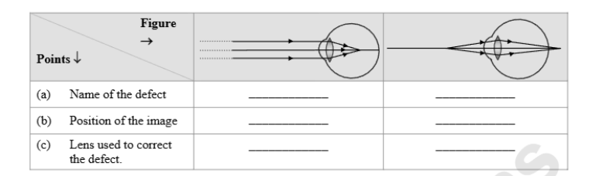
iv. Complete the following table by observing the figures:

v. Write any three general properties of ionic compounds.

vi. Observe the figure and answer:
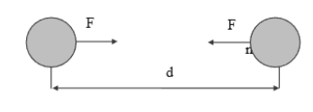

(a) State Newton’s universal law of gravitation.
(b) If distance between two bodies is tripled, how will gravitational force change?
(c) What will happen if mass of one object is doubled?

vii. The orbit of a satellite is exactly 35780 km above Earth's surface and its
tangential velocity is 3.08 km/s.
How much time will the satellite take to complete one revolution?
(Radius of Earth = 6400 km)

viii. What is a solenoid? Draw a neat diagram and name its components.
---------------------------------------------------------------------

Q.4. Answer the following (any one): [5]

i. Observe the diagram and answer:
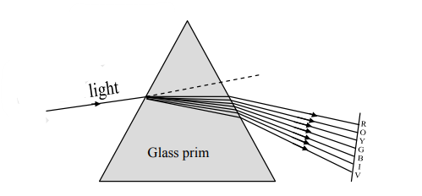

(a) Name the process shown.
(b) Name the colour that deviates the most.
(c) Name the colour that deviates the least.
(d) Name any one natural phenomenon based on this process.
(e) Define ‘spectrum’.
---------------------------------------------------------------------

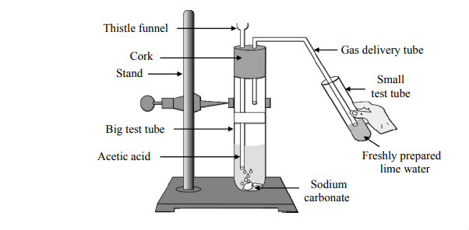
ii. Observe the diagram and answer:

(a) Name the reactants in the reaction.
(b) Which gas comes out as effervescence?
(c) What is the colour change in the lime water?
(d) Instead of sodium carbonate, which chemical can produce the same product?
(e) Write one use of acetic acid.
---------------------------------------------------------------------

