**Part I**

**Choose the right answer!**

1. I would cook soup if you **brought/had brought** some vegetables this morning.
2. If she **doesn’t hurry/doesn’t hurries,** she will be late.
3. If it **rains/rain**, the grass grows.
4. My Ideal holiday would **be/have been** a week in my house without do nothing.
5. I would **have been/been** a famous writer if I had **send/sent** my work to the publisher.
6. If I **had had/have** good luck, I would have won the first prize.
7. If I **got/get** the earlier bus, I **could/can** come home at 5 o'clock.
8. If you had told me the truth, I **would have helped/help** you.
9. If Susan **takes/take** her driving lessons regularly, she will pass her driving test.
10. I'll give you a piece if mother **makes/make** apple pie.

**Part II**

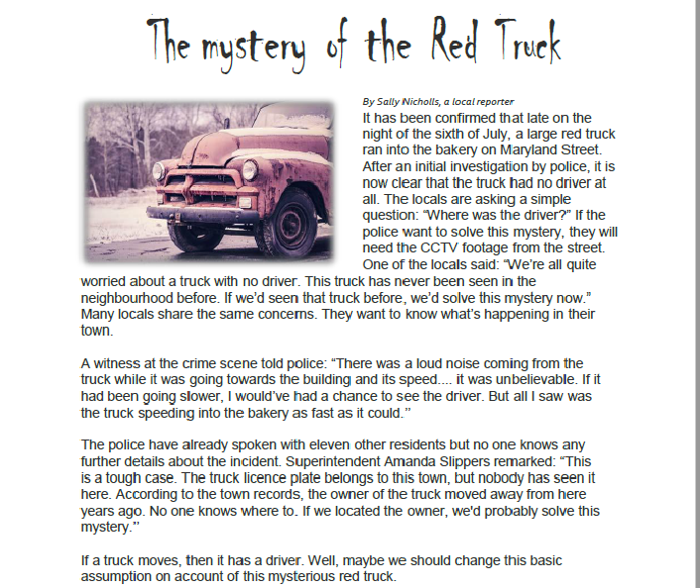**Read the text carefully and identify the "If conditional" expression from the text.**

**1. How many “If Conditional” expressions did you find? Please write them down!**

|  |
| --- |
| 1. If the police want to solve this mystery , they will need the CCTV ( first conditional) |
| 2. if we’d seen that truck before , we’d solve this mystery now . (Third conditional + second conditional) |
| 3. If it had been going slower , I would’ve had a chance to see the driver (Third Conditional |
| 4. if we located the owner , we’d probably solve this mystery (Second Conditional) |
| 5. if a truck moves , then it has a driver (Zero Conditional) |
|  |

**2. Decide if the statements are *true* or *false* according to the text.**

1. The locals knew that the red truck had an old driver. False
2. The police have investigated all the people in the town. True
3. The CCTV footage of the street will help the police. True
4. The locals haven’t seen the truck in the town before. True
5. The truck ran into the building very slowly. False