**Mauritius Registry Software**

**User Manual V1**

Contents

**OVERVIEW** 3

**GET STARTED** 3

**1.1** **How can I register a new patient?** 3

**1.2** **How can I view the patient registration form details?** 4

**1.3** **How can I edit a patient’s registration form?** 5

**1.4** **How can I start/change of KRT modality for a patient?** 7

**1.5** **How can I view a patient’s KRT modality form?** 9

**1.6** **How can I edit a patient’s KRT modality form?** 11

**1.7** **How can I add assessment for dialysis patient?** 13

**1.8** **How can I view a patient’s dialysis assessment?** 15

**1.9** **How can I edit a patient’s dialysis assessment?** 17

**1.10** **How can I stop a dialysis?** 19

**1.11** **How can I edit a patient’s stop dialysis form?** 20

# **OVERVIEW**

List of functionalities covered in this manual:

* New patient registration, view and edition of the form.
* Start/Change of KRT modality for a patient, view and edition of the patient’s KRT modality form.
* Add assessment for dialysis patient, view and edition of the assessment form.
* Stop dialysis/treatment and edition of the stop dialysis form.

# **GET STARTED**

Suggestion: Include the following questions in the Mauritius application as Help/Support pages.

## **How can I register a new patient?**

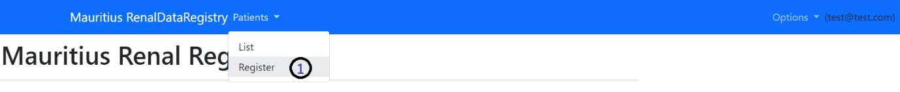

## **How can I view the patient registration form details?**

## **How can I edit a patient’s registration form?**

Edit:

## **How can I start/change of KRT modality for a patient?**

## **How can I view a patient’s KRT modality form?**

## **How can I edit a patient’s KRT modality form?**

Edit:

## **How can I add assessment for dialysis patient?**

Note: To add a dialysis assessment the system requires that the patient is in a dialysis mode (HD or PD).

## **How can I view a patient’s dialysis assessment?**

## **How can I edit a patient’s dialysis assessment?**

Edit:

## **How can I stop a dialysis?**

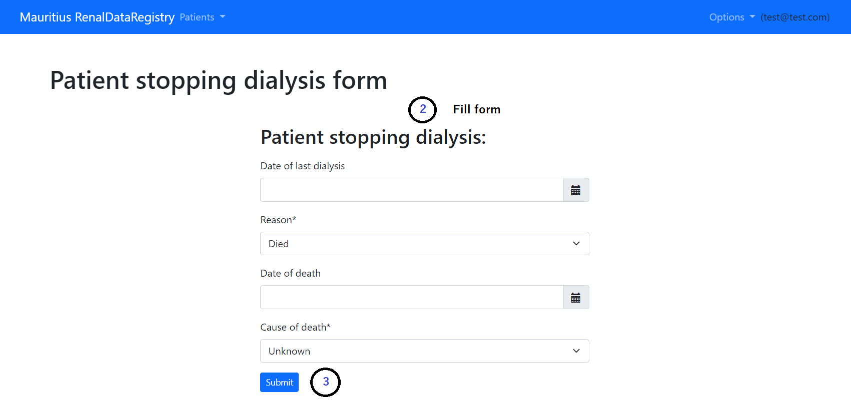

## **How can I edit a patient’s stop dialysis form?**

