**Group Assignment – Website**

DECISIONS AND THEIR REASONS – RENAN OLIVEIRA AND WILSON KHOR WEBSITE

The design of the website was based on e-sport teams websites, the main inspiration for this project was the INTZ website, all the websites that were used as a base for this one are in the list of references which can be found in the directories of the project as a .txt file.

Github is been used for the development, choice made since we’ve learned how to use the git tool in the SD1 course, github chosen due to it’s facilities and easy use.

Trello.com is been used as a form of organization for the tasks, in there it’s easy to create the categories for the tasks (to do, doing, waiting resources, done).

DAY 1

Started designing the team design components as the logo, jersey, banners, backgrounds, all those files are in the folder called media with their respective editable

Files such as PHOTOSHOP, ILLUSTRATOR. (total work time = 3 hours).

DAY 2

The main working layout of the website was decided and started to be implemented, tests in both mobile and computer versions and some bugs were identified on the tests.

DAY 3

We went to the ECO CAFFEE to work on the project, the desktop version, mobile and ipad were improved and many decisions were made, github was an issue already solved, it made us loose some time to figure out how to solve the conflicts. Overall the project improvement was a success.

DAY 4

We went again to the same caffe and worked on the flexbox for organizing the content, the footer, the slides and it’s compatibility with the mobile and ipad versions. This day left the landscape version due to fix.

DAY 5

Content of the main page was created and updated to it. The website now has an online version to check in the real mobile phones to see how it is working now. This website is hosted in Renan’s server.

DAY 6

In this day all the pages were made and it’s content were created, additional comments were added, a contact form connected to an API for sending those forms to the team email was added and it is already working.

**WIREFRAMES:**



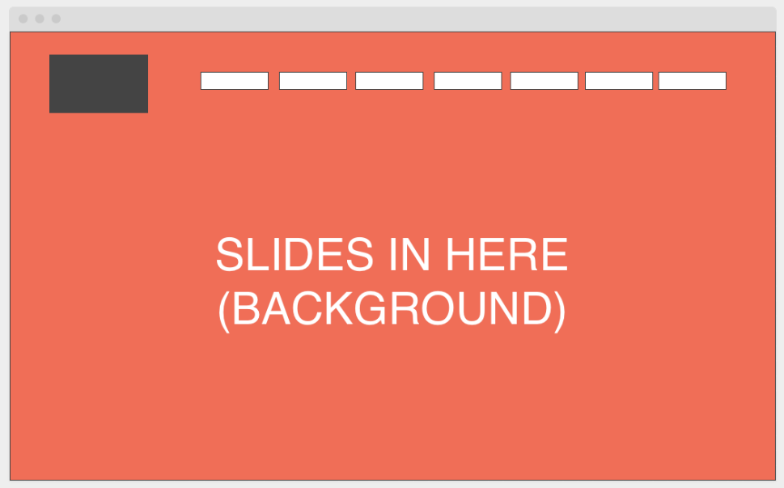

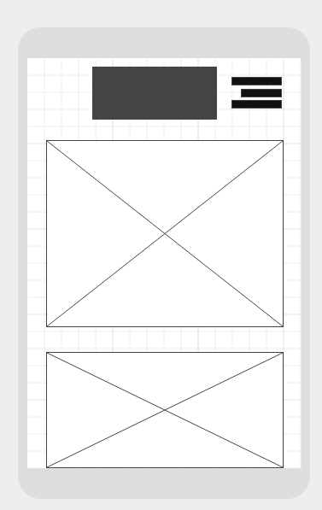

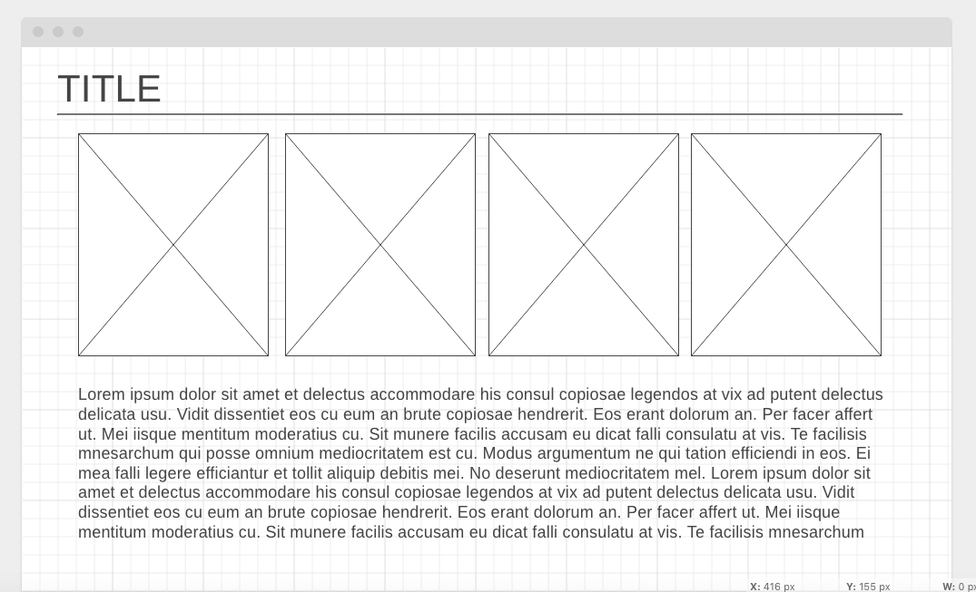

**HTML MAIN PAGE VALIDATION:**

