Final project – machine learning

Renana Rimon – 207616830

Talya Shitreet – 314855099

**DataSet:**

The dataset is from 'kaggle': <https://www.kaggle.com/datasets/shiekhburhan/face-mask-dataset>

The dataset has a total of 14,535 images.

Goal: classifying pictures of people - are they wearing a mask, and if so - are they wearing it properly?

The classification will be in 3 classes as will be explained later. Each class has 2 types of images, simple and complex. This is for the data to be more reliable and describe a real situation, so that we can classify correctly not only in training the model but also in the world.

We emphasize that the classification is for 3 classes only, and the division of each class into 2 is to describe a more correct situation, but in terms of the classification, the goal is to classify whether a person wore a mask properly / wore a mask poorly / did not wear a mask at all.

**The data consists of 3 classes:**  
a) **incorrect mask** – 5000 images

* 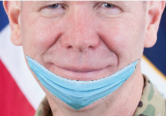"**Mask On Chin**": These are the images in which masks are put on a chin only. The mouth and the nose of a person are visible. (2500 images)
* 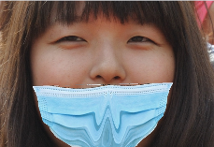"**Mask On Chin Mouth**": In this, the mask is covering the chin and the mouth area. The nose of a person is not covered. (2500 images)

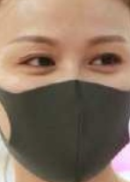b) **with mask**: 4789 images

* "Simple With Mask" images: It consists of data samples of face masks without any texture, logos, etc. (4000 images)
* "Complex With Mask" images: It includes the images of the sophisticated face masks with textures, logos, or designs printed on them. (789 images)

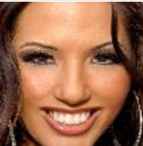C) **without mask** – 4746 images

* "Simple Without Mask images: These are images without any occlusion. (4000 images)
* "Complex Without Mask" images: It consists of faces with occlusion, such as beard, hair, and hands covering the face. (746 images)

**Techniques:**

1. Separation by a multidimensional plane (i.e., SVM)
2. Decision trees (i.e., random forest)
3. Nearest neighbor search (i.e., KNN)
4. Regression (i.e., logistic regression one-vs-one)