
Adjectives
Teacher
Renan Grossi
(51) 98135 3067

Quick Reminder
- Adjectives describe nouns (big, small, happy, red, old, new...)
- They usually come before the noun: a big house
- Order of adjectives (when using more than one):
Opinion – Size – Age – Color – Origin – Material – Purpose
Example: a beautiful big old red Italian leather bag

Exercise 1: Fill in the Blanks
Choose the best adjective from the box.
Box: big, small, happy, sad, old, new, red, blue, hot, cold, beautiful, ugly, fast, slow, tall, short
- I live in a ________ house.
- She is a ________ girl.
- The car is ________.
- It is a ________ day today.
- He is a ________ man.
- The water is ________.
- This is a ________ book.
- The dog is very ________.
- She wears a ________ dress.
- The train is ________.

Exercise 2: Order of Adjectives
Put the adjectives in the correct order.
- (red / big / car) → a ________ ________ ________
- (beautiful / old / house) → a ________ ________ ________
- (small / black / cat) → a ________ ________ ________
- (Italian / leather / new / bag) → a ________ ________ ________ ________
- (tall / young / man) → a ________ ________ ________
- (delicious / hot / soup) → ________ ________ ________
- (blue / small / box) → a ________ ________ ________
- (old / wooden / chair) → an ________ ________ ________
- (happy / little / girl) → a ________ ________ ________
- (fast / red / sports / car) → a ________ ________ ________ ________

Exercise 3: Sentence Formation
Rearrange the words to form correct sentences.
- (big / house / a / is / this) → _________________________________.
- (happy / she / is / girl / a) → _________________________________.
- (red / car / fast / is / the) → _________________________________.
- (old / man / the / is / tall) → _________________________________.
- (small / baby / the / is / cute) → _________________________________.
- (beautiful / is / flower / this) → _________________________________.
- (cold / water / the / is) → _________________________________.
- (hot / coffee / my / is) → _________________________________.
- (short / the / boy / is) → _________________________________.
- (slow / turtle / the / is) → _________________________________.

Exercise 4: Error Correction
Correct the mistakes.
- This is a house big. → _________________________________.
- She is girl happy. → _________________________________.
- The car red is fast. → _________________________________.
- He is man old. → _________________________________.
- The baby is small and cute. → _________________________________.
- This flower beautiful is. → _________________________________.
- The water cold is. → _________________________________.
- My coffee hot is. → _________________________________.
- The boy is short. → _________________________________.
- The turtle slow is. → _________________________________.

Exercise 5: Writing Practice
Describe the picture below using at least 3 adjectives in the correct order.
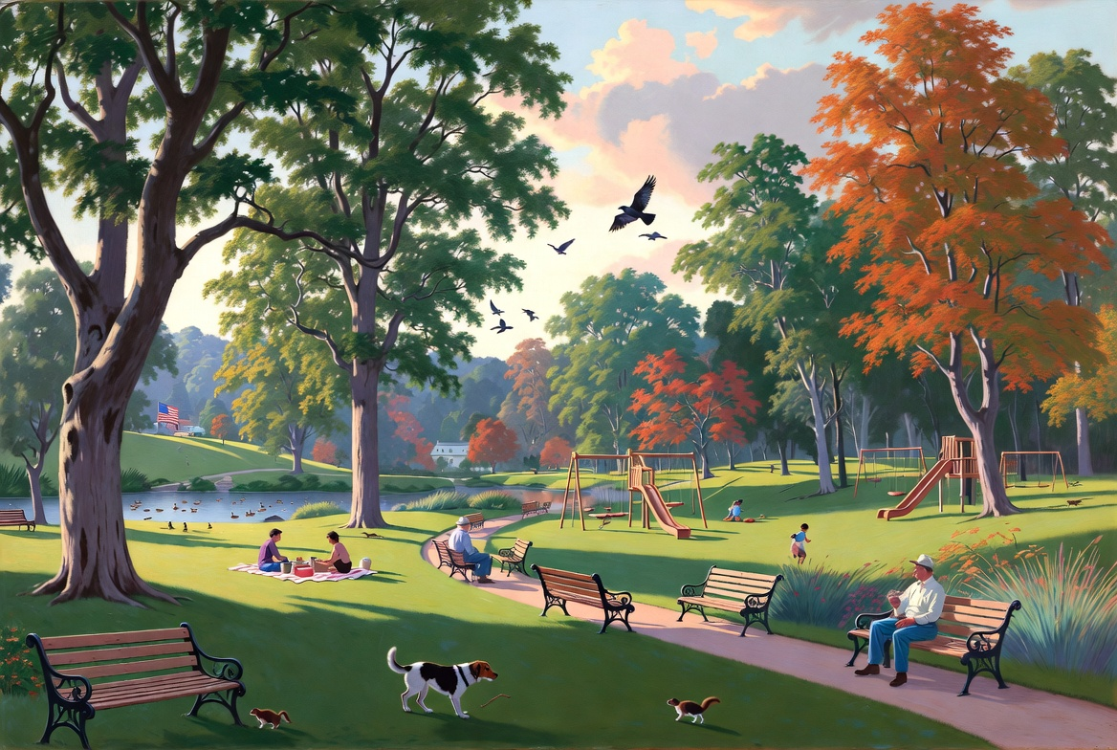

Example:
I see a beautiful big green tree in the park.
Your sentences:
________________________________________
________________________________________
________________________________________
________________________________________

